NAME: BLOCK:
Lesson 3-2: Adding, Subtracting, and Multiplying Polynomials
Math Objective | Add, subtract, and multiply polynomials. Understand closure of polynomials under these operations. Apply polynomial operations to real-world problems.
Language Objective | Students will be able to explain the steps to add, subtract, and multiply polynomials using academic vocabulary, with the support of sentence frames and think-pair-share strategies.
Essential Understanding | Polynomials can be added, subtracted, and multiplied using the Associative, Commutative, and Distributive Properties. The set of polynomials is closed under these operations.

3-2: Explore and Reason – Found on Schoology – Done in small groups – shared out as full class.
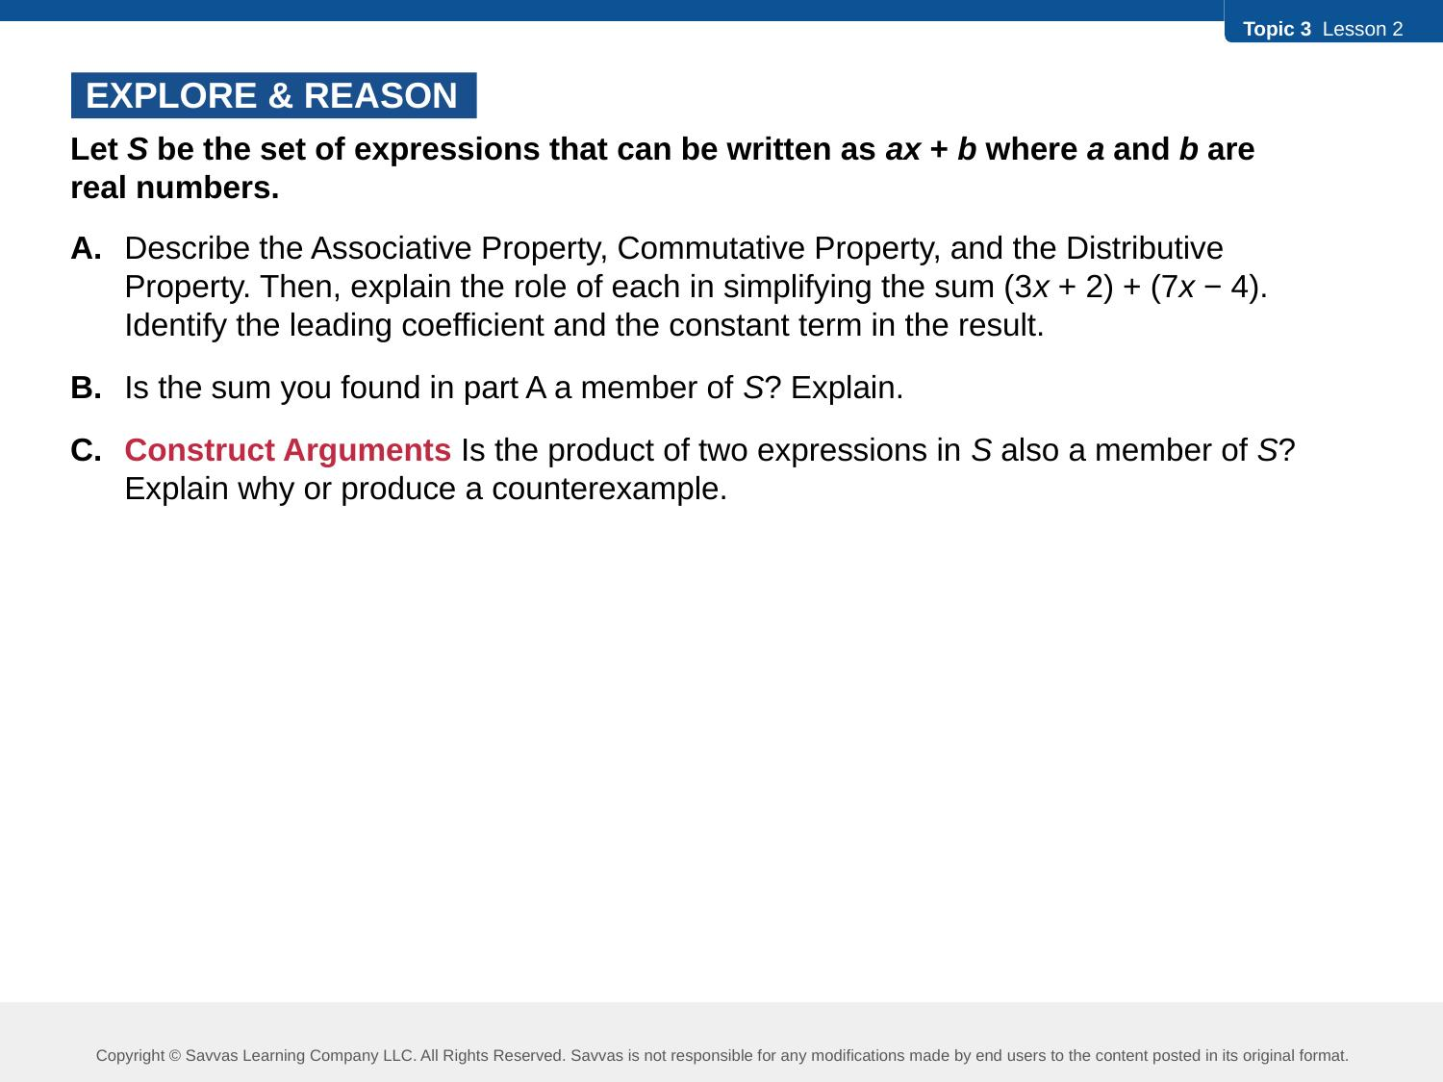
We will enter notes together in 3-2 Interactive Student Edition Ex.1 "Try It!"
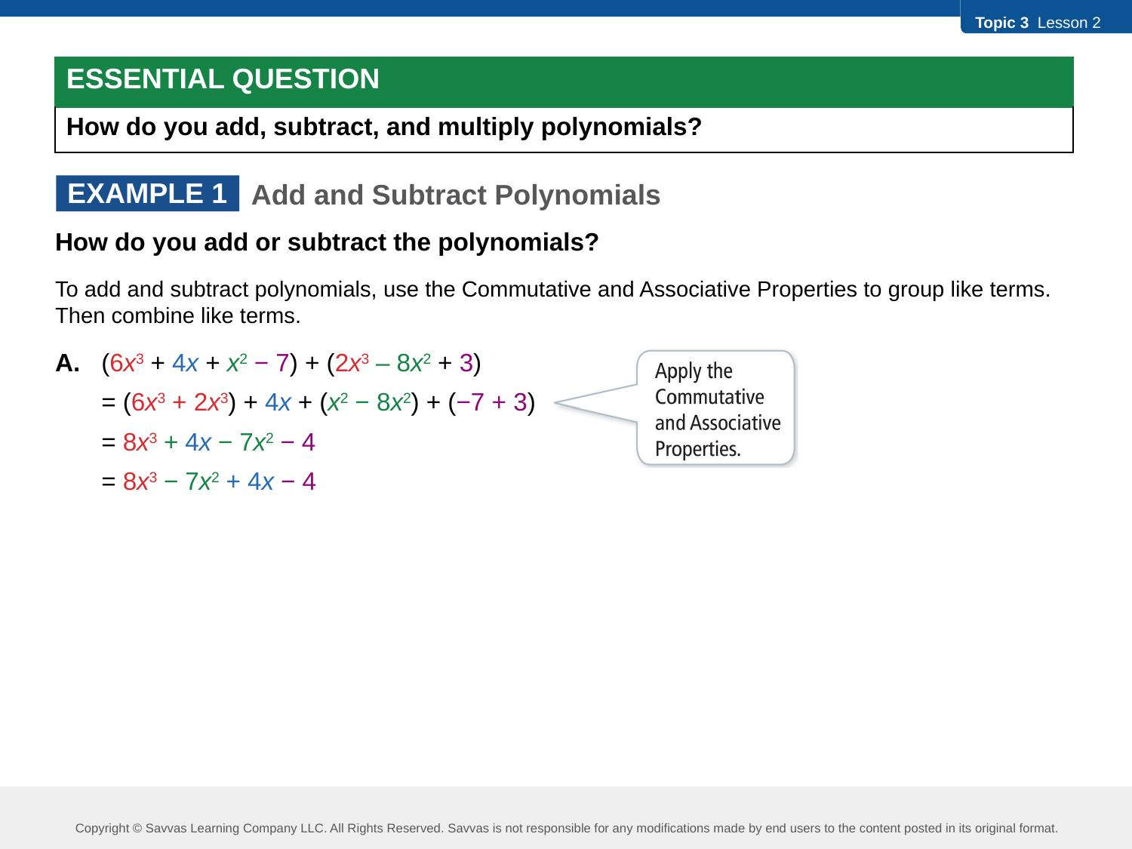
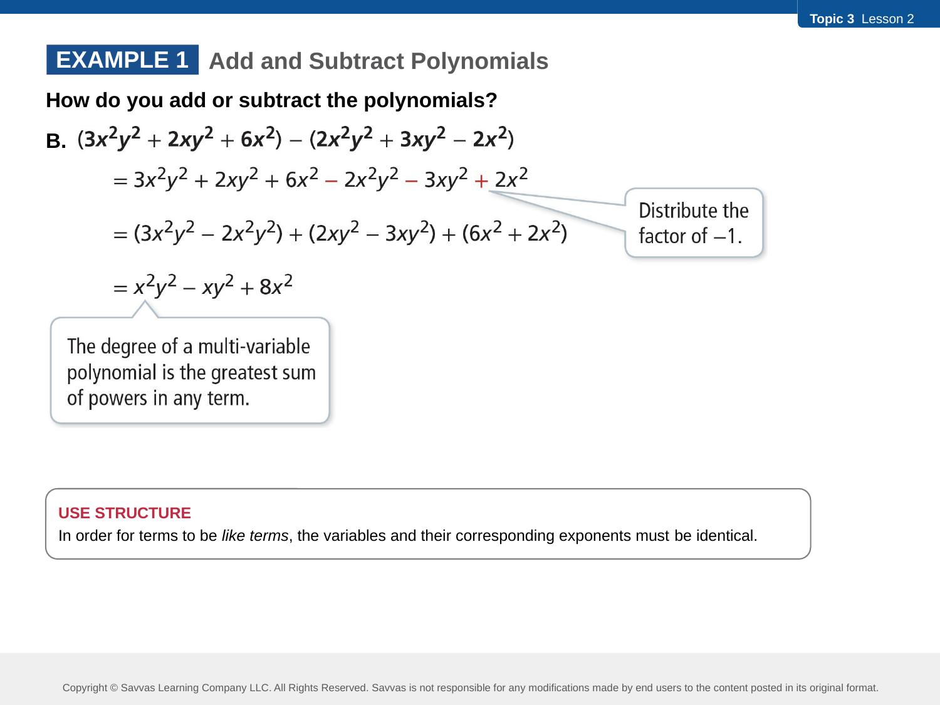
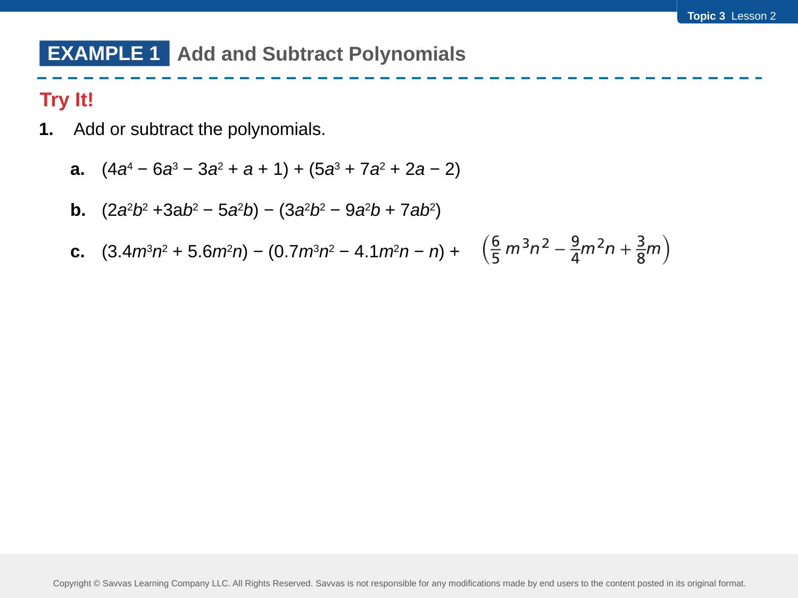
We will enter notes together in 3-2 Interactive Student Edition Ex.2 "Try It!"
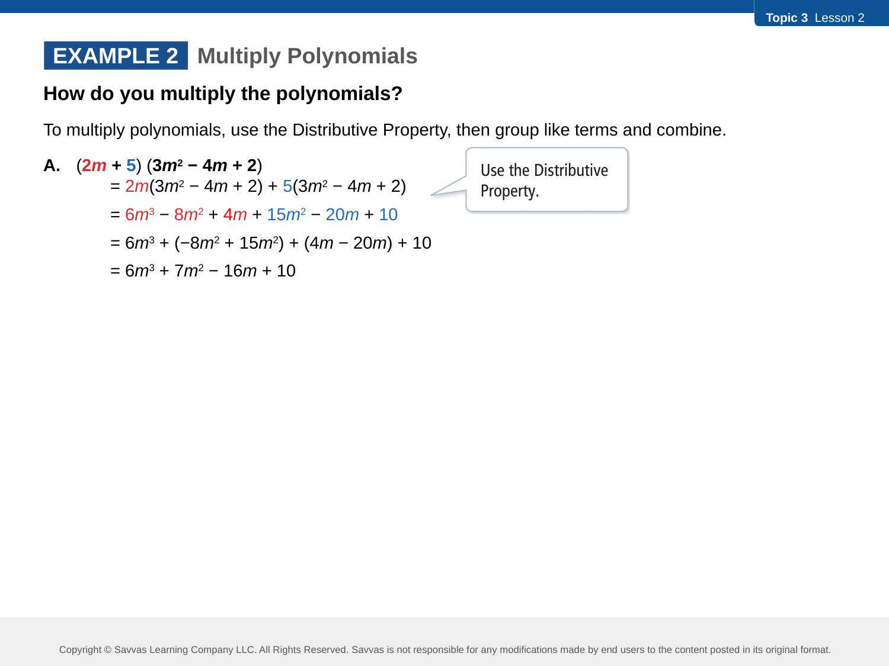
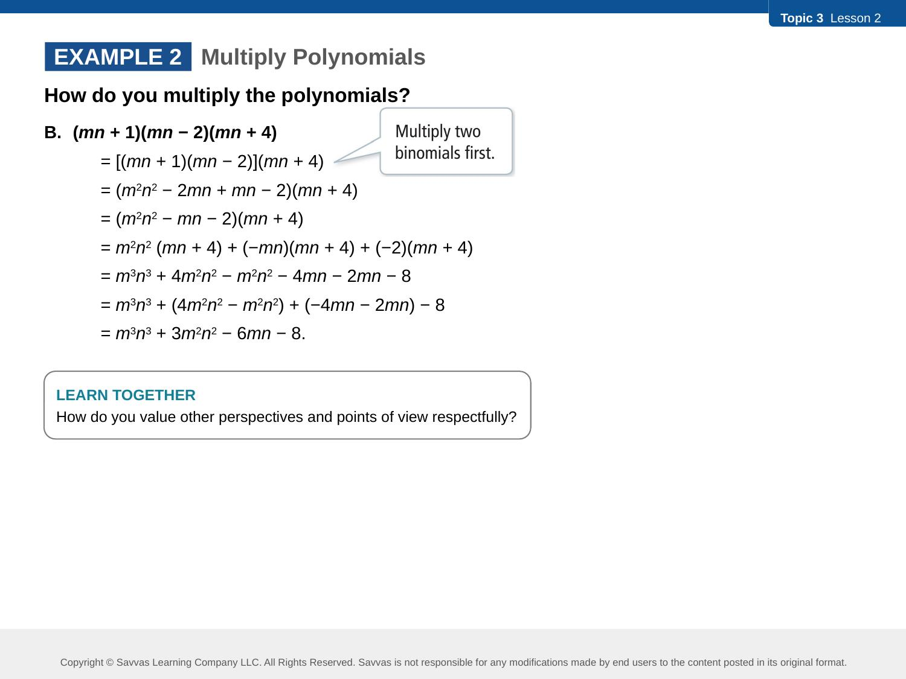
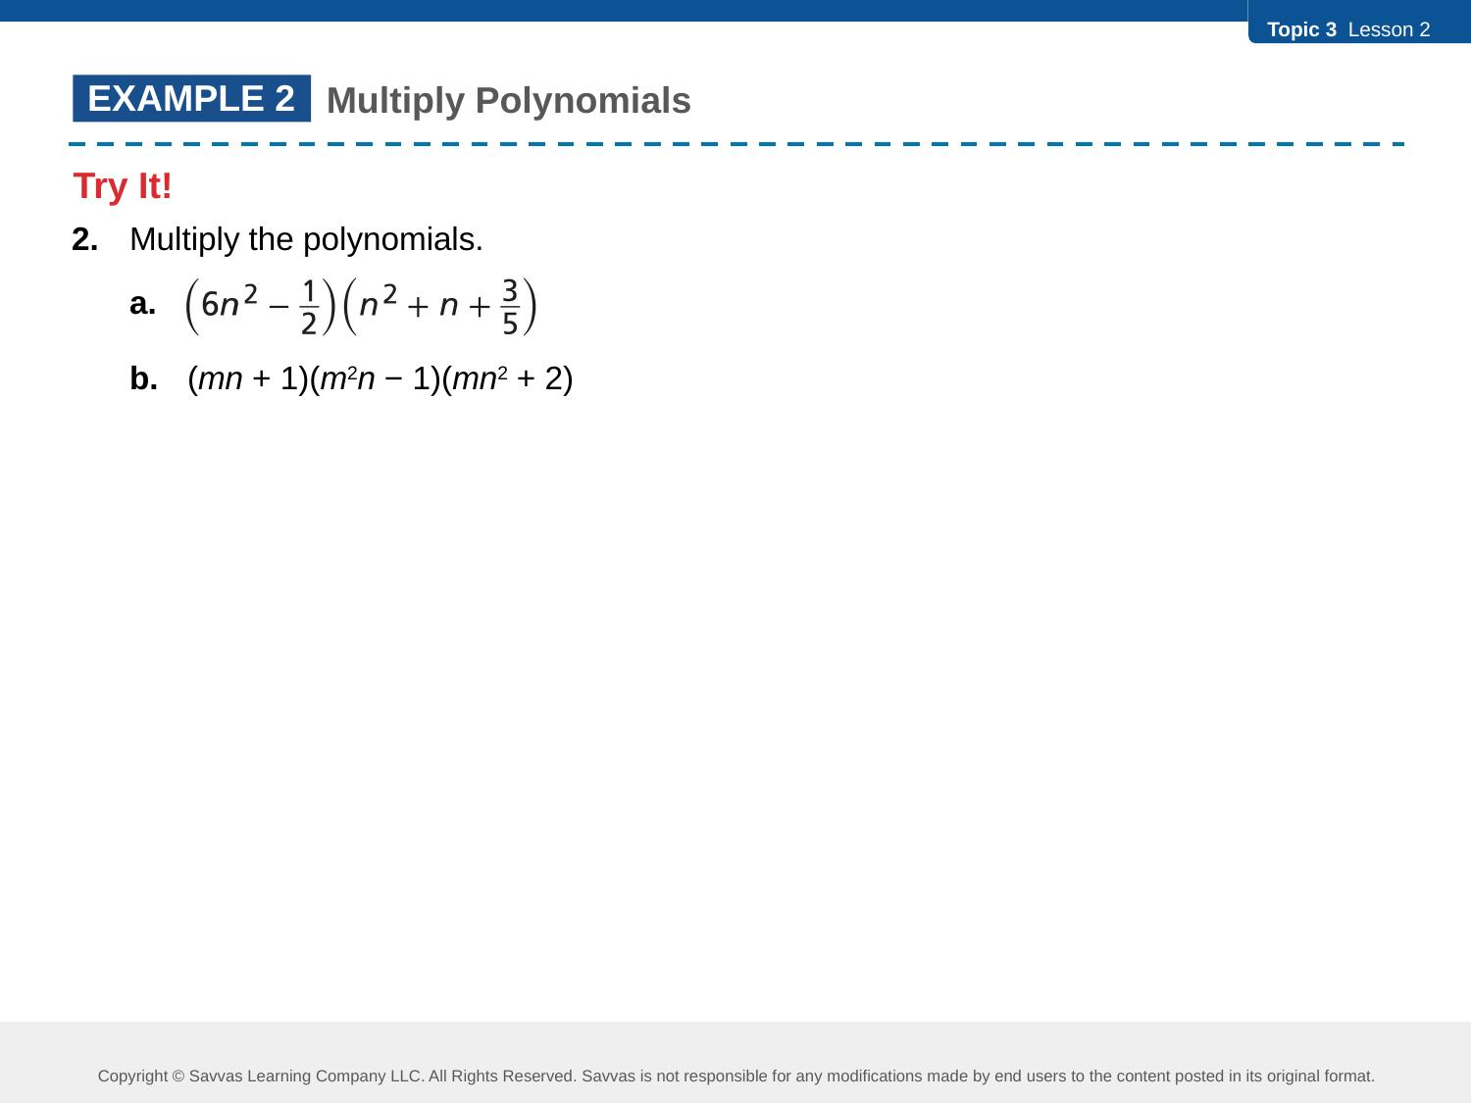
We will enter notes together in 3-2 Interactive Student Edition Ex.3 "Try It!"
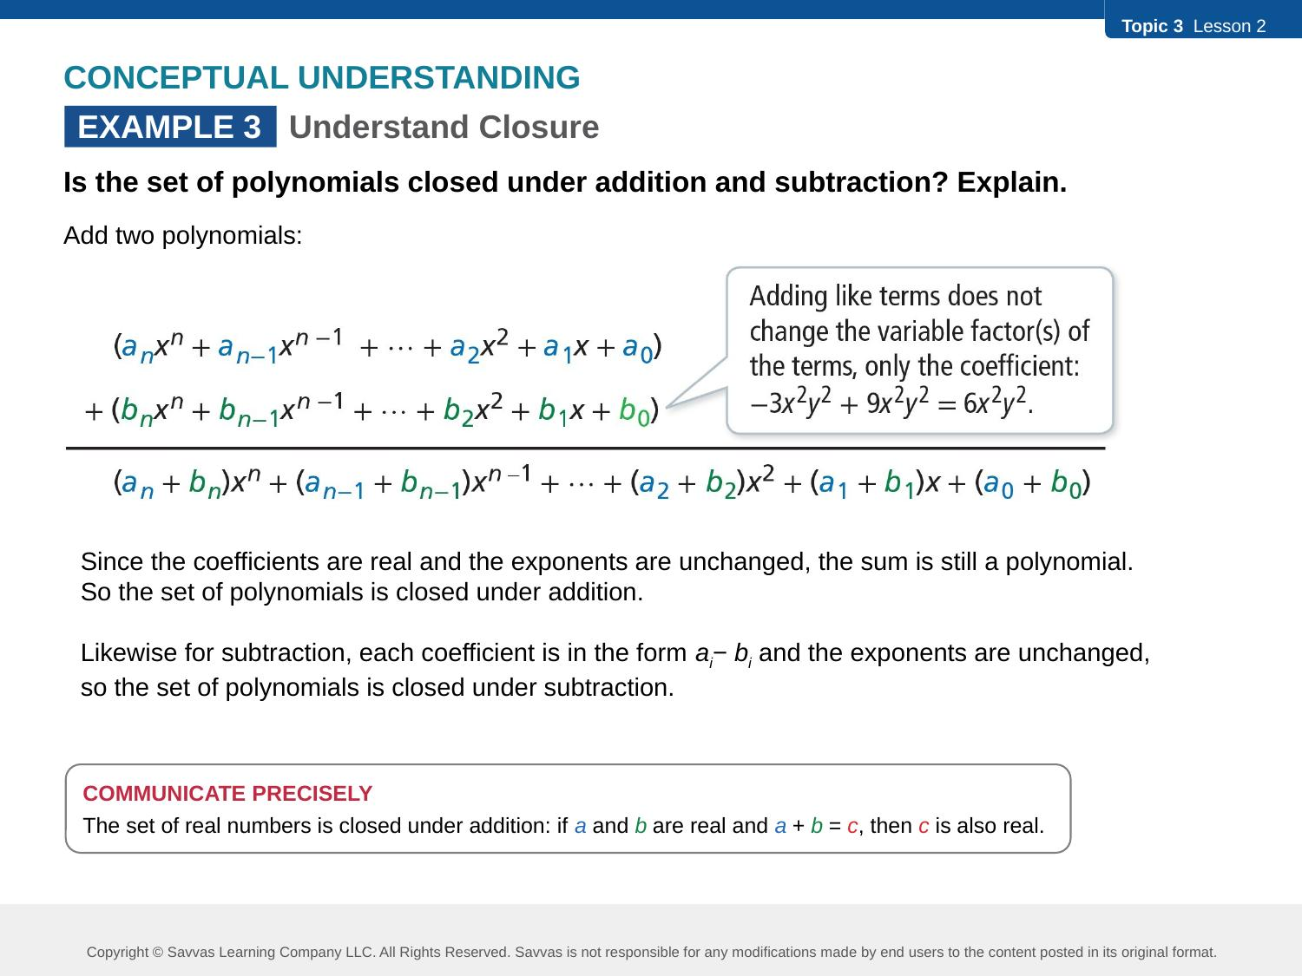
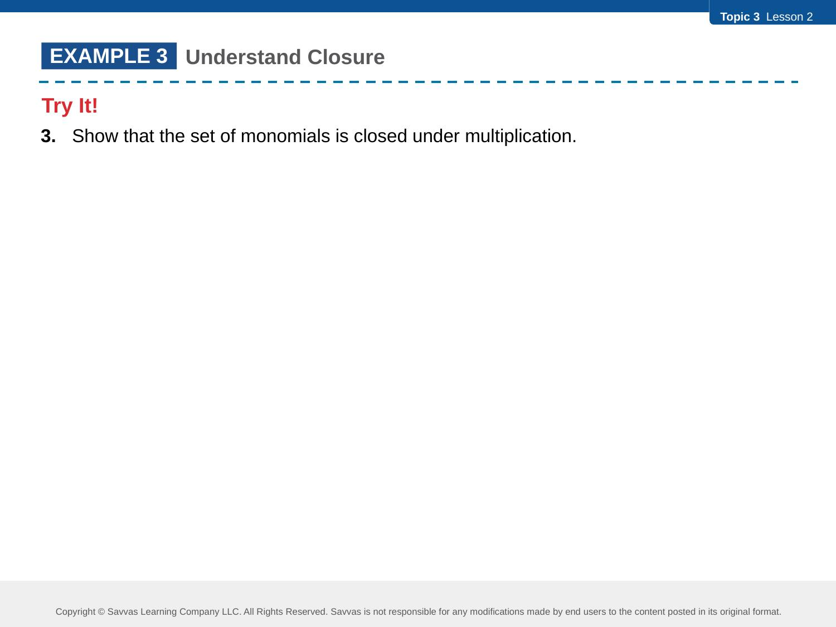

We will enter notes together in 3-2 Interactive Student Edition Ex.4 "Try It!"
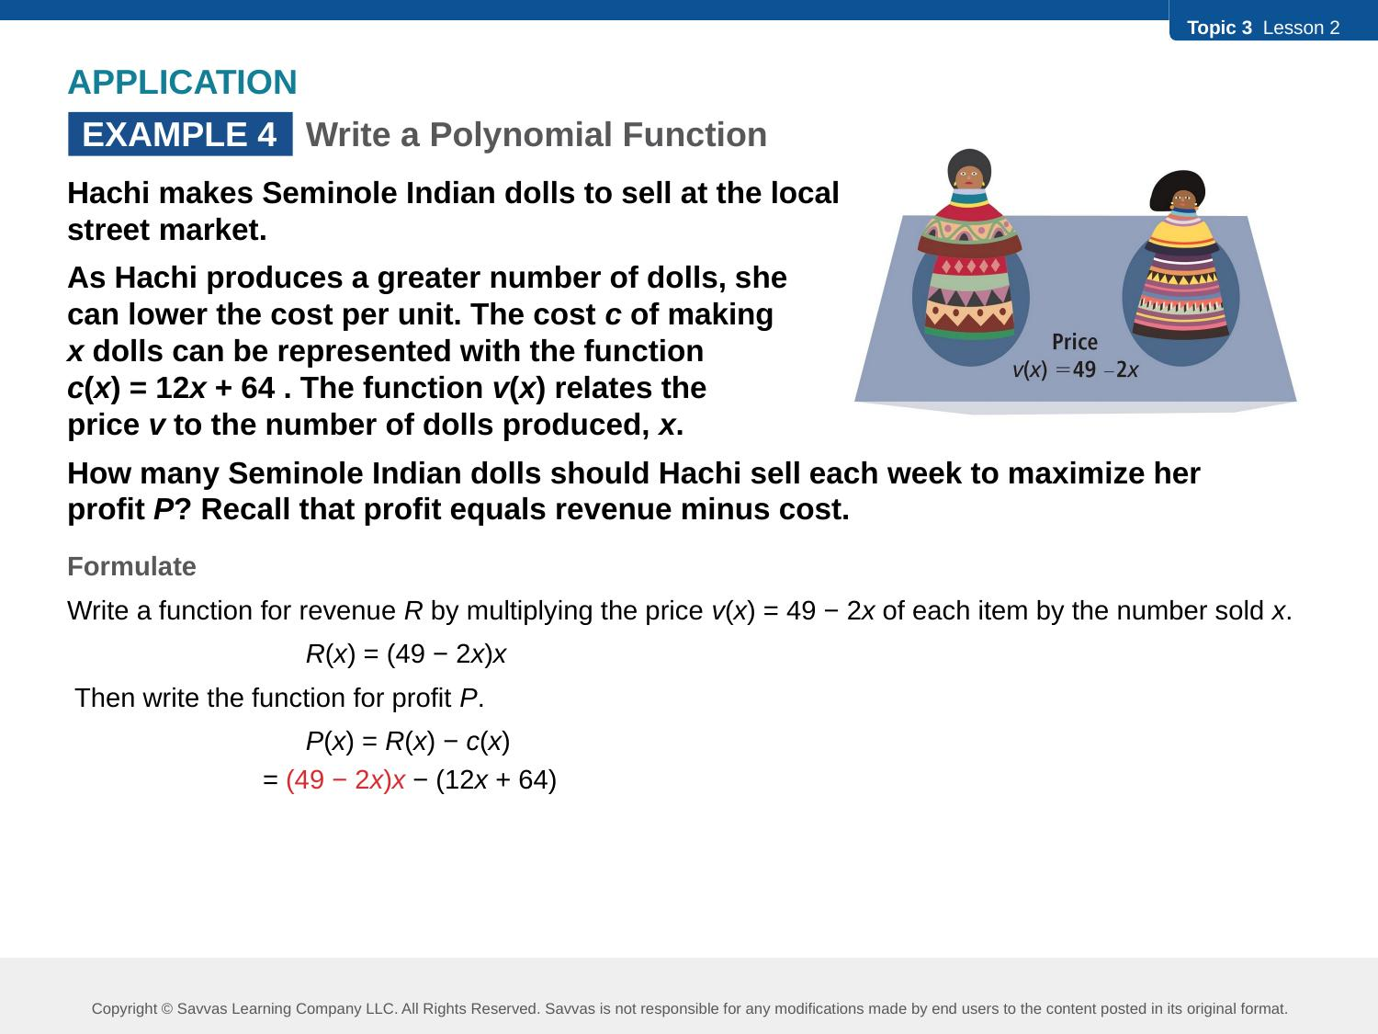
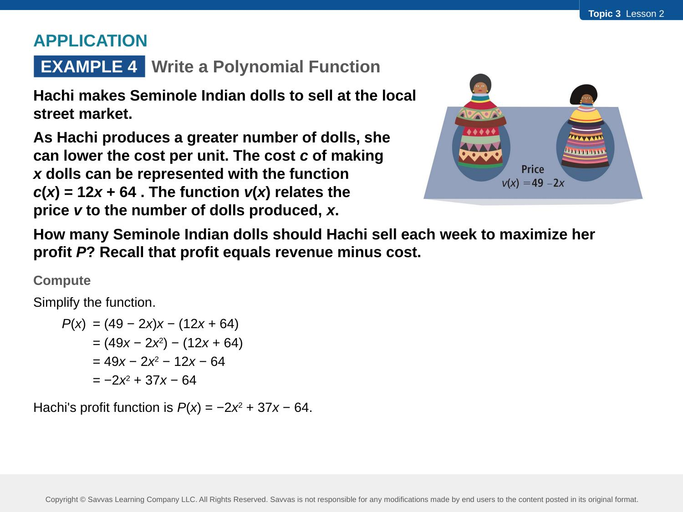
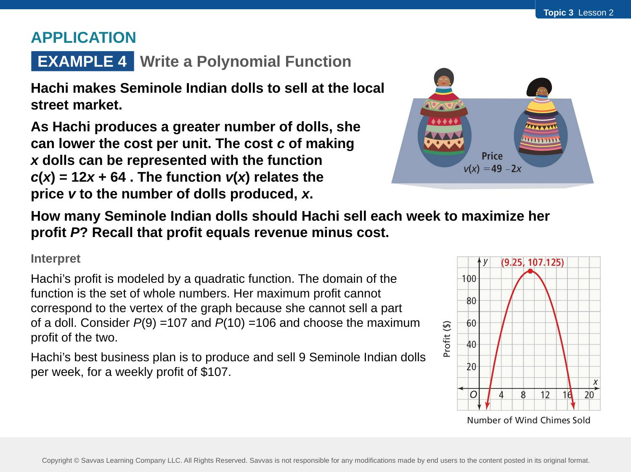
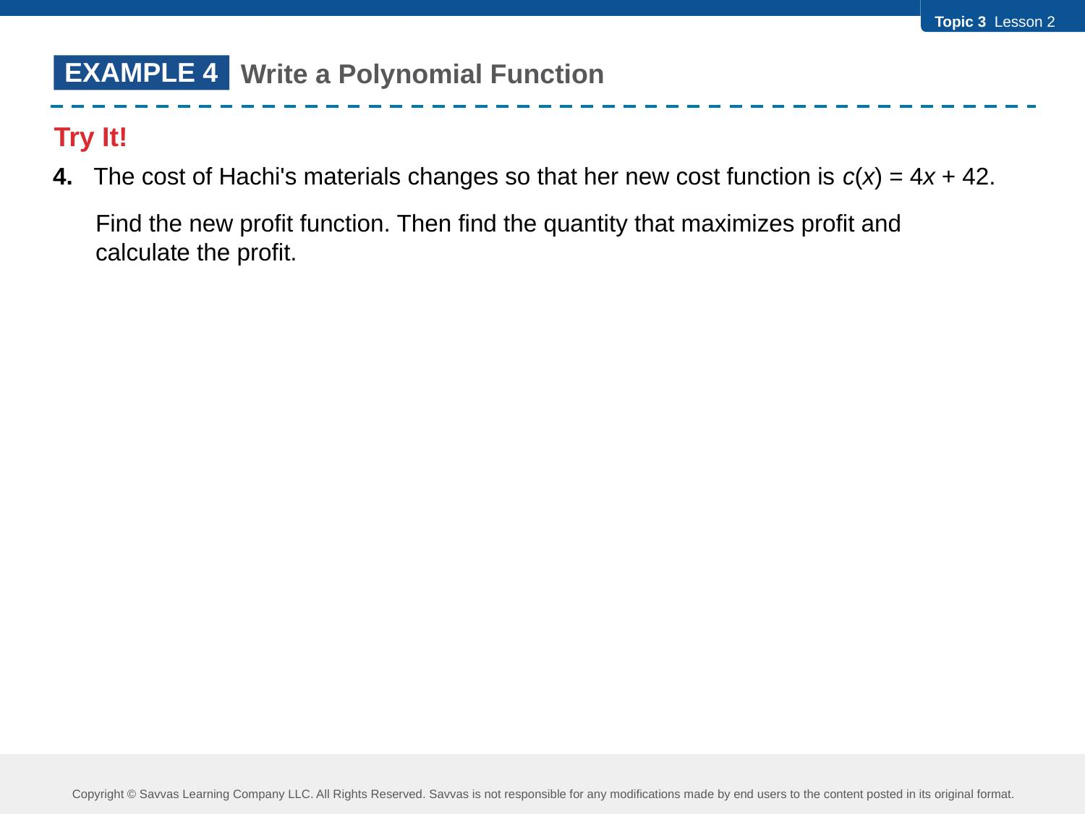
We will enter notes together in 3-2 Interactive Student Edition Ex.5 "Try It!"
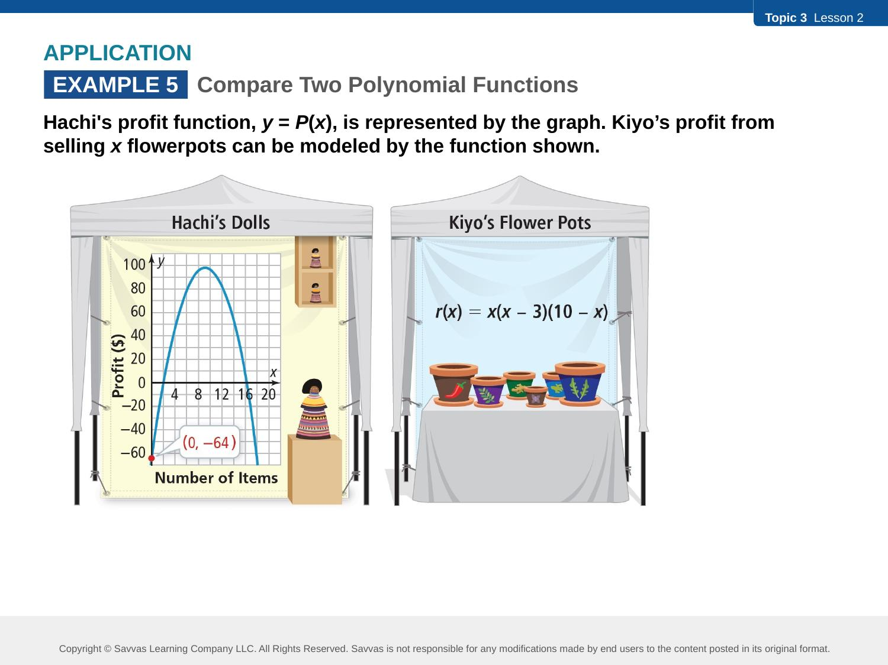
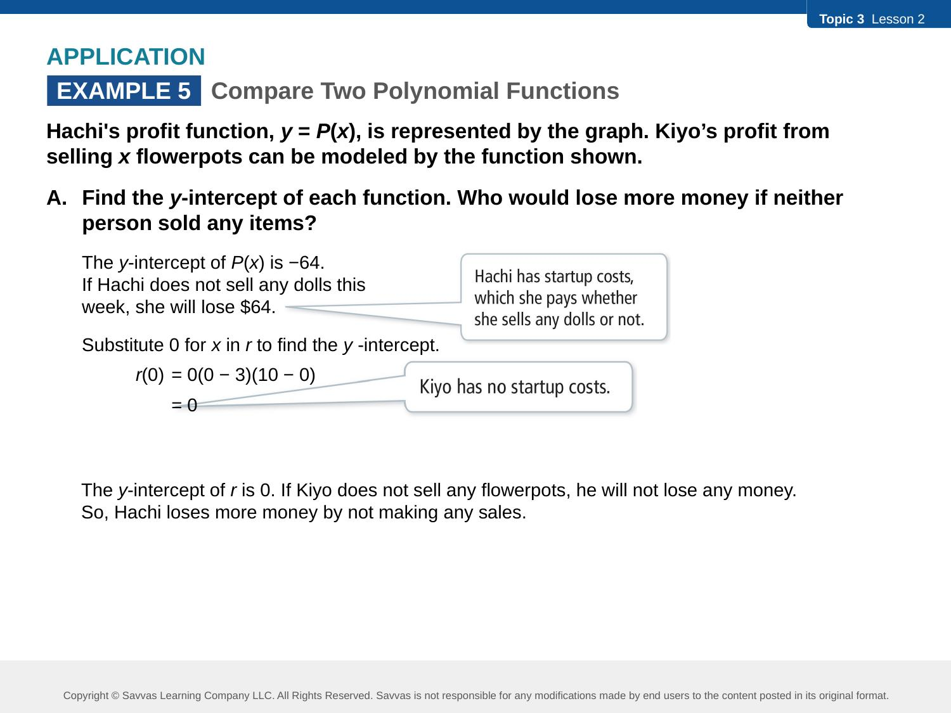
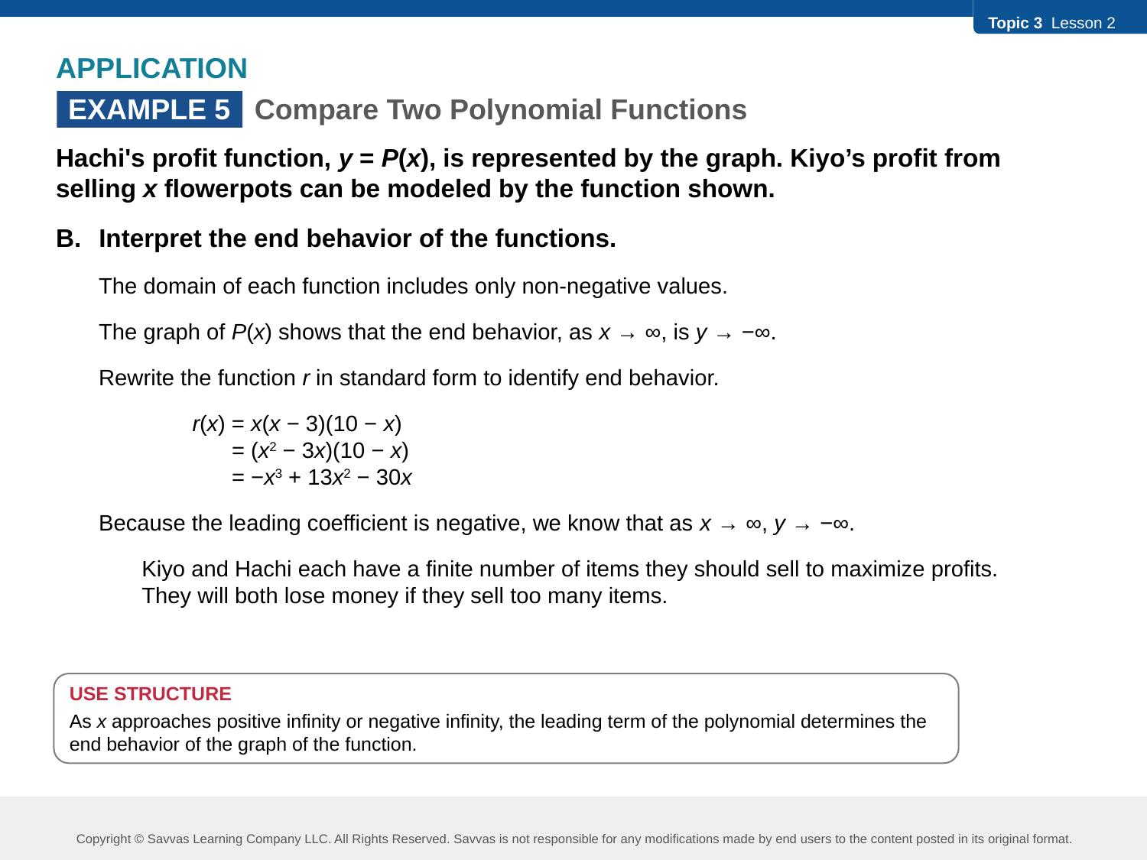
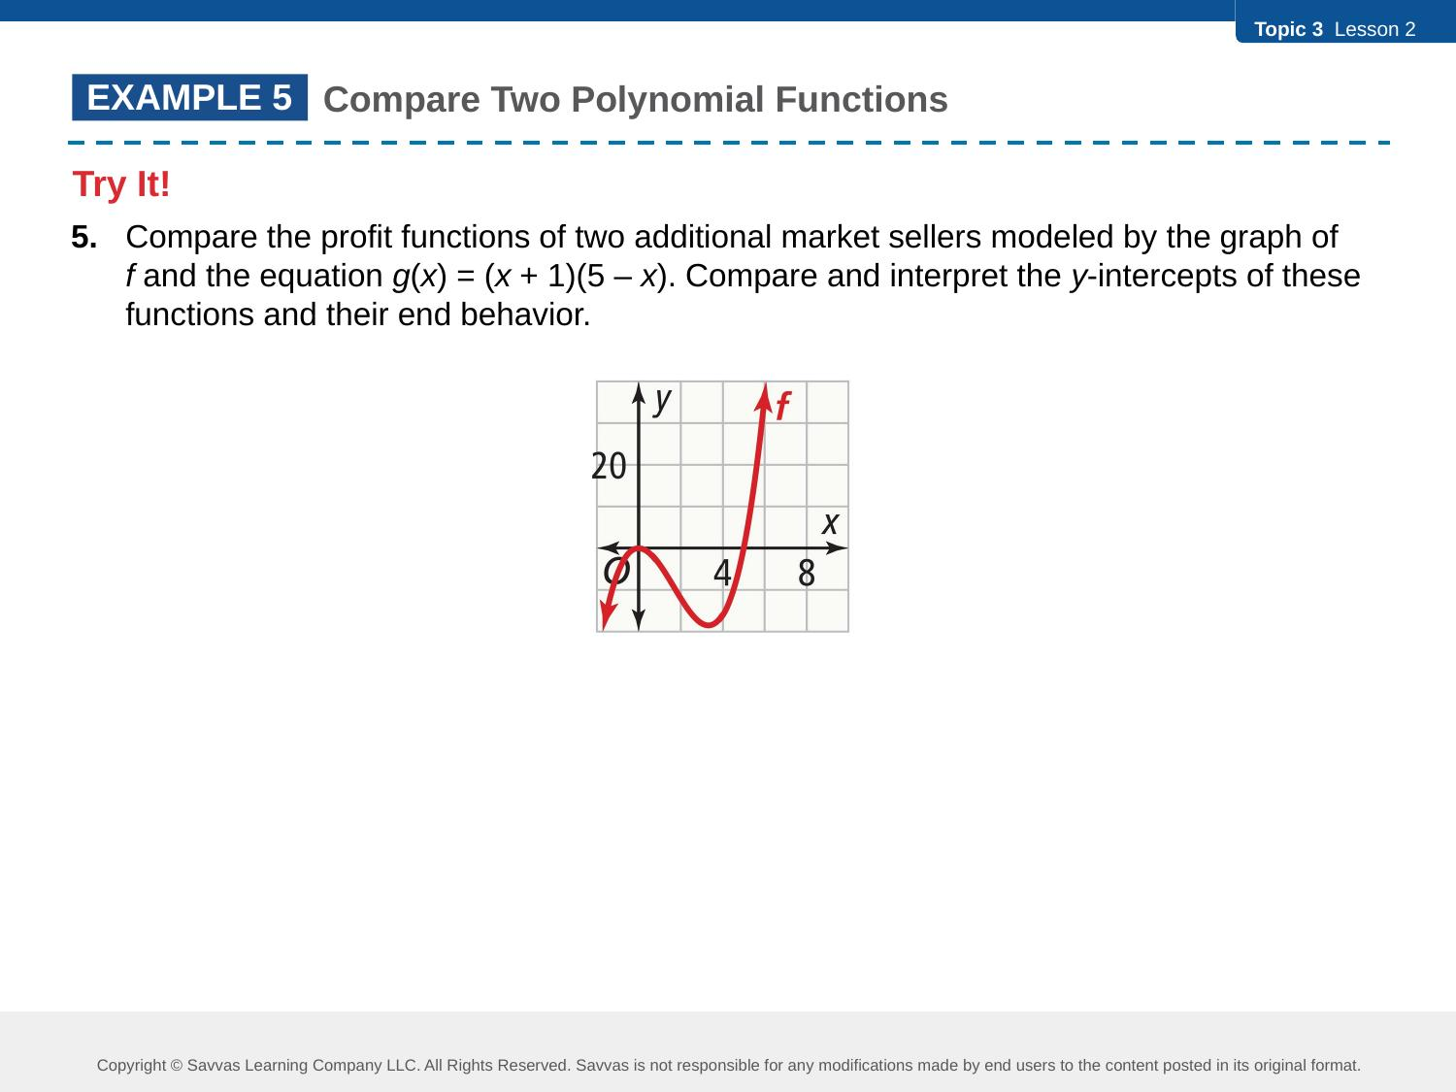
CONCEPT SUMMARY
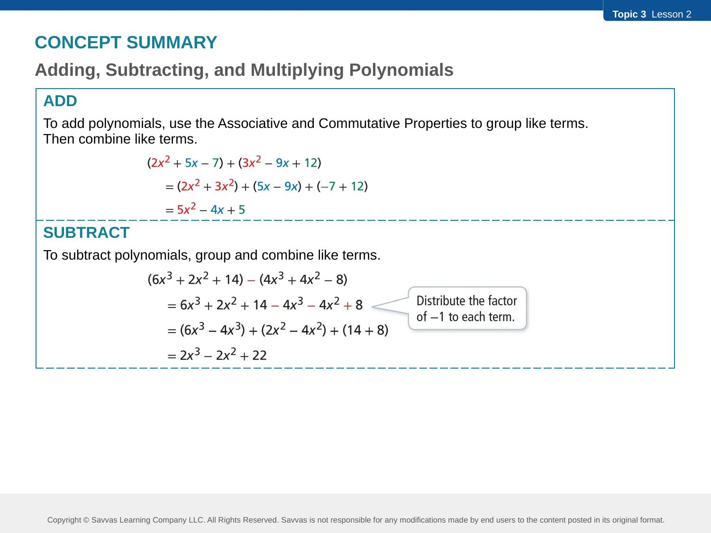
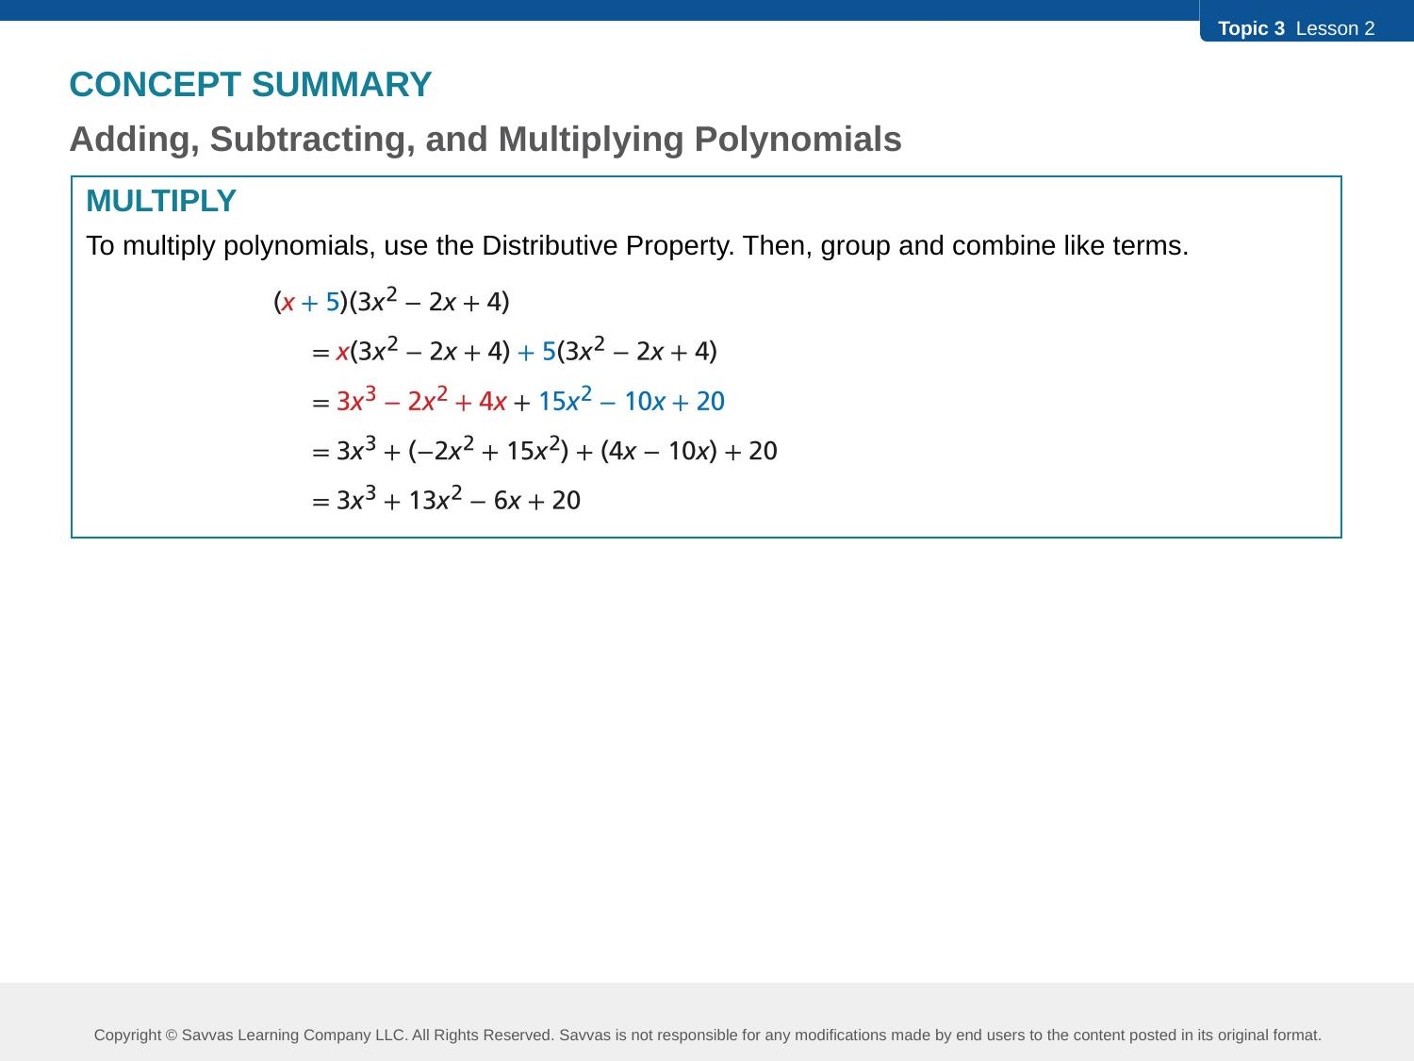
Do You Understand? / Do You Know How?
