NAME: BLOCK:
Lesson 3-3: Polynomial Identities
Math Objective | Prove polynomial Identities. Use identities to multiply and factor polynomials. Expand polynomials using Binomial Theorem & Pascal’s Triangle.
Language Objective | Students will be able to describe the pattern for binomial expansion, with the support of sentence frames and think-pair-share strategies.
Essential Understanding | Polynomial Identities and The Binomial Theorem are helpful tools to efficiently rewriting expressions or describing relationships.

3-3: Explore and Reason – Found on Schoology – Done in small groups – shared out as full class.
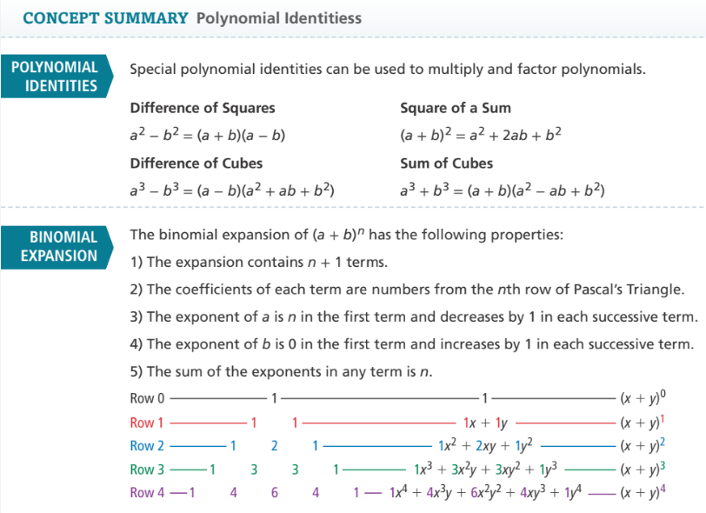

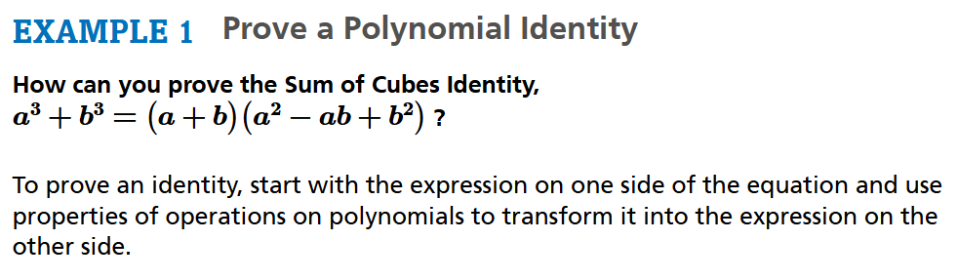

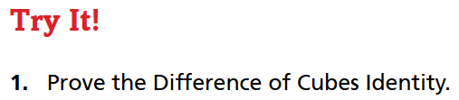

We will enter notes together in 3-3 Interactive Student Edition Ex.1 “Try It!”

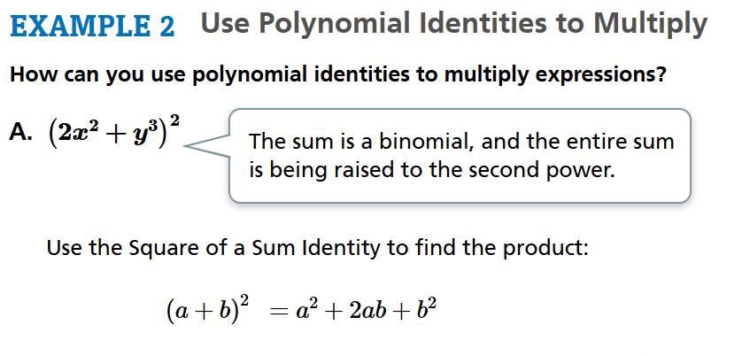

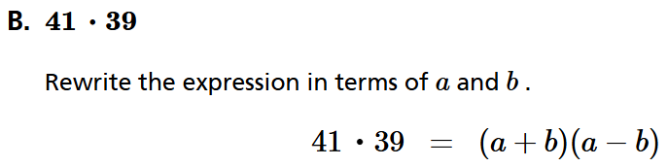

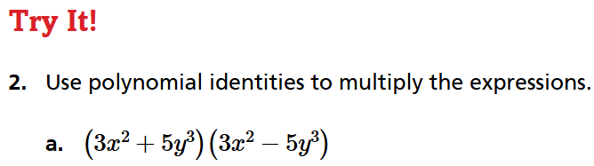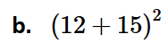
We will enter notes together in 3-3 Interactive Student Edition Ex.2 “Try It!”

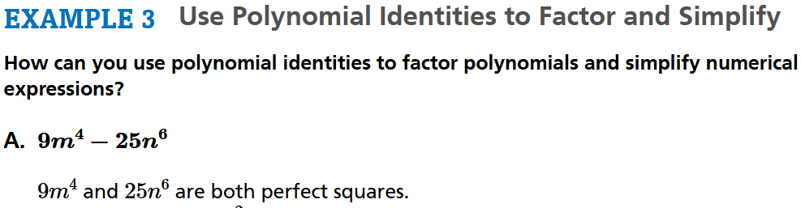

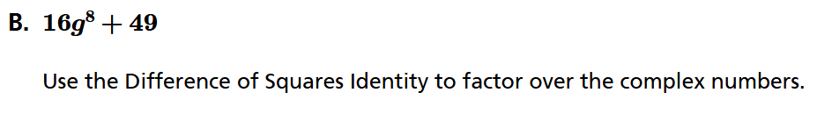

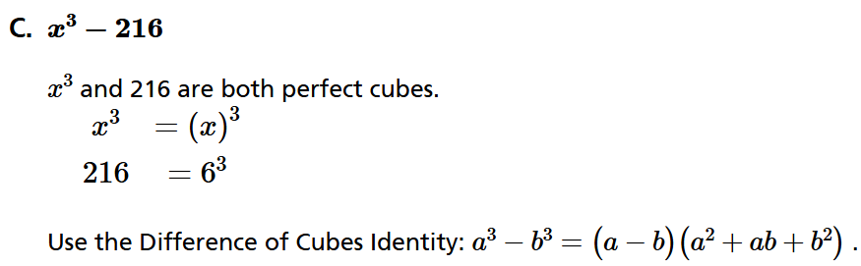

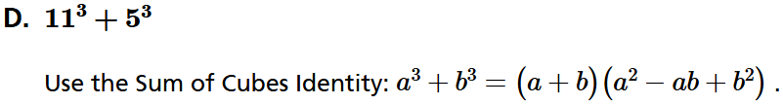

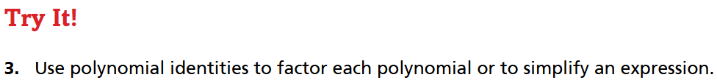
We will enter notes together in 3-3 Interactive Student Edition Ex.3 “Try It!”
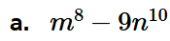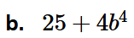

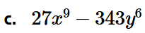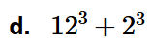

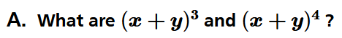
We will use Pascal’s Triangle to expand.

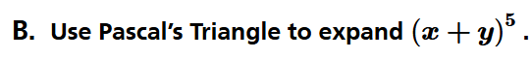

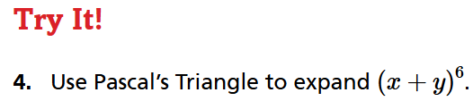
We will enter notes together in 3-3 Interactive Student Edition Ex.4 “Try It!”

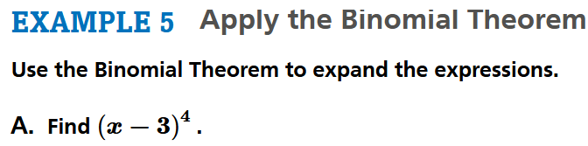

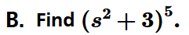

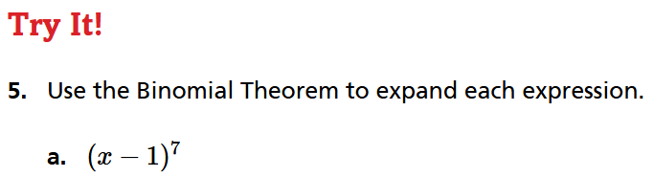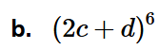

We will enter notes together in 3-3 Interactive Student Edition Ex.5 “Try It!”
