Lesson: 3-4 Polynomial Division
Math Objective | Divide polynomials using long division and synthetic division.  Use synthetic division to rewrite polynomials.
Language Objective | Students will be able to explain how to build the remainder in writing and orally using think-write-pair-share.
Essential Understanding | Polynomial expressions can be divided by linear factors using long division or synthetic division. The Remainder Theorem is used to determine the remainder of a polynomial division problem.

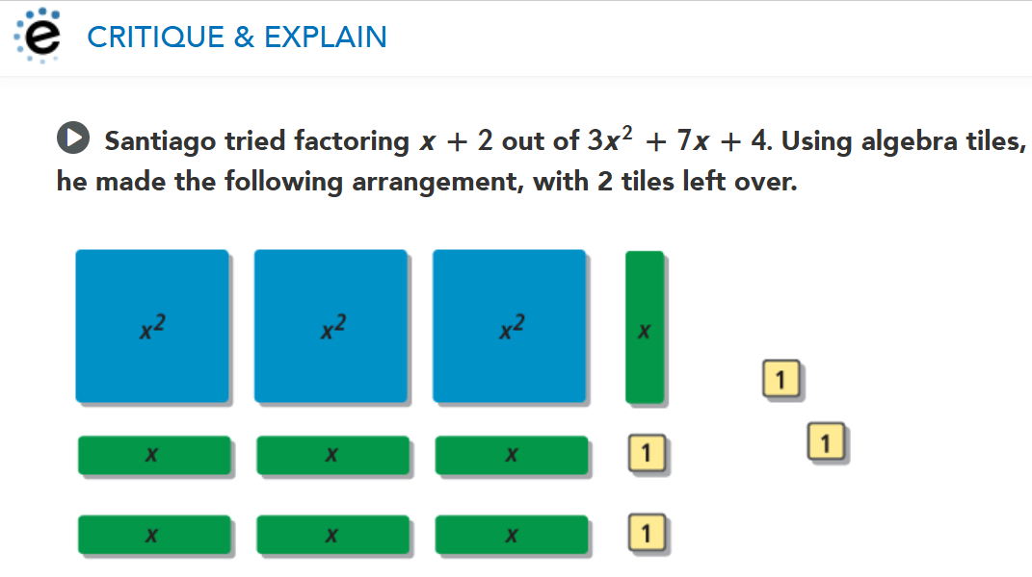
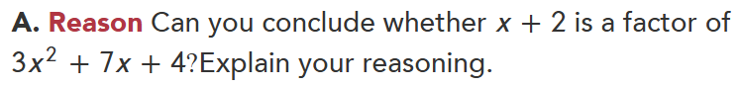

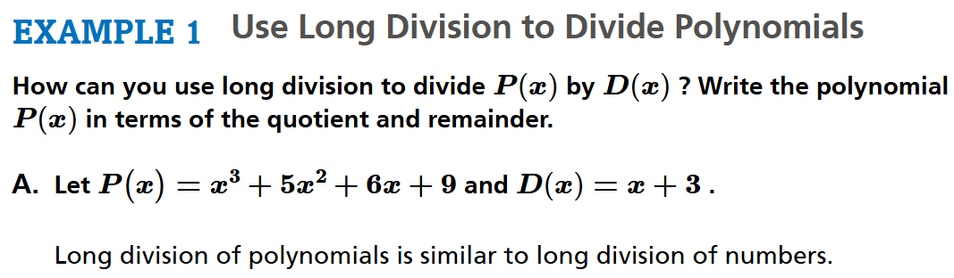

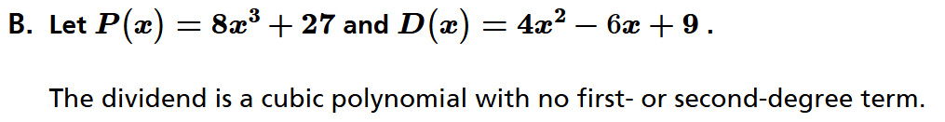

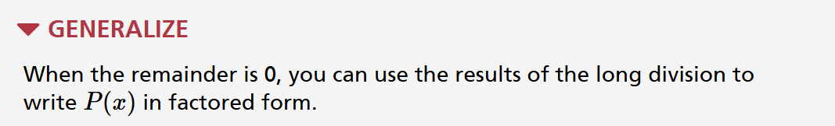
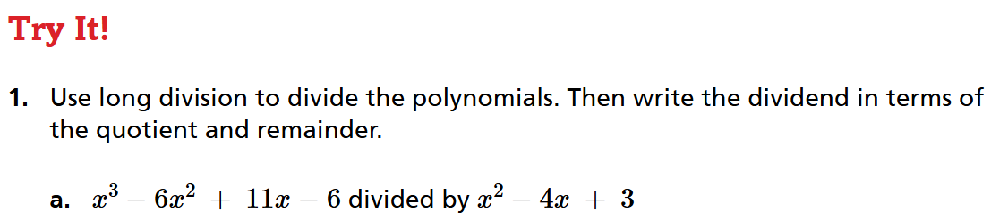

Think-Write-Pair-Share: Write how to build the remainder if it is not zero?
My Sentence:

My partner’s sentence:
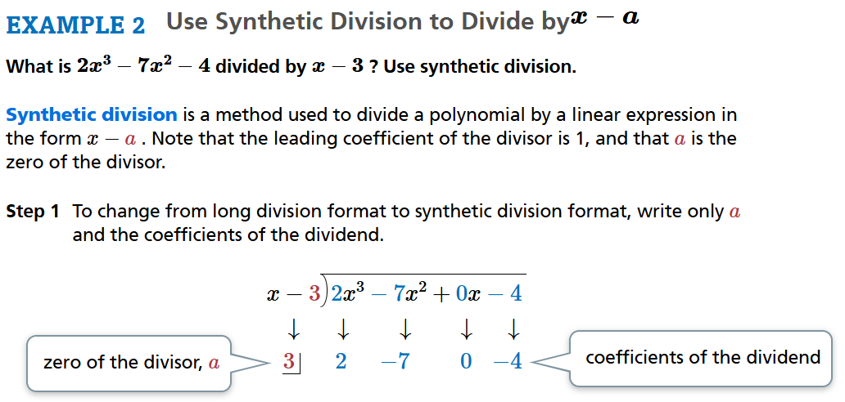

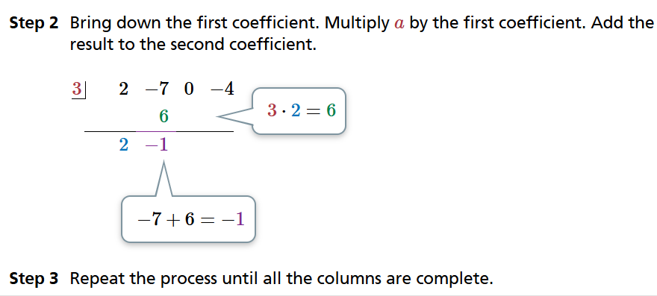
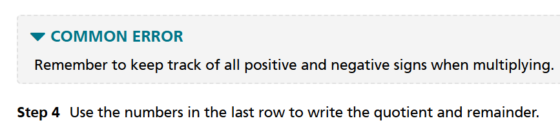

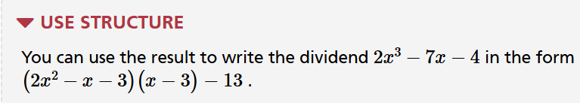
Let’s finish the example from above…
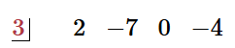

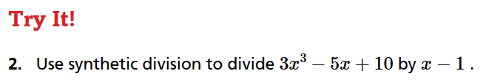

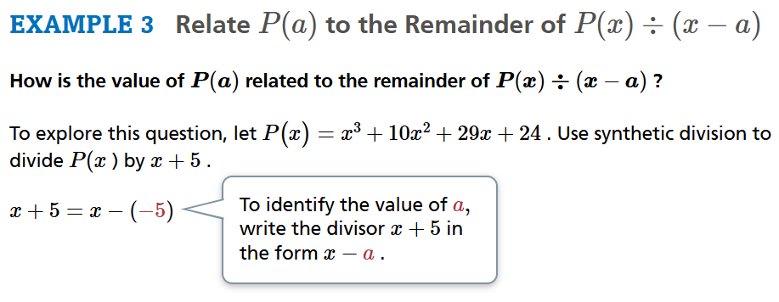

Find the value of P(-5).

Think-Write-Pair-Share: Write about what you think the quotient and P(-5) have in common.
My answer:

My partner’s answer:

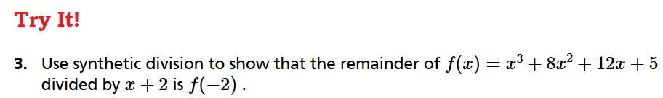

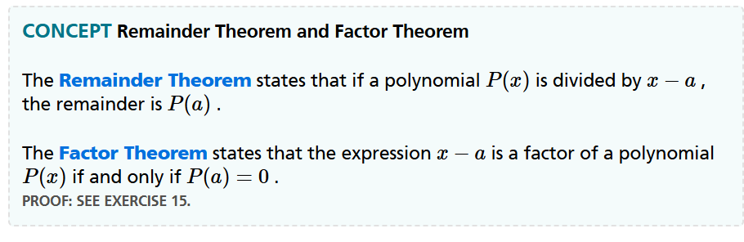
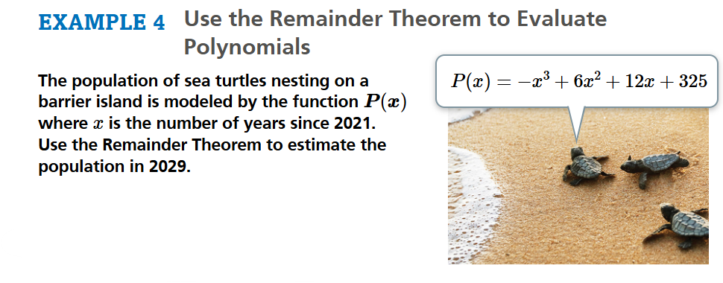
First Read - Understanding the Context – What is the problem about?
- I think this problem is about...
- In this problem, I think that...is happening.
Second Read - Interpreting the Question – What are we trying to find out or do?
- The question is...
- I know the problem is asking...because...

Third Read - Identifying Important Information – Quantities, relationships, other.
- The quantities are...
- These quantities help me to answer...
- The information that we need is...

First Read Answer:

Second Read Answer:

Third Read Answer:

Solution

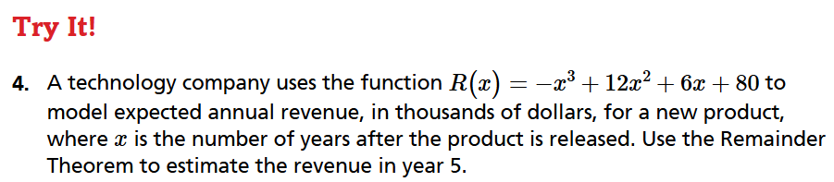
First Read - Understanding the Context – What is the problem about?
- I think this problem is about...
- In this problem, I think that...is happening.
Second Read - Interpreting the Question – What are we trying to find out or do?
- The question is...
- I know the problem is asking...because...

Third Read - Identifying Important Information – Quantities, relationships, other.
- The quantities are...
- These quantities help me to answer...
- The information that we need is...

First Read Answer:

Second Read Answer:

Third Read Answer:

SOLUTION:

