Algebra 2 Lesson: 3-5 Zeros of Polynomial Functions
Math Objective | Identify the zeros of a function using factoring or synthetic division. Use zeros to graph a polynomial function.
Language Objective | Students will write what they think about a problem using “Notice and Wonder”.  Students will orally discuss in a small group problems using “Three Read”.  Students will write and orally share an answer to a question using “Think-Pair-Share”.
Essential Understanding | The zeros of a polynomial function can be determined using factoring or synthetic division. The zeros can be used to sketch its graph.



Notice & Wonder – Model & Discuss
What do you notice?

What do you wonder?

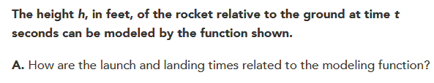

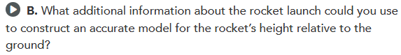

What information in the problem helped you determine the value of c?

How can you determine the maximum height?

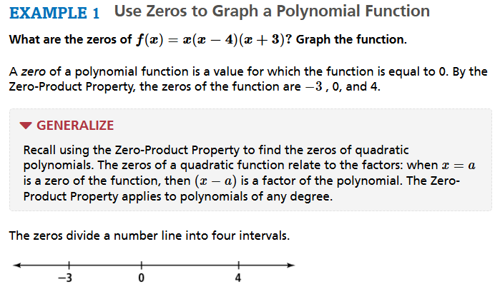
Zero Product Property
$$x=0$$
$$x-4=0$$
$$x+3=0$$
When solved the zeros are 0, 4 and -3.
They are then plotted.
To determine the curve needed to sketch the graph use end behavior and figure out if the other intervals are positive or negative.

TRY IT !!!
Factor each function, then sketch the graph.
$f\left(x\right)=4x^{3}+4x^{2}-24x$ $f\left(x\right)=x^{4}-81$

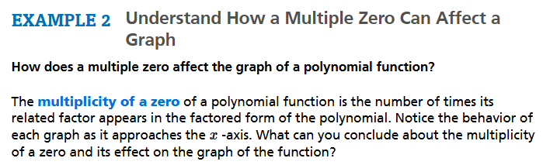
For example: In the factored function $f\left(x\right)={\left(x-3\right)}^{3}{(x+2)}^{2}(x-1)$ the $\left(x-3\right)$ has multiplicity 3 because of the exponent; $(x+2)$ has multiplicity 2 because of the exponent; $(x-1)$ has multiplicity 1.

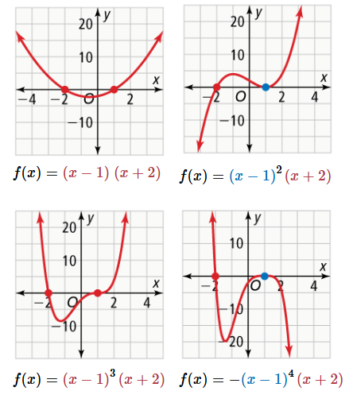
List all factors with multiplicity 4. What happens there?

List all factors with multiplicity 3. What happens there?

List all factors with multiplicity 2. What happens there?

List all factors with multiplicity 1. What happens there?

TRY IT !!!
Describe the behavior of the function at each of its zeros.
$f\left(x\right)=x(x+4){(x-1)}^{4}$ $f\left(x\right)=\left(x^{2}+9\right){\left(x-1\right)}^{5}{\left(x+2\right)}^{2}$

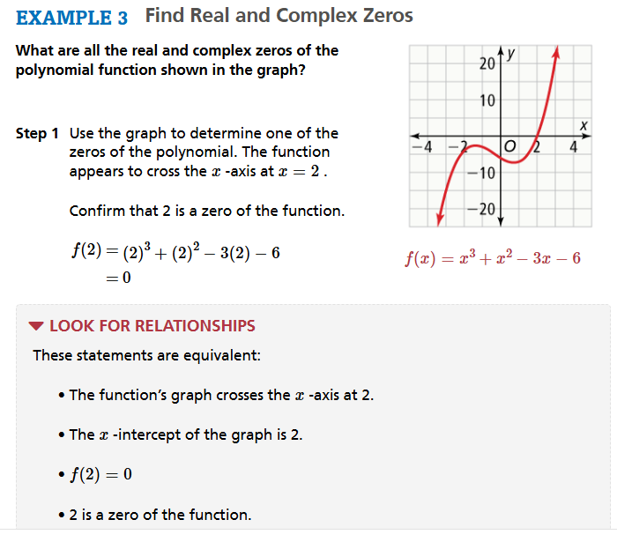
Real Zeros are part of the graph.
Complex Zeros are not part of the graph.

In your group do this THINK-PAIR-SHARE.
Why do you think that complex zeros are not part of the graphing?
MY ANSWER

PAIR’S ANSWER
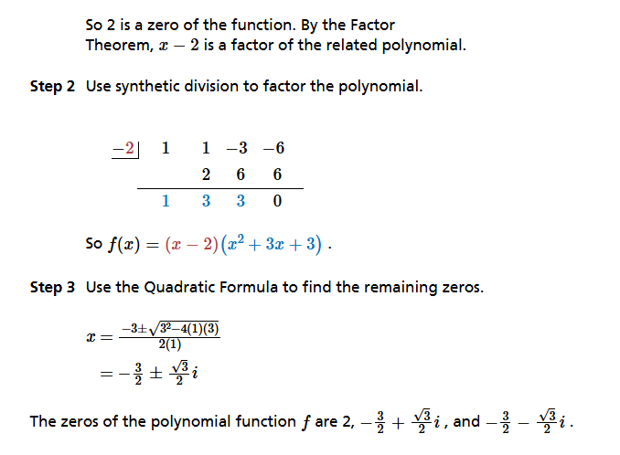

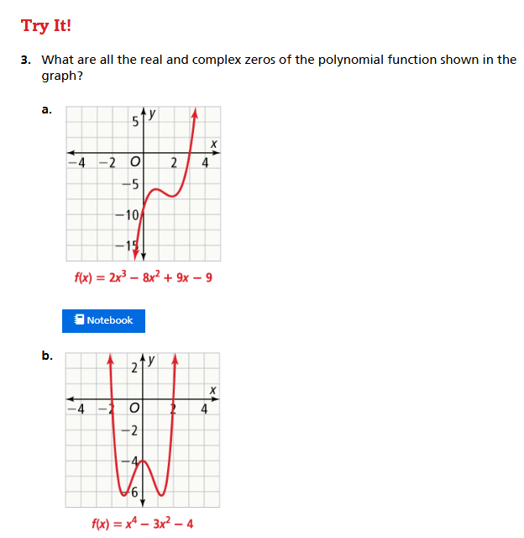

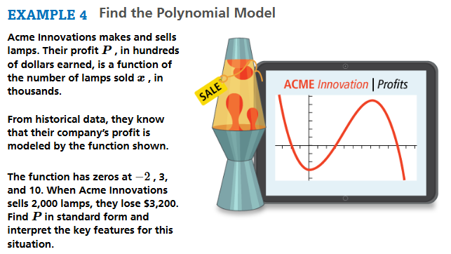
First Read - Understanding the Context – What is the problem about?
- I think this problem is about...
- In this problem, I think that...is happening.
Second Read - Interpreting the Question – What are we trying to find out or do?
- The question is...
- I know the problem is asking...because...

Third Read - Identifying Important Information – Quantities, relationships, other.
- The quantities are...
- These quantities help me to answer...
- The information that we need is...

First Read Answer:

Second Read Answer:

Third Read Answer:

SOLUTION

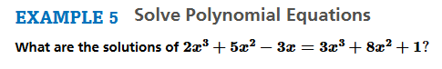

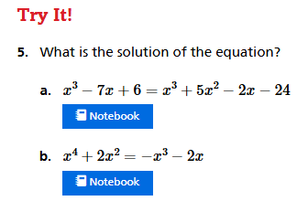



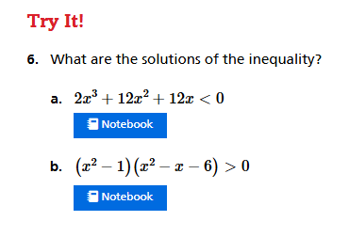

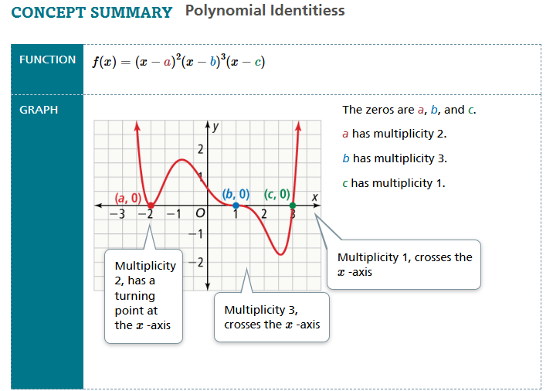
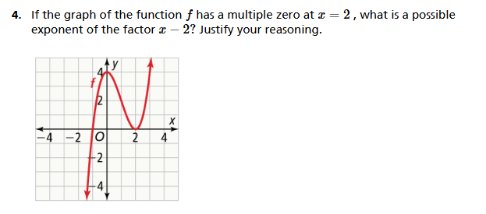

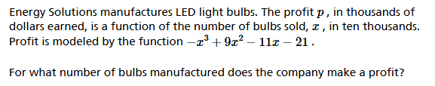
First Read - Understanding the Context – What is the problem about?
- I think this problem is about...
- In this problem, I think that...is happening.
Second Read - Interpreting the Question – What are we trying to find out or do?
- The question is...
- I know the problem is asking...because...

Third Read - Identifying Important Information – Quantities, relationships, other.
- The quantities are...
- These quantities help me to answer...
- The information that we need is...

First Read Answer:

Second Read Answer:

Third Read Answer:

SOLUTION

ANSWER ON ADDITIONAL PAPER

