Lesson 4-1: Inverse Variation/Reciprocal Function
Math Objective | Identify and use Inverse Variation. Graph reciprocal functions.
Language Objective | Students will write what they think about a problem using “Notice and Wonder”.  Students will orally discuss in a small group problems using “Three Read”.  Students will write and orally share an answer to a question using “Think-Pair-Share”.
Essential Understanding | The reciprocal function is used to model inverse variation, which is a proportional relationship between 2 variables such that when one increases, the other decreases.

DO NOW:
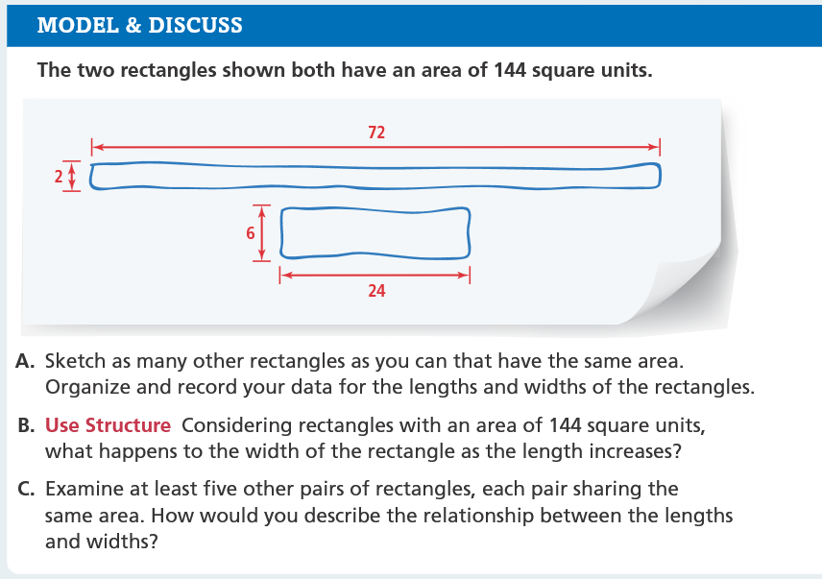

*Create a table to organize different dimensions

THOUGHTS AND ANSWERS

Part A:

Part B:

Part C:

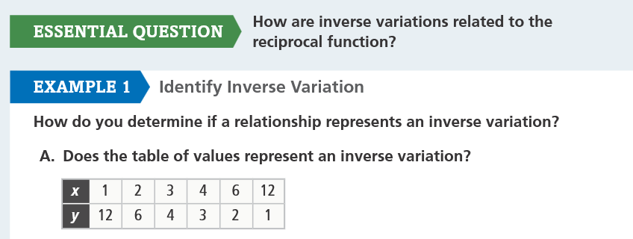

Sentence Frame: The Relation Does / Does not show an inverse variation because _______________________

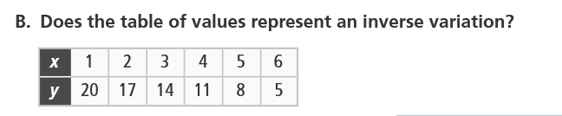

Sentence Frame: The Relation Does / Does not show an inverse variation because _______________________

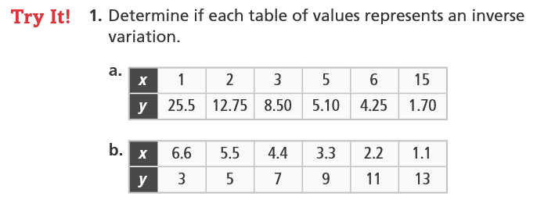

1A) Sentence Frame: The Relation Does / Does not show an inverse variation because

1B) Sentence Frame: The Relation Does / Does not show an inverse variation because

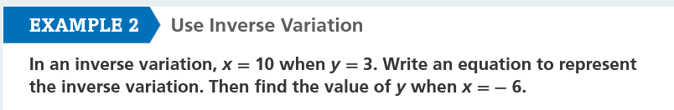



2A) 2B)

Example 3:
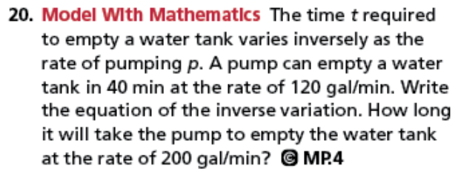
First Read - Understanding the Context – What is the problem about?
- I think this problem is about...
- In this problem, I think that...is happening.
Second Read - Interpreting the Question – What are we trying to find out or do?
- The question is...
- I know the problem is asking...because...

Third Read - Identifying Important Information – Quantities, relationships, other.
- The quantities are...
- These quantities help me to answer...
- The information that we need is...

First Read Answer:

Second Read Answer:

Third Read Answer:

SOLUTION

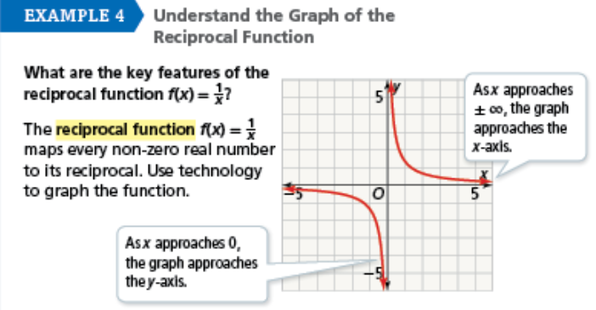
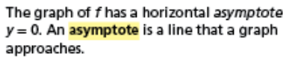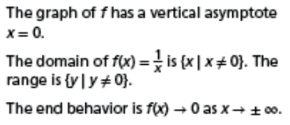

If x = 0 what would happen to the answer? Why will the y-value never reach zero?
So how would we know what x-values not Will the y-value ever have other values
To include in the domain? that it cannot reach?



