Algebra 2 Lesson: 3-5 Zeros of Polynomial Functions
Math Objective | Identify the zeros of a function using factoring or synthetic division. Use zeros to graph a polynomial function.
Language Objective | Students will write what they think about a problem using “Notice and Wonder”.
Essential Understanding | The zeros of a polynomial function can be determined using factoring or synthetic division. The zeros can be used to sketch its graph.

For the following function:
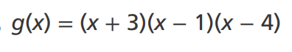
What do you Notice?  - About the factors?  - About the x intercepts? | What do you Wonder?  - About how it will graph?  

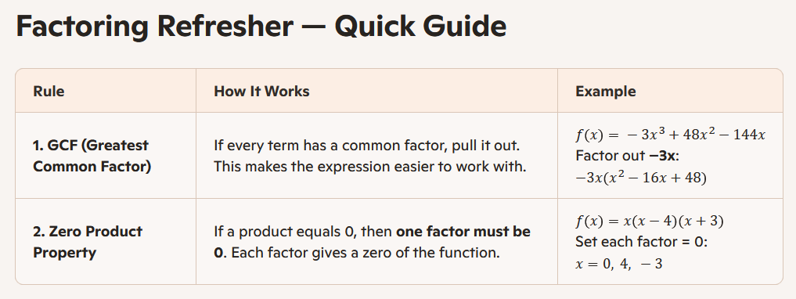
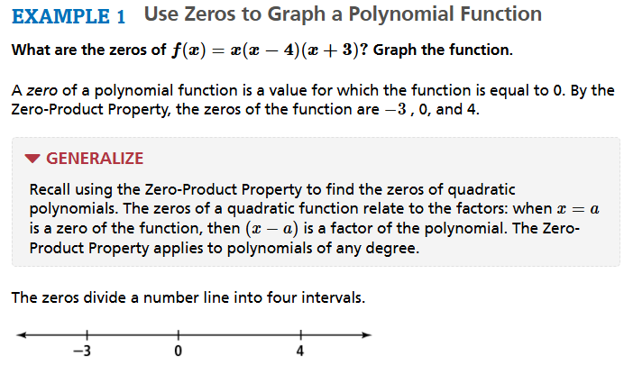
To determine the curve needed to sketch the graph use end behavior and figure out if the other intervals are positive or negative.
End Behavior = How the graph behaves at the far left and far right of the graph.
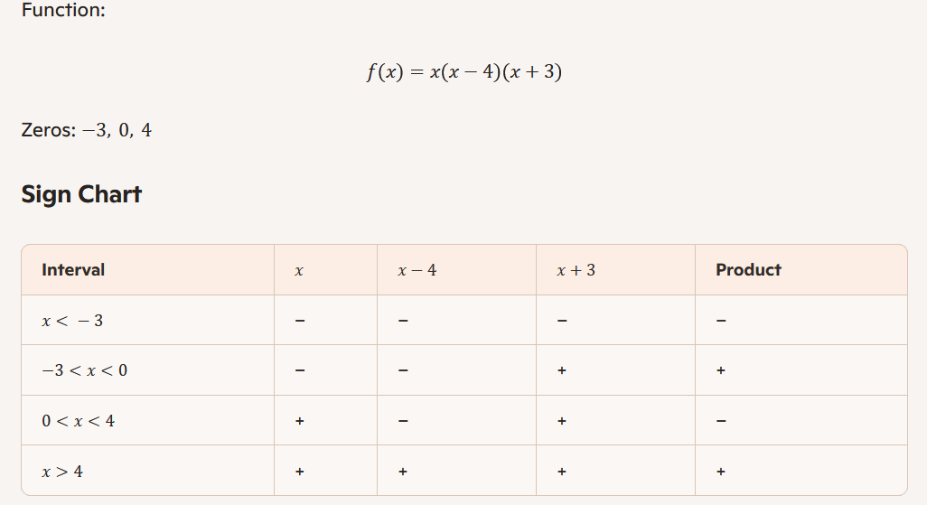
TRY IT:
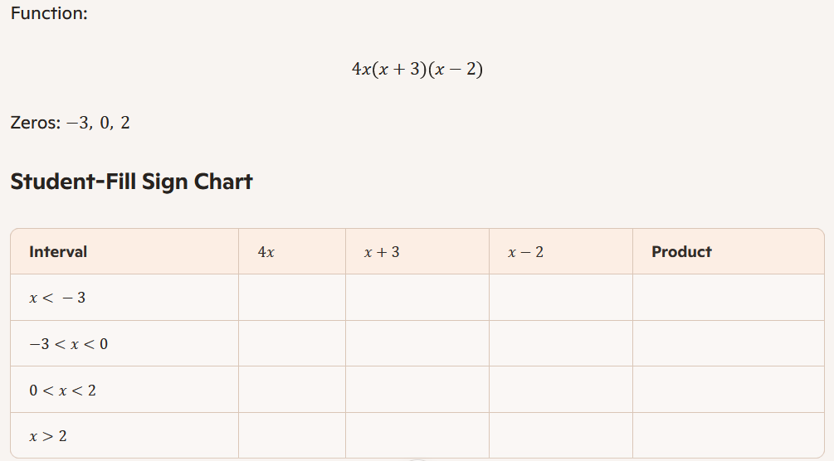

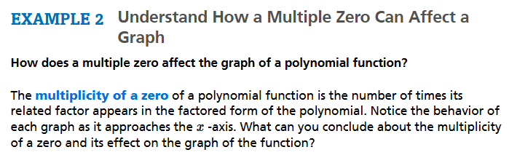
For example: In the factored function $f\left(x\right)={\left(x-3\right)}^{3}{(x+2)}^{2}(x-1)$ the $\left(x-3\right)$ has multiplicity 3 because of the exponent; $(x+2)$ has multiplicity 2 because of the exponent; $(x-1)$ has multiplicity 1.
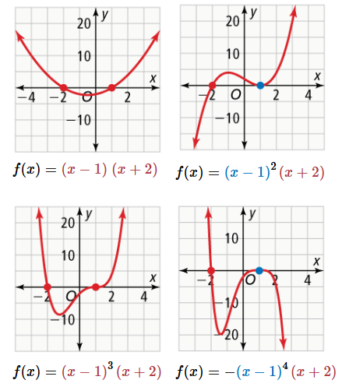
List all factors with multiplicity 4. What happens there?

List all factors with multiplicity 3. What happens there?

List all factors with multiplicity 2. What happens there?

List all factors with multiplicity 1. What happens there?

TRY IT !!!
Describe the behavior of the function at each of its zeros.
$f\left(x\right)=x(x+4){(x-1)}^{4}$

Example 4
Venetta opened several deli sandwich franchises in the year 2000. Her profit $P$, in hundreds of dollars, after $t$ years can be modeled by the function:  $$P(t)=t(t+3)(t-2)$$ | 

A. Sketch a graph of the function (and confirm with DESMOS)
Use the factored form to identify the zeros and the behavior of the graph.
B. During what years did Venetta not make a profit?
Use the zeros and the sign of each interval to determine when the profit is negative. Confirm visually that the graph is negative in these intervals.

C. If the model is appropriate, predict the amount of profit Venetta will earn in 2020.
(Remember: $t=20$ corresponds to the year 2020.) Substitute or identify the point with your graph.

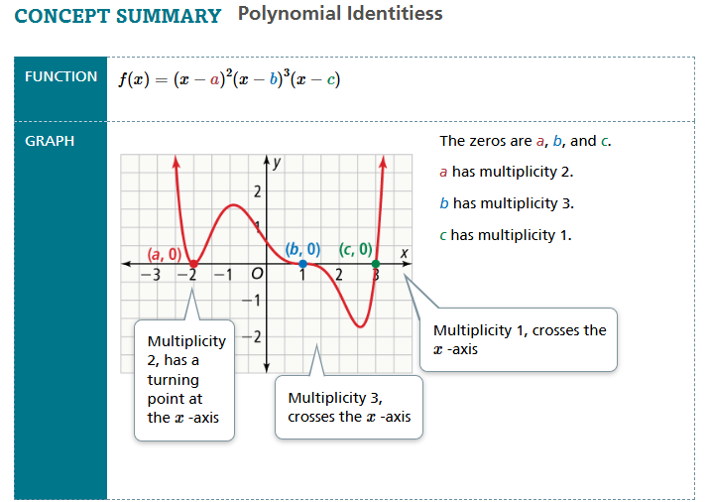

Select Exercises
14. Find the zeros of the function, and describe the behavior of the graph at each zero.
$$f(x)=x(x-4)^{2}$$

18. Waterworks is a company that manufactures and sells paddleboards. Their profit $P$, in hundreds of dollars, is a function of the number of paddleboards sold $x$, measured in thousands.

The profit can be written in factored form as:
$$P(x)=-3x(x-4)(x-12)$$

What do the zeros of this function tell you about how many paddleboards Waterworks should produce?
GRAPH W/ DESMOS
