Lesson 4-2: Graph Rational Functions
Math Objective | Identify vertical and horizontal asymptotes. Rewrite and graph rational functions using algebraic structure.
Language Objective | Students will be able to describe the asymptotes and end behavior of a rational function using sentence frames or vocabulary supports.
Essential Understanding | Rational functions have predictable structure: vertical asymptotes occur where the denominator is zero, and horizontal asymptotes describe end behavior based on the degrees of the numerator and denominator.

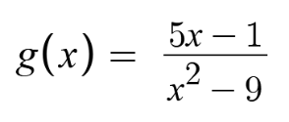
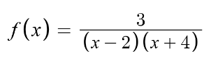
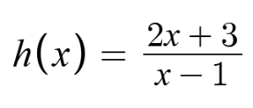
Which one doesn’t belong? (WODB)
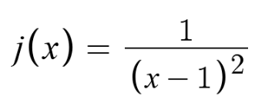
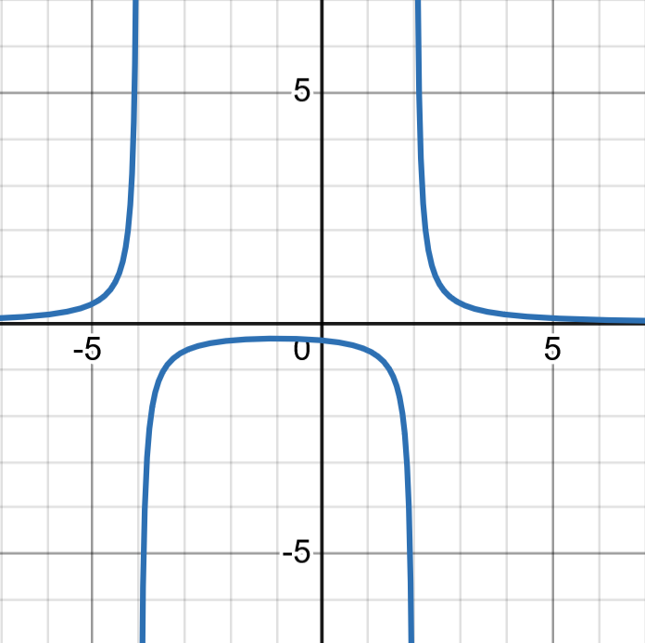 | 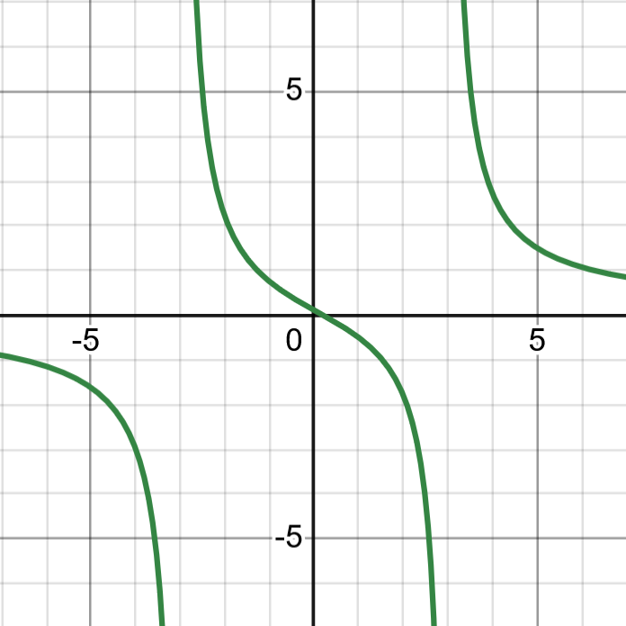
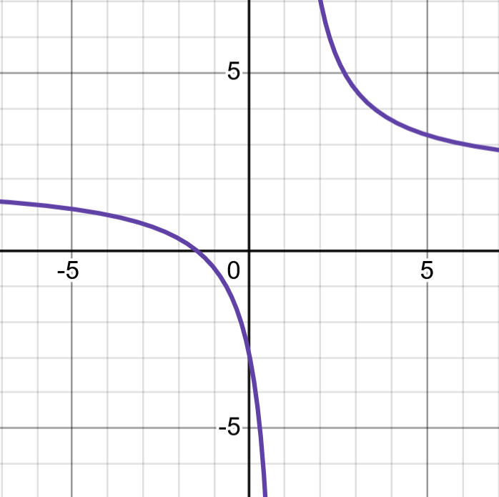 | 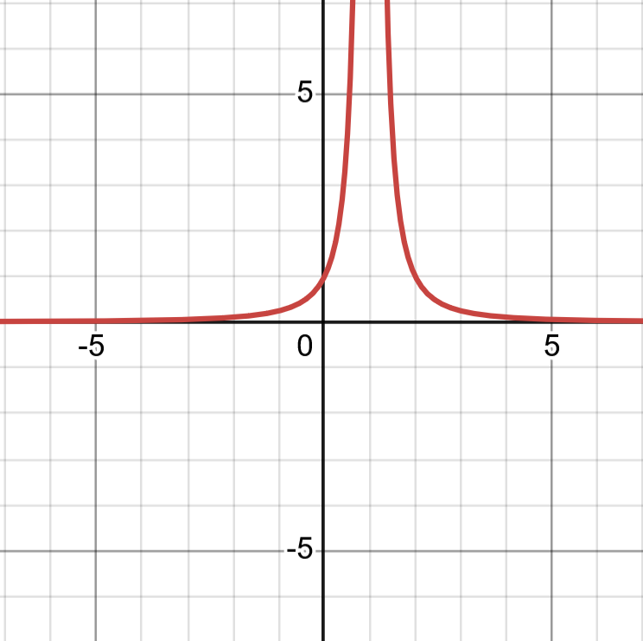

Choose one graph that you think doesn’t belong. Explain your thinking. (Sentence Frames Below)

I notice that this graph ________. | This one is different because ________. | This graph looks like it is ________.
This graph has ________, but the others have ________. | Only this graph shows ________. | The others all ________, but this one does not.
This graph gets close to a line at ________. | This one goes up/down very fast near ________. | This graph flattens out near ________, but the others don’t.
I think this one doesn’t belong because ________. | My reason is that ________. | I chose this graph because ________.

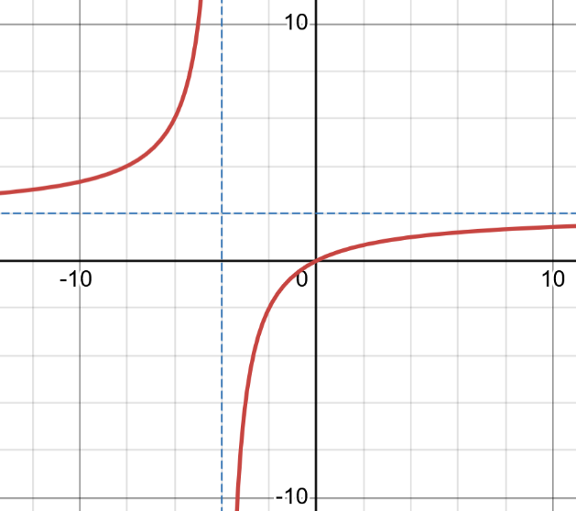
EXAMPLE 1 — Rewrite a Rational Function

We want to understand the “breaking” behavior of:
$$f(x)=\frac{2x}{x+4}$$

Step 1: Divide the numerator by the denominator

Step 2: Rewrite the function
$$f(x)=2-\frac{8}{x+4}$$

Step 3: What does this tell us about the graph?
- The “2” tells us the graph gets close to the line $y=2$.
- The “$x+4$” in the denominator tells us the graph has a vertical break at $x=-4$.
- Lines that the graph approaches but never touches are called asymptotes.
  - The graph will appear to ‘break’ near these lines.

TRY IT 1 — Rewrite to Understand the Function

Rewrite the function using division. Then describe what the rewrite tells you about how the graph behaves.
$$f(x)=\frac{3x}{x-2}$$

EXAMPLE 2 — Vertical Asymptotes from a Factored Denominator

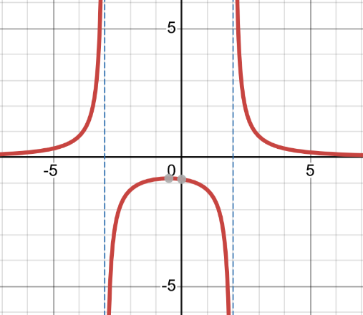
Look at the function:
$$f(x)=\frac{5}{\left(x-2)(x+3\right)}$$

How can we use algebra to find its asymptotes?

Step 1: Set each factor in the denominator equal to zero
$$x-2=0⇒x=2$$
$$x+3=0⇒x=-3$$
Step 2: What does this mean for the graph?
- The graph cannot use $x=2$ or $x=-3$.
- The graph will break at both of these x-values.
- The curve goes up or down very fast near each value.

Conclusion
The graph has two vertical asymptotes:
$$x=2 \text{and} x=-3$$

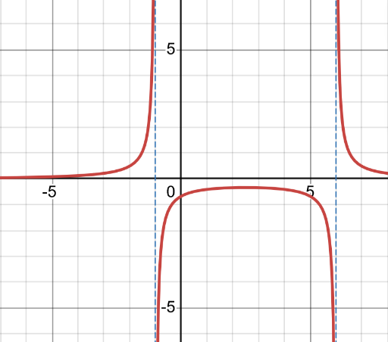
TRY IT 2 — Find the Vertical Asymptotes
Look at the function:
$$f(x)=\frac{4}{\left(x+1)(x-6\right)}$$
Step 1: Set each factor in the denominator equal to zero.

Step 2: Write the vertical asymptotes.

EXAMPLE 3 — Horizontal Asymptotes Show End Behavior

A horizontal asymptote tells us what value the graph gets close to when $x$ becomes very large (to the right) or very small (to the left).

All Three End-Behavior Cases

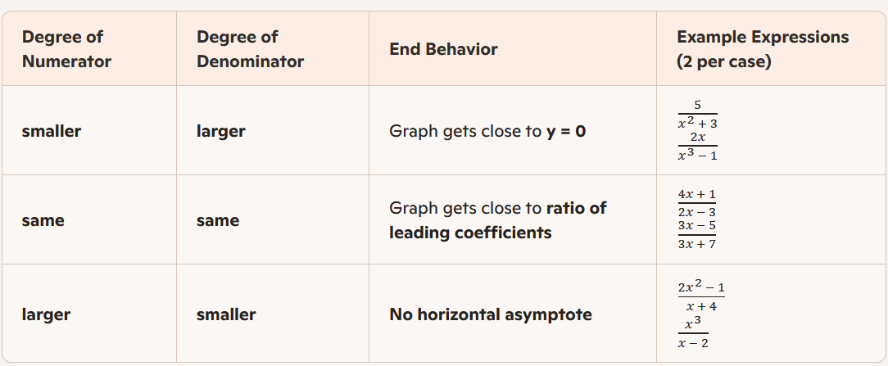

Look at the function:
$$f(x)=\frac{3x+1}{x-4}$$
Step 1: Compare the degrees
- Numerator degree: 1
- Denominator degree: 1

Step 2: Use the matching case from the table
Degrees are the same, so the graph gets close to:

$$y=\frac{\text{leading coefficient of numerator}}{\text{leading coefficient of denominator}}$$

Step 3: Apply it
$$y=\frac{3}{1}=3$$
Conclusion
The graph has a horizontal asymptote at:
$$y=3$$

TRY IT 3 – Find the Horizontal Asymptotes (Refer to TABLE above)

$$f(x)=\frac{5}{x^{2}-3x+2}$$ | $$f(x)=\frac{2x^{2}-1}{x+4}$$

DESMOS - Graphing Rational Functions

Directions: In Desmos, enter the following four rational functions. Then complete the table and questions based on what you see.

Function | Vertical Asymptote(s) | Horizontal Asymptote(s)
$$A(x)=\frac{4}{\left(x-1)(x+2\right)}$$
$$B(x)=\frac{2x+3}{x-4}$$
$$C(x)=\frac{x^{2}-4}{x-1}$$
$$D(x)=\frac{2}{x+3}-1$$

Pick two functions from the table above and describe what happens as the graph gets close to ONE of its asymptotes (horizontal or vertical).

____(x)

____(x)

As x gets close to ___, the graph goes ___ because ___. | When x is very large or very small, the graph approaches ___ because ___.
Near the line ___, the graph moves toward ___ on the graph. | The graph changes direction near ___ because ___.


Pick one function to roughly sketch below. Identify and label any asymptotes.

____(x) =

Vertical Asymptote(s):

Horizontal Asymptote(s):

Select Exercises
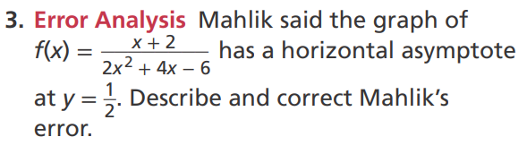

DOK1
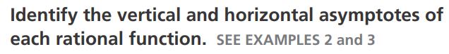
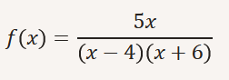
DOK2
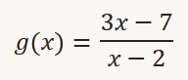
DOK2
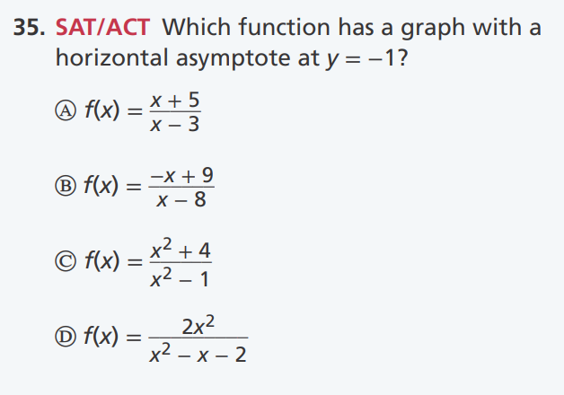
DOK2
 DOK3

