Lesson 4-3: Multiply and Divide Rational Expressions
Math Objective | Use structure of rational expressions to rewrite them in different forms  Understand that rational expressions are analogous to rational numbers, and follow similar rules when multiplying and dividing.
Language Objective | Students will explain how to state the domain for a simplified rational expression using sentence fames.
Essential Understanding | I can find the product and the quotient of rational expressions.

1. Quick Check
Look at the expression:  $$\frac{x-2}{x-2}$$ | Do you think it always equals 1? Circle one:  Yes No Not sure

2. Test It 3. Explain What You See
 | The expressions breaks at ____ because dividing by zero is not allowed.  It equals 1 for all values except ____ because the denominator becomes zero.
  x | $$\frac{x-2}{x-2}$$
  0
  1
  2
  3
  4

Some values make an expression “break.” Now we will practice rewriting expressions and checking which values are allowed.

EXAMPLE 1 – Write Equivalent Rational Expressions

We can rewrite an expression by multiplying by a form of 1.
A “form of 1” looks like this:
$$\frac{x}{x} \frac{x+2}{x+2} \frac{5}{5}$$
These fractions all equal 1 (as long as the denominator is not zero).

Start with the expression:
$$x+3$$
Multiply by a form of 1:
$$(x+3)⋅\frac{x}{x}$$

Rewrite it as a rational expression:
$$\frac{x(x+3)}{x}$$

These two expressions look different, but they represent the same value for all $x$ except 0.
- The original expression $x+3$ is defined for every real number.
- The rewritten expression $\frac{x(x+3)}{x}$ is undefined when $x=0$ because the denominator becomes zero.
So the expressions are equivalent only on the shared domain

● Turn and Talk: Why can multiplying by 1 change the domain?

Value | Zero
Denominator | Restriction

TRY IT 1

Rewrite the expression below by multiplying by a form of 1. Then state the value that must be excluded from the domain.
$$x-5⟶(x-5)⋅\frac{x+2}{x+2}$$

Domain restriction:

EXAMPLE 2 — Simplifying a Rational Expression

A rational expression is in simplest form when the numerator and denominator have no common factors (other than 1).

We can simplify by canceling common factors, but we must also state the domain (values that make the denominator zero).

Simplify the expression:
$$\frac{\left(x-2)(x+5\right)}{\left(x-2)(x-3\right)}$$
Step 1: Identify the common factor
Both numerator and denominator contain the factor $\left(x − 2\right)$.

Step 2: Cancel the common factor
$$\frac{\left(x − 2\right)(x+5)}{\left(x − 2\right)(x-3)}=\frac{x+5}{x-3}$$

Step 3: State the domain
The original denominator was $\left(x-2)(x-3\right)$. So the expression is undefined when:
- $x=2$
- $x=3$

Final Answer
$$\frac{x+5}{x-3}, \text{for }x≠2,3$$

❦ Short Write: Explain why we must use the original denominator (not the simplified one) to determine the domain of a rational expression.

We use the original denominator because | Even though the factor was canceled, it still affects the domain since
The simplified expression does not show the restriction at ____ because | This shows that simplifying does not change

Try It 2

Simplify the expression and state the domain:
$$\frac{\left(y+4)(y-1\right)}{\left(y-1)(y-6\right)}$$

Simplified form: Domain: $y≠___$, $y≠___$

EXAMPLE 3 — Multiplying Rational Expressions

When we multiply rational expressions, we multiply straight across (numerator × numerator, denominator × denominator). Then we cancel any common factors.

This works exactly like multiplying numerical fractions.

Multiply and simplify:
$$\frac{x}{x+3} ⋅ \frac{x+3}{x-1}$$
Step 1: Multiply across
$$\frac{x(x+3)}{\left(x+3)(x-1\right)}$$

Step 2: Cancel the common factor
$$\frac{x+3 ⋅x}{x+3 (x-1)}=\frac{x}{x-1}$$

Step 3: State the domain
The original denominators were $x+3$and $x-1$. So the expression is undefined when:
- $x=-3$
- $x=1$
Final Answer
$$\frac{x}{x-1},\text{for }x≠-3,1$$

● Turn and Talk: Did canceling remove the domain restriction? Why or Why not?

Cancel | Denominator | Restriction
Factor | Zero | Original expressions

Try It 3

Multiply and simplify. Then state the domain.
$$\frac{\left(x − 4\right)}{\left(x + 2\right)} ⋅ \frac{\left(x+2)(x+5\right)}{\left(x-4)(x-1\right)}$$

Simplified form: Domain: $x≠___$, $x≠___$, $x≠___$

EXAMPLE 5 — Dividing Rational Expressions
To divide rational expressions, we multiply by the reciprocal of the divisor. Then we cancel any common factors and state the domain.

Divide and simplify:
$$\frac{\left(x+1)(x+4\right)}{\left(x − 2\right)} ÷ \frac{\left(x + 1\right)}{\left(x-2)(x+5\right)}$$
Step 1: Multiply by the reciprocal
$$\frac{\left(x+1)(x+4\right)}{\left(x − 2\right)} ⋅ \frac{\left(x-2)(x+5\right)}{\left(x + 1\right)}$$
Step 2: Cancel common factors
Cancel $\left(x + 1\right)$and $\left(x − 2\right)$:
$$\frac{\left(x + 1\right)(x+4)}{\left(x − 2\right)} ⋅ \frac{\left(x − 2\right)(x+5)}{\left(x + 1\right)}$$
What remains:
$$\left(x+4)(x+5\right)$$

Step 3: State the domain
The original denominators were:
- $x-2$
- $\left(x-2)(x+5\right)$

So the expression is undefined when:
- $x=2$
- $x=-5$
- $x=-1$ (from the canceled $\left(x + 1\right)$ in the divisor)

Final Answer
$$\left(x+4\right)\left(x+5\right), \text{for }x≠-5, -1, 2$$

❦ Short Write: Explain why dividing rational expressions can create multiple domain restrictions, including some that come from factors that get canceled.

Division creates more restrictions because ____ | Even canceled factors matter because they were originally in a _____
Any factor in the original denominators causes a restriction when ____ | This means the final domain must include restrictions from ______

Try It 5

Divide and simplify. Then state the domain.
$$\frac{\left(x-3)(x+2\right)}{\left(x + 4\right)} ÷ \frac{\left(x − 3\right)}{\left(x+4)(x-1\right)}$$

Simplified form: __________________________ Domain: $x≠___$, $x≠___$, $x≠___$
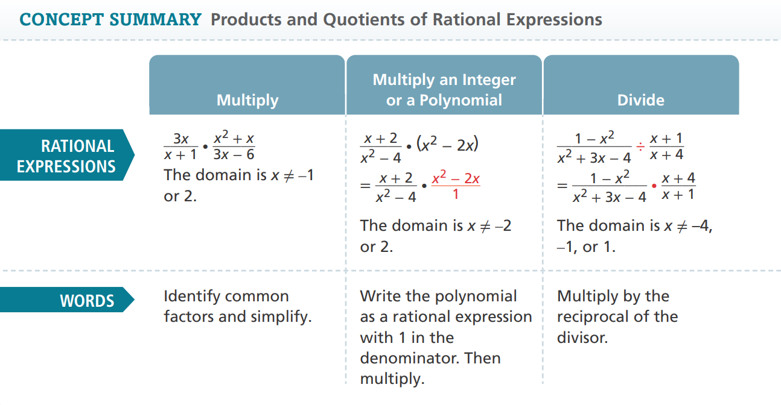 | 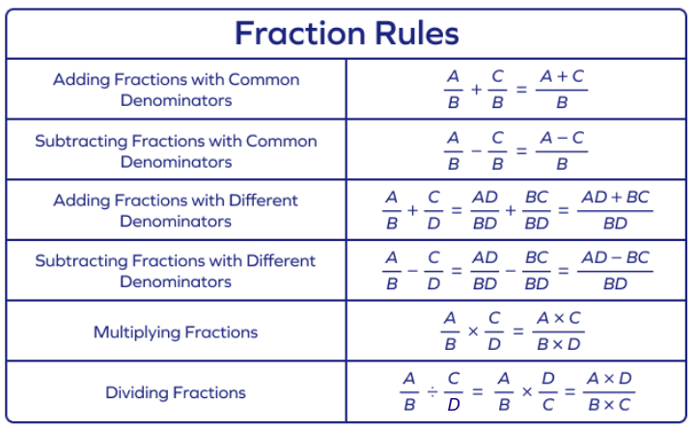

Select Exercises
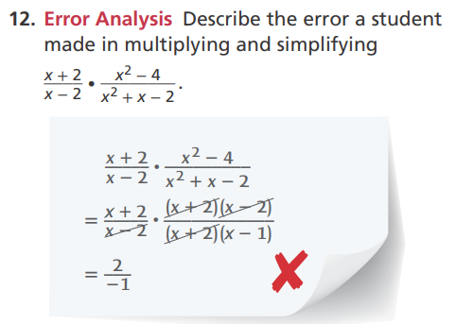DOK2
Simplify the expression and state the domain.
$$\frac{\left(x-4)(x+7\right)}{\left(x-4)(x-1\right)}$$
DOK1
Multiply, simplify, and state the domain.

$$\frac{\left(x + 3\right)}{\left(x-2)(x+5\right)} ⋅ \frac{\left(x-2)(x-1\right)}{\left(x + 3\right)}$$

DOK1
Divide, simplify, and state the domain.

$$\frac{\left(x-6)(x+2\right)}{\left(x + 4\right)} ÷ \frac{\left(x − 6\right)}{\left(x+4)(x-3\right)}$$

DOK1
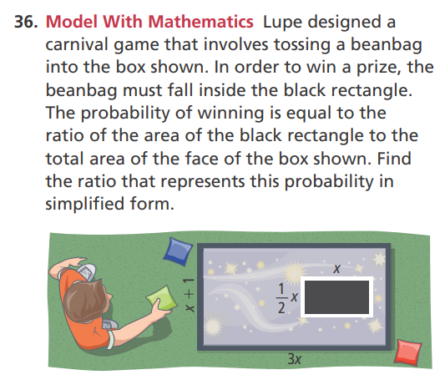 DOK3

