Lesson 4-4: Adding and Subtracting Rational Expressions
Math Objective | Understand that rational expressions form a system analogous to the system of rational numbers and use that understanding to add and subtract rational expressions
Language Objective | Students will build rational expressions for a d=rt word problem using a graphic organizer.
Essential Question | I can find the sum or difference of rational expressions
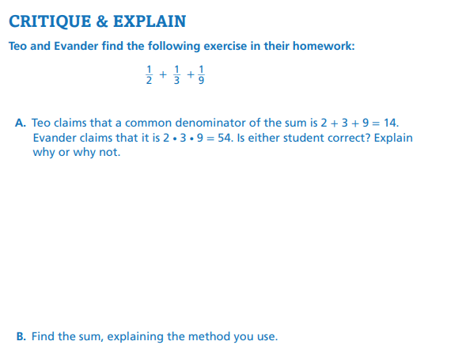

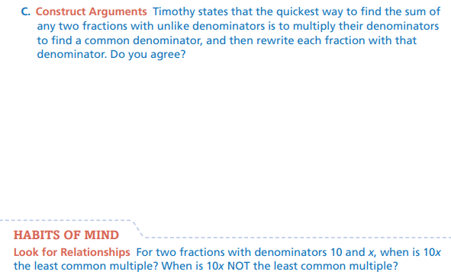
What do you notice about the expression in the exercise?
How can there be more than one answer to the problem?
EXAMPLE 1 — Add or Subtract Rational Expressions with Like Denominators

When rational expressions have the same denominator, we combine the numerators and keep the denominator the same. This procedure is just like numerical fractions.

$$\frac{x+5}{x+4}+\frac{3}{x+4}$$

Since both fractions have the denominator $x+4$, we add the numerators:
$$\frac{x+5+3}{x+4}=\frac{x+8}{x+4}$$

Explain why it does not make sense to add the denominators?
Domain:
The denominator $x+4$ cannot be zero, so
$$x≠-4$$

TRY IT 1
Add or Subtract the rational expressions. Then state the domain.

$$\frac{4}{3x+1}+\frac{x+9}{3x+1}$$  Simplified form:  Domain: $x≠____$ | $$\frac{2x-3}{x-7}-\frac{5}{x-7}$$  Simplified form:  Domain: $x≠____$

EXAMPLE 2 — Find the LCD of Rational Expressions
To add or subtract rational expressions, we first need a common denominator. When denominators are factored, the LCD is the product of all unique factors.

Find the LCD of:
$$\frac{7}{x+4} \text{and} \frac{3}{\left(x+4)(x-6\right)}$$
Step 1 — Identify factors
- First denominator: $x+4$
- Second denominator: $\left(x+4)(x-6\right)$

Step 2 — Combine all unique factors
LCD: $\left(x+4)(x-6\right)$
Why didn’t we include x+4 twice?
TRY IT 2
Find the LCD of the following rational expressions:
$$\frac{5}{x+2} \text{and} \frac{9}{\left(x+2)(x-5\right)}$$ | $$\frac{3}{x-1} \text{and }\frac{5}{x^{2}-1}$$  Difference of squares!

EXAMPLE 3 — Add or Subtract Rational Expressions With Unlike Denominators
When rational expressions have different denominators, the process is the same whether you are adding or subtracting:
- Find the LCD
- Rewrite each fraction using the LCD
- Combine the numerators (add or subtract)
- State the domain

Example A - Addition
$$\frac{5}{x+3}+\frac{x-2}{\left(x+3)(x-1\right)}$$
Step 1: LCD
$$\left(x+3)(x-1\right)$$
Step 2: Rewrite
$$\frac{5}{x+3}⋅\frac{x-1}{x-1}=\frac{5(x-1)}{\left(x+3)(x-1\right)}$$
Why are we allowed to change fractions before adding them?
Second fraction already has the LCD.
Step 3: Add
$$\frac{5(x-1)+(x-2)}{\left(x+3)(x-1\right)}$$
Simplify numerator:
$$5x-5+x-2=6x-7$$

Final Answer
$$\frac{6x-7}{\left(x+3)(x-1\right)}$$
Domain
$$x≠-3, x≠1$$

Example B – Subtraction

$$\frac{x+7}{x-3} - \frac{4}{x+2}$$
Step 1: LCD
$$\left(x-3)(x+2\right)$$
Step 2: Rewrite
$$\frac{x+7}{x-3}⋅\frac{x+2}{x+2}=\frac{\left(x+7)(x+2\right)}{\left(x-3)(x+2\right)}$$
$$\frac{4}{x+2}⋅\frac{x-3}{x-3}=\frac{4(x-3)}{\left(x-3)(x+2\right)}$$
Step 3: Subtract
$$\frac{\left(x+7)(x+2)-4(x-3\right)}{\left(x-3)(x+2\right)}$$
Expand:
$$(x+7)(x+2)=x^{2}+9x+14$$
$$4(x-3)=4x-12$$
Subtract:
$$x^{2}+9x+14-(4x-12)$$
Be careful with the subtraction:
$$x^{2}+9x+14-4x+12=x^{2}+5x+26$$
Final Answer
$$\frac{x^{2}+5x+26}{\left(x-3)(x+2\right)}$$
Domain
$$x≠3, x≠-2$$
What extra step(s) do we need here that we don’t do with regular fractions?
How is the distribute property used when subtracting rational expressions?

TRY IT 3
Add these expressions  $$\frac{4}{x-5}+\frac{x+3}{\left(x-5)(x+1\right)}$$  Simplified form:  Domain: $x≠___, x≠___$ | Subtract these expressions  $$\frac{x-8}{\left(x + 4\right)}-\frac{6}{\left(x+6\right)}$$  Simplified form:  Domain: $x≠___, x≠___$

EXAMPLE 5 — Use Rational Expressions to Solve Problems

Jorge drives his car to the mechanic, then he takes the commuter rail train back to his neighborhood. The average speed for the 10-mile trip is 15 miles per hour faster on the train. Find an expression for Jorge’s total travel time. If he drove 30 mph, how long did this take?
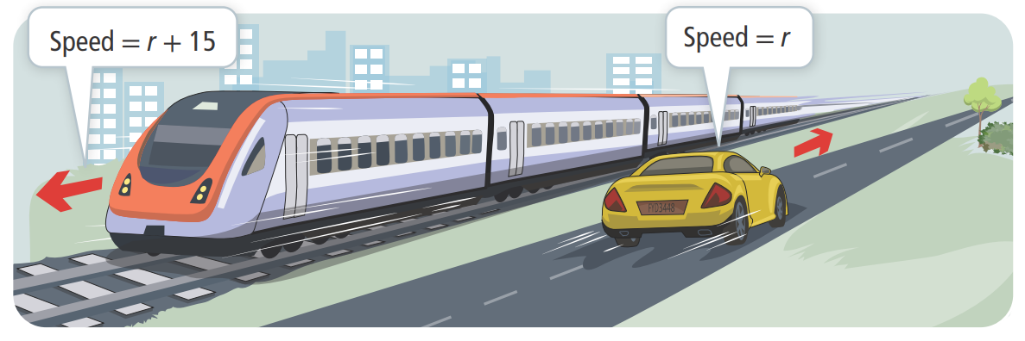

How do you know you need to add these expressions to solve the problem?
What does each fraction represent in the context
How is a table a useful tool in solving this problem?

TRY IT – 5

Jorge drives to visit his friends. His 20 mile trip to their house is congested with traffic, but it has cleared by the time he travels home. He can travel 5 miles per hour faster. Write an expression that represents Jorge’s total travel time.

Select Exercises
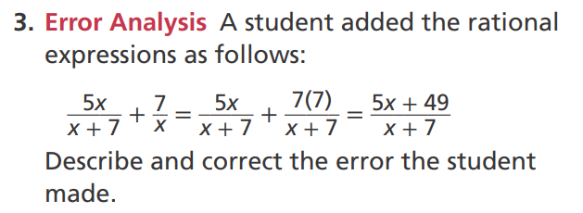 DOK2
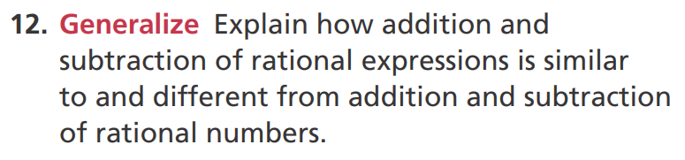
DOK2
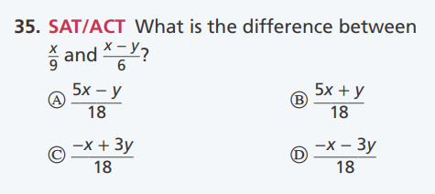 DOK1
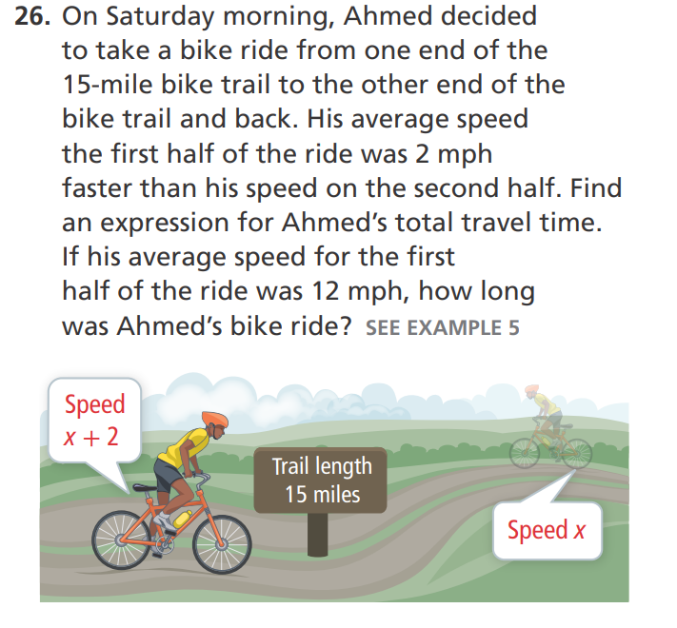
DOK2
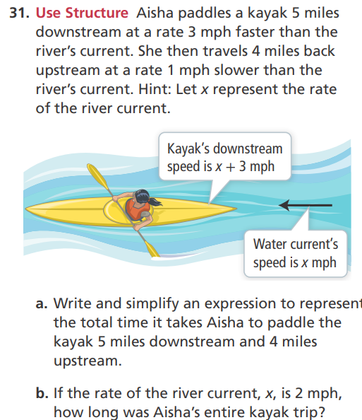
DOK3

