Lesson 4-5: Solve Rational Equations
Math Objectives | - Solve rational equations in One Variable  - Identify extraneous solutions to rational equations and give examples of how they arise
Language objective | - Students will write how to solve a rational equation word problem using a graphic organizer.
Essential Question | - How can I solve rational equations and identify extraneous solutions?

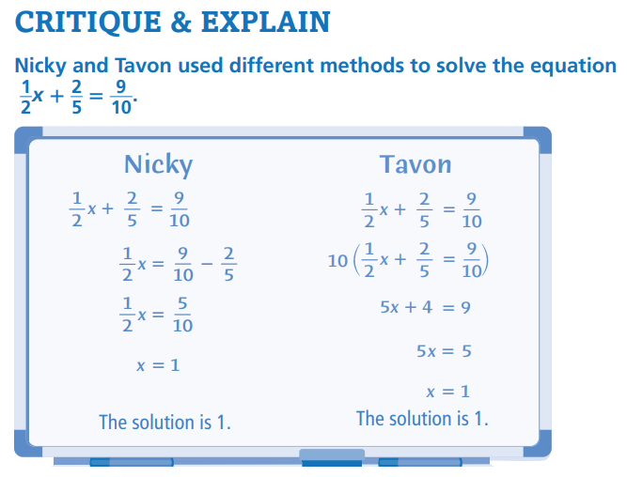 | Explain different strategies that Nicky and Tavon used and the advantages and disadvantages of each.
Did Nicky use a correct method to solve the equation? Did Tavon? | Use Structure. Why might Tavon have chosen to multiply both sides of the equation by 10. Could he have used another number? Explain

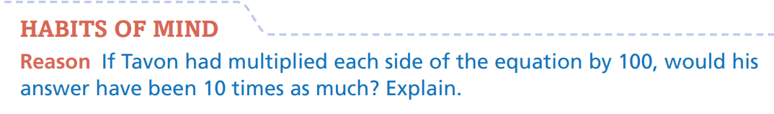

What do you notice about the equation?
What strategies do each of them use?
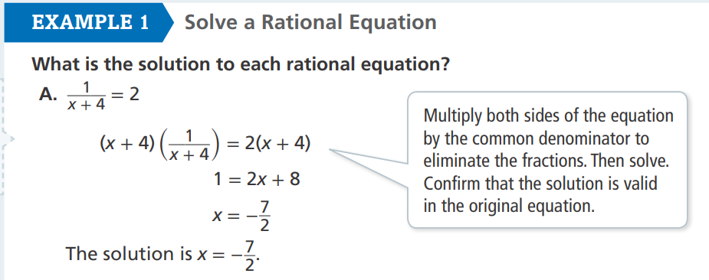
Why do you have to confirm that the solution is valid in the original equation?

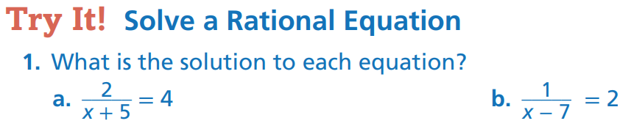

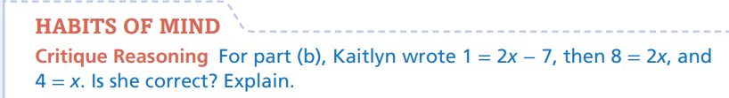
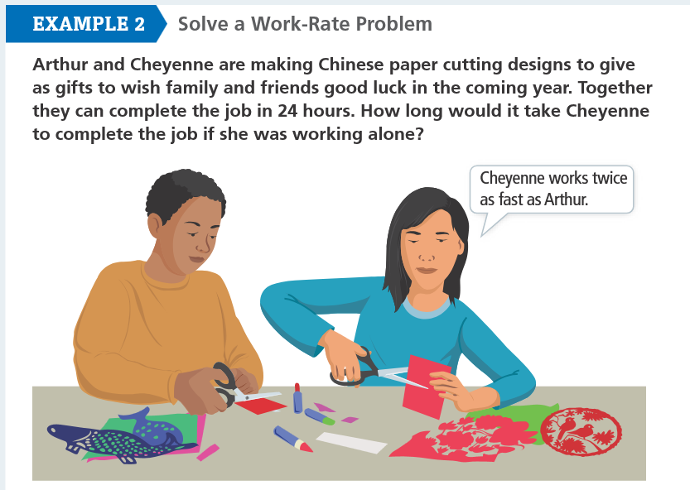

Why is it important to define the variable(s) before writing an equation to represent the problem?

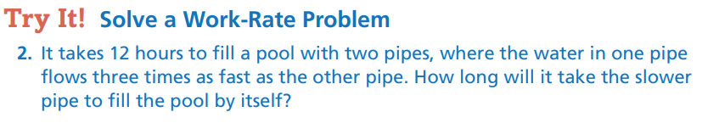


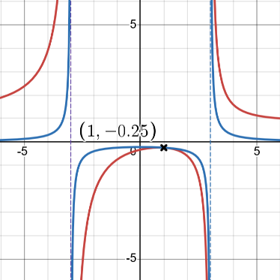
Solve the equation and identify any extraneous solutions:
$$\frac{1}{x-3} + \frac{x}{x+3} = \frac{2}{x^{2}-9}$$
Note: $x^{2}-9$ is a difference of squares
Step 1: Identify any restrictions on the domain
Step 2: Multiply each side of the equation by the common denominator $x^{2}-9$

Step 3: Solve
Step 4: Check for extraneous solutions
Step 5: Verify by Graphing / Extraneous Solution

Do you have to multiply both sides of the equation by the LCD to eliminate the fractions?
How can you determine values that cannot be solutions before solving?

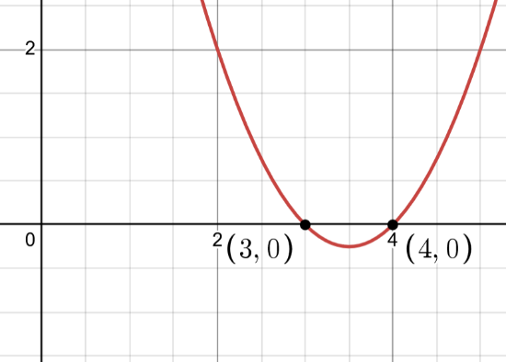
What are the solution(s) to the following equation?
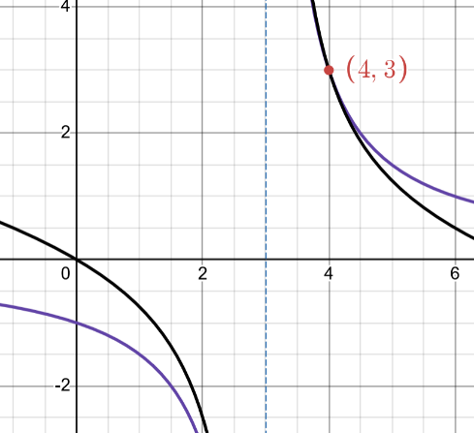
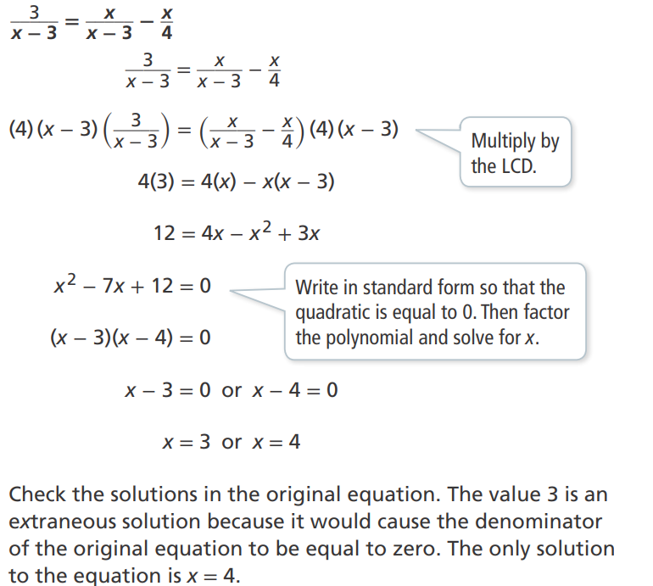
How could you use a graph to verify your solution?

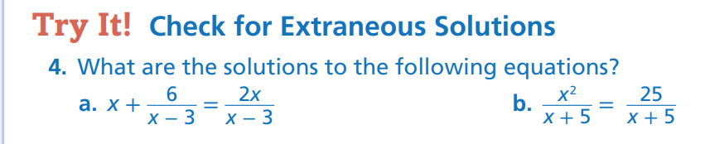
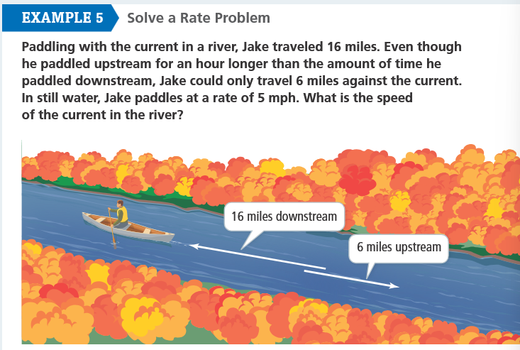
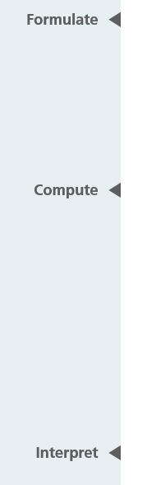

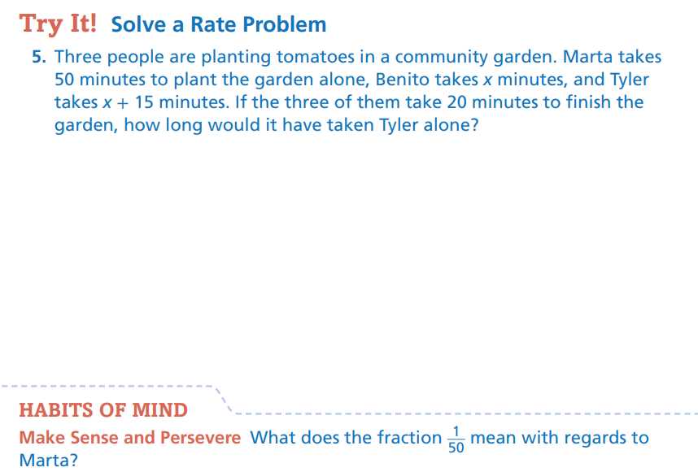

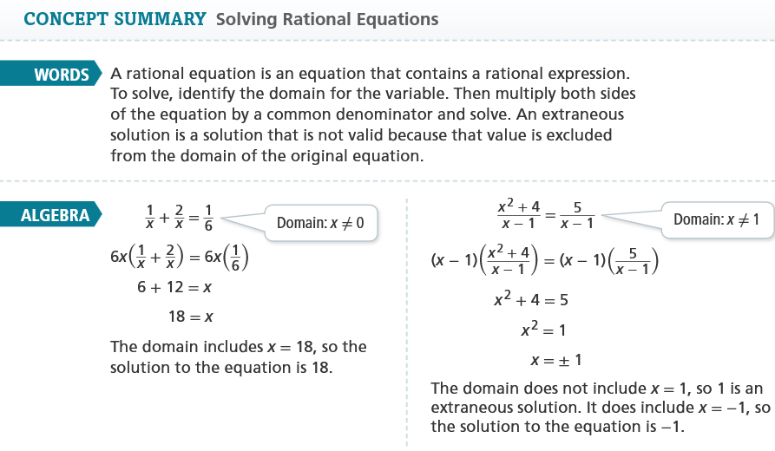
Select Exercises
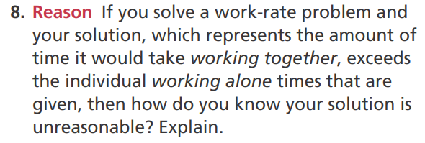DOK3
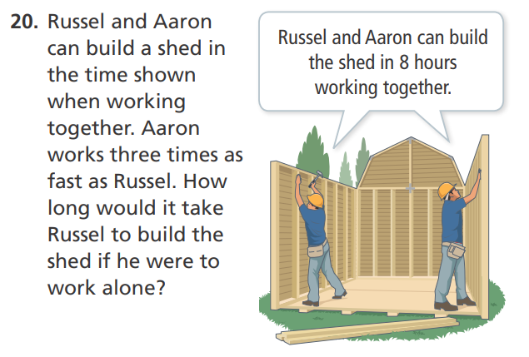
DOK2
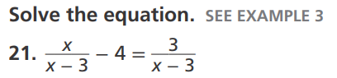DOK2
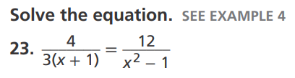DOK2
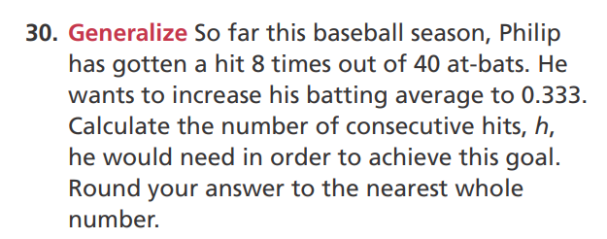
DOK3

