Lesson 5-1: nth Roots, Radicals, and Rational Exponents
Math Objective | - Use properties of exponents to rewrite expressions involving radicals in terms of rational exponents  - Find all real nth roots of a number  - Evaluate expressions with rational exponents  - Use nth roots to solve equations
Language Objective | Students will explain how to convert rational exponents and radical expressions using sentence frames.
Essential Question | How are roots and rational exponents related? How can this understanding help simplify expressions and solve equations?

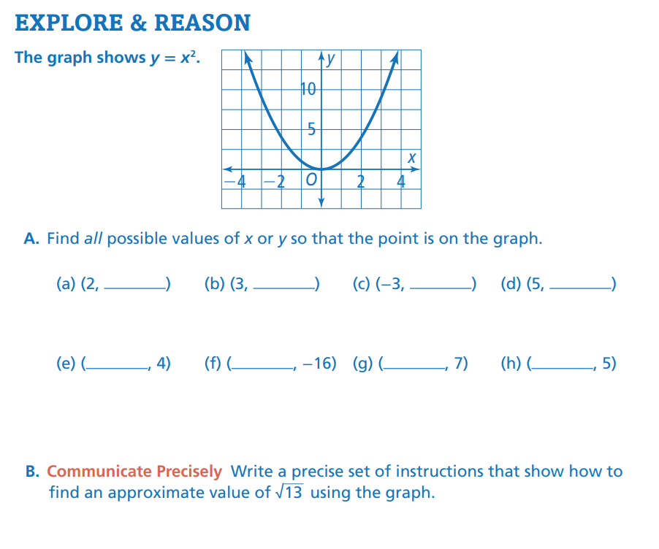
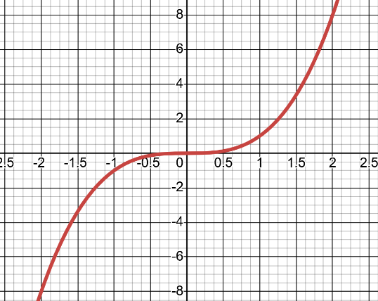
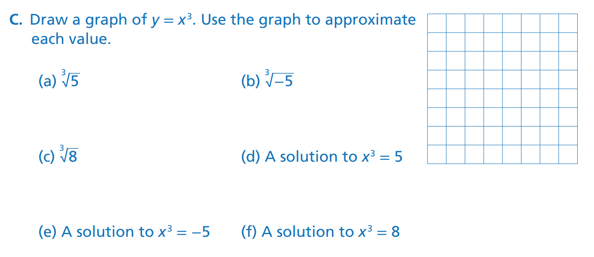
What do you notice about the graph?
What is true about the possible missing x values compared to the y values?
What do you notice about the answers in Part c?
EXAMPLE 1 – Find all real nth Roots
Find real roots of 49  Solve:  $$x^{2}=49$$  $$x^{2}-49=0$$  Difference of squares:  $$(x-7)(x+7)=0$$  Real solutions:  $$x=7,x=-7$$ | Find real cube roots of 64  Solve:  $$x^{3}=64$$  $$x^{3}-64=0$$  Difference of cubes:  $$x^{3}-4^{3}=0$$  $$(x-4)(x^{2}+4x+16)=0$$  $$x-4=0⇒x=4$$  From the quadratic factor:  $$x^{2}+4x+16=0$$  $$b^{2}-4ac=16-64=-48$$  Negative = imaginary roots:
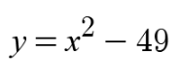  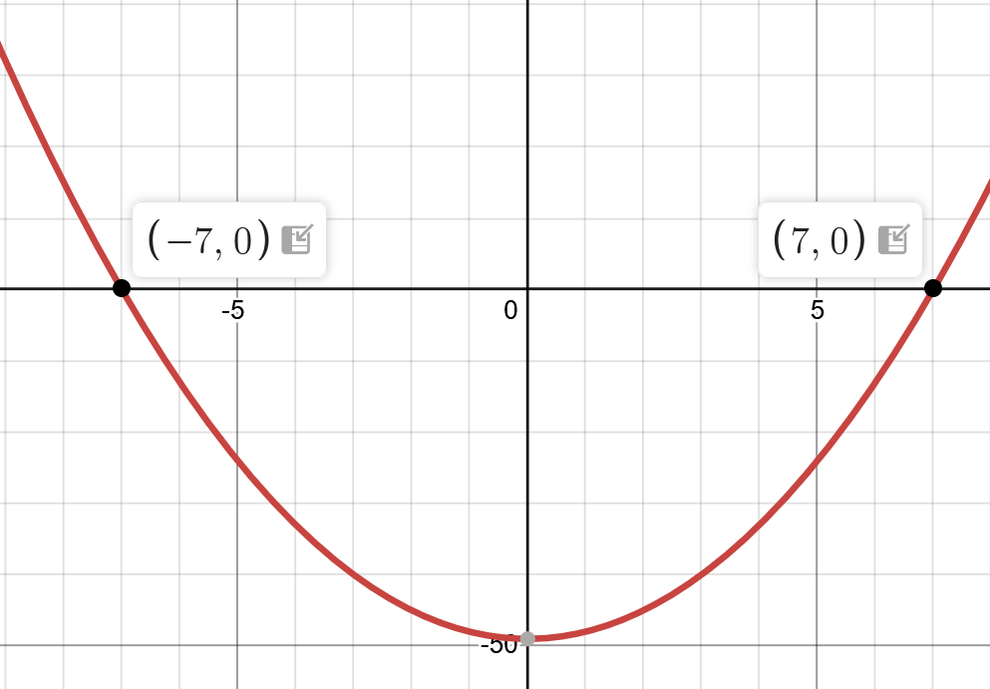 | 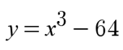  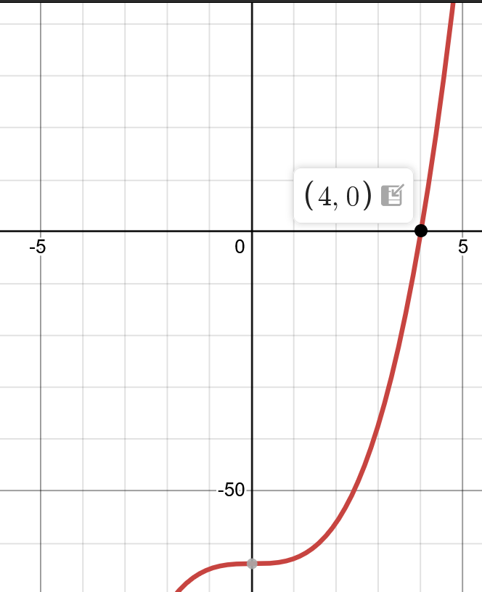
- Even roots can have TWO real answers. | - Odd roots usually have ONE real answer.
Try it 1
Find the real fourth roots of 81 | Find the real cube roots of 125
What do you know about the roots of a number before you solve the problem?

One way √5 is related to 5 is that it… | I notice that each root of 5 becomes…
Compared to 5, ³√5 is… | A root of a number usually means that the number becomes…

EXAMPLE 2 – Understand and Evaluate Rational exponents
Key Ideas
- $\sqrt[n]{a}$ means “what number multiplied by itself $n$ times equals $a$?”
- Rational exponents and radicals are equivalent.
$$a^{\frac{1}{n}}=\sqrt[n]{a} \\ a^{\frac{m}{n}}={\left(\sqrt[n]{a}\right)}^{m}$$
  Radical Form | Exponential Form
  $$\sqrt{25}$$ | $${25}^{1/2}$$
  $$\sqrt[3]{8}$$ | $$8^{1/3}$$
  $$\sqrt[4]{x^{3}}$$ | $$x^{3/4}$$

Try It 2

Rewrite each expression in the other form, then find the value.

Expression | Radical Form | Value
$${81}^{1/2}$$
$${512}^{1/3}$$
$${32}^{6/5}$$

Could a rational exponent have a 1 in the denominator?
Does the order in which you apply the power and find the nth root matter?

EXAMPLE 4 – Simplify nth roots
What is another approach you could use to simplify the expression in part A?
Why is it necessary to assume all the variables represent positive numbers in part B?
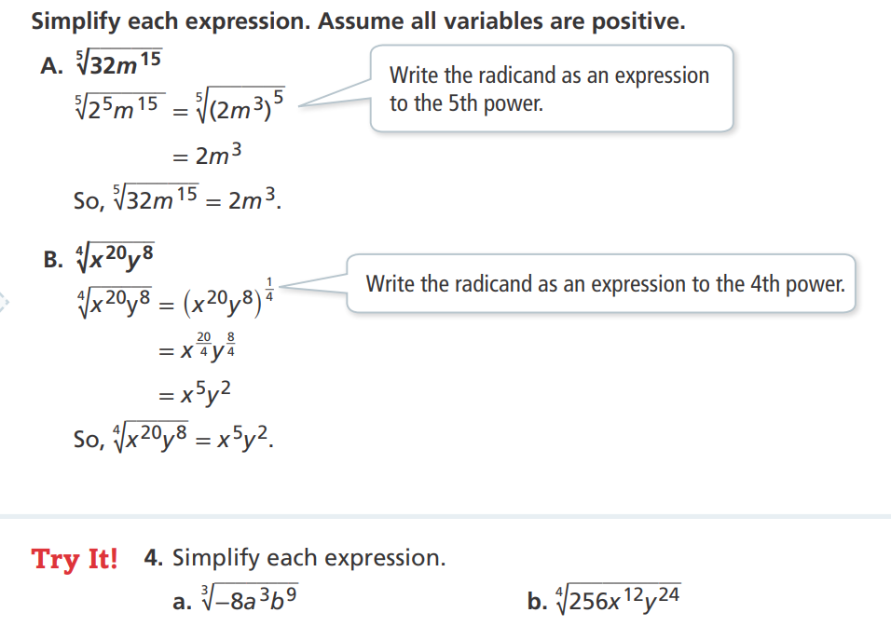

EXAMPLE 5 – Using nth roots to solve equations
Solve.
$$5x^{3}=320 \\ x^{3}=64 \\ x=4$$ | $$2x^{4}=162 \\ x^{4}=81 \\ x=±3$$
What do you notice about these equations that makes them easy to solve?
Try it 5
Solve
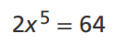 | 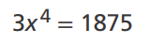

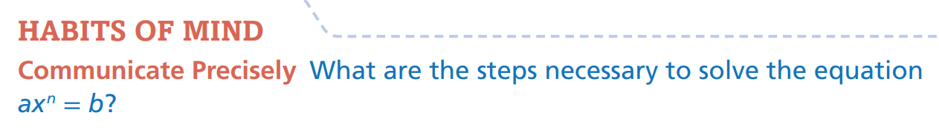

First, I would…, then I would…, and finally I would… | To isolate $x$, I need to…
This step is necessary because it helps me… | To solve an equation of the form $ax^{n}=b$, I usually…

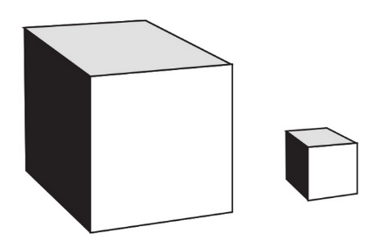
EXAMPLE 6- Applications of nth roots

Shipping Crates
A small cube-shaped shipping crate has volume $216{\text{ in}}^{3}$.
A second cube-shaped crate has side lengths 2 inches longer than the first crate.
How much larger is the larger crate’s volume compared to the smaller crate?
- Find the ____________ of the _____________ crate.
- Find the ____________ of the _____________ crate.
- Find the __________ of the larger crate.
- Compare the __________ using ______________.

