Lesson 6-2: Exponential Models
Math Objective | - Interpret the parameters of compound interest functions  - Construct Exponential models using regression
Language Objective | Students will write sentences explaining the properties of exponential models using sentence frames.
Essential Question | How to write exponential models in different ways to solve problems?
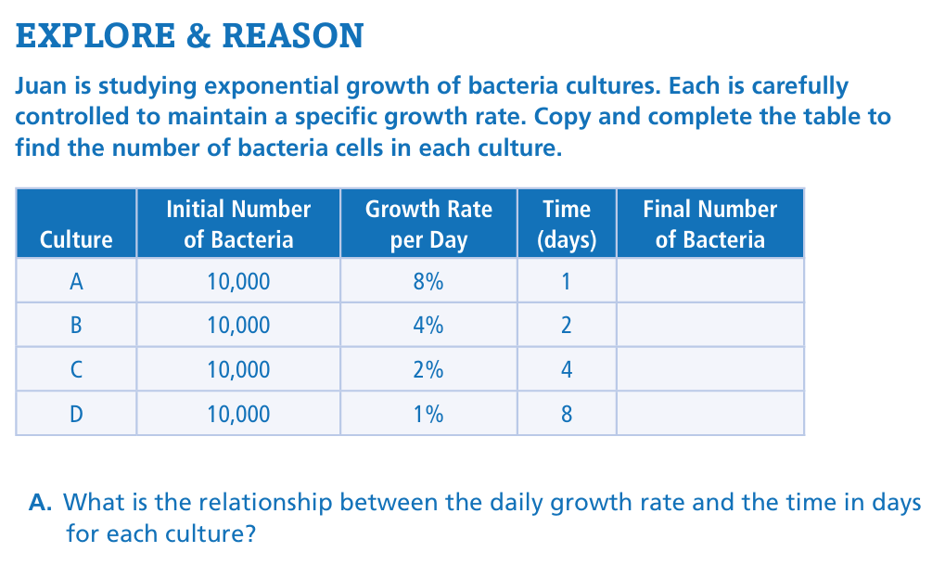

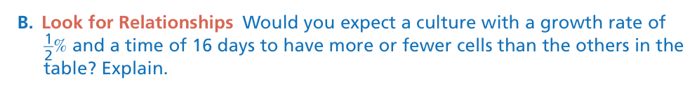

Do you expect the number of bacteria to be the same for each culture?
How do the growth rate of 0.5% and 16 days fit the table?
How would the result change if this was decay instead of growth?

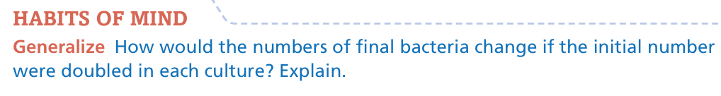

If the initial amount doubles, the final amount… | With the same growth rate, the final number…
The table pattern shows the final bacteria would… | Doubling the start value leads to…

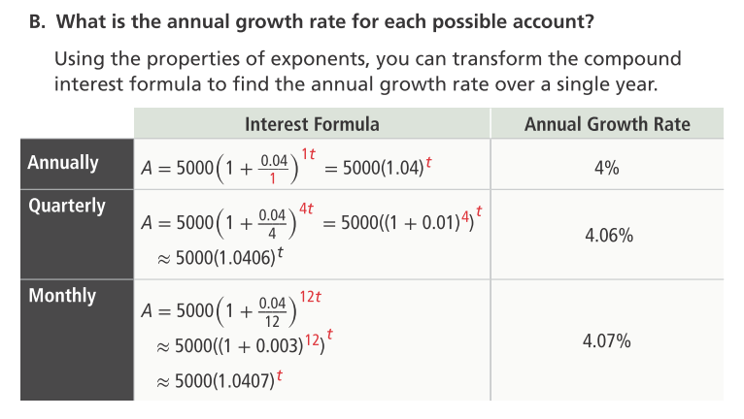
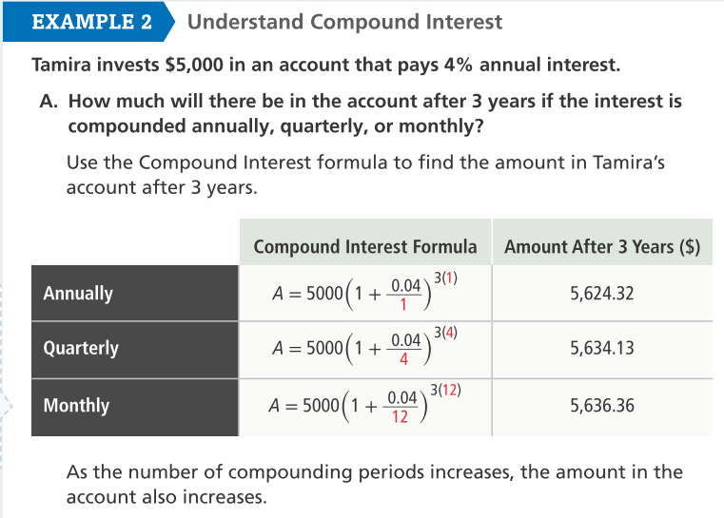
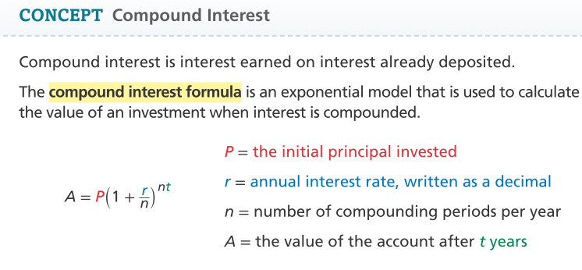

What things might you do or might happen annually? Semi-annually? Quarterly? Monthly? Weekly?
Why is 0.04 used in the formula for r rather than 4?
When banks advertise an interest rate of 3% interest compounded quarterly, do they really pay 3% every quarter?

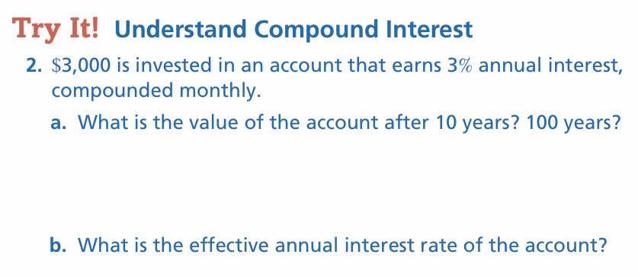

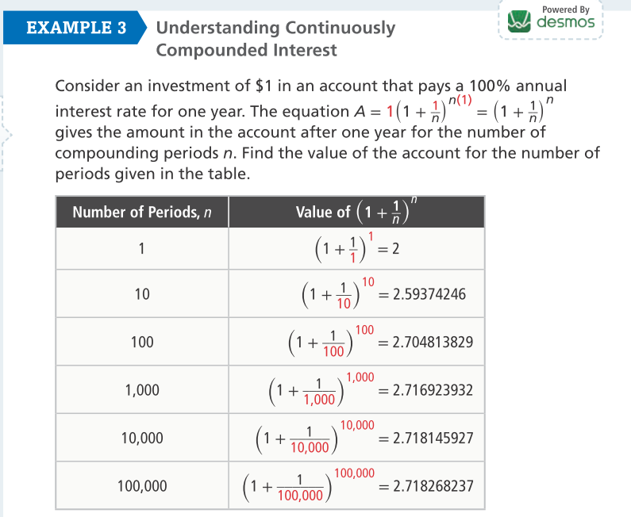
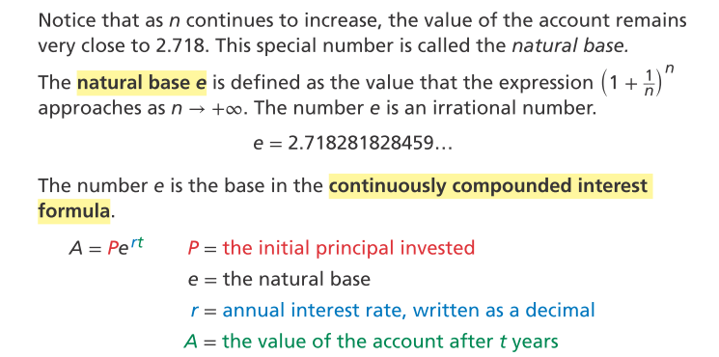
Are these exact values?
Is it necessary to calculate the value of the account to nine decimal places?

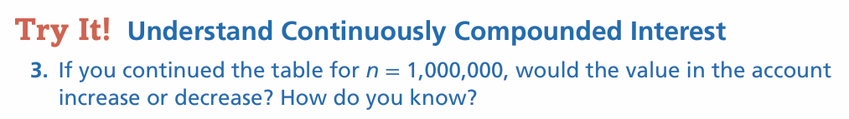

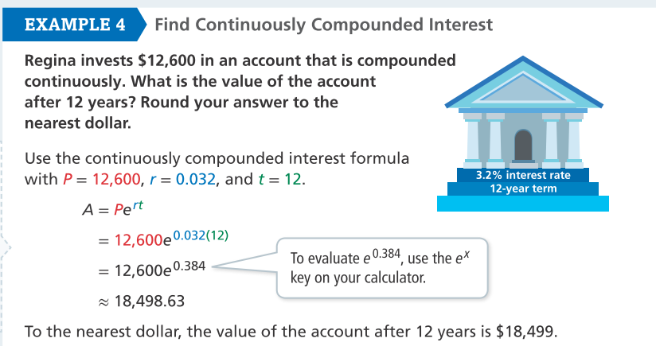
What part of the continuously compounded formula represents continuous?

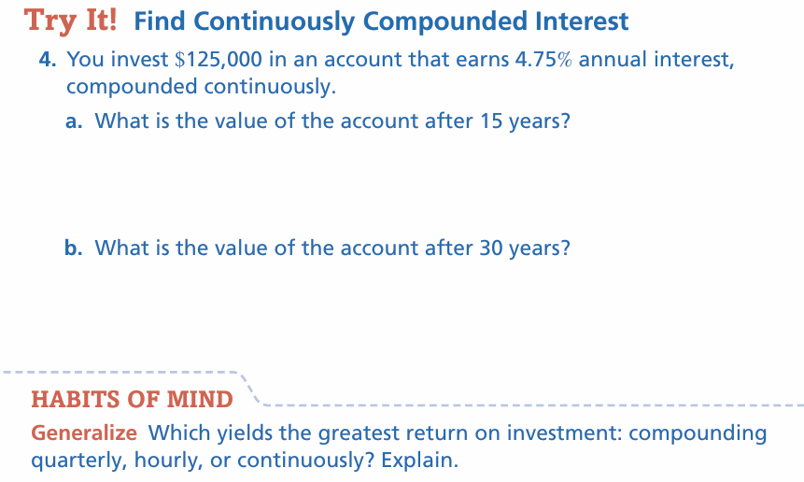

Continuous compounding grows faster because… | With $e^{rt}$, the final amount becomes…
Quarterly vs. hourly vs. continuous shows that… | As compounding becomes more frequent…

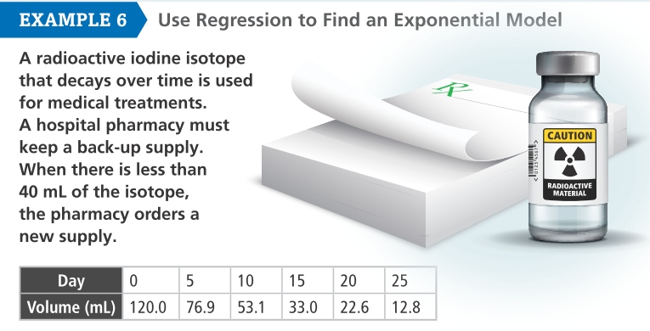 | - Find an exponential decay model for this isotope.  - Should the pharmacy reorder on the 12th day?
Would it make sense to use an exponential growth model in this situation?

DESMOS: Input data into a table. Use an “Exponential Regression” to fit the data. Find volume on day 12.
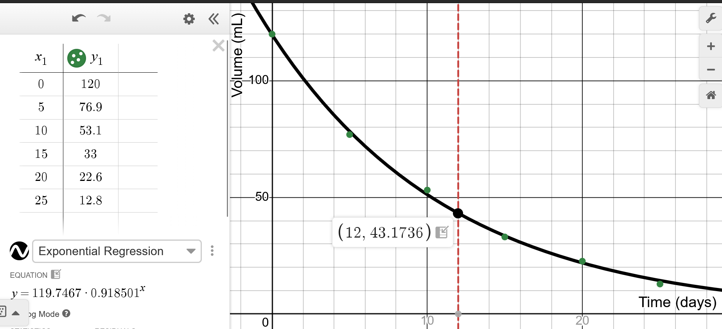
Why can’t the y value ever go below 0?
What does ~0.918 in the equation represent in this context?



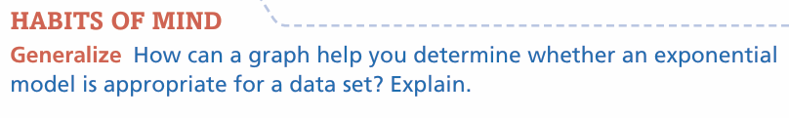
A graph shows an exponential trend when… | If the data curves downward, the model…
The shape of the points suggests… | When the graph levels off, it means…

Select Exercises
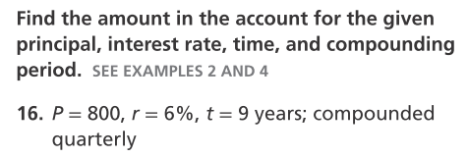DOK1
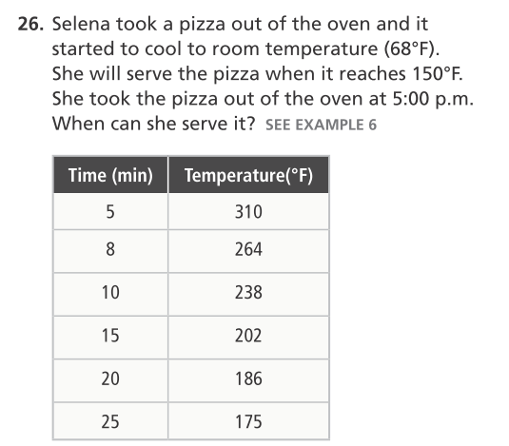 DOK2
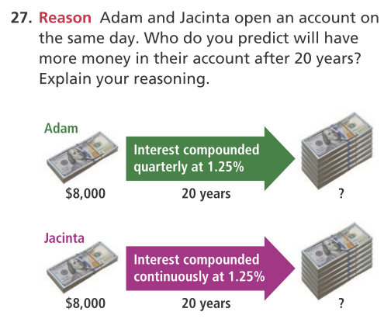 DOK3
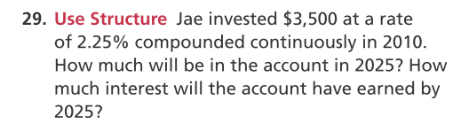 DOK2
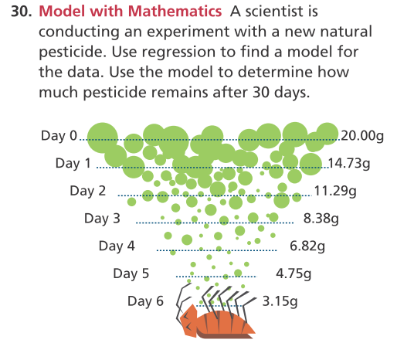 DOK2

