Lesson 4.1: **Inverse Variation and the Reciprocal Function**

|  |  |
| --- | --- |
| Objectives | * Use inverse variation to write and graph reciprocal functions. * Identify the effect of transformations on the graph of the parent reciprocal function and define the effects of h and k on the function f(x) =1/(x-h) + k.. |
| Language Objective | * Students will write their own definition of key vocabulary. |
| Essential Understanding | A reciprocal function is used to model inverse variation, which is a proportional relationship between two variables such that when one variable increases, the other decreases. |

**Using words or pictures, define the following Vocabulary:  
  
Asymptote:_______________________________________________________________________  
  
________________________________________________________________________________  
  
  
  
  
  
  
Constant of Variation:______________________________________________________________  
  
________________________________________________________________________________**

**Inverse variation:__________________________________________________________________  
  
________________________________________________________________________________  
  
  
  
reciprocal function:________________________________________________________________  
  
________________________________________________________________________________**

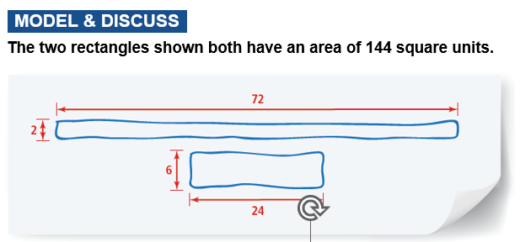

1. **​Sketch as many other rectangles as you can that have the same area on a piece of graph paper. organize and record your data for the lengths and widths of the rectangles.**A graph paper with red line

   Description automatically generated
2. **Considering rectangles with an area of 144 square units, what happens to the width of the rectangle as the length increases? Show your reasoning below, use pictures, words, or mathematical expressions.**
3. **​Examine at least five other pairs of rectangles, each pair sharing the same area. How would you describe the relationship between the lengths and widths? Show your reasoning below, use pictures, words, or mathematical expressions.**

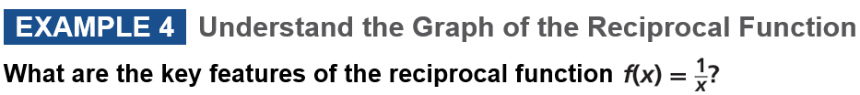

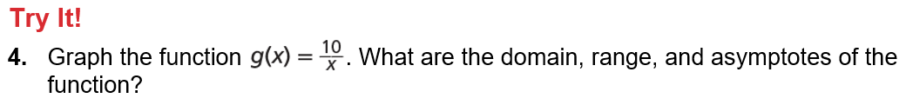

**Practice & Problem Solving**

|  |  |
| --- | --- |
|  |  |
|  |  |
|  |  |
|  |  |
|  |  |

