
Lesson 1.2: Transformations of Functions
Math Objectives | - Graph a transformed function by identifying the effect on the graph of replacing f(x) by f(x) + k, kf(x), f(kx), and f(x + k) for specific values of k.  - Write an equation of a transformed function.  - Relate the domain of a function to its graph and the real-world situation it describes.  HSF.BF.B.3, HSF.IF.B.5
Language Objective | Students will explain transformations of functions, provided pre-taught vocabulary, the three-reads strategy, and structured student-talk time.
Essential Question | How do values a, b, h, and k in $a∙f\left[b\left(x-h\right)\right]+k$ transform the graph of a parent function, f(x)?
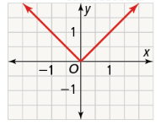
The graph of the function $f\left(x\right)=|x|$ is shown.
- Graph the function $g\left(x\right)=|x+c|$ several times with different values of c (any value of -5 to 5).

- Look for Relationships Predict what will happen to the graph if c is a number greater than 100. What if c is a number between 0 and $\frac{1}{2}$?

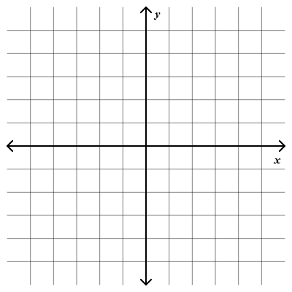
- Graph the function $f\left(x\right)=x^{2}$ for the domain [-2, 2].
The graph of g is the graph of f after a translation of 3 units down. How are the functions, domains, and ranges of f and g related?

- Graph the function $f\left(x\right)=x^{2}$ for the domain [-2, 2].
The graph of g is the graph of f after a translation 3 units to the right.
How are the functions, domains, and ranges of f and g related?

- Compare the intercepts of f to the intercepts of g in part (a). | - Compare the intercepts of f to the intercepts of g in part (b).

- Graph $f\left(x\right)=2x-6$ for the domain $[0,∞)$ and the function g, whose graph is the reflection of the graph f across the x-axis. How are their functions related?

- Graph $f\left(x\right)=2x-6$ for the domain $[0,∞)$ and the function g, whose graph is the reflection of the graph f across the y-axis. How are their functions related?

- What is the function for the reflected graph? Check by graphing.

- The graph of $f\left(x\right)=x^{2}-2$ reflected across the x-axis. | - The graph of $f\left(x\right)=x^{2}-2$ reflected across the y-axis.

- Graph $f\left(x\right)=|x|$ with domain [-4, 4] and $g\left(x\right)=2∙f(x)$.
How are the graphs, domains, and ranges related?
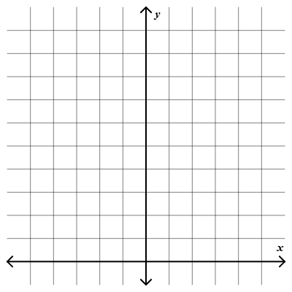
Use a table to find points on the graph(s).
x | $$f\left(x\right)=|x|$$ | $$g\left(x\right)=2∙f(x)$$ | $$(x, g\left(x\right))$$

A transformation that increases the distance between the points of a graph and a given line, usually the x-axis, by the same factor, is called a stretch.

- Graph $f\left(x\right)=|x|$ with domain [-4, 4] and $h\left(x\right)=f(2x)$.
How are the graphs, domains, and ranges related?
Use a table to find points on the graph(s).
x | $$f\left(x\right)=|x|$$ | $$h=f(2x)$$ | $$(x, h\left(x\right))$$

A transformation that decreases the distance between the points of a graph and a given line, usually the y-axis, by the same factor, is called a compression.

- The domain of $j(x)$ is [a, b]. Show that $j\left(x\right)=f(\frac{1}{2}x)$ is a horizontal stretch of the graph of f. What is the domain of f?

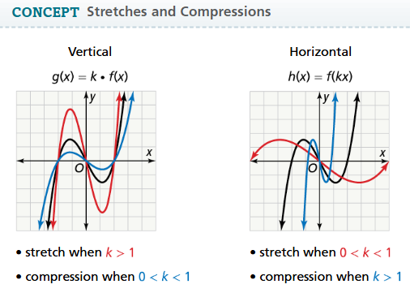
Using the graph $y=f(x)$, how can you graph a combination of transformations?
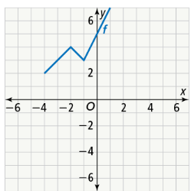
- Graph $y=-f(x+2)$.

- Graph $y=\frac{1}{2}f\left(x\right)+3$.

- Using the graph of f above, graph each equation.
- $y=f\left(2x\right)-4$ | - $y=f\left(2x-3\right)-2$

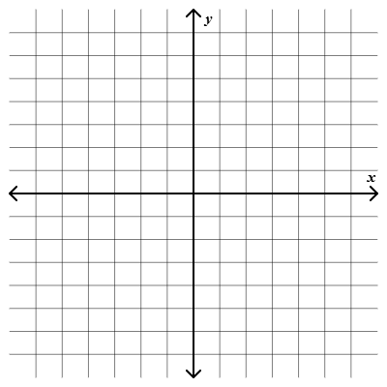
What transformations of $f\left(x\right)=x^{2}$ result in the graph of the function g?
- $g\left(x\right)=-{\left(\frac{1}{3}x\right)}^{2}$

- $g\left(x\right)={\left(x-4\right)}^{2}+5$

- What transformations of the graph of $f\left(x\right)=|x|$ are applied to graph the function g?
- $g\left(x\right)=\frac{1}{2}|x+3|$ | - $g\left(x\right)=-\left|x\right|+2$

  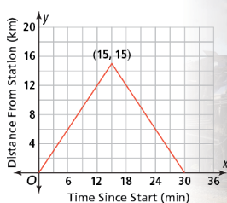  A scenic train ride makes trips on an old mining line. The graph shows the distance y in kilometers of the train from the station x minutes after the ride begins. What equation represents the distance from the station as a function of time? What is its domain? |  | Student Responses (in complete sentences) |  | Additional Responses
 |  | First Read – Understanding Context
What is the core of the problem?
- I think the problem is about …
 |  | Second Read – Interpreting the Question
What are you trying to find out?
- The problem is asking …
 |  | Third Read – Identifying Necessary Information
What are the important quantities, relationships, and other relevant information?
- The important information is…
Explore Reasoning – What are three different ways to think about solving this problem?
Solution (show and explain your answer)
Interpretation of Solution (interpret your solution in your own words)

- How would the graph and equation be affected if the train traveled twice as far in the same amount of time?

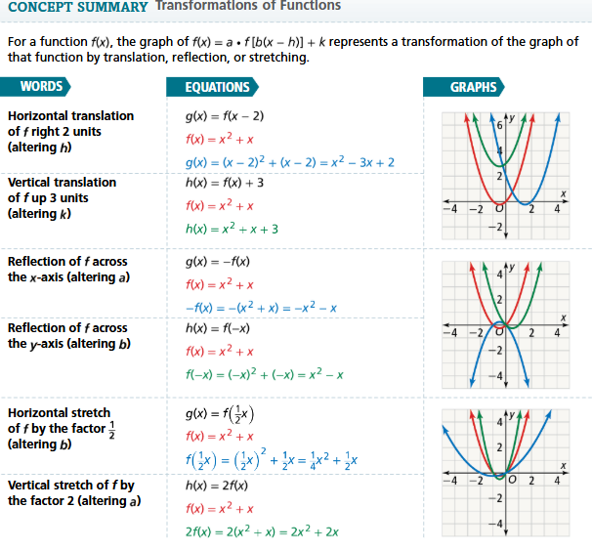
- Essential Question How do the values a, b, h, and k in $a∙f\left[b\left(x-h\right)\right]+k$ transform the graph of a parent function, $f(x)$?

- Reason Do k and h affect the input or output for $g\left(x\right)=f\left(x\right)+k$ and $g\left(x\right)=f\left(x-h\right)$? Explain.

Graph each function and its parent function.
- $g\left(x\right)=\left|x\right|-1$   | - $g\left(x\right)={\left(x-3\right)}^{2}$
- $g\left(x\right)=-|x|$ | - $g\left(x\right)=-x$
- $g\left(x\right)=x^{2}-2$ | - $g\left(x\right)=\frac{1}{2}|x|$
- $g\left(x\right)=4x$ | - $g\left(x\right)=|5x|$

