Robert Colson’s

Lesson 4.1: **Inverse Variation and the Reciprocal Function**

|  |  |
| --- | --- |
| Objectives | * Use inverse variation to write and graph reciprocal functions. * Identify the effect of transformations on the graph of the parent reciprocal function and define the effects of h and k on the function f(x) =1/(x-h) + k.. |
| Language Objective | * Students will write their own definition of key vocabulary. * Students will do a 3 reads on pg. 2 * Students will complete sentence frames with a word bank on pg. 8 |
| Essential Understanding | A reciprocal function is used to model inverse variation, which is a proportional relationship between two variables such that when one variable increases, the other decreases. |

**define the following Vocabulary:  
  
Asymptote:_______________________________________________________________________  
  
________________________________________________________________________________  
  
  
  
  
Constant of Variation:______________________________________________________________  
  
________________________________________________________________________________**

**Inverse variation:__________________________________________________________________  
  
________________________________________________________________________________  
  
  
  
reciprocal function:________________________________________________________________  
  
_______________________________________________________________________________**

|  |  |  |
| --- | --- | --- |
|  | **First Read - Understanding the Context** |  |
| *What is the core of the problem?*   * I think this problem is about... * This problem is about... * In this problem, I think that...is happening. * I agree with you that... * I disagree because... |  |
| **Second Read - Interpreting the Question** |  |
| *What are we trying to find out?*   * The question is... * I know the problem is asking...because... |  |
| **Third Read - Identifying Information** |  |
| *What are the important quantities, relationships, and other relevant information?*   * The quantities are... * I can count... * I notice the quantities are... * These quantities help me to answer... * The information from the situation that we need is... |  |
|  | |



|  |  |
| --- | --- |
| **Fill in the following sentences with terms from the word bank ->>** | **Word Bank** |
| **The graph of f has a ______________ asymptote y = 0.**  **An ____________ is a line that a graph approaches.**  **For x-values close to 0:**  **- As x approaches 0 from ______________ values, f(x) goes to ∞**  **- As x approaches 0 from ______________ values, f(x) goes to -∞**  **The graph of f has a ______________ asymptote x = 0.**  **The domain of f(x) = 1/x is { __________ | x ≠ 0}.**  **The range is {y | y ___________ 0}.**  **The end behavior is f(x) → __________ as x → ±∞.** | **Vertical** |
| **≠** |
| **x** |
| **Negative** |
| **0** |
| **Horizontal** |
| **Positive** |
| **asymptote** |

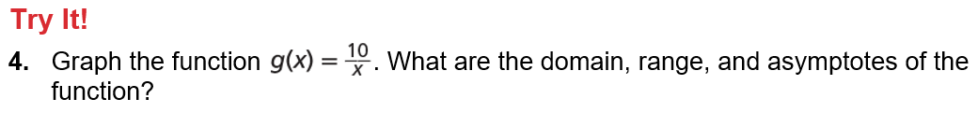

****

**  
Sketch g(x), and then check with DESMOS.com.  
  
**

**Practice & Problem Solving**

|  |  |
| --- | --- |
|  |  |
|  |  |
|  |  |
|  |  |
|  |  |

