CU LEEDS Meeting Charts - January 21, 2016

State Demography Office

January 21, 2016

# County Growth Rate Rankings

These charts compare the compund annual growth rates for each of three periods (1990 to 1999, 2000 to 2009, 2010 to 2014). These periods are slightly different than the periods used by Chris in the final section showing the 'resilient' counties.

**All 64 counties**

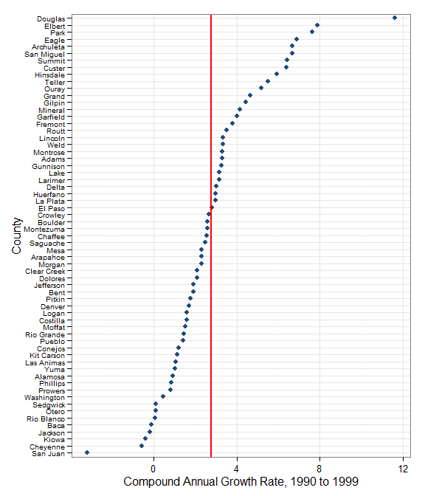

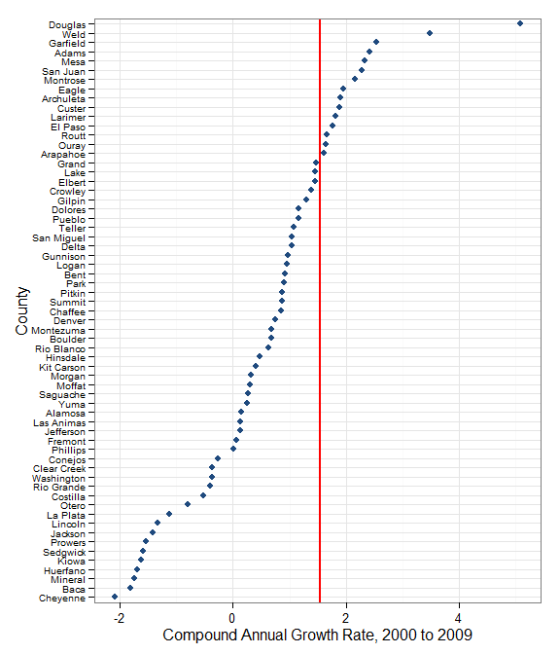 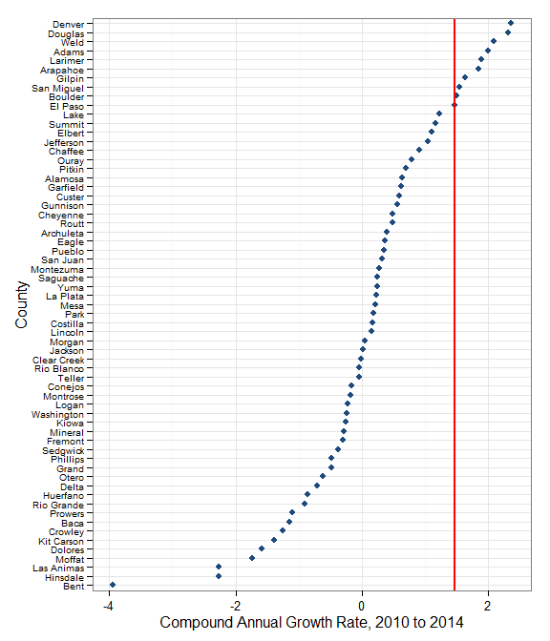

## Non-Metro counties

# 

# Hierarchical Clustering Exercise

To begin the thought process of clustering or segmenting counties by population growth, a preliminary hierarchical cluster analysis is often useful. The charts below are clustering tree diagrams. They are read by tracing the brackets. The highest clusters show two clusters and include every branch from their split and below. For each branching, this is the method until each county would be technically a cluster. This can help see how a rather uninformed method would cluster these counties based on CAGRs from 1990 to 1999.

## All 64 counties

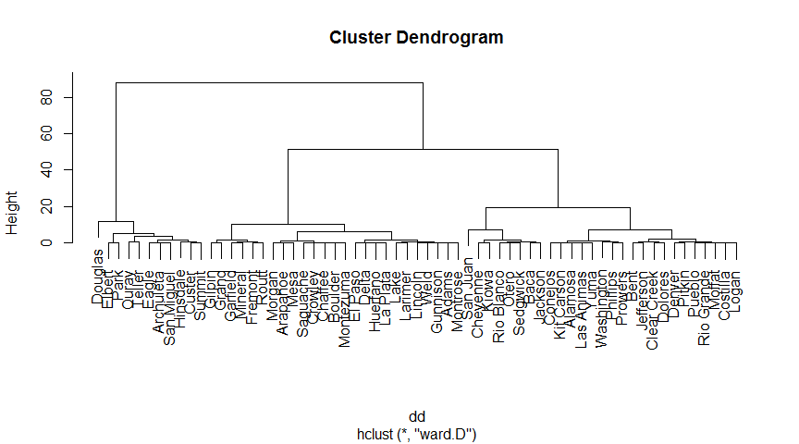

## Non-metro counties

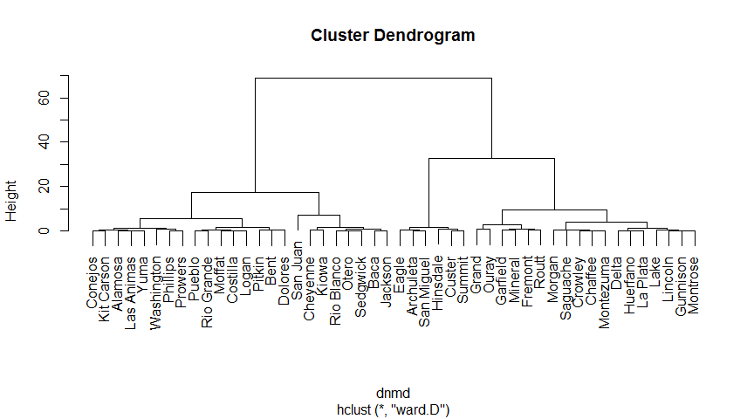

# Resilient population counties





