
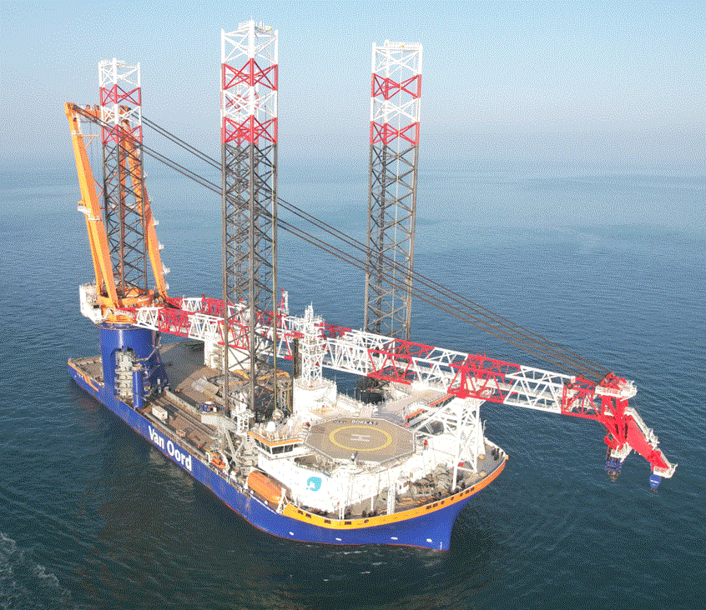

Template v3.0
  - <Business domain>
High Level Design
<System Name>

HLD <System Name> Version 1.0
<Author> | <Date>

  - Tender
High Level Design
<System Name>

Tender | | rev. 1
Reference Client [Reference] | Reference [Our reference]

  - [Location]

Document Control

Approvals
I have read, understand, and approve the proposed design for <System Name>.
Approver | Initials | Date
Head of Enterprise Architecture |  | <MMM DD, YYYY>
Head of IT Operations |  | <MMM DD, YYYY>
Business Application Manager / System Owner |  | <MMM DD, YYYY>
Project Manager |  | <MMM DD, YYYY>
Table 1 – Approvals

Revision History
Date | Version | Author / Editor | Reason for Revision
<MMM DD, YYYY> | 0.1 | <Initials> | <Reason>
Table 2 - Document History

Table of Contents
Document Control 2
Approvals 2
Revision History 2
Table of Contents 3
1. About this Document 5
1.1. Purpose 5
1.2. Audience 5
1.3. Related Documents/ References 5
1.4. Abbreviations and Acronyms 5
2. System & Solution Context 6
2.1. System Introduction 6
2.2. Process Context 6
2.3. Solution Concept 6
3. Information Architecture 7
3.1. Business Information Flows 7
3.2. Data Store diagram 7
4. Application Architecture 8
4.1. Logical Application Architecture 8
4.2. Technical Application Architecture 8
4.3. Environments Overview 8
5. Communication & Interfacing 9
5.1. Exposed Services 9
5.2. Interfaces 9
5.3. Interface, connectivity or communication Specifics 9
6. System Continuity & Resilience 10
6.1. Continuity Objectives 10
6.2. Continuity Risks & Mitigations 10
6.3. Disaster Recovery and Continuity Strategy 11
6.4. Backup & Restore Design 11
6.5. Disaster Recovery Infrastructure 12
7. Identity & Access Management (IAM) 13
7.1. Identity types 13
7.2. Account Types 13
7.3. Account Types & Lifecycle 13
7.4. Identity Federation & Governance 14
7.5. Authentication 14
7.6. Authorization 15
8. Legal, Regulatory & Contractual Compliance 16
8.1. Compliance Overview 16
8.2. Compliance Design 16
9. Security & Privacy 17
9.1. Security Objectives & Assumptions 17
9.2. Security Controls 17
9.3. Information Classification 17
9.4. Security Logging & Monitoring 17
9.5. Encryption & Key Management 17
9.6. Privacy 18
10. Infrastructure Architecture 19
10.1. Infrastructure Architecture 19
10.2. Environment Specification 19
10.3. Solution & Cloud Topology 20
Appendix A – Security Control Mapping 21

About this Document

Purpose
This document describes the high-level Architecture and Solution design for <System Name>.
It aims to provide a high-level understanding of how business requirements are translated into a solution direction.

<This is a SYSTEM document – please do not make references to any PROJECT in this document>

Audience
The intended audiences for this document are:

- Business Application Management
- Project Teams
- Architecture, Design and Engineering
- Service Delivery

Related Documents/ References
The following documents have been referred to while preparing this design document:
Document Title | Description
SharePoint Location for these documents | <Link>
Table 3 - Related Documents

Abbreviations and Acronyms
Abbreviation | Description
Table 4 - Abbreviations and Acronyms

HLD Creators:
BA: Business Analyst
SA: Solution Architect / Designer
EA: Enterprise Architect
IA: Integration Architect
ICA: Infrastructure & Cloud Architect
SEC: Information Security Architect

System & Solution Context

System Introduction
BA: Introduce background, what the system is about and how we intend to use it.

Process Context
BA: Offer the high-level overview of the process that this system will support.

Process Outline
BA: Provide a simplified process overview explaining the process that this System will support.(Represented in a swim lane diagram or a flow chart)

Process Reference
BA: Provide a reference (link to a place in a repository) where the detailed process descriptions (To-Be) can be found (eg. in a BPM tool or on SharePoint).

Solution Concept
BA + EA: Describe the high-level solution architecture for this system, in a simplified way. Provide a simple sketch & description (aka the ‘whiteboard-quick-sketch’ level).

Information Architecture

Business Information Flows
BA + EA: Business Information flows describe which information (expressed in business terms) is exchanged between business applications or between an actor and a business application. Model the To-Be (proposed) information flows that are relevant to this system(s) and include a copy of the diagram in this section.

Data Store diagram
BA + EA: The data store diagram reflects where the single source of truth resides for each business concept referenced or used within/by this application. Please make sure this is in line with the Data Catalogue, as maintained by the Data Governance Team.

Below is an example data store diagram shown as a reference.
This section is optional but needed when the solution is a ‘system of systems’.

Application Architecture

Logical Application Architecture
BA: Functional view: How is business/application logic (=functionality) grouped / organized; how do functional blocks interact with each other.

<Insert Logical Application Diagram>

Technical Application Architecture
ICA + SA: Technical view: Which technologies are used, what is the technical architecture of the system/solution or application, what are the layers that the application is based on – indicating relevant technical components, connections, technologies, protocols, databases, cloud application components, etc.

<Insert Technical Application Diagram>

Environments Overview
This section defines the environments required to support the solution throughout its lifecycle (e.g., Development, Testing, Acceptance, Production). For each environment, provide relevant details to ensure proper management, compliance with data handling policies, and alignment with operational and security requirements. For large or complex systems with different topologies or data flows per environment a supporting diagram must be included.
ICA + SA: List & Explain which application environments (Prod/UAT/Test/DEV etc.) are needed.
Big systems with different topologies per environment must have individual diagrams.

Name | Type | Location | Persistence | Interfaces | Responsible | Data | Backup | Access Control | Notes
Environment name (e.g., DEV, Test, etc.) | Environment type (e.g., Development, Test, Acceptance, Production) | Hosting location (e.g., Cloud provider, on-premises) | Whether the environment is temporary or permanent | Connected systems or interfaces | The team or person responsible for this environment | Type of data stored (empty, production copy, etc.) | Whether backups are taken (Yes/No) | Who has access and restrictions (e.g., developers, admins, business users) | Additional remarks or access restrictions
*Permanent Application Environments must be tracked in the VO CMDB.
**Temporary environments must be actively managed by the project/change team(s) and must not persist beyond their intended purpose.

Each defined environment will be explained with relevant and related components in paragraph 10.2 Environment Specification.

Communication & Interfacing
This section describes services exposed by the system and interfaces - between this application and others.
- Services are points on applications or integration layers that can accept connections from the ‘outside’ with the purpose of exchanging information. These can be implemented through web services and can be one-way or request/response. Services have a schema contract. Services can call other Services.
- Interfaces represent the end-to-end communication between Business Systems, for a specific message as part of a Business Process.

Exposed Services
BA + IA: List the details of Services exposed by this system.

Application  Name | Service Name | Information /(ORDER,INVOICE, Product Data, …) | Exposed by  (Integration Platform, Application) | Service Type  (SOAP,REST) | Message Format (XML, JSON, CSV, PDF, EDIFACT, …) | Average Payload Size (kb) | Authentication Type (certificate, OAUth2.0, API Keys, username and password)

Interfaces
BA + IA: With which applications/systems does this system exchange information? List the Interfaces for inbound and outbound data exchange between this system/application and others. Additional Details for these interfaces are registered in the Information Architecture Workbook.

Interface name | Data Source | Destination | Information flow | service called | Integration Type | Push or Pull
<Interface name - see convention below > | <System or Application name > | <System or Application name > | <from the Information flow diagram> | <name of the service that this Interface calls > | <see table below>

Naming Convention:
<Source app name>-<target app name>-<Integration code>

Integration type | Integration code
WebServices | SVC
Managed File Transfer | MFT
Adapter | ADPT
Publish Subscribe | PUBSUB
Direct connection | DC

Push: Data is pushed by the source
Pull: Data is pulled from the source
Before building starts, Interfaces must be designed and verified using an ISD (Interface Specification Document).

Interface, connectivity or communication Specifics
BA + IA: This paragraph provides extra required information, explanation or justification for any of the Interfaces (or Services) that are mentioned in this chapter. For example: Some interfaces may require increased security.

System Continuity & Resilience

Continuity Objectives
Recovery Time Objective (RTO) and Recovery Point Objective (RPO) values, as defined in the NFR document, serve as the primary reference for continuity planning. These must not be altered without formal approval.
BA + SEC: Please define in this chapter the architecture and controls required to ensure that <System Name> remains resilient in the face of disruptions. It outlines the principles, objectives, and design choices supporting continuity of critical business processes and the recovery of IT services in case of system outages, disasters, or other significant incidents.

Service/ System | Business Criticality Level (CL1-4) | RTO (Recovery Time Objective) | RPO (Recovery Point Objective) | Recovery Dependencies
Example: Payment Gateway | CL4 | 2 hours | 15 minutes | - Core Banking System  - Cloud Database
<System Name>

Guidance for filling out the table:
- Service / System: Name of the system or business service.
- Business Criticality Level: Categorization based on business impact (CL4 = Mission Critical, CL1 = Non-Critical).
- RTO: The maximum allowable downtime before business impact becomes unacceptable.
- RPO: The acceptable data loss window in case of an incident.
- Recovery Dependencies: Upstream or downstream systems/services required for full recovery.

Continuity Risks & Mitigations
BA + SEC: In this part of the chapter, describe the key continuity risks that could impact the ability of <System Name> to meet RTO/RPO targets. Include business impact considerations, known vulnerabilities, single points of failure, and supply chain dependencies. Assign risk ownership and document current mitigation or compensating controls.

Service/ System | Continuity Risk Description  (E.g., single data center dependency, SaaS vendor SLA uncertainty) | Business Impact if Risk Materializes  (E.g., loss of financial transactions, reputational damage) | Risk Owner | Planned Mitigation / Control  (E.g., geo-redundancy, vendor contractual review)
Example: Payment Gateway | Single-region cloud deployment could cause regional outage. | Major loss of payment processing and customer trust. | Functional Admin Team | Transition to multi-region failover setup; validate DR readiness semi-annually.
<System Name>

Guidance for filling out this table:
- Service / System: Name of the system or business service.
  - Continuity Risk Description: Describe the key continuity risks and known weaknesses.
- Business Impact: Explain what would happen if the risk occurs (financial, regulatory, or reputational impacts).
- Risk Owner: Person or team accountable for tracking and managing the risk.
- Planned Mitigation / Control: Current or future actions to reduce the likelihood or impact.

Disaster Recovery and Continuity Strategy
Disaster recovery addresses large-scale events that impact system availability, such as infrastructure outages, ransomware attacks, or natural disasters. This section defines how <System Name> will meet defined Recovery Time Objectives (RTO) and Recovery Point Objectives (RPO) under disaster conditions, and how recovery is coordinated across IT and business teams.
BA + SEC: Use this section to describe DR capabilities and failover strategies, and how they align with the Continuity Objectives defined in section 6.1. Indicate how DR plans are tested and who is responsible for triggering and executing recovery.
Service/ System | Disaster Recovery Capability | RTO (hrs) | RPO (hrs) | Failover / Recovery Method | DR Test Frequency | Responsible Role / Team
Example: Payment Gateway | Regional failover using active-passive design | 8 | 4 | DNS switch + failover runbook | Annual | - TAS (Technical Application Support)
Example 2: SaaS ERP Platform | Snapshot replication to standby storage | 24 | 12 | Restore from DR snapshot | Semi-annual | - Hosting Services
<System Name>

Guidance for filling out the table:
- Component / Service: Affected system or critical component.
- Disaster Recovery Capability: Type of DR supported (e.g., regional failover, DRaaS, backup-based).
- RTO / RPO: Target recovery metrics (as per NFR).
- Failover / Recovery Method: High-level method for resuming service (manual, automated, hybrid).
- DR Test Frequency: How often DR capabilities are tested (e.g., annually).
- Responsible Role / Team: Both technical teams and business continuity coordinators.

Backup & Restore Design
Backup and restore capabilities focus on recovering from operational issues such as user errors, accidental deletion, or data corruption. Backup retention periods and restore capabilities must align with the data retention, archiving, and classification requirements as defined in the NFR. The aim is to ensure that backup procedures support day-to-day continuity needs, allow granular restoration, and are tested regularly.
BA + SEC: Use this section to describe the backup and restore strategy for <System Name>. Indicate how backups support the RTO/RPO targets defined in the NFR template and how recovery is managed for operational events (not disasters).

Service/ System | Backup Infrastructure / Platform | Backup Frequency | Backup Retention Period | Backup Storage Location | Recovery Method | Responsible Role / Team
Example: Payment Gateway | Veeam Cloud Backup + Azure Blob Vault | 8 hours | 90 days | Cloud based encrypted storage | Restore procedure <link> | - IT Hosting Services (Restore)  - Functional Admin TeamX (Validation)
Example 2: SaaS ERP Platform | SaaS vendor-managed backup (IFS native daily backup) | Daily automatic backups | 30 days | Vendor-managed, replicated in geo-distributed cloud regions | Restore from vendor interface (point-in-time restore) | - SaaS Vendor (execution)  - BA (Validation)
<System Name>

Guidance for filling out the table:
- Service / System: Name of the system or business service.
- Backup Infrastructure / Platform: Specify tools (e.g., Veeam, Wasabi, SaaS tools). State cloud/on-prem/hybrid.
- Backup Frequency: How often backups are taken (e.g., hourly, daily).
- Backup Retention Period: Retention time (aligned to classification/retention policy).
- Backup Storage Location: Where backups are stored (e.g., encrypted cloud vault).
- Restore Method: Full or granular restore process.
- Responsible Role / Team: Include both technical and business validation responsibilities.

Disaster Recovery Infrastructure
If designed and furnished yourself, explain here. In the case of SaaS, a link to existing supplier documentation is allowed. Picture, max 1-2 paragraph explanation, etc.

Identity & Access Management (IAM)
BA + SEC: please describe the architecture, governance, and controls for Identity & Access Management (IAM) supporting <System Name>. please cover how identities are provisioned and federated, how users and systems authenticate, how authorization is enforced, and how privileged and emergency access is managed.
The design must align with enterprise IAM governance standards and security policies.

Identity types
Types of identities the system supports and are translated to accounts.
The following types of digital identities may be present in this system. Remove types that are not relevant for this specific system.

Identity type | Description | Identity Flow (Systems) | System of Record (SoR)
Pre-worker | Not yet started; pending onboarding | Example: Avature -> Workday -> <System Name> | Avature
Worker | Active employee or contractor | Workday -> SailPoint -> <System Name> | Workday
Employee | Internal staff (subset of Worker) |  | Workday
Contingent worker | External temp/consultant (subset of Worker) |  | Workday
Supplier | External supplier |  | ?
Customer | External user (non-HCM managed) |  | ?
Non-human | Service identities (apps/scripts/devices) | ServiceNow (Request Form) -> MS Entra ID -> <System Name> | Entra ID

Account Types
Remove types that are not relevant for this specific system.
Account type | Description | Privileged?
Standard User Accounts | Used interactively by workers of the organization. | No
Guest User Accounts | An external user authenticated via their own organization’s identity provider. | No
Shared User Accounts | Includes application accounts, machine accounts | Yes
Privileged User Accounts |  | Yes
Service Principle Accounts |  | Yes
Etc…

Account Types & Lifecycle
This section outlines how identity and access are managed across the solution, including provisioning processes, account types, and integration with enterprise Identity and Access Management (IAM) systems. The IAM approach ensures that access is properly authorized, traceable, and compliant with Van Oord’s Policies and Standards.
Remove types that are not relevant for this specific system.
Account Type | Privileged? | Request/Creation Process | Approval Required? | Account Store | Integrated with IDM? | (De)Provisioning Process | (De)Provisioning Mechanism & Protocol
Users | No | Auto-Provisioned via HR System (SailPoint) | Yes (HR Approval) | MS EntraID | Yes (SailPoint IdentityNow) | Based on HR JML workflow | SCIM API, Auto-sync from HR System
Admins | Yes | Request-Based | Yes (CISO/IT Sec) | MS EntraID | Yes (SailPoint IdentityNow) | Linked to personal user account JML workflow | ServiceNow Workflow,
Service Accounts/ Principles | Yes | Created via ServiceNow ITSM | Yes (Integration/IAM) | MS EntraID | ??? | ??? | Automated Scripting, CyberArk Vault API

Identity Federation & Governance
BA + SEC: Describe how the system integrates with the enterprise identity platform (SailPoint) and manages account lifecycles.

Example text
<System Name> integrates with MS EntraID via federation using SAML 2.0. User identities are provisioned automatically from HR systems using SCIM-based lifecycle management. Local account creation is disabled; all authentication and authorization use federated identities. Role-based access models are defined as per enterprise authorization matrix template: <link to document>. Please consult with systems supplier and IAM team to facilitate System-to-IAM integration.

Authentication
This section describes the authentication flows and access enforcement models used for all relevant account types within the system. The solution applies differentiated security controls based on the identity type, sensitivity of access, and risk profile — in line with Van Oord’s identity architecture and the security requirements defined in NFR: Authentication & Authorization.
To reduce complexity and increase consistency across systems, the organization applies a set of standardized authentication policies. These policies align with user roles, access sensitivity, and enterprise security policies. By consolidating authentication flows and conditional access rules into a small number of managed policies, the approach ensures clarity, scalability, and centralized control.
BA + SEC: Please review and update the table below to document authentication protocols, MFA enforcement, conditional access policies, session management, and permitted devices for each account type.
Remove types that are not relevant for this specific system.
Account Type | Authentication Provider | Authentication Policy/ Flow | Protocol | MFA Provider & Type | Session Timeout | Sign-In Frequency | Notes
Pre-Workers | <System Name> | <System Name> Authentication Policy for Van Oord - Production | Direct login (browser) via HTTPS | <System Name> – Email OTP | 20 minutes idle time-out | <System Name>
All Workers | MS EntraID | Generic User SSO Access Flow | SAML 2.0 | EntraID – App OTP | 20 minutes idle time-out | Conditional access policy assigned, 90 days Sign-in frequency.
(Line) Managers | MS EntraID | Generic User SSO Access Flow | SAML 2.0 | EntraID – App OTP | 20 minutes idle time-out | Conditional access policy assigned, 90 days Sign-in frequency.
HR Managers | MS EntraID | Generic User SSO Access Flow | SAML 2.0 | EntraID – App OTP | 20 minutes idle time-out | Conditional access policy assigned, 90 days Sign-in frequency.
Administrators | MS EntraID | Privileged User SSO Access Flow | SAML 2.0 | EntraID – App OTP | 20 minutes idle time-out | Conditional access policy assigned, 12 hours Sign-in frequency.
Integration Users  (ISU) | <System Name> | <System Name> Authentication Policy for Van Oord - Production | Oauth 2.0 Authorization code or Client credentials + subscription key | <System Name> – IP Whitelisting | 20 minutes idle time-out | <System Name>
Emergency access accounts | <System Name> | <System Name> Authentication Policy for Van Oord - Production | Direct login (browser) via HTTPS | <System Name>– IP Whitelisting | 20 minutes idle time-out | <System Name> | Whitelisted IP’s:  213.208.215.42  213.208.215.43  212.123.245.92  212.123.245.93
Implementation Team/ Consultants** | <System Name> | <System Name> Authentication Policy for Van Oord – Production | Direct login (browser) via HTTPS | - <System Name> – App OTP | 20 minutes idle time-out | <System Name>
Support Staff (Ext) | <System Name> | <System Name> Authentication Policy for Van Oord - Production | Direct login (browser) via HTTPS | - <System Name> – App OTP | 20 minutes idle time-out | <System Name>

Authorization
BA + SEC: This section describes how authorization to the system is structured, governed and enforced. Clearly outline the authorization model, including how users are assigned access based on roles (e.g. RBAC), group memberships, personas or template roles.

Describe how the authorization model aligns with business processes and roles, and how access is provisioned, changed and revoked (e.g. joiner/mover/leaver flows). Also specify whether and how the solution integrates with the Identity Management (IDM) environment (e.g. SailPoint), including any automated provisioning, request-based access or manual “last-mile” configuration steps.

Detailed application roles, permissions and permission sets, and their mapping to IT roles and Business roles, must be documented per application in the application access governance matrix. The standard template can be found in VOMS: VOMS-PR1-10-ITSEC-TE05 Template - Role Based Access Control.xlsx.

The objective is to provide a clear and complete view of how access is controlled, managed and governed within the solution.

Example summary of the application access governance matrix setup:
Authorization Mechanism | Description | Integration with IDM | Used For
RBAC - Role-Based Access Control | Permissions are assigned based on roles, which are linked to job functions. Users inherit permissions from their assigned roles. | Fully integrated with IDM; roles and permissions are synced automatically | Users  Admins
ReqBAC - Request-Based Authorization | Users request access to specific resources, often requiring approval before access is granted. | IDM manages approval workflows and logs access requests | Admins  Users
Locally Managed Assignments | Access is granted manually within an application, without relying on centralized IDM policies. | No direct IDM integration; permissions are handled at the application level | Service Principles

Legal, Regulatory & Contractual Compliance
This section explains how the system design complies with applicable legal, regulatory, enterprise, and contractual security requirements. These obligations are identified in the NFR template (Section 7.1) and originate from internal policies (e.g., ISO/IEC 27001 alignment), external regulations (e.g., GDPR, NIS2), or customer agreements.
The goal is to demonstrate that system design decisions (such as data encryption, access control, logging, and architecture choices) meet these obligations in a secure, auditable, and operationally feasible way.

Compliance Overview
This section summarizes the relevant legal, regulatory, and contractual obligations that apply to the system (including those documented in the associated NFR). It explains how the system is designed to ensure demonstrable compliance, including where requirements are embedded in design.

Brief narrative summarizing:
- The applicable obligations (as referenced from the NFR)
- The system’s overall approach to ensuring compliance (e.g., controls embedded in design, mapped to enterprise frameworks)

Compliance Design
This section/ table outlines how specific compliance requirements are addressed in the solution design, and how they map to implemented controls and relevant system sections.

Compliance Requirement | Design | Controls Implemented | Referenced Sections
Example: GDPR (Personal Data) | All personal data is encrypted in transit (TLS 1.3) and at rest (AES-256). Data subject rights supported via audit trail and export/delete APIs. Lower environments use masked data only. |  | 7.1 IAM
Example: GDPR (Sensitive Data) | Special categories of data (if applicable) are handled in isolation with ABAC rules, explicit consent management, and stricter access review cycles.
Example: ISO/IEC 27001 Controls | Controls implemented for access control (RBAC/Entra ID), incident response (SIEM integration), and audit logging. Appendix A maps controls to ISO clauses. |  | Appendix A: Security Controls Mapping

Each row provides:
- The source of the requirement (e.g., regulation, internal policy, standard)
- A narrative of the design response, including encryption, segregation, audit, or policy enforcement
- Controls implemented to meet the requirement
- A reference to supporting documentation, such as section 7.1 (IAM) or Appendix A (controls mapping)
- This design-level traceability ensures auditability and enables early validation of compliance obligations during system reviews.

Security & Privacy

Security Objectives & Assumptions
This section explains the most important security goals and expectations that the system must meet. These goals help make sure the system is safe to use and protects the information it handles. It also includes any rules we must follow, such as privacy laws (like GDPR), company security policies, or agreements with customers.
BA + SEC Guidance: Describe what kind of security rules apply (for example: GDPR, ISO 27001, or customer security contracts). Make sure this matches the security details from the NFR document.

Security Controls
This section outlines the security controls designed for <System Name> aligned with Van Oord’s Control Framework, which is based on ISO/IEC 27001:2022.
BA + SEC Guidance: Complete Appendix A: ISO/IEC 27001 Control Mapping to document how applicable controls are met by the solution’s architecture. Where relevant, provide references to supporting policies, standards, or procedures (e.g., encryption guidelines, IAM configurations, audit log retention, secure development practices).

Only controls not elsewhere documented in HLD should be explained here. rest of controls should be registered in the appendix and referred to the chapters where the design is documented.
Note to self: discuss w/ security which are system controls and which are procedural (that have no place in HLD).

Information Classification
This section describes how different types of information in the system are categorized (e.g., public, internal, confidential, restricted), and how each category is protected. Information classification influences access control, encryption level, audit logging, and how data is handled in non-production environments. Please refer to NFR Section 4.1 for information classification levels and definitions.

Security Logging & Monitoring
This section outlines which events and data are logged, how logs are stored and protected, and how security events are monitored and responded to. Logs should support incident detection, investigation, and compliance reporting. State what is logged, how it’s stored, monitored, and correlated (e.g., integrated with SIEM).

Encryption & Key Management
This section details how encryption is implemented across the system and how encryption keys are stored, rotated, and protected.
Data/ Traffic Type | Encryption Method | Key Storage | Key Rotation | Notes
Example: Data in Transit (API) | TLS 2.0 | N/A | Enforced by Platform
Example: Data at Rest (Database) | AES-256 | Azure Key Vault | Every 12 months
Example: Secrets/ Credentials | In vault with RBAC | Secret Server | Every 6 months
<Data/ Traffic>
<Data/ Traffic>
<Add more if needed>

Guidance for filling out the table:
- Data or Traffic Type: Describe what’s being encrypted (e.g., database, network traffic).
- Encryption Method: Protocol or algorithm (e.g., AES-256, TLS 1.2).
- Key Storage: Where keys are stored (e.g., Azure Key Vault).
- Rotation Policy: How often keys are rotated or renewed.
- Notes: Clarify any special conditions or policies.

Privacy
This section outlines how privacy requirements are addressed in the architecture and design of the system. It explains how the system protects personal and sensitive data, supports data subject rights, and ensures lawful processing in line with GDPR and internal privacy policies. These controls are implemented to meet the principles of Privacy by Design and by Default. Refer to NFR Sections 4.1 (Classification) and 7.1 (GDPR applicability) for background.

Privacy principle | Applicable | Design Implementation
Privacy by Design and Default
Lawfulness, fairness and transparency
Purpose limitation
Data minimisation
Accuracy
Storage limitation
Confidentiality and integrity

Guidance for Completion
- Tailor each row to how this specific system processes personal data.
- If the system does not handle personal data, refer to the NFR where this is indicated.
- For cloud-based or externally hosted systems, clarify how the vendor’s privacy posture is validated (e.g., via DPA, RoPA, SOC2, ISO 27701).
- Link to the DPIA if available.

Infrastructure Architecture

Infrastructure Architecture
ICA + SA: This section explains how infrastructure will be structured / organized to support the System, and how this system relates to the overall Van Oord (cloud) infrastructure. It also covers software infrastructure / middleware layers & components like databases, cloud services, etc.
Note: Do not forget network security aspects (FW, WAF, load balancing etc..)

<Insert Infrastructure Diagram>

Hosting Model
On-premise/VO Azure/Public Cloud/SaaS Vendor/Hybrid

Service Regions
Explain/List regions/data centers used by the SaaS Vendor

Network Security
TLS version, mutual TLS, firewall rules, WAF, DDoS

Data Location:
Where is data stored?

Vendor DR/BCP
Describe vendor’s (tenical) DR, backup, and failover capabilities

Environment Specification
ICA + SA: List & Explain which environments (Prod/UAT/Test/DEV etc.) as mentioned in paragraph 4.3 are needed to support this environment. Include also the resources needed to support from external to support this environment (e.g. Integration Platform, Sailpoint, etc). Outline which external resources (Prod/ UAT/Test/DEV etc.) is supporting this environment (e.g. Sailpoint Test is supporting the UAT environment). Include infrastructure diagrams to clearly visualize the layout. If applicable, explain the set up in each Azure Subscription (if the solution involves using Azure resources).
Big systems with different topologies per environment must have individual infrastructure diagrams.

Below is a simplified example of an environment specification diagram shown as a reference.

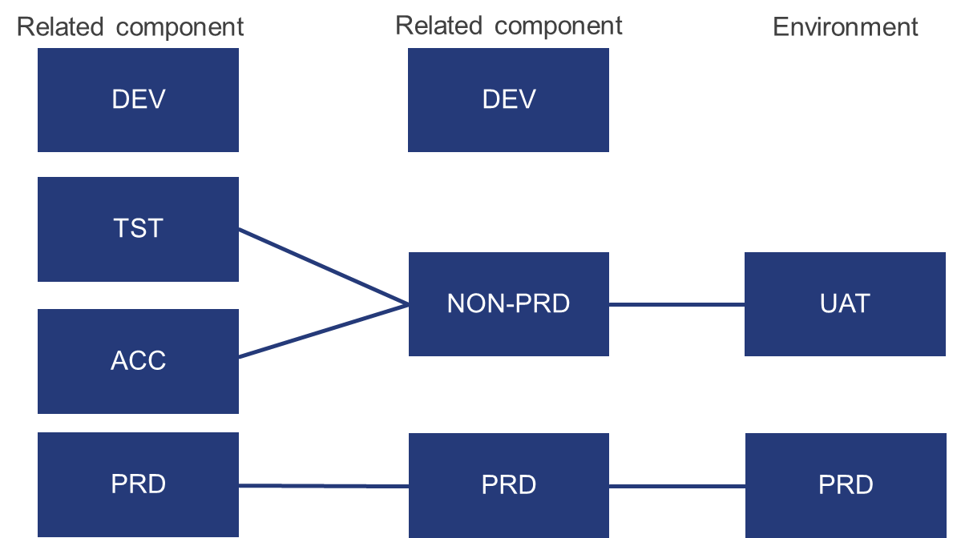

Solution & Cloud Topology
ICA + SA: Where are the components and users of this system located? Describe (using a diagram) how the solution components and its users are geographically spread. Needs to depict the way that traffic is travelling across the WAN (or Internet) and indicate whether any high-latency links are involved, and how these influence design decisions.

Diagram
<Insert Solution Topology Diagram>
Show involved (SaaS) Vendors, Van Oord, and integration points, including user locations, network flows, and any on-prem/cloud connectors

Latency Considerations
Describe any high-latency links, impact on UX

Appendix A – Security Control Mapping
This appendix maps ISO/IEC 27001:2022 Annex A controls to corresponding design decisions or components within the solution architecture. It supports security governance, audit readiness, and compliance alignment.

Control Reference | Control Description | How Addressed? | Implemented (Y/N/Partial) | Reference Section
Example:  A5.9 | Inventory of Information and other Assets | Asset registry and CMDB integration planned; all services tagged and documented. | Partial | Section 7.1

