ReBolt™ Security Adapter
"Pop Goes the Weasel"
Product Specification & Sales Deck
April 2026
CONFIDENTIAL

The Product

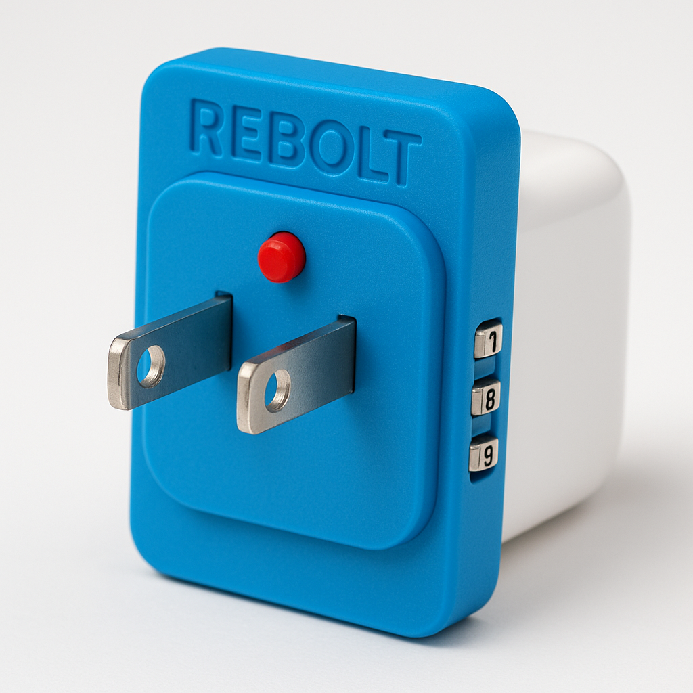
UNLOCKED — Ready to Plug In

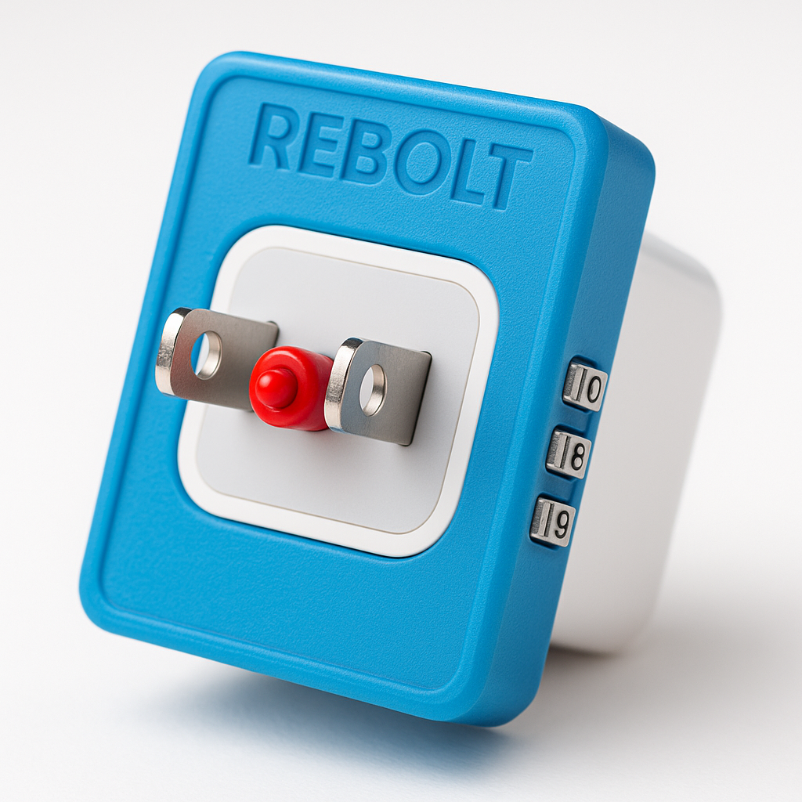
LOCKED — Pin Popped, Cannot Plug In

What Is ReBolt?
A spring-loaded security adapter that attaches to any US charger block, locks the AC prongs with a telescopic pin, and requires a 3-digit combination code to unlock — deterring casual charger theft in homes, dorms, offices, and shared spaces.
When unplugged from a wall outlet, the spring-loaded pin fires out instantly between the prongs — "Pop Goes the Weasel" — automatically locking the charger without any user action.

Key Features
- Default state is LOCKED — pin always blocks prongs unless code is entered
- Spring-loaded auto-lock: unplug from wall → pin pops out → charger is locked
- 3-digit mechanical combination dial — no battery, no app, no electronics
- Blue overhang plate visible from any angle — deterrent + branding ("ReBolted!")
- Prong clamps + medical-grade adhesive = permanent one-time attachment
- Works on ANY standard US 2-prong charger block
- Fully mechanical — no UL certification required

Physical Specifications
Specification | Value
Adapter Thickness | ~10mm
Overhang Past Charger | 3-5mm on all sides
Pin Diameter | 3mm
Pin Extension | 10-12mm (extends past prong tips)
Combo Lock | 3-digit mechanical dial, recessed on edge
Prong Compatibility | Standard NEMA 1-15 (all US chargers)
Attachment | Prong clamps + adhesive = permanent
Materials | Injection-molded ABS body, stainless steel pin + spring
Weight | Under 15 grams
Colors | 4-6 SKU colors at launch

How It Works

For the Owner
1. Pick up charger — pin is blocking prongs (LOCKED)
2. Enter 3-digit combo on the dial (~2 seconds)
3. Pin retracts flush into the ReBolt body
4. Plug charger into wall outlet normally
5. Charge device — ReBolt visible as blue overhang (branding/deterrent)
6. Unplug charger — PIN POPS OUT INSTANTLY — charger is locked again

For a Thief
1. Thief sees charger plugged in with blue ReBolt visible
2. Thief grabs charger and yanks from wall
3. PIN FIRES OUT — startling spring-loaded snap
4. Thief now holds a charger with prongs blocked and locked
5. Thief does not know the code — charger is useless
6. Thief sees "ReBolted! PRIVATE CHARGER" — gives up

Pricing & Margin Analysis

Unit Economics
Metric | Value
Landed Cost (at scale) | $1.50 - $2.50
Retail Price | $12.99 - $14.99
Gross Profit Per Unit | $10.49 - $12.49
Gross Margin | 80% - 85%

Amazon FBA Economics
Item | Amount
Selling Price | $14.99
Amazon Referral Fee (~15%) | -$2.25
FBA Fulfillment Fee | -$3.50
Storage + Misc | -$0.25
Landed Product Cost | -$2.50
NET PROFIT PER UNIT | $6.49

Market Opportunity
400 million+ chargers sold annually in the United States alone. ReBolt is positioned as a mass-market impulse product ($12.99-$14.99) with broad everyday relevance across:
- College dorms (40M+ students)
- Offices and coworking spaces
- Hotels and Airbnbs
- Coffee shops and public charging areas
- Schools and libraries
- Families with teenagers
- Gyms and fitness centers

Startup Investment
Estimated total startup investment: $16,500 - $40,000
Breakeven at ~2,250 units (~4-5 months at 500 units/month)

Marketing Campaign

"Pop Goes the Weasel"
Primary Tagline: "Pop Goes the Weasel"
Secondary Tagline: "Don't Get Jacked"
Brand Verb: "ReBolted!"
The campaign ties together the familiar nursery rhyme, the surprise of a jack-in-the-box toy, and the ReBolt spring-loaded locking mechanism. Playful, memorable, and instantly visual.

Distribution Roadmap
- Phase 1: Tuckerton Lumber Company register placement
- Phase 2: Amazon FBA launch
- Phase 3: College bookstores (September back-to-school)
- Phase 4: Big-box retail (Target, Walmart, Best Buy)
- Phase 5: Licensing to charger brands & accessory manufacturers

Vanilla Ice Partnership
Vanilla Ice's 1991 "Pop Goes the Weasel" sampled the melody. His current home renovation TV persona connects naturally to hardware retail. Proposed: 15-second social Reel — he tries to borrow a charger and gets ReBolted. Budget: $5,000-$15,000 for social posts.

Product Roadmap

V1: ReBolt Standard — $12.99-$14.99
- Mechanical 3-digit combo dial
- Spring-loaded telescopic pin
- No battery, no electronics, no app
- 4-6 colors at launch
- Direct store + Amazon FBA

V2: ReBolt Pro — $24.99-$29.99
- Electronic keypad (999+ combinations)
- Optional fingerprint unlock
- LED feedback (red/green)
- CR2032 battery (1-2 year life)
- Premium materials and finish

V3: ReBolt for Power Tools
- Larger mounting for power tool chargers and corded tools
- Heavy-duty spring and latch for high-value equipment
- Licensing to tool manufacturers (DeWalt, Milwaukee, Makita)
Confidential — Joe Lynch — April 2026

