Task 1 – Prepare, Design, and Plan

Scenario
The client has requested that a website be created for their home gym equipment business. It is a small local business that seeks to establish itself as a leading provider of home gym equipment and installation services in Co. Clare, with plans to expand across Munster and beyond. The client (James Doe) is an experienced fitness instructor who has identified a need for a dedicated home gym equipment purveyor in Co. Clare. He is seeking a polished, professional website for his business that will appeal to a wide range of customers with varying budgets. The website users will mainly consist of young, health-conscious individuals who are looking to convert a space in their home/apartment/studio into a highly versatile workout area. The client also wants to target individuals who are uncomfortable with commercial gym environments and who are seeking to attain their fitness goals in a private space.

Aim of Content
The client is seeking a professional, highly interactive, and user-friendly website that will attract users to make home gym equipment purchases both in store and online. They seek to foster goodwill with their users by highlighting the founder’s background, as well as the company’s values, such as its commitment to sustainability, product quality, community involvement, and transparent pricing. The user should be able to easily navigate and interact with the website. The key client/user requirements for the user are outlined below:
- The website should consist of five main pages: Home, Background, Shop, Instructional Videos, and Contact Us pages. There should also be a Checkout page for purchases.
- The website needs to be responsive for use across desktops, laptops, tablets, and mobile devices.
- The website needs to be compatible across all the primary browsers, including Chrome, Firefox, Brave, and Edge.
- Each webpage should contain a header section with the company’s logo and a navigation bar that condenses into a “hamburger” menu when viewed on a smaller screen.
- Each webpage should contain a footer section that contains a “Back to Top” link for ease of navigation to the top of the page.
- The Home page should feature a hero image, with a “Shop Now” button that links to the Shop page. It should provide a short segment on the story behind the company, a section for why the user should choose this company, and an area for current promotions/events (such as holiday promotions and extended business hours). It should also contain sections for customer testimonials and store locations.
- The Background page should foster goodwill by highlighting the founder’s background and commitment to quality home gym equipment, as well as the company’s mission statement and core values. The client wants a historical timeline that lists the key milestones that the company has attained over the years. There should also be sections detailing the company’s commitment to sustainability and community involvement. The founder would like photos of himself and his core team to be displayed, including a profile photo of the founder and a slideshow of the core team members.
- The Shop page should list products in rows that become columns as the screen shrinks. There should be three categories of equipment: Calisthenics, Cardio, and Weight Training. A functional shopping cart is required, with the ability to add and remove items.
- A Checkout page should be included that is accessible only when the user proceeds with their purchases and be linked directly back to the shop.
- The Instructional Videos page should list several videos that demonstrate how to assemble and maintain various pieces of home gym equipment.
- The Contact Us page should present a list of FAQs that should answer a large proportion of customer queries. A form should also be presented to the user that takes the user’s name and email address. It should provide a text box that allows the user to submit a query, returning messages if any required field is left blank. Upon sending the query, the web page should present a message stating that the query has been successfully received.

Web Site overview
The wireframes for each page are presented in this section, with the contents detailed in bullet points under each wireframe.

Home page
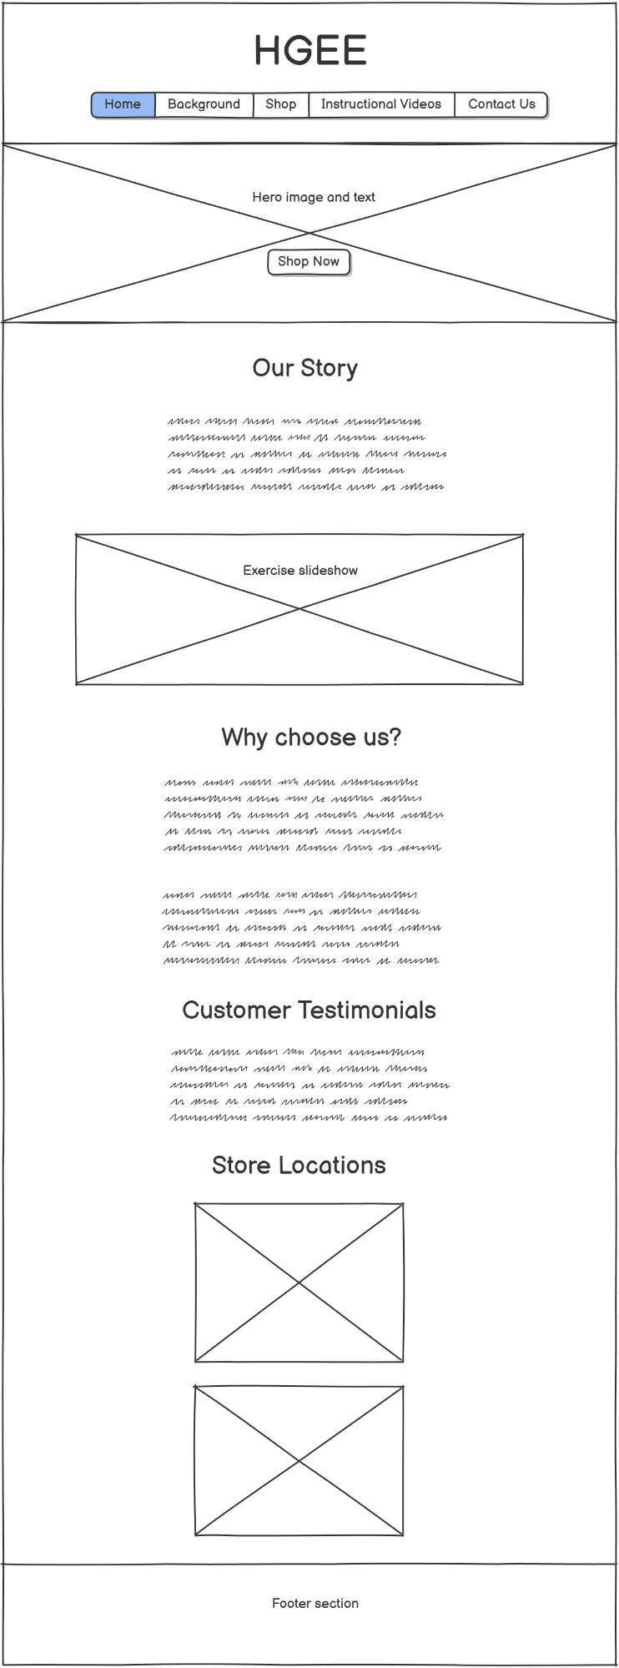
- Header section, containing company logo and navigation bar.
- Hero image, with text and Shop Now button.
- “Our Story” section, with slideshow showing people exercising.
- “Why Choose Us?” section, outlining advantages of ordering from this company.
- “Customer Testimonials” section, with short testimonials from customers.
- “Store locations”, with iframes of the two (fictitious) locations for the stores in Ennis and Kilrush.
- Footer section (containing Back to Top button and copyright message).

Background page
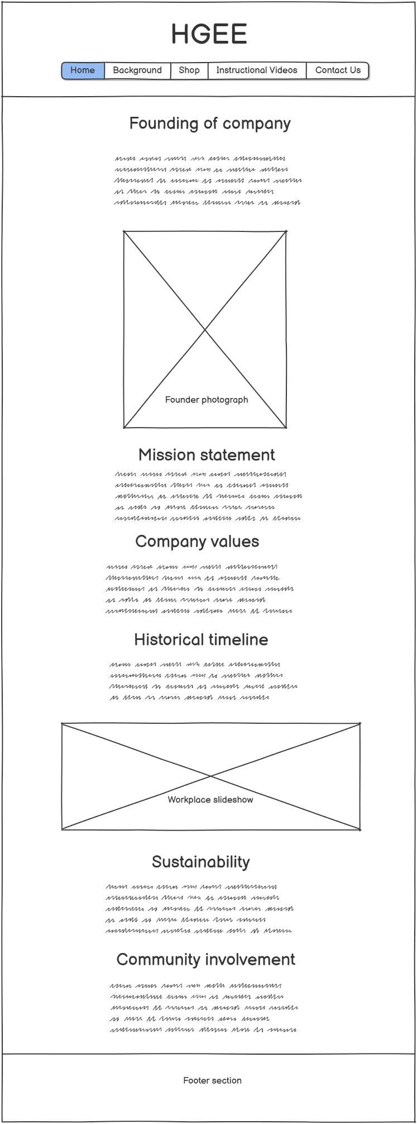
- Header section, containing company logo and navigation bar.
- “Founding of Our Company” section, with short description and image of the founder, James Doe.
- “Mission Statement”, “Company Values”, and “Historical Timeline” sections, with relevant details given for each.
- Automatic slideshow, showing photographs of the core team at work.
- Sections on “Sustainability” and “Community Involvement” to conclude the page.
- Footer section (containing Back to Top button and copyright message).

Shop page
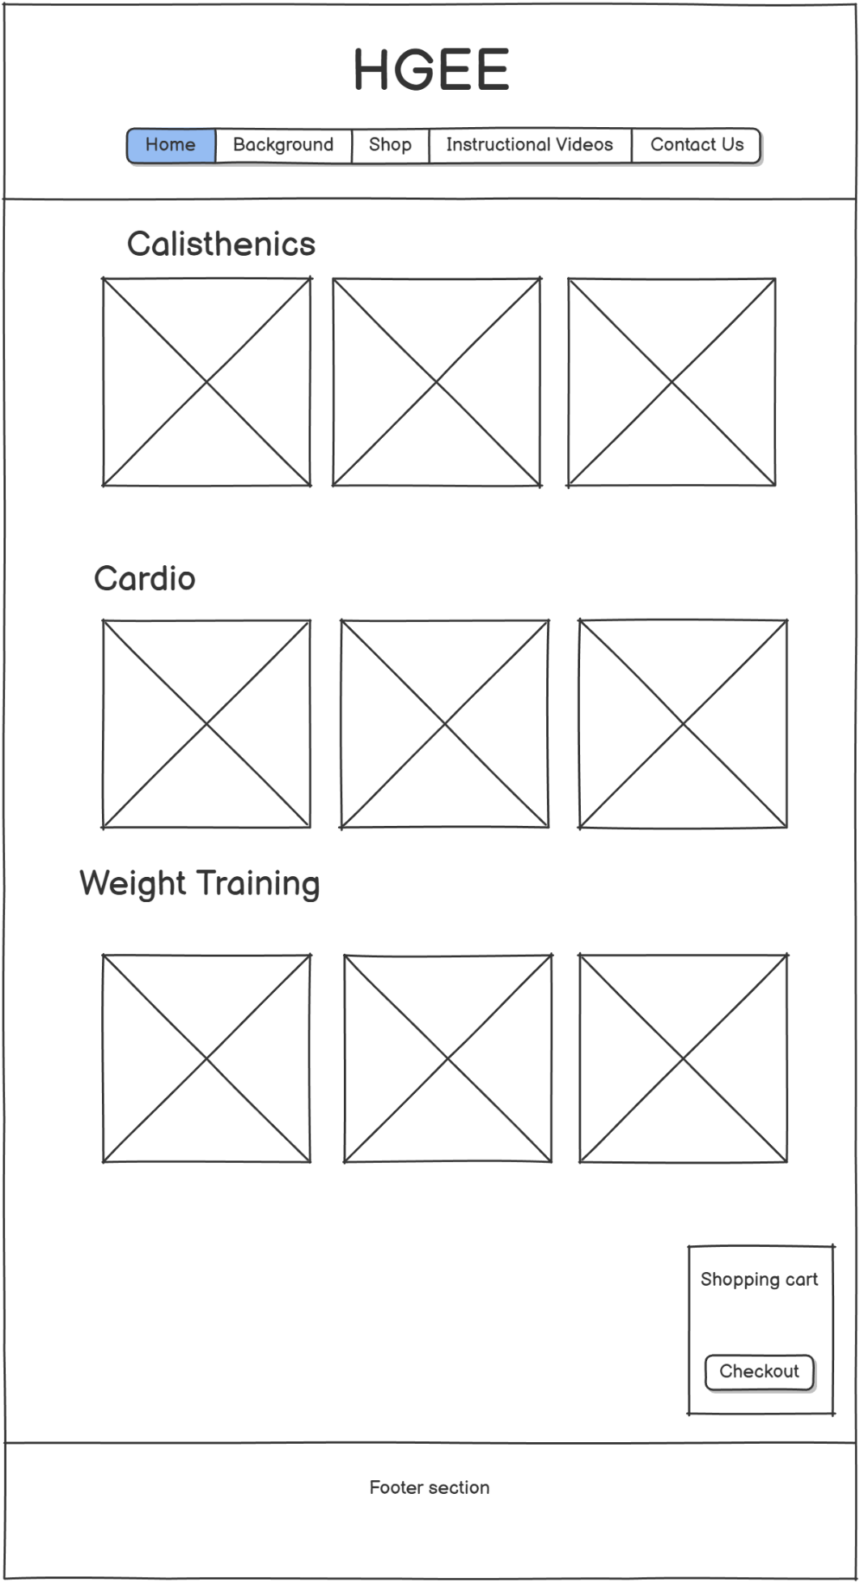
- Header section, containing company logo and navigation bar.
- Three different sections for the categories of products on sale (Calisthenics, Cardio, and Weight Training), with products shown as cards under each category heading.
- Shopping cart that remains fixed to the screen as the user scrolls and links to the Checkout Page.
- Footer section (containing Back to Top button and copyright message).

Checkout page
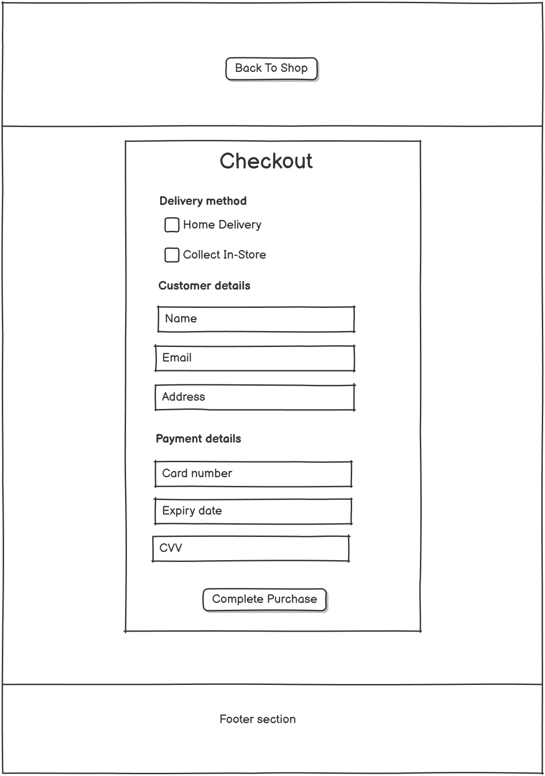
- Header section, with “Back to Shop” button.
- Checkout form that takes user input, including choice of delivery method, customer details, and payment details, with a submission button at the bottom.
- Footer section (containing Back to Top button and copyright message).

Instructional Videos page
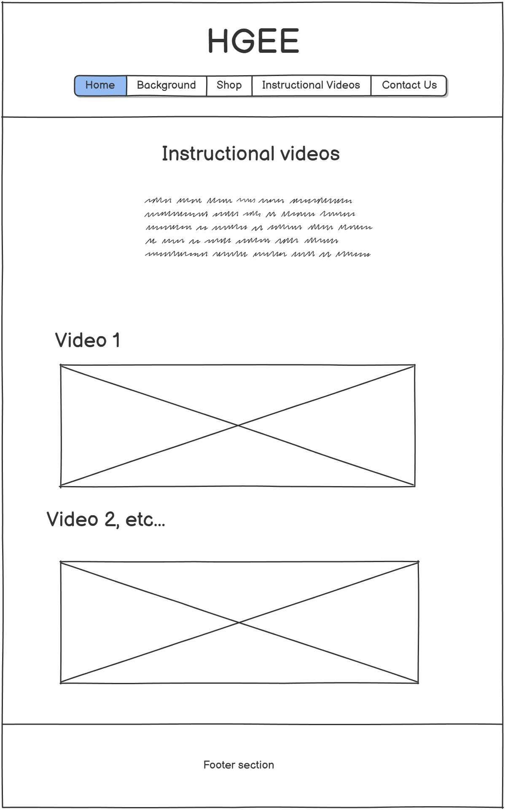
- Header section, containing company logo and navigation bar.
- “Instructional videos” section, with a list of videos that link to the appropriate position in the page where the video is located.
- Sections for each of the videos with their corresponding titles.
- Footer section (containing Back to Top button and copyright message).

Contact Us page
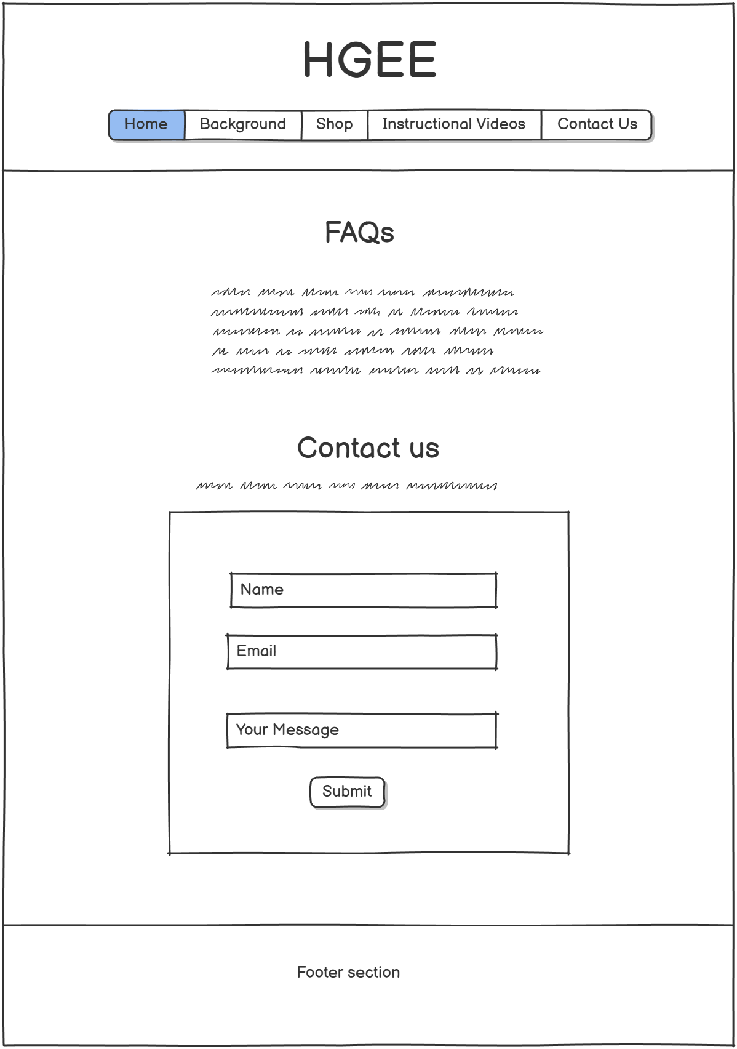
- Header section, containing company logo and navigation bar.
- “FAQ” section, with list of collapsable FAQs.
- “Contact Us” section that invites the user to fill out a form with their name, email, and message.

Navigation
The user should be able to jump to any page of their choosing from any other page that they are currently on (except for the Checkout page, which will link directly to the Shop page). This will mainly be achieved by presenting a functional navigation bar on each page that links to the other pages, and a clickable company logo that always redirects the user to the Home page. There will also be links included within the content of various pages to direct users to other pages (e.g., a button with a link to the Shop page within the hero image). These clickable links enhance the overall responsiveness of the website, allowing users to rapidly change pages. A navigation diagram is provided below, showing the connections between all pages:

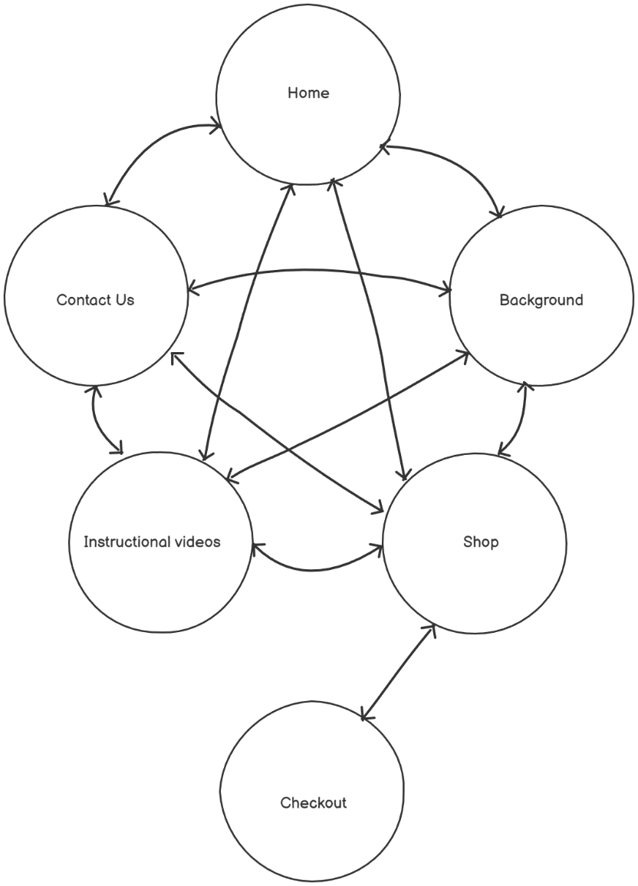

User Interactions
Users will be able to interact with the website in a number of ways, as listed below:
- Clickable links in the navigation bar allow for easy navigation between pages.
- “Back to Top” link that redirects the user to the top of a given page.
- Functional shopping cart that allows users to add and remove items from their cart.
- Embedded videos to allow users to view product assembly/maintenance videos without having to leave the website.
- Contact Us form that allows users to make enquiries, and collapsable FAQ section.
- Checkout page that the user can fill in to submit their order.

Interactive Features
The interactive features of this website are listed below:
- The options in the navigation bar will change colour when the cursor hovers over them.
- The company logo will slightly expand when the cursor hovers over it.
- The current page will be highlighted in a different colour in the navigation bar.
- The item cards in the Shop page will slightly expand when the cursor hovers over them.
- The “Add to Cart” buttons will change colour when the cursor hovers over them.
- The item name, quantity, and cost will be displayed upon adding it to the cart. The total cost of all items will also be presented.
- The cart will be scrollable when the list reaches a threshold number of items.
- The number and price of items in a cart will be displayed as the user adds items to the cart.

Animation
The website will feature various animations that will aim to provide a more professional feel to the website. The following animations will be included:
- The options in the navigation bar will change colour when the cursor hovers over them by setting the :hover pseud-class background property to a different colour.
- The company logo will slightly expand upon hovering the mouse over it by setting the :hover pseudo-class transform property to scale(1.08).
- The product cards will slightly expand and cast a shadow when the mouse hovers over them by setting the :hover pseudo-class transform property to scale(1.05) and box-shadow property to 0 6px 15px rgba(0,0,0,0.25).
- The “Add to Cart” buttons will change colour when the mouse hovers over them per the :hover pseud-class background property.
- The “Proceed to Checkout” button will pulse only when items are present in the cart. This will be achieved using a pulse animation and @keyframes.
- In the Background page, the founder’s name will be displayed, and their photo will become slightly transparent when the mouse cursor hovers over it per the :hover pseud-class opacity property.
- Slideshows will automatically cycle through photos on the Home and Background pages using a carousel() function outlined in the JavaScript file.
- A video will autoplay on the Instructional Videos page by specifying controls autoplay muted within the <video> tag.

HTML 5 Feature(s)
The website will make use of various HTML5 features, as listed below:
- Semantic tags, such as the <header> and <footer> tags, will be used on every page. There will also be other semantic tags in use, such as the <aside> tag for identifying sections of text that will stand out from the main theme of a page (e.g., placing promotional text sections within the home page). Additionally, <nav> tags will be used to define the navigation bar section within the <header> tags on each page.
- A video tag will be used to display a video that autoruns on the Instructional Videos page.
- <figure> and <figcaption> tags will be used on the Background and Home pages. In future updates to the website, these tags can be used to format the figures/captions in specific ways.

Search Engine Optimization (SEO) Approaches
The website will make use of the following SEO techniques:
- Semantic tags help search engines understand the meaning and hierarchy of the content. For example, <header> and <nav> tags are used for site branding and navigation, <main> for primary content, <section> and <article> for grouped thematic content, and <footer> for copyright and secondary links. Aside from helping search engines better understand page structure, these tags also improve the accessibility of the website.
- <meta name=”description”> tags with important keywords in the content on the home and shop pages help boost their SEO rankings and draw traffic to the most important pages of the website.
- <title> tags improve click-through rates by clearly describing the page.
- Logical heading tags (e.g., only one main <h1> per page, with <h2>, <h3>, etc. for subheadings) helps search engines better understand content importance.
- Keyword-relevant content (e.g., “Home Gym Equipment”, “Calisthenics”, “Weight Training”, “Cardio”, etc.) aligns with user search intent, helping the website to rank higher in search results.
- Standard <a href=””> links are consistent across all pages, allowing search engine bots to easily crawl through the site.
- alt=”” attributes enhance SEO by making images more discoverable through image search. It also improves accessibility, which Google values, leading to higher rankings.
- Mobile-friendly and responsive design, such as the use of meta viewport tags and @media (min-width: 768px) improves user experience, helping the website to rank better on mobile searches.
- Use of .avif images for faster loading times and better performance on mobile networks.
- Clean, descriptive URLs (e.g., shop.html) can help users understand the page content from the URL.

Conclusion
In conclusion, this design document provides the blueprints for how the website will look and function. By following the instructions and wireframes set out in this document, the web developer will be able to create a professional, highly interactive, and responsive website for the client.

