Task 1 – Prepare, Design, and Plan

Scenario
The client has requested that a website be created for their home gym equipment business. It is a small local business that seeks to establish itself as a leading provider of home gym equipment and installation services in Co. Clare, with plans to expand across Munster and beyond. The client (James) is an experienced fitness instructor who has identified a need for a dedicated home gym equipment purveyor in Co. Clare. He is seeking a polished, professional website for his business that will appeal to a wide range of customers with varying budgets. The website users will mainly consist of young, health-conscious individuals who are looking to convert a space in their home/apartment/studio into a highly versatile workout area. The client also wants to target individuals who are uncomfortable with commercial gym environments and who are seeking to attain their fitness goals in a private space.

Aim of Content
The client is seeking a professional, highly interactive, and user-friendly website that will attract users to make home gym equipment purchases both in store and online. They seek to foster goodwill with their users by highlighting the founder’s background, as well as the company’s values, such as its commitment to sustainability, product quality, community involvement, and transparent pricing. The user should be able to easily navigate and interact with the website. The key client/user requirements for the user are outlined below:
- The website should consist of five pages: Home, Background, Shop, Instructional Videos, and Contact Us pages.
- The website needs to be responsive for use across desktops, laptops, tablets, and mobile devices.
- The website needs to be compatible across all the primary browsers, including Chrome, Firefox, Brave, and Edge.
- Each webpage should contain a header section with the company’s name and a navigation bar that condenses into a “hamburger” menu when viewed on a smaller screen.
- Each webpage should contain a footer section that contains a “Back to Top” link for ease of navigation to the top of the page.
- The Home page should feature a hero image, with a “Shop Now” button that links to the Shop page. It should provide a short segment on the story behind the company, a section for why the user should choose this company, and an area for current promotions (including holiday promotions, extended business hours, and featured products). It should also contain sections for customer testimonials, quality assurance, and calls-to-action with links to the shop and instructional videos.
- The Background page should foster goodwill by highlighting the founder’s commitment to quality home gym equipment, as well as the company’s mission statement and core values. The client wants a historical timeline that lists the key milestones that the company has attained over the years. There should also be sections detailing the company’s commitment to sustainability, quality, customer impact, community involvement, and future vision. There should be an image carousel displaying photos of people working out at home, gym equipment, etc.
- The Shop page should list products in rows that become columns as the screen shrinks. There should be three categories of equipment: Calisthenics, Cardio, and Weight Training. A functional shopping cart is required, with the ability to add and remove items.
- The Instructional Videos page should list several YouTube videos that demonstrate how to assemble and maintain various pieces of home gym equipment.
- The Contact Us page should present a form to the user that takes the user’s first and second names, email, and phone number. It should provide a text box that allows the user to submit a query, returning messages if any required field is left blank or an input is invalid. Upon sending the query, the web page should present a message stating that the query has been successfully received.

Web Site overview
List and bullet point description of each page
Wire Frame diagrams of each page. Include a bullet point description of contents of each page
Navigation
The user should be able to jump to any page of their choosing from any other page that they are currently on. This will mainly be achieved by presenting a functional navigation bar on each page that links to the other pages. There will also be links included within the content of various pages to direct users to other pages (e.g., a button with a link to the Shop page within the hero image). These clickable links enhance the overall responsiveness of the website, allowing users to rapidly change pages. A navigation diagram is provided below, showing the connections between all pages.
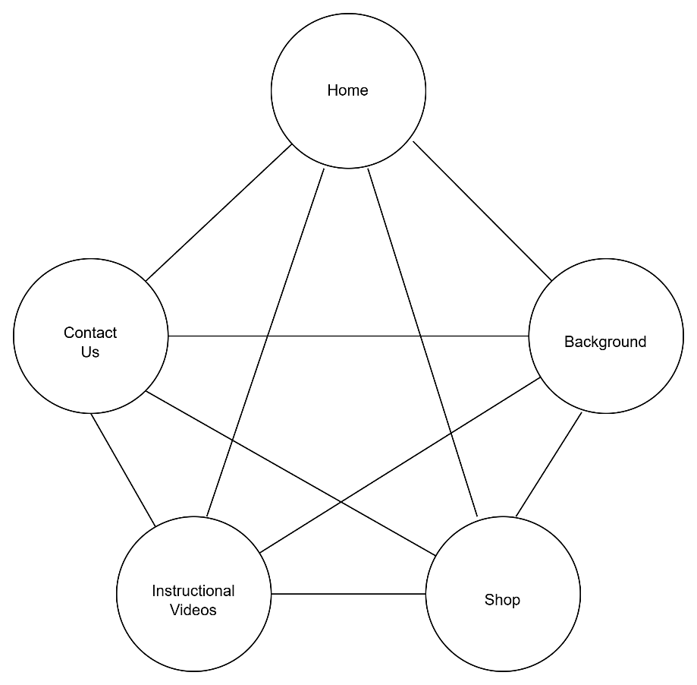
User Interactions
What actions can the user take.
Ability to select items, make donation, shopping cart, easy navigation, accessibility, Feedback, Email query
Users will be able to interact with the website in a number of ways, as listed below:
- Clickable links in the navigation bar allow for easy navigation between pages.
- Functional shopping cart that allows users to add and remove items from their cart.
- Embedded videos to allow users to view product assembly/maintenance videos without having to leave the website.
- Contact Us form that allows users to make enquiries.

Interactive Features
List, describe and justify some interactive features of your site.
Possibilities include - Highlighting active menu, Dropdown list to avoid spelling mistakes, Number inputs for quantities and prices etc.
The interactive features of this website are listed below:
- The options in the navigation bar will change colour when the cursor hovers over them.
- The current page will be highlighted in a different colour.
- The “Add to Cart” buttons will change colour when the cursor hovers over them.
- The number and price of items in a cart will be displayed as the user adds items to the cart.
Animation
Describe and justify the animation features(s) of your site.
The website will feature various animations that will aim to provide a more professional feel to the website. The following animations will be included:
- The company logo will fade in on each page when it is accessed.
- The product cards will zoom in when the mouse hovers over them.

HTML 5 Feature(s)
List, describe and justify some HTML features of your site.
The website will make use of various HTML5 features, as listed below:
- Semantic tags, such as the <header> and <footer> tags, will be used on every page. There will also be other semantic tags in use, such as the <aside> tag for identifying sections of text that will stand out from the main theme of a page (e.g., placing promotional text sections within the home page). Additionally, <nav> tags will be used to define the navigation bar section within the <header> tags on each page.
- A video tag will be used to display a video that autoruns on the Instructional Videos page.

Search Engine Optimization (SEO) Approaches
List and describe 3 SEO techniques.

Conclusion
1-2 sentences explaining what the design document achieves
In conclusion, this design document provides the blueprints for how the website will look and function. By following the instructions and wireframes set out in this document, the web developer will be able to create a professional, highly interactive, and responsive website for the client.

