# **Problem Statement**

In order to avoid delivery delays, a balance must be maintained when estimating the delivery date. If a customer places an order and receives an estimated delivery date, it must be fulfilled on or before the estimated delivery date that was provided without losing the sale.

# **Goal**

To create a model capable of estimating the delivery date which is accurate and competitive so that the customer experience is enhanced.

# **Dataset**

* 8932 instances
* 11 features

# **Data Preprocessing**

* Used Robust scaler to remove outliers
* Created new features such as distance, shipping days, etc. using given features.
* Used k-means to convert longitude/latitude to clusters

# **Modeling Approaches**

1. Ridge regression
2. Random Forest
3. Neural Network

# **Evaluation**

Random forest with robust scaler outperformed the other models.

# **Deployment**

# Flask

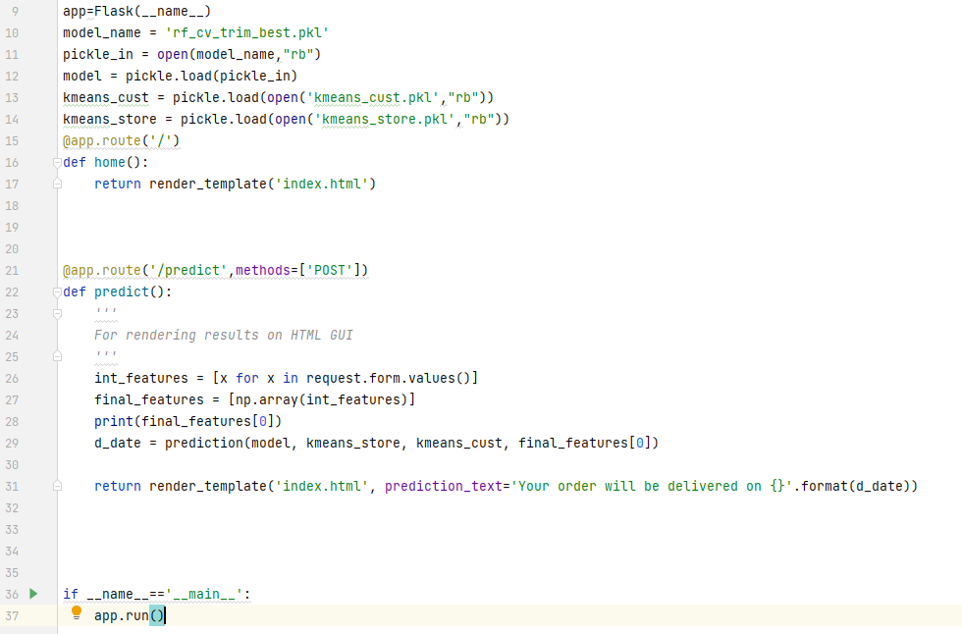

After parsing entries from the UI, we perform a prediction for the delivery date and display it on the same UI.

## Heroku

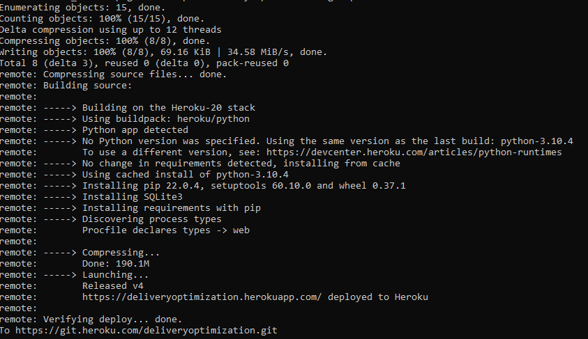

We used Heroku to deploy our project. We just had to push our repo to Heroku, and it is automatically deployed to the following link:

<https://deliveryoptimization.herokuapp.com>