# **Introduction:**

Apple trees are plagued with various diseases, which increases cost of production and environmental impact due to incorrect use of chemicals and various other pesticides. This results in wastage of resources (time and money) and leads to a significant environmental impact.

# **Problem Statement:**

Given a photo of an apple leaf, we need to assess its health by distinguishing between:

* leaves which are healthy
* those which are infected with apple rust
* those that have apple scab
* those with more than one disease.

# **Goal:**

To detect diseases in apple trees to reduce the use of chemicals and pesticides, which in turn reduces costs and benefits all parties in the entire supply chain

# **Dataset**

* 3642 total images
* 1821 train images (labelled): 515 healthy, 90 multiple diseases, 621 rust, 591 scab

# **Modeling Approaches**

1. Custom CNN
2. Custom deep CNN with data augmentation
3. Transfer learning (inception)

# **Results**

Custom deep CNN with data augmentation outperformed other models

# **Deployment**

# Flask

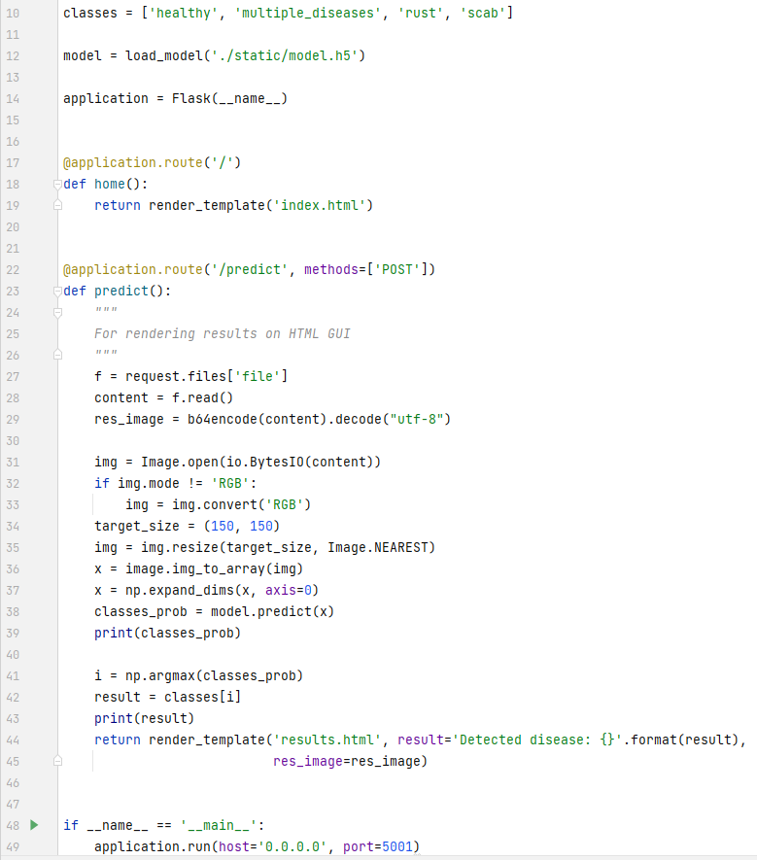

# Docker

* + Created a virtual environment
  + Added app.py, requiremts.txt, model, html and CSS files
  + Created a dockerfile and .dockerignore file
  + Build an image file and loaded it in container

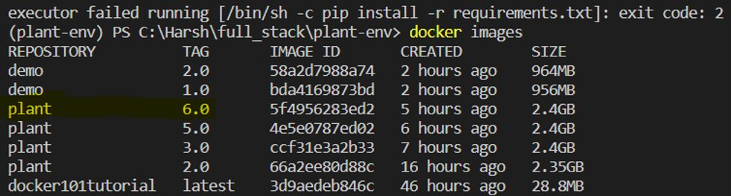

* + Pushed the container to Dockerhub

# Google Cloud

* Pulled the container to google cloud from Dockerhub
* Deployed the container on the cloud using Google cloud SDK
* Link: <https://plant-ai-348305.nn.r.appspot.com/>