EXECUTIVE REPORTING SUITE

Executive Reporting Suite
  - Overview
Generated May 2026

Contents
- At a glance
- What users can do
- Capability summary
- Users and permissions
- Multi-company architecture
- Platform strengths
- Where we’re investing next

At a glance
The Executive Reporting Suite is a self-service reporting platform that turns raw business data into reports, dashboards, and scheduled email deliveries — with minimal engineering involvement.
Users log in with their corporate Microsoft account and:
- Build reports against live data without writing SQL.
- Visualize results as interactive grids, charts, and summary dashboards.
- Share saved reports with teammates or entire groups.
- Schedule automated email delivery on any cadence.
- Export to Excel or CSV in one click.
Administrators configure the data sources, control who sees what, and curate the list of fields users can pick from. The same platform serves multiple companies from a single deployment — each tenant has its own databases, its own user directory, and its own report library, all isolated by design.
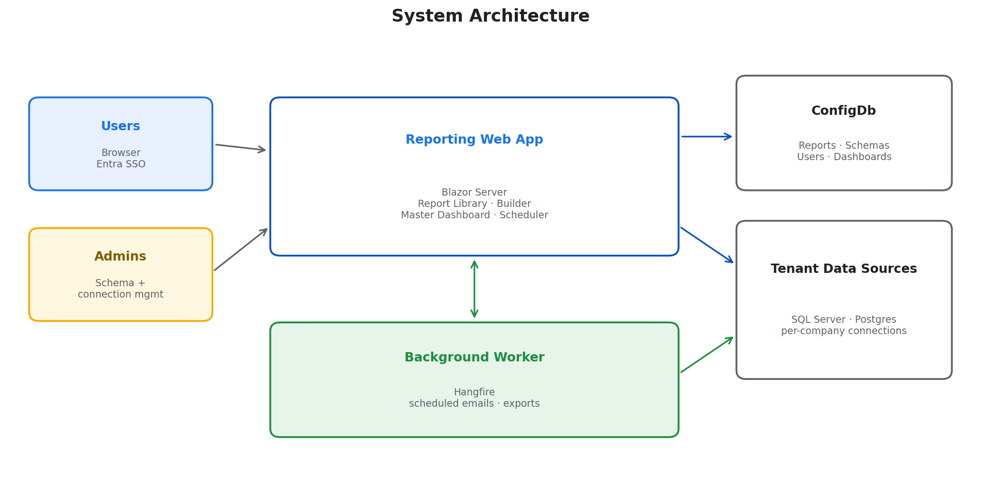

What users can do
Every user starts in the Report Library — a searchable list of reports they own or have had shared with them. From there, any report can be opened, edited, run, scheduled, or exported.
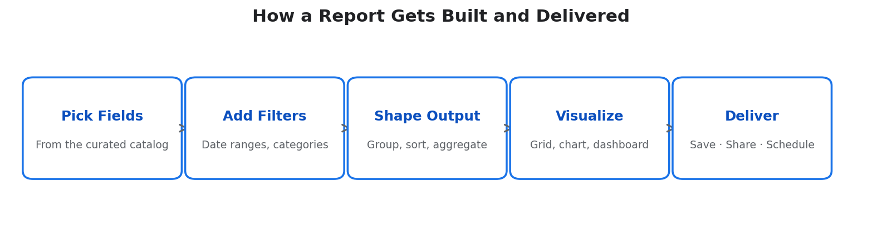
The Report Builder lets users pick from a curated catalog of business fields, apply filters (date ranges, categorical selections, free-form text), group and sort, and view the output as a grid, chart, or summary dashboard. No SQL knowledge required — the platform generates the underlying query safely and efficiently.
Delivery options beyond viewing in the browser:
- Master Dashboard — a shared per-company landing page where administrators pin the reports the team watches most frequently. Tiles show live aggregates and small summary tables, are organized into tabs and named sections (e.g. one tab per loan program), and any tile can be clicked to drill from the summary into the underlying row-level detail view — without losing the dashboard’s filter context.
- Scheduled email — any report can be sent on a recurring cadence to one or more recipients, with the data embedded in the email and attached as Excel or CSV.
- Share — grant another user (or an Entra security group) view or edit access, without copying the report.
Built-in clarity for the people who configure reports. When the catalog has multiple fields with similar names (e.g. a “Loan Type” on both the lead and opportunity tables), every filter, sort, and group-by control surfaces the underlying source on hover, so administrators can confirm exactly which column the report is targeting. A “Show SQL” panel exposes the generated query for any view — table, dashboard, or detail — which dramatically shortens the cycle when an admin is checking that a report is asking the right question of the database.

Recent enhancements
Library sections are now editable in place. Each section header has a kebab menu with Rename and Remove. Removing a section moves any reports inside it back to (Uncategorized) automatically — nothing is orphaned or deleted.
Exporting an empty tile now prompts for confirmation. When a Master Dashboard tile currently has zero records, the Export menu asks whether to download a headers-only file (useful as a template scaffold) before producing it.
Dropdowns scroll to the current selection. Opening any dropdown with an item already selected (Connection, Company, Sort By, etc.) lands the list scrolled to that item — no hunting through hundreds of options for the value you already chose.
Schema Builder table aliases are now enforced lowercase and connection-unique. The Alias field lowercases your typing in real time, the dialog flags duplicates inline, and an empty alias keeps Save disabled — protecting against the silent join-config drift that case-sensitive or duplicate aliases used to cause.
Loading transitions are quieter. The Master Dashboard, Report Viewer, and Detail View now render a layout-shaped skeleton during load instead of a blank screen, so the page shape is visible from the first frame and does not jump when data arrives.

Capability summary
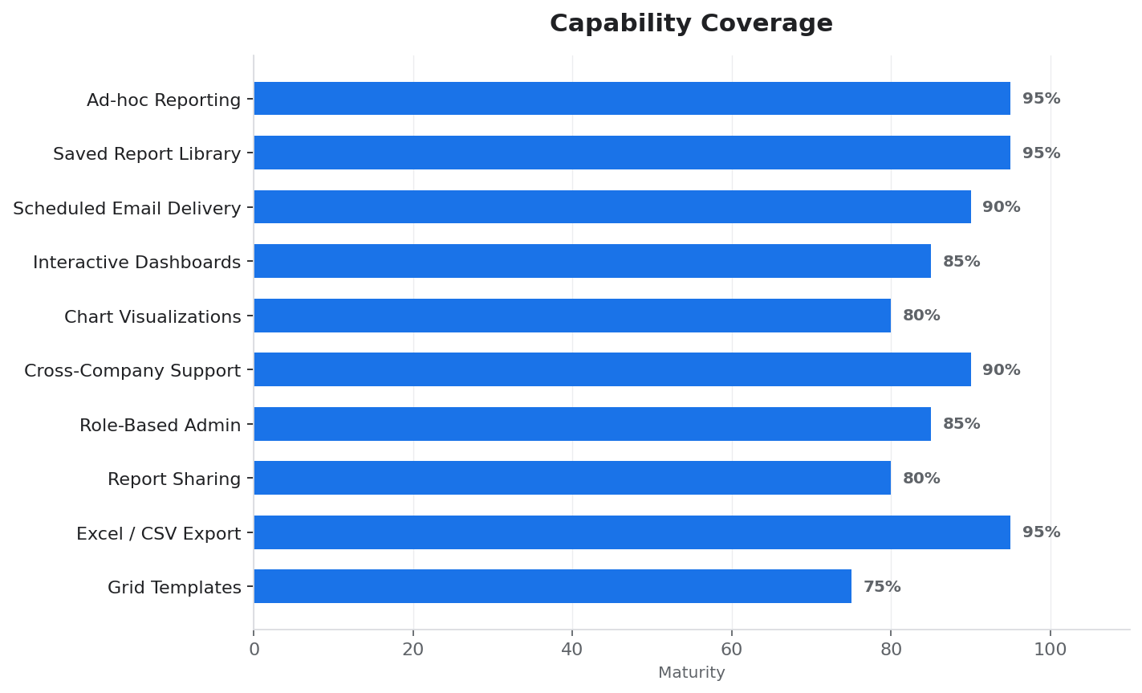
The platform is mature in its core capabilities (ad-hoc reporting, exports, library management) and continues to invest in features that reduce admin friction — things like grid templates (reusable report skeletons) and starter reports (curated primary tables for non-technical users).

Users and permissions
Access is governed by three tiers, each inheriting the capabilities of the tier below.
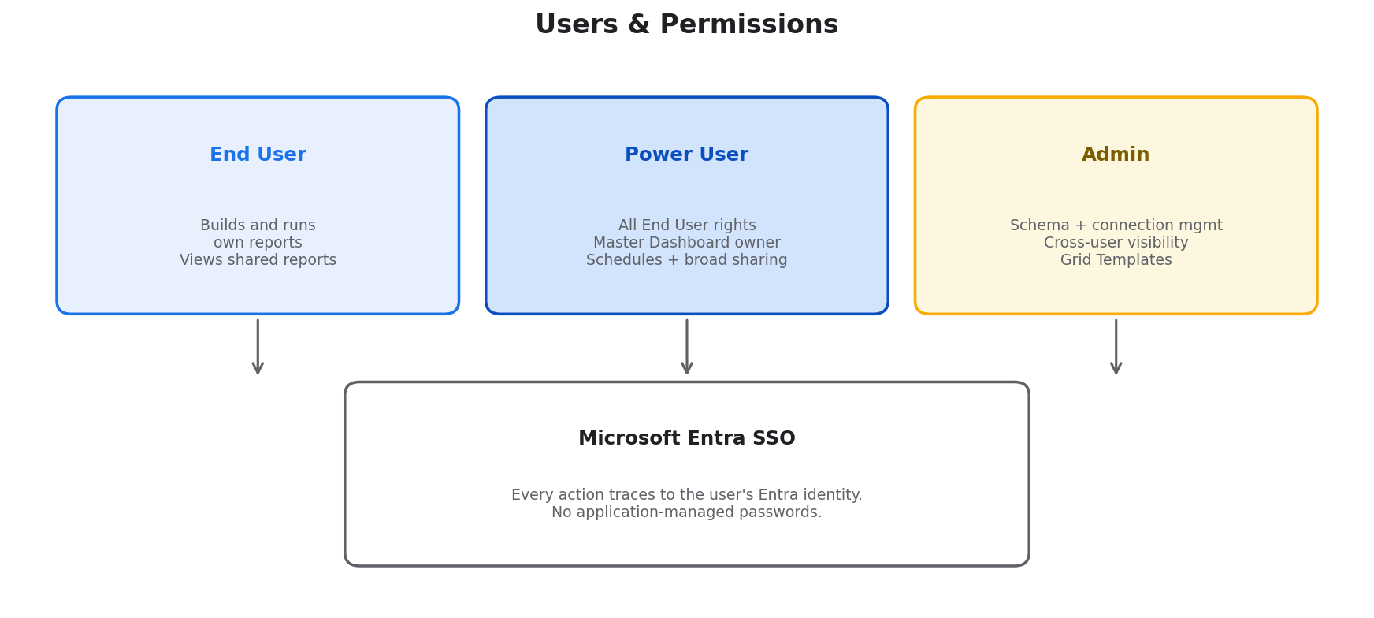
- End users build their own reports, see reports shared with them, and export/schedule their own work.
- Power users get a personal Master Dashboard, can pin reports across companies they have access to, and can schedule or share broadly.
- Administrators configure data-source connections, curate the field catalog for each tenant, and have visibility into every report in the system for auditing and support.
Authentication is fully delegated to Microsoft Entra (Azure AD). There are no passwords to manage inside the application. Every action — from saving a report to sending an email — traces back to the user’s corporate identity, making audit and access reviews straightforward.

Multi-company architecture
A single deployment of the platform can serve multiple tenant companies, each with their own databases and their own field catalogs. Users see only the companies they’re assigned to; data never crosses company boundaries inside a query.
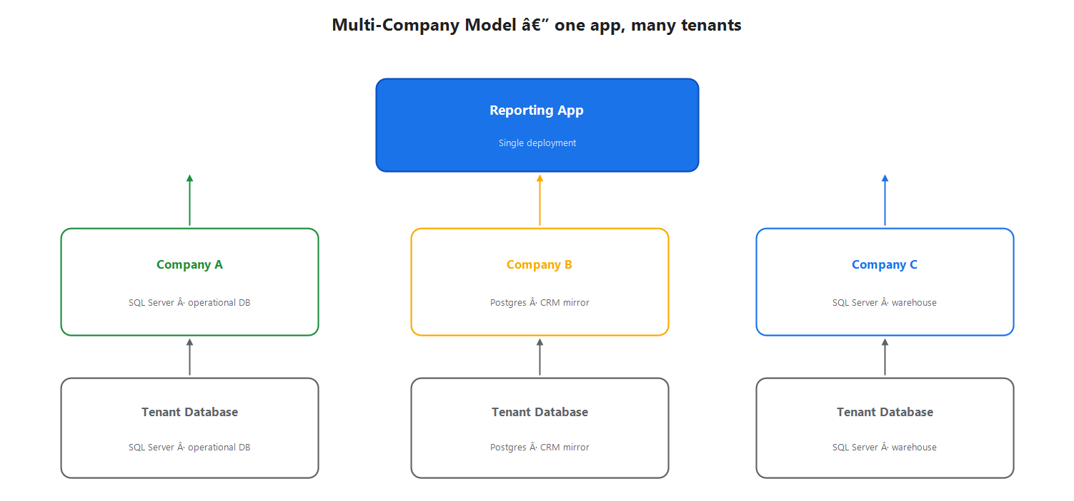
Practical implications:
- Onboard a new tenant without a new deployment. An administrator adds a company, wires in its database connection, defines the field catalog, and the platform is live for that tenant.
- Mix database engines freely. Some companies run on SQL Server, others on Postgres; the same reporting features work against either.
- Per-company branding and preferences. Each tenant can have its own dashboard title, logo, time zone, and default page sizes — controlled by that tenant’s administrator.

Platform strengths
- Self-service, by design. Business users don’t need to file a ticket to get a new report. The admin-curated field catalog acts as guardrails, while the builder feels like a spreadsheet pivot table.
- Safe by construction. Every query the platform emits is parameterized and validated against the curated schema; users cannot inject raw SQL. Row-level data access is governed by the tenant’s own database permissions, and per-user role scoping (self / team / all) is enforced server-side — a user who only has access to their own pipeline cannot accidentally see anyone else’s by editing a saved report.
- Stable, deterministic results. Pagination, sorting, and row-level drill-down are all anchored on the underlying primary keys behind the scenes, so a report that returns 50,000 rows always returns those same rows in the same order between runs — no shuffled pages, no duplicate or missing rows when an admin scrolls.
- Responsive at scale. Frequently-read configuration is cached in-memory across sessions, and dashboard tiles load lazily per section. A returning user’s tab switches feel instant; a fresh session warms back up automatically. Editor pages bypass the cache so administrators always see the live state of what they’re editing.
- Audit-ready. Every schema change is versioned. Every report has an owner, a created-by, and a full edit history. Every scheduled email logs its recipients and send status.
- Low operational overhead. The platform runs as a single web app plus a background worker; no client install, no report server farm. Adding a tenant is a configuration change, not a code change.
- Extensible without code. New fields, joins, lookups, custom filters, and even entire data sources are added through the administrator UI — no redeployment required.

Where we’re investing next
Reducing admin ceremony. The platform originally required hand-editing a JSON schema file for every new field. Today an administrator can point-and-click to add fields, preview queries, and save straight from the browser. Continued work focuses on making this experience usable by non-engineers — named “primary tables” with business labels, starter report templates, and contextual help throughout.
Better cross-team collaboration. Sharing today is per-report. Next up: report folders, subscription lists that any manager can manage, and a lightweight approval flow for reports that are promoted to the company-wide dashboard.
Deeper dashboarding. The Master Dashboard now organizes tiles into named sections per tab, drills from a summary tile into row-level detail with the dashboard’s filters preserved, and reuses cached results when an admin returns to a recently-viewed tab. Next on the roadmap: live-refresh for pinned tiles, a per-user “personal layout” mode that doesn’t require admin privileges, and a richer chart library (today the dashboard tile renders bar / column / pie / line; we’re adding stacked, percent-of-total, and small-multiples views).
Performance investments. Slow queries against the source database are now visible in the platform’s own perf logs, attributed per tile and per section, so the team can target indexing work where it matters. The next step is bringing those signals into an admin-facing “slow tile” report so non-engineers can see which dashboard tiles are costing time without reading server logs.

Prepared for executive review — April 2026. Questions or deeper walkthroughs available on request from Engineering.

