Student Name: Ruturajsinh Solanki | Section: 004
Student ID: 0827884 | Date: 2026-11-07
1. Steps of building a decision tree, based on the data provided by the CEO.
City Size | Average Income | Local Investor | LOHAS Awareness | Decision
Big | High | Yes | High | Yes
Med | Med | No | Med | No
Small | Low | Yes | Low | No
Big | High | No | High | Yes
Small | Med | Yes | High | No
Med | High | Yes | Med | Yes
Med | Med | Yes | Med | No
Big | Med | No | Med | No
Med | High | Yes | Low | No
Small | High | No | High | Yes
Small | Med | No | High | No
Med | High | No | Med | No
- First to select the root node: Average Income (as its error rate is lowest)
- Error table for City Size:

Attribute | Rules | Error | Total Error
City Size | Big Yes | 1/3 | 5/12
 | Med No | 1/5
 | Small Yes | 3/4

- Error table for Average Income:

Attribute | Rules | Error | Total Error
Average Income | High Yes | 2/6 | 3/12
 | Med No | 0/5
 | Low Yes | 1/1

3) Error table for Local Investors:

Attribute | Rules | Error | Total Error
Local Investors | Yes Yes | 4/6 | 6/12
 | No No | 2/6

- Error table for LOHAS Awareness:

Attribute | Rules | Error | Total Error
LOHAS Awareness | High Yes | 2/5 | 5/10
 | Med No | 1/5
 | Low Yes | 2/2
- According to these error tables, we can say that if Average Income is MED than the decision is also NO for every instance. On the other hand, for Average Income’s LOW values the decision is NO for every instance. Thus, now we will create next level of decision tree using HIGH values of Average Income.
- Subbranches using Average Income
- High: use this branch data to build the subtree further.
- Med: no branch. (Decision = NO)
- Low: no branch. (Decision = NO)

City Size | Local Investor | LOHAS Awareness | Decision
Big | Yes | High | Yes
Big | No | High | Yes
Med | Yes | Med | Yes
Med | Yes | Low | No
Small | No | High | Yes
Med | No | Med | No

- For first subbranch of the tree:

- Error table for City Size with Average Income HIGH:

Attribute | Rules | Error | Total Error
City Size | Big Yes | 0/2 | 1/6
 | Med No | 1/3
 | Small Yes | 0/1

- Error table for Local Investor with Average Income HIGH:

Attribute | Rules | Error | Total Error
Local Investor | Yes Yes | 1/3 | 3/6
 | No No | 2/3

- Error table for LOHAS Awareness with Average Income as HIGH:

Attribute | Rules | Error | Total Error
LOHAS Awareness | High Yes | 0/3 | 2/6
 | Med No | 1/2
 | Low Yes | 1/1

- As it can be clearly seen from the tables that City Size attribute has lowest total error. Thus, we will take next City Size as next branch.

City Size | Local Investor | LOHAS Awareness | Decision
Big | Yes | High | Yes
Big | No | High | Yes
Med | Yes | Med | Yes
Med | Yes | Low | No
Small | No | High | Yes
Med | No | Med | No

- As it is clear from the above table if the City Size is SMALL or BIG than the decision is YES. Thus, we will create subbranches using City Size values of Med.

- Subbranches using City Size:

- Big: no branch. (Decision = YES)
- Med: use this branch data to build the subtree further.
- Small: no branch. (Decision = YES)

- For second Subbranch of the tree:
- Now, we will create using City Size = Med

- Error table for Local Investor where City Size = MED:

Attribute | Rules | Error | Total Error
Local Investor | Yes Yes | 1/2 | 1/3
 | No No | 0/1

- Error table for LOHAS Awareness where City Size = MED:

Attribute | Rules | Error | Total Error
LOHAS Awareness | High Yes | 0/0 | 2/3a
 | Med No | 1/2
 | Low Yes | 1/1

- For subbranch City Size = Med, we will create it’s new subbranch using Local Investor as it has least error.

Local Investor | LOHAS Awareness | Decision
Yes | Med | Yes
Yes | Low | No
No | Med | No

- Subbranches using Local Investor:
- Yes: use this branch data to build the subtree further.
- No: no branch. (Decision = NO)

- For third Subbranch of the tree:

- Error table for LOHAS Awareness where Local Investor = YES:

Attribute | Rules | Error | Total Error
LOHAS Awareness | High Yes | 0/0 | 2/2
 | Med No | 1/1
 | Low Yes | 1/1

- Thus, when the value of Local Investor = YES, we have just one variable left so we have no need of further dividing the tree.

2. Draw the decision tree in PowerPoint or Word.

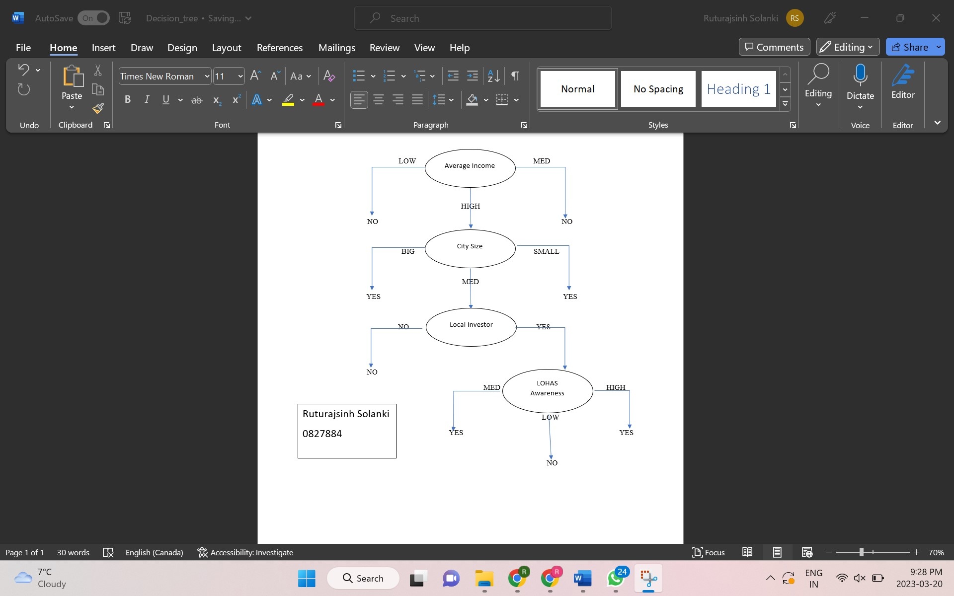

3. Your advice to the CEO about the new application.

Based on the available information, it is recommended that we refrain from opening a new store at this location. The reason for this is that the data within the new application appears to already be present in the provided dataset, and the decision based on this data is negative. This can be further confirmed by consulting the decision tree provided above.

4. Compute the correlations.

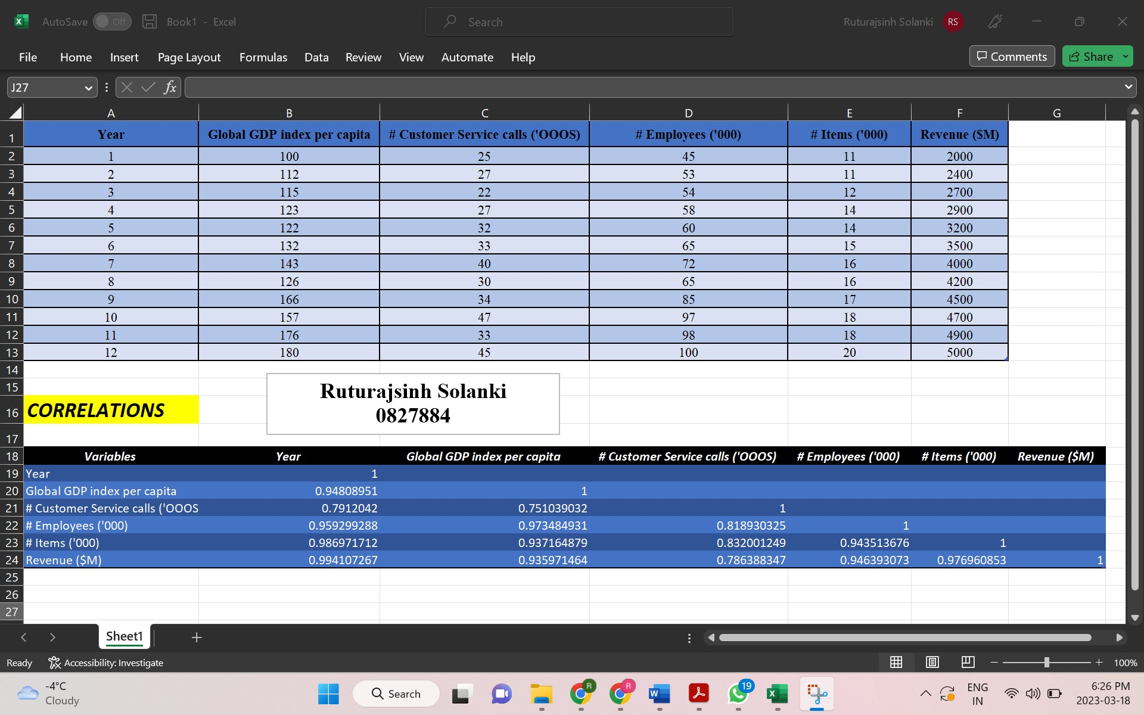

5. Explain which variables are strongly correlated.

Based on the correlation matrix, we can see that there are several variables that are strongly correlated with each other. The following pairs of variables have a correlation coefficient of above 0.95: (year is tightly correlated from all the variables)

- Year and Revenue - 0.994107267
- Year and Number of Items - 0.986971712
- Year and No. of Employees - 0.959299288
- Global GDP and Employees - 0.973484931
- Number of Items and Revenue - 0.976960853

Other variables are also strongly related with almost every pair of variables having correlation coefficient of above 0.8.

Just the pairs with Number of Customer Service Calls variable have coefficient less than 0.8.

6. Your regression model for predicting the revenue.
Regression Equation: Revenue ($M) = 3081 + 414.4(Year) + 4.2(Global GDP index per capita) + 12.6(# Customer Service calls) - 14.1(# Employees) - 138.3(# Items)

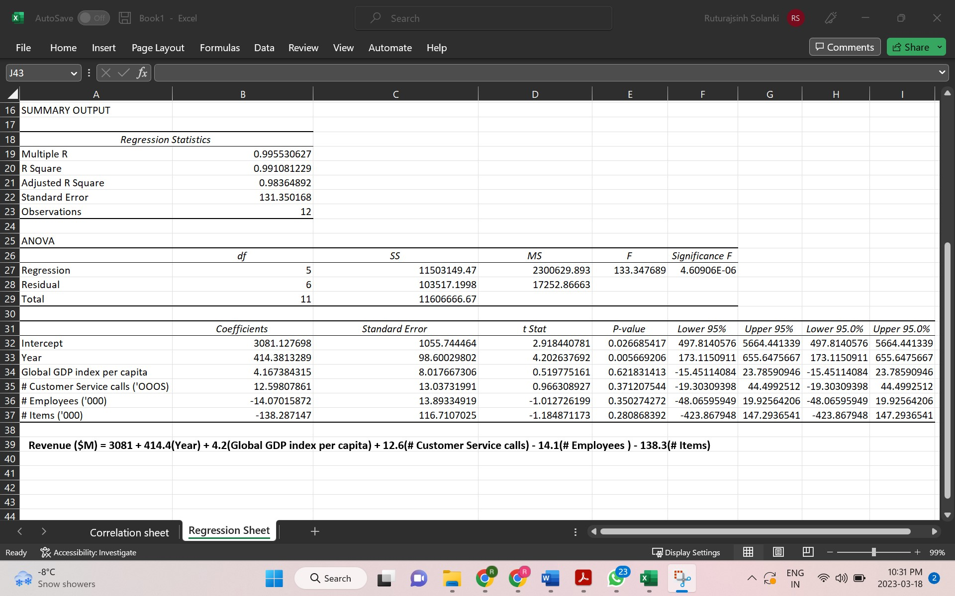

Below are bonus questions:
7. Determine the right number of customer segments. (30 points)
- First, we will plot scatter plots for our data one using No. of transections vs. Income and another using No. of transection and Total Purchase.
- Then, we can use gridline to see where we can see clusters and by adding a trendline we can divide our customer segment in two parts.
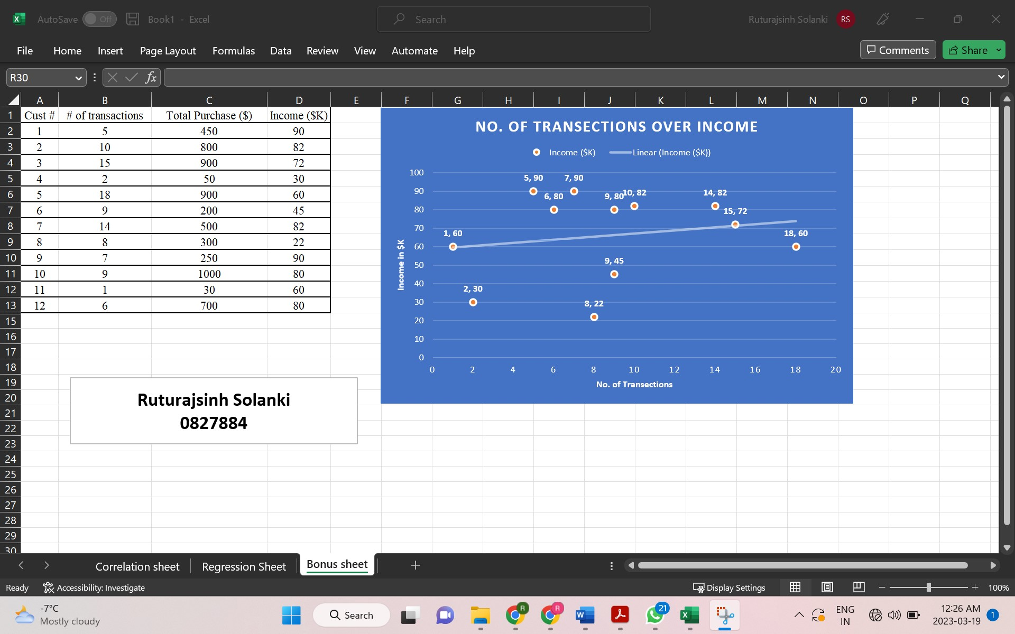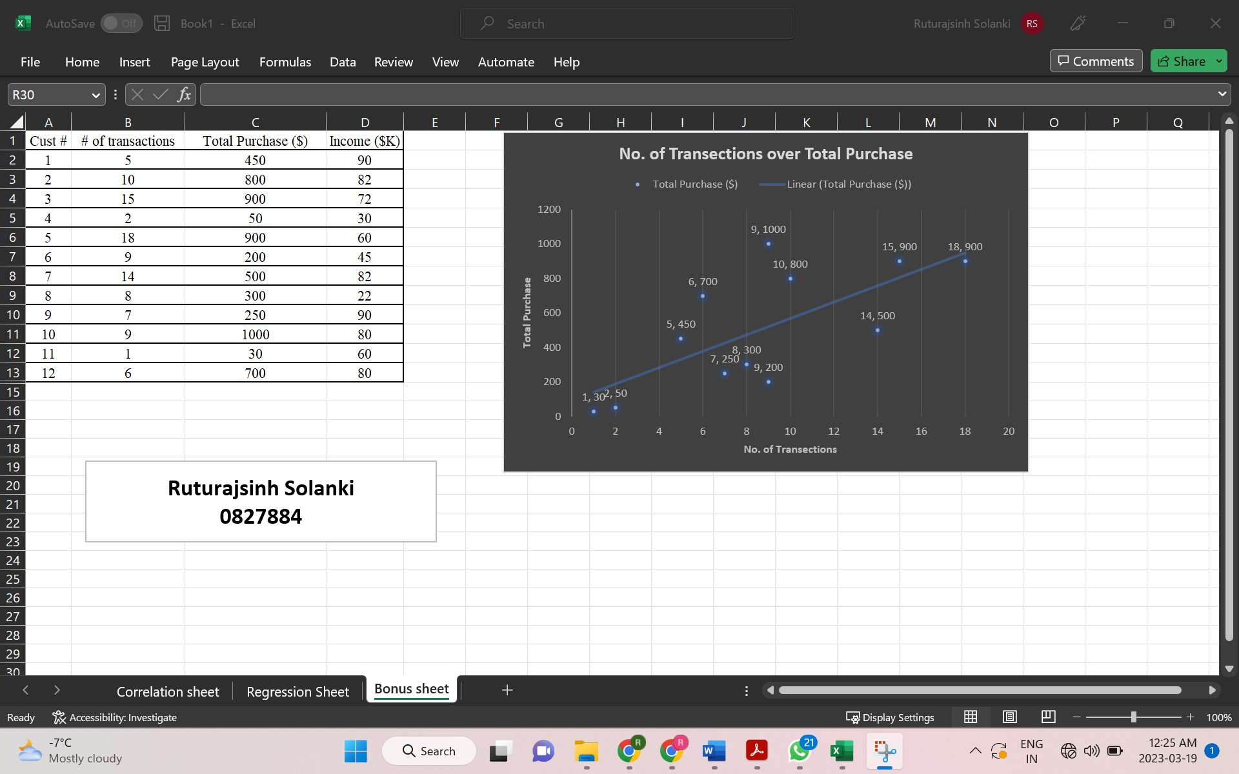
8. Centroids of each customer segments. (30 points)
- To create Centroid first we will need to find average of our features. Then, we will add this average to our both graphs using select data function of graph and then using add option we can add values respective to our graphs.
