Student Name: Ruturajsinh Solanki | Section: 004
Student ID: 0827884 | Date: 2026-11-07
Tasks
1. Create a comprehensive dashboard for the CEO of the company. (20 points)
[You can use Paint, hand draw on a piece of paper, any painting software and GUI tool. Sign on your image. Name the file as DAB100-ASS1-082788401.JPG] Insert your image below.

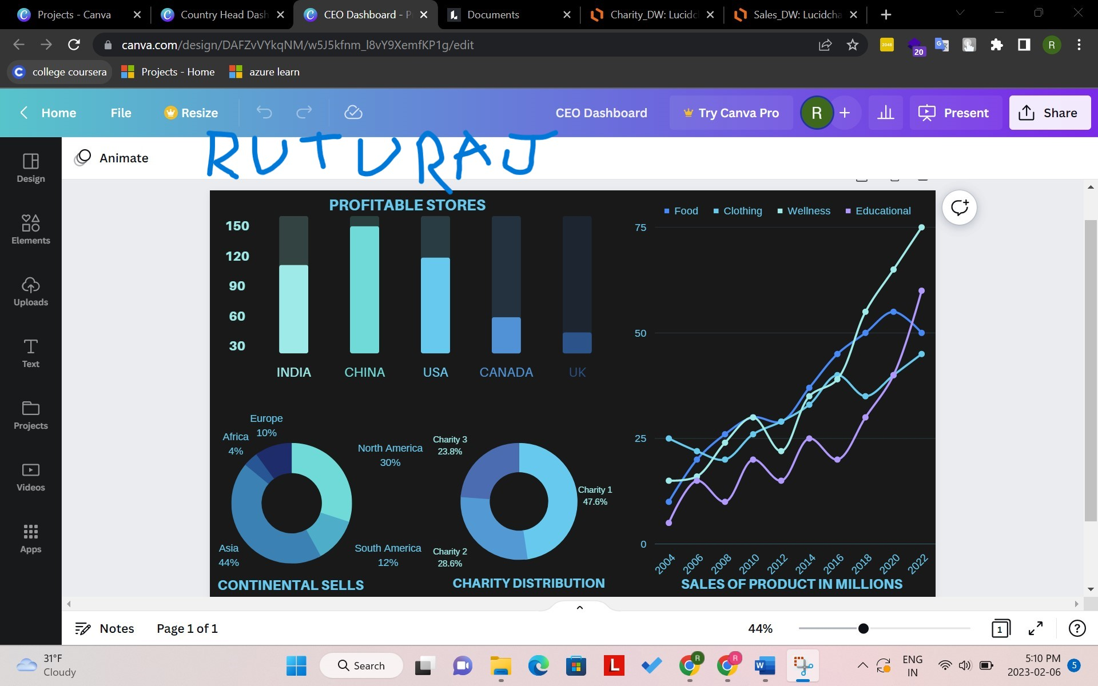

2. Create another dashboard for a country head. (20 points)
[You can pick any country that you would like. You can use Paint, hand draw, any painting software and GUI tool. Sign on your image. Name the file as DAB100-ASS1-082788402.JPG] Insert your image below.

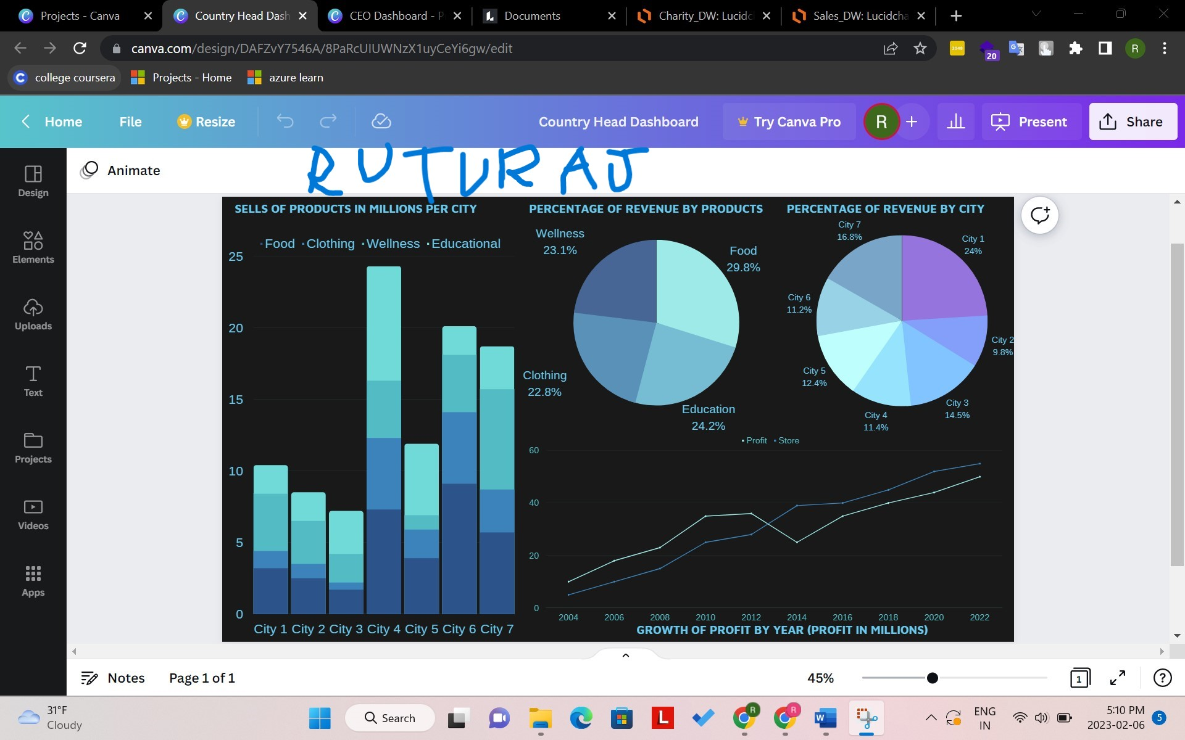

3. Design a DW structure for the company to monitor its sales performance. (20 points) (Hint: Using a star schema, design the central table and lookup tables.)
[Use Excel, PowerPoint, or Word for this structure. Using the snipping tool to take a screenshot of the structure, sign on it, and name the file as DAB100-ASS1-082788403.JPG] Insert your image below.

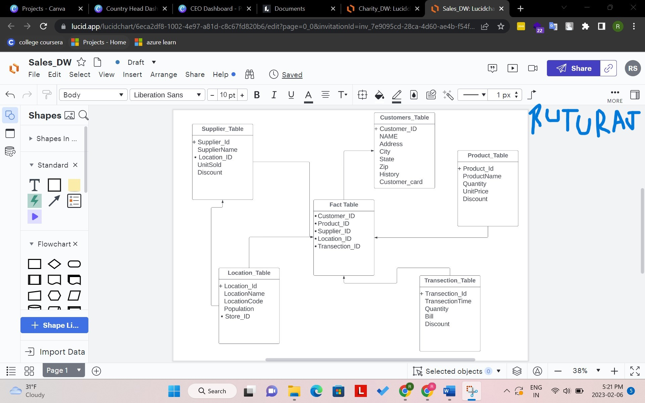

4. Design another DW for the company's sustainability and charitable activities. (20 points) (Hint: Using a star schema, design the central table and lookup tables.)
[Use Excel, PowerPoint, or Word for this structure. Using the snipping tool to take a screenshot of the structure, sign on it, and name the file as DAB100-ASS1-XXXXXX04.JPG] Insert your image below.
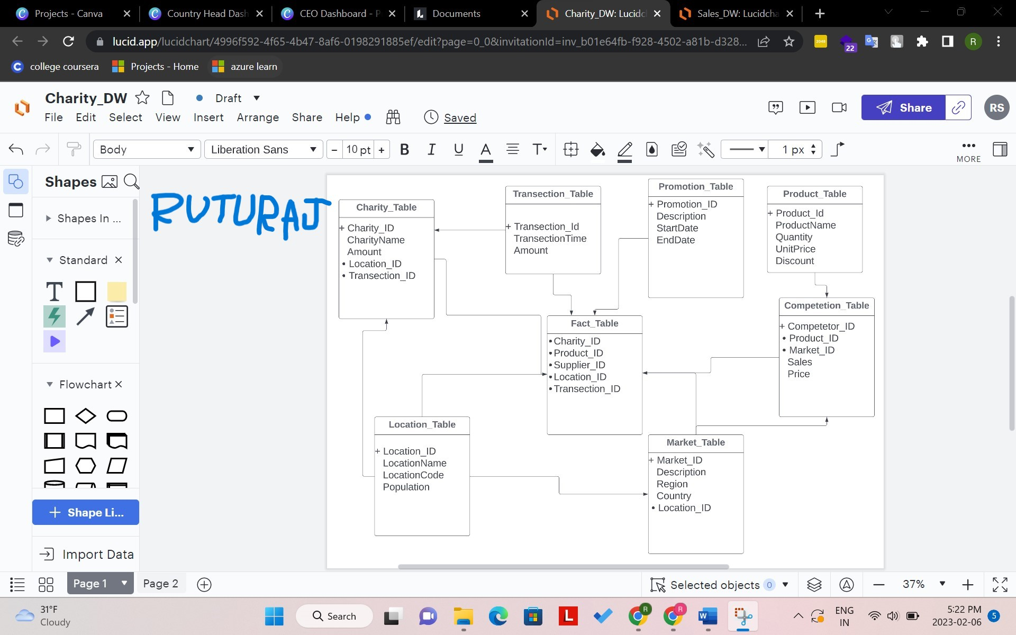

5. What data mining techniques would you use to analyze and predict sales patterns? (10 points)
Describe your chose and explain the reasons. Word counts: 100 – 150 English words. Insert your answers below.
Using the snipping tool to take a screenshot of the structure and name the file as DAB100-ASS1-082788405.JPG] Insert your answers below.
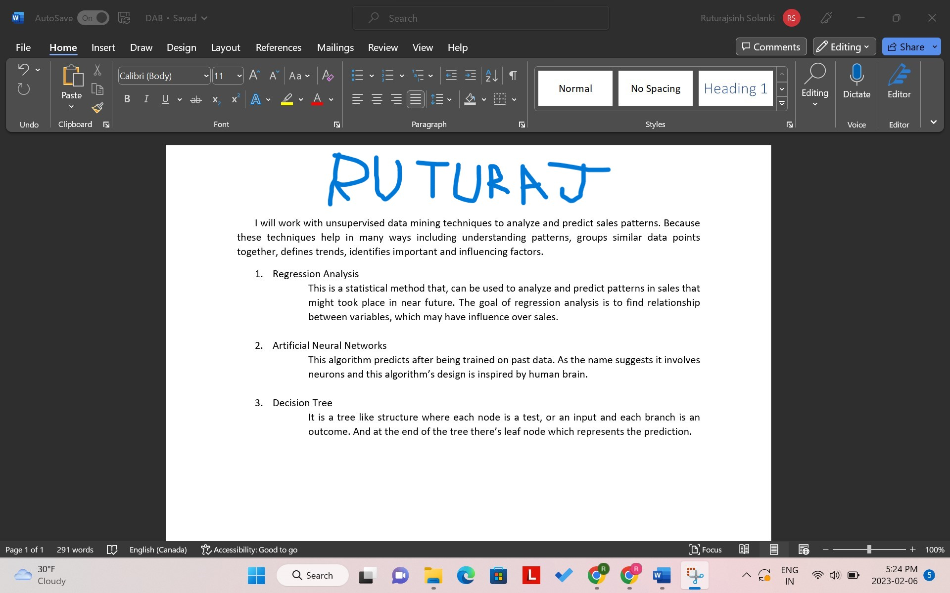

6. What data mining technique would you use to categorize its customers? (10 points)
Describe your chose and explain the reasons. Word counts: 100 – 150 English words. Insert your answers below.
Using the snipping tool to take a screenshot of the structure and name the file as DAB100-ASS1-082788406.JPG]
