Student Name: Ruturajsinh Solanki | Section: 004
Student ID: 0827884 | Date: 2026-11-07

Save this file on your hard drive and rename it as: "DAB100-Lab6-0827884.docx". Replace the XXXXXX with the last 6 digits of your student number.

Your full-sized screenshot of Step 1. (10 Points)

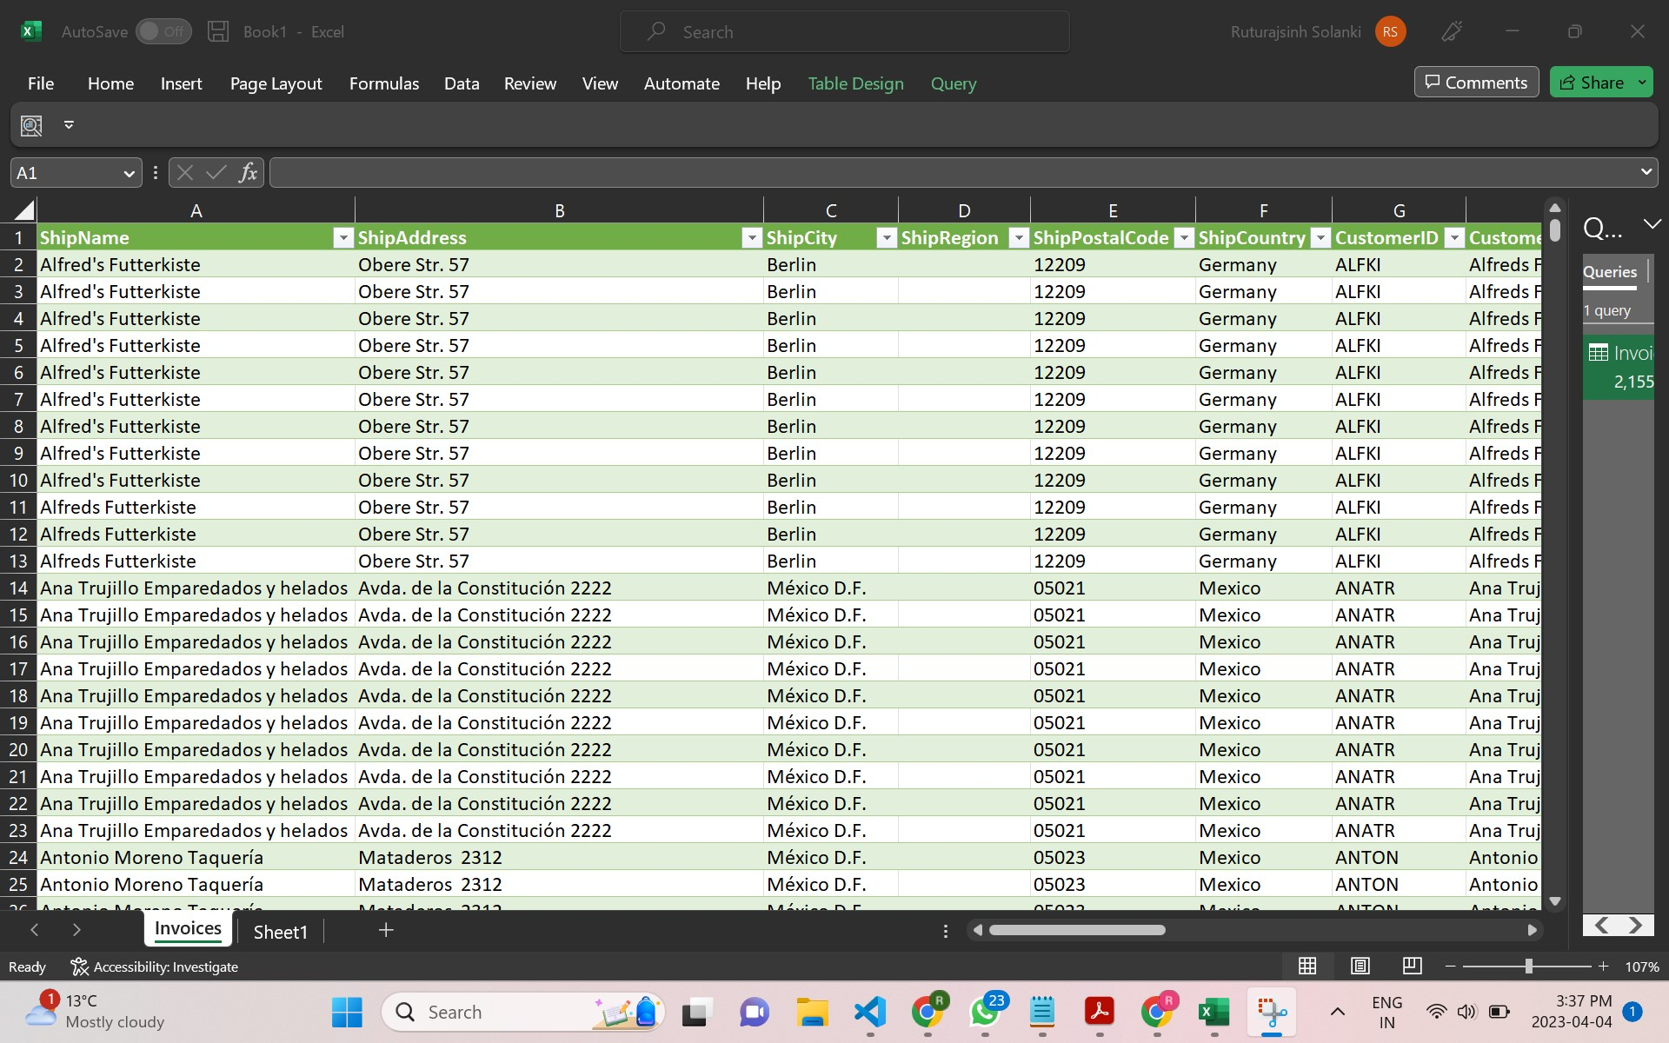

Your full-sized screenshot of Step 2. (10 Points)

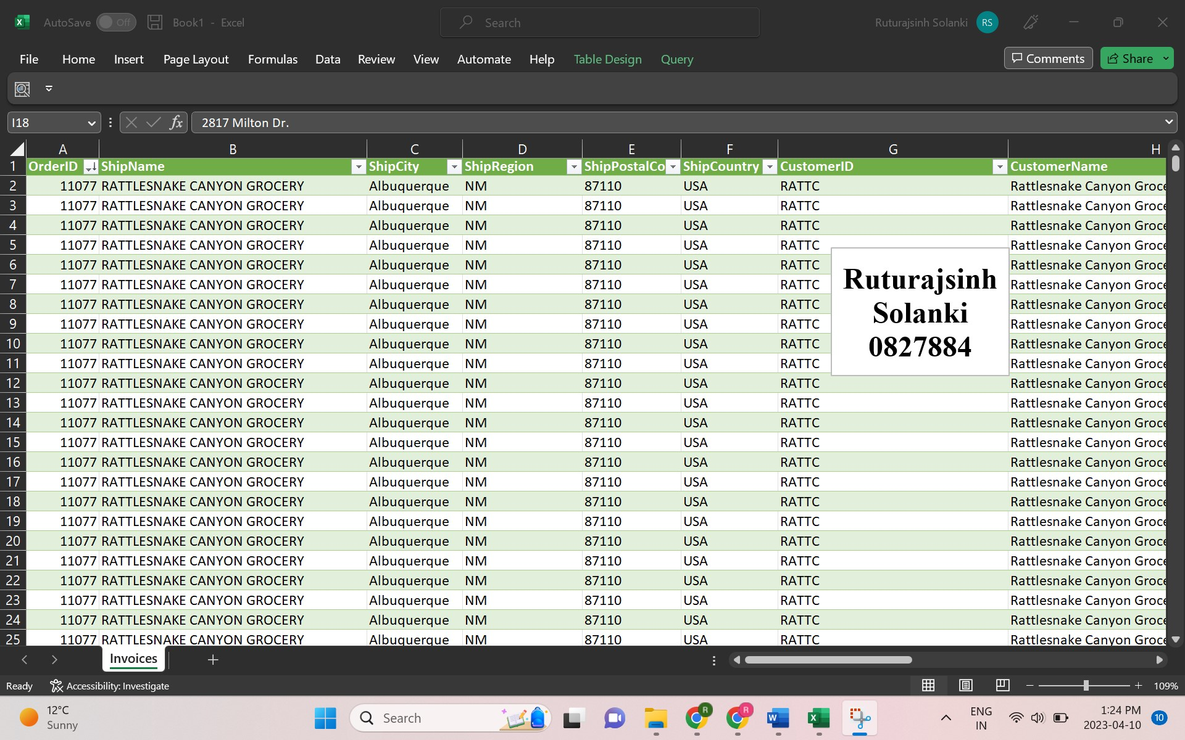

Your full-sized screenshot of Step 3. (10 Points)

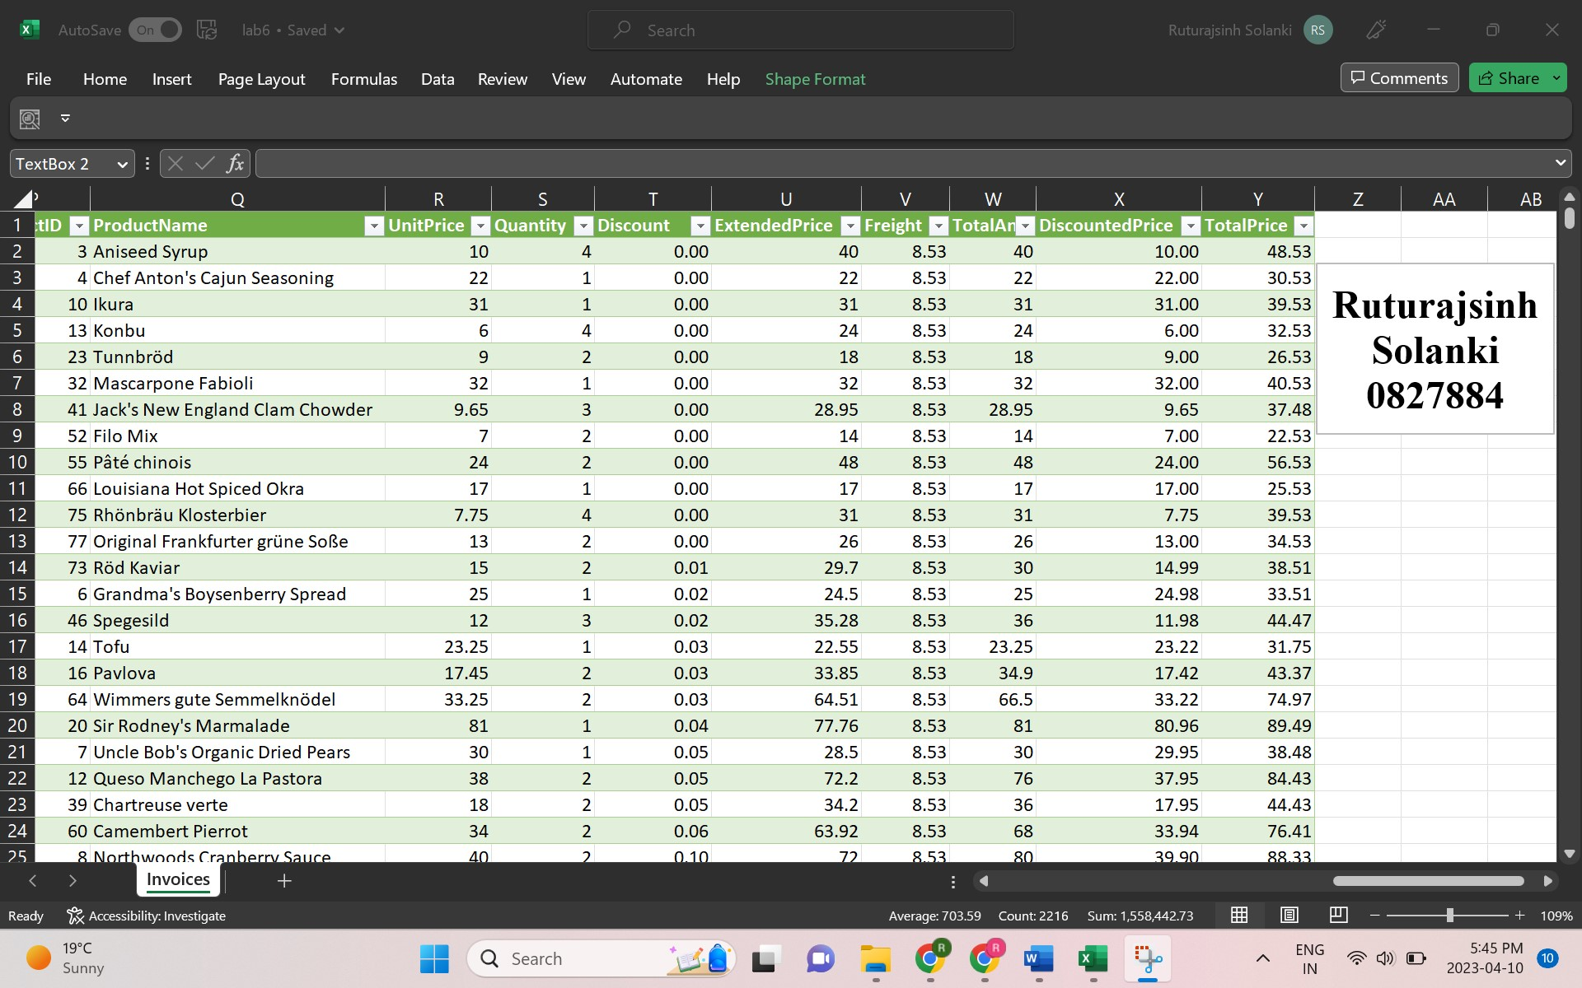

Your full-sized screenshot of Step 4. (10 Points)

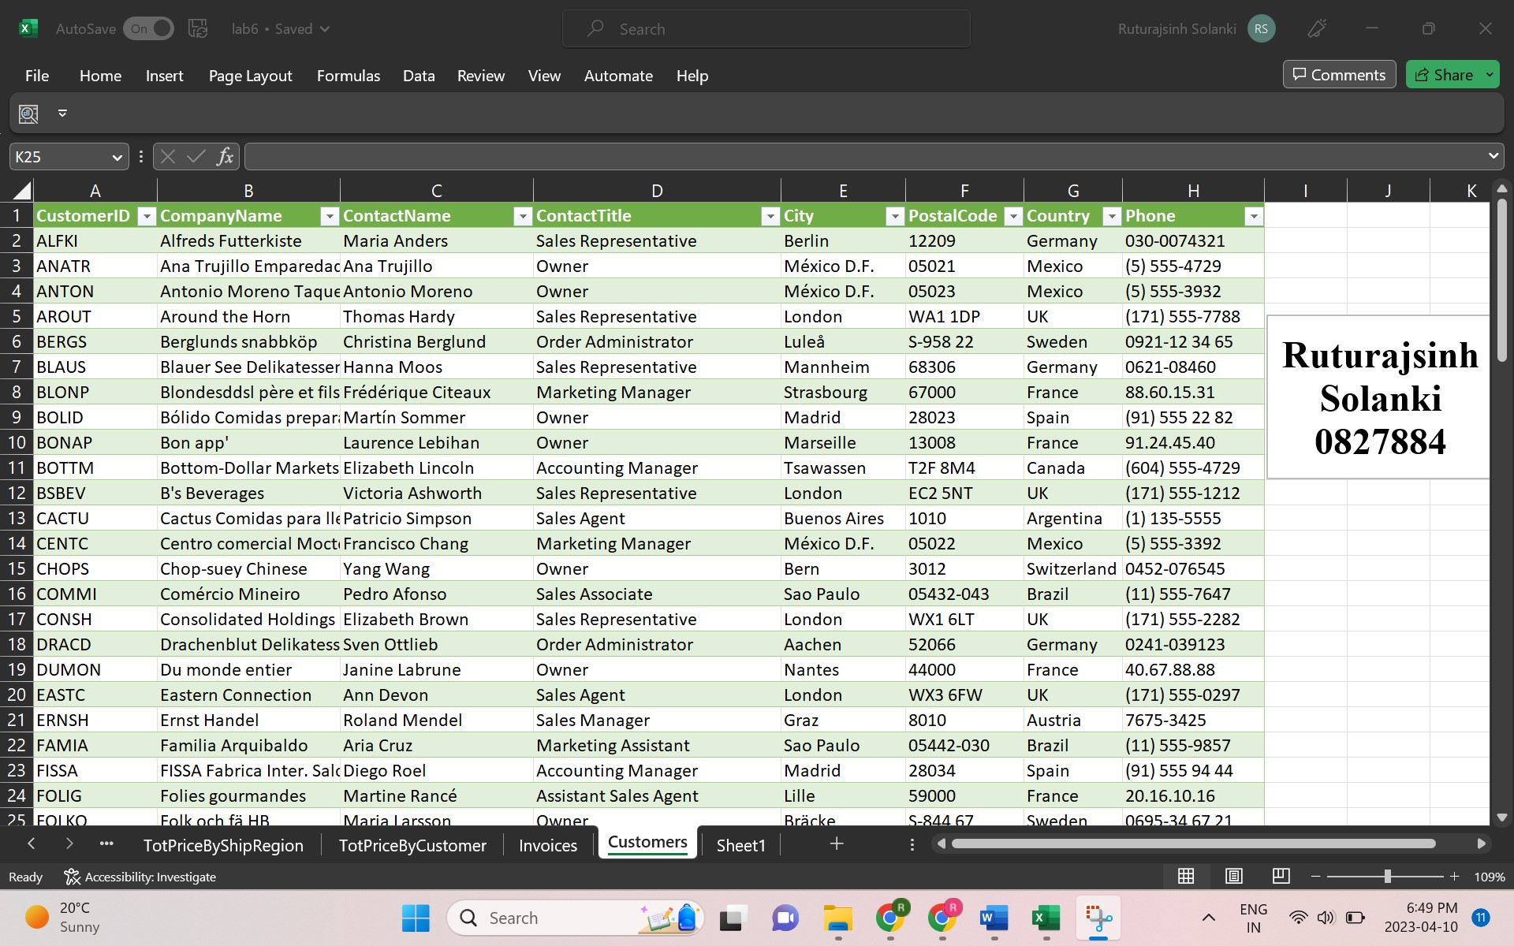

Your full-sized screenshot of Step 5. (60 Points, 15 points each)

- Chart 1

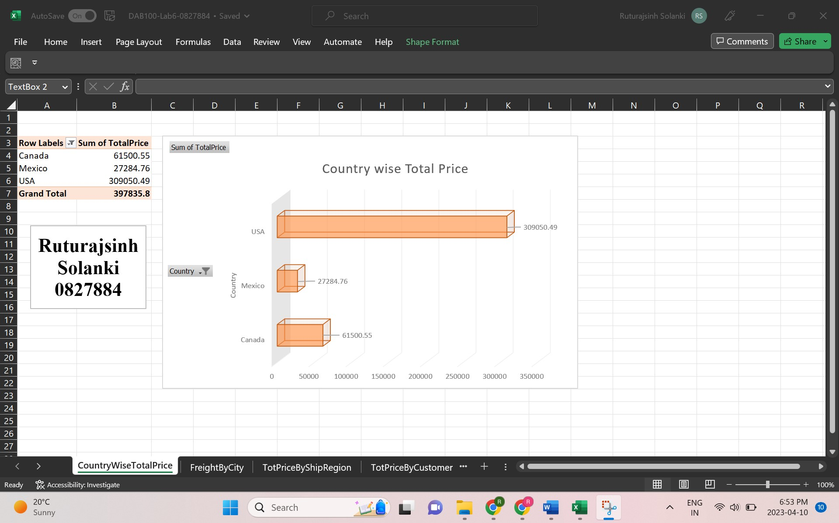

- Chart 2

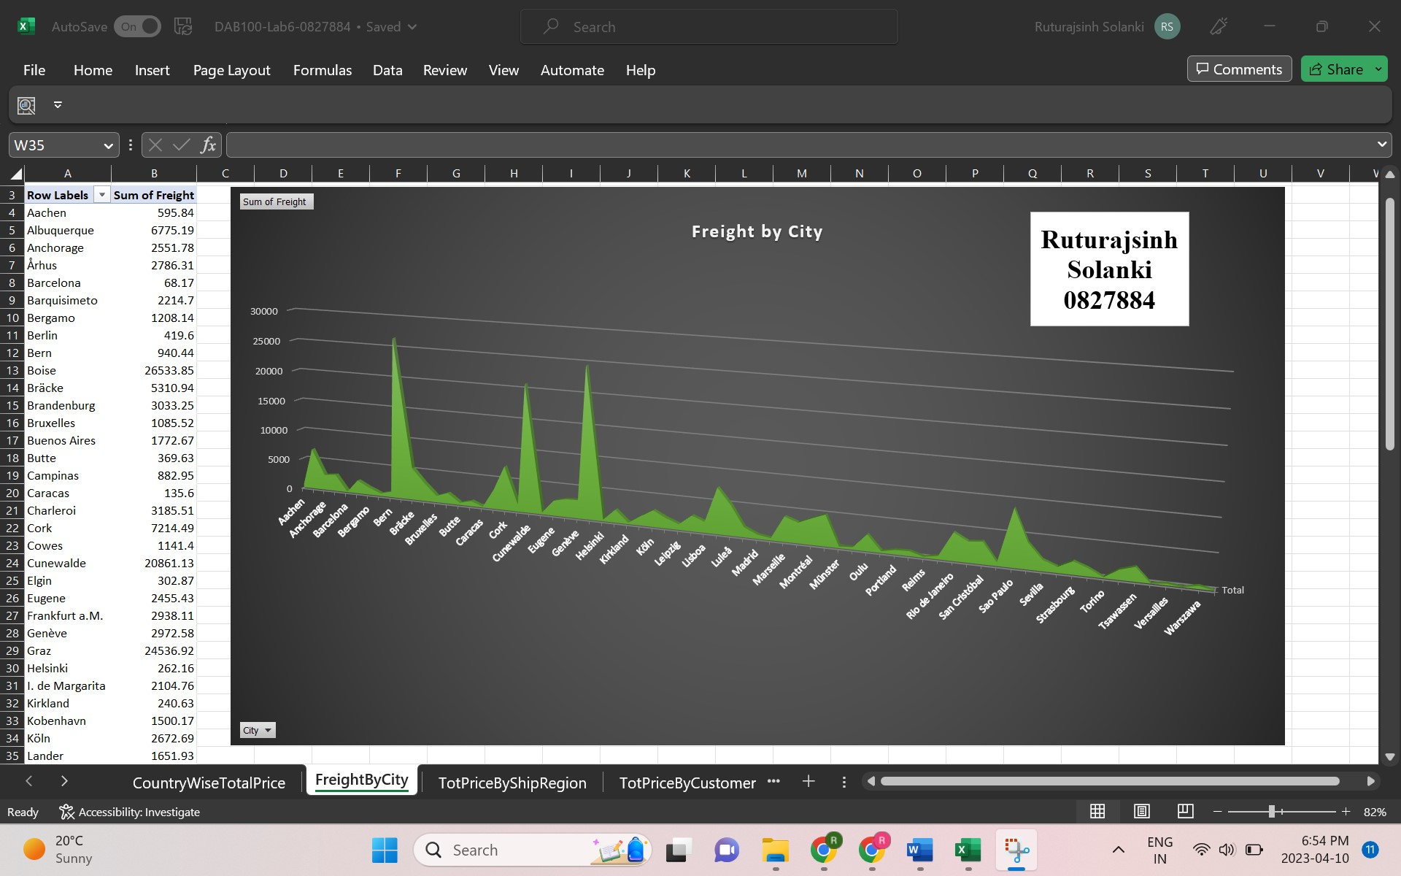

- Chart 3

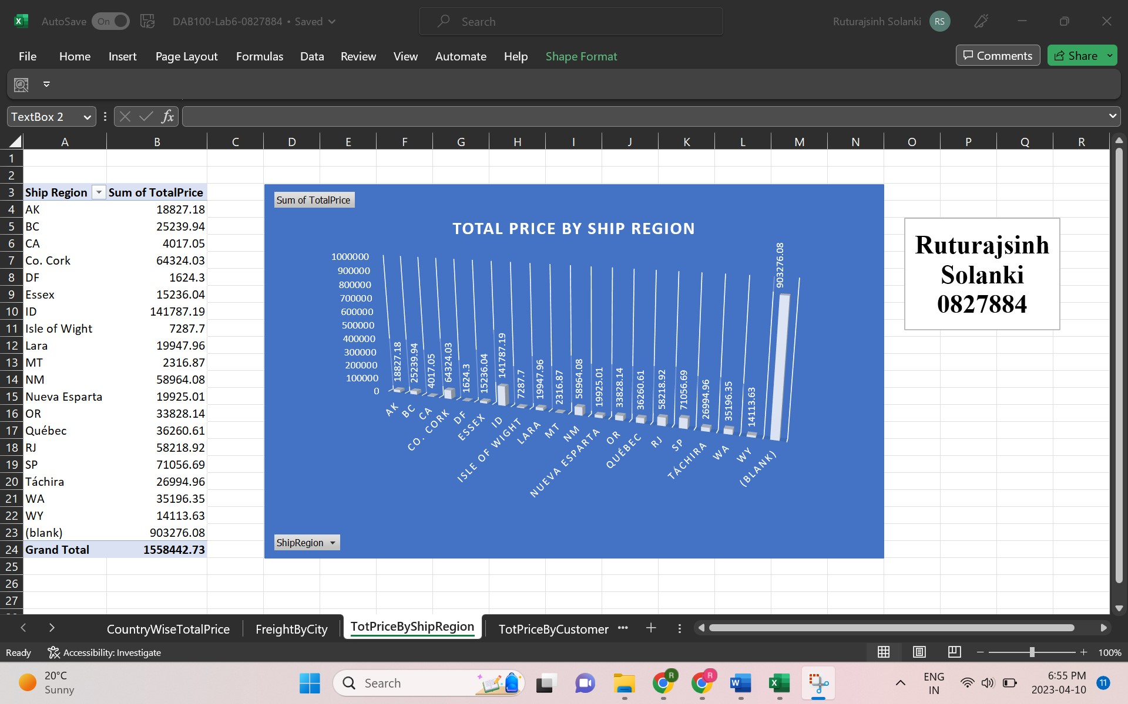

- Chart 4
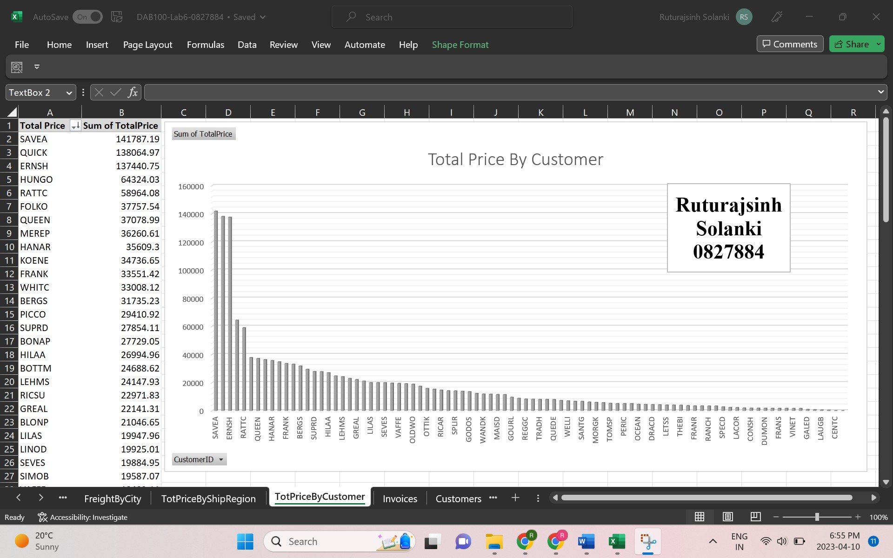

Save this file on your hard drive as: DAB100-Lab6-XXXXXX.PDF

Upload the following documents for your lab submission:
1. The PDF file, DAB100-Lab6-0827884.PDF
2. Your finished EXCEL file, DAB100-Lab6-XXXXXX.xlsx
3. Lab6-01-XXXXXX.jpg
4. Lab6-02-XXXXXX.jpg
5. Lab6-03-XXXXXX.jpg
6. Lab6-04-XXXXXX.jpg
7. Lab6-05-XXXXXX.jpg
8. Lab6-06-XXXXXX.jpg
9. Lab6-07-XXXXXX.jpg
10. Lab6-08-XXXXXX.jpg

