Student Name: Ruturajsinh Solanki | Section: 004
Student ID: 827884 | Date: 2026-11-07

Your full-sized screenshot of Step 1. (10 Points)

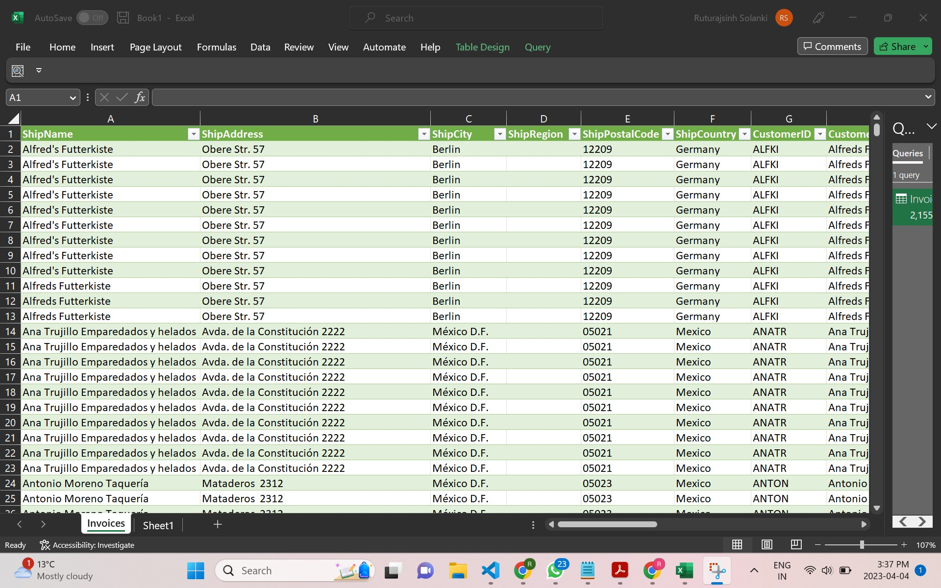
Ruturajsinh Solanki
0827884

Your full-sized screenshot of Step 2. (10 Points)

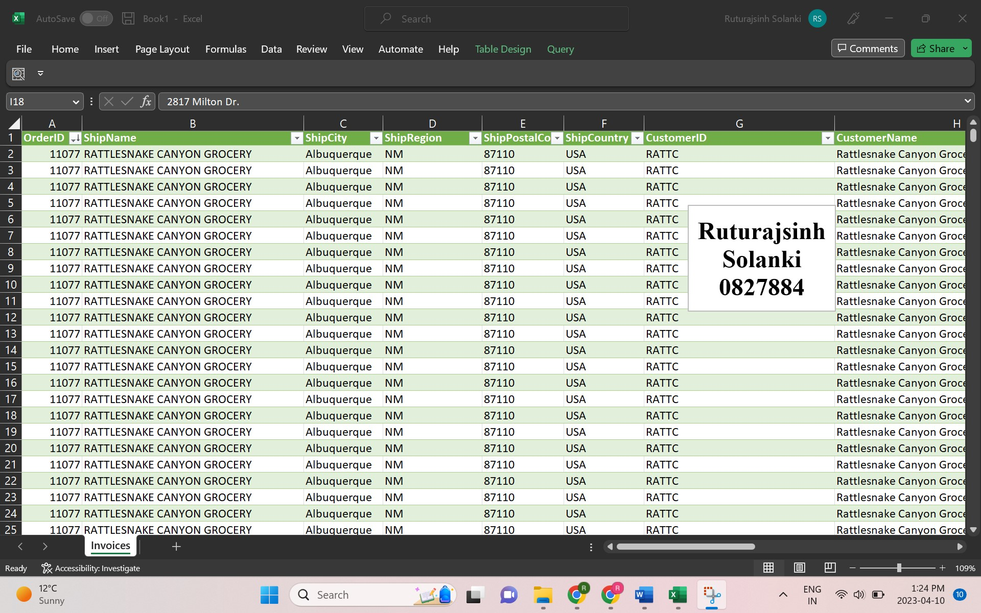

Your full-sized screenshot of Step 3. (10 Points)

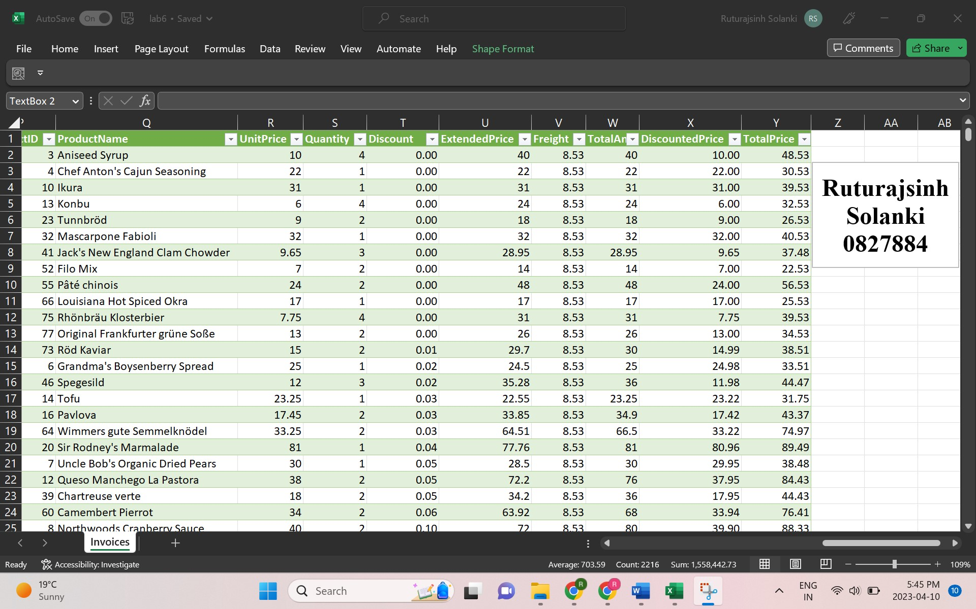

Your full-sized screenshot of Step 4. (10 Points)

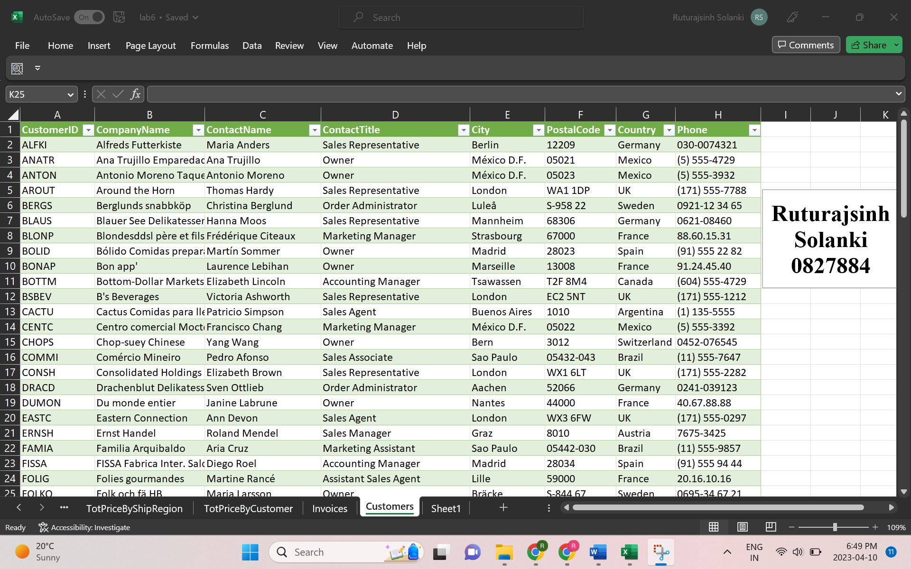

Your full-sized screenshot of Step 5. (60 Points, 15 points each)

- Chart 1

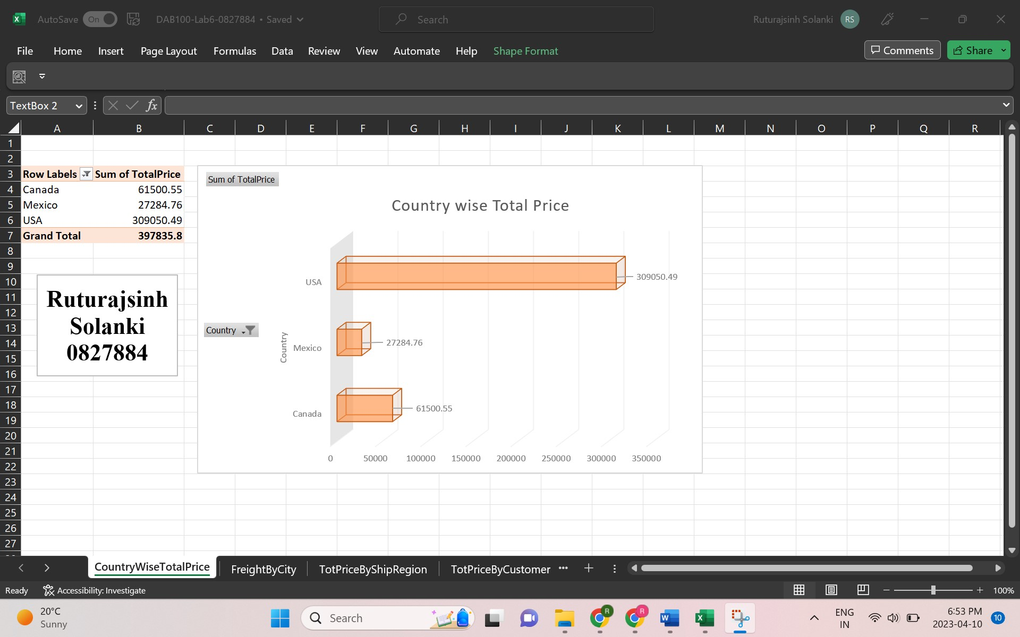

- Chart 2

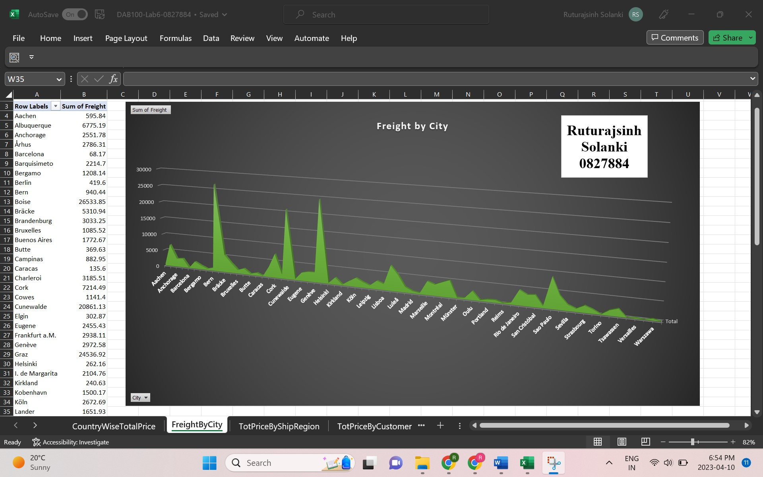

- Chart 3

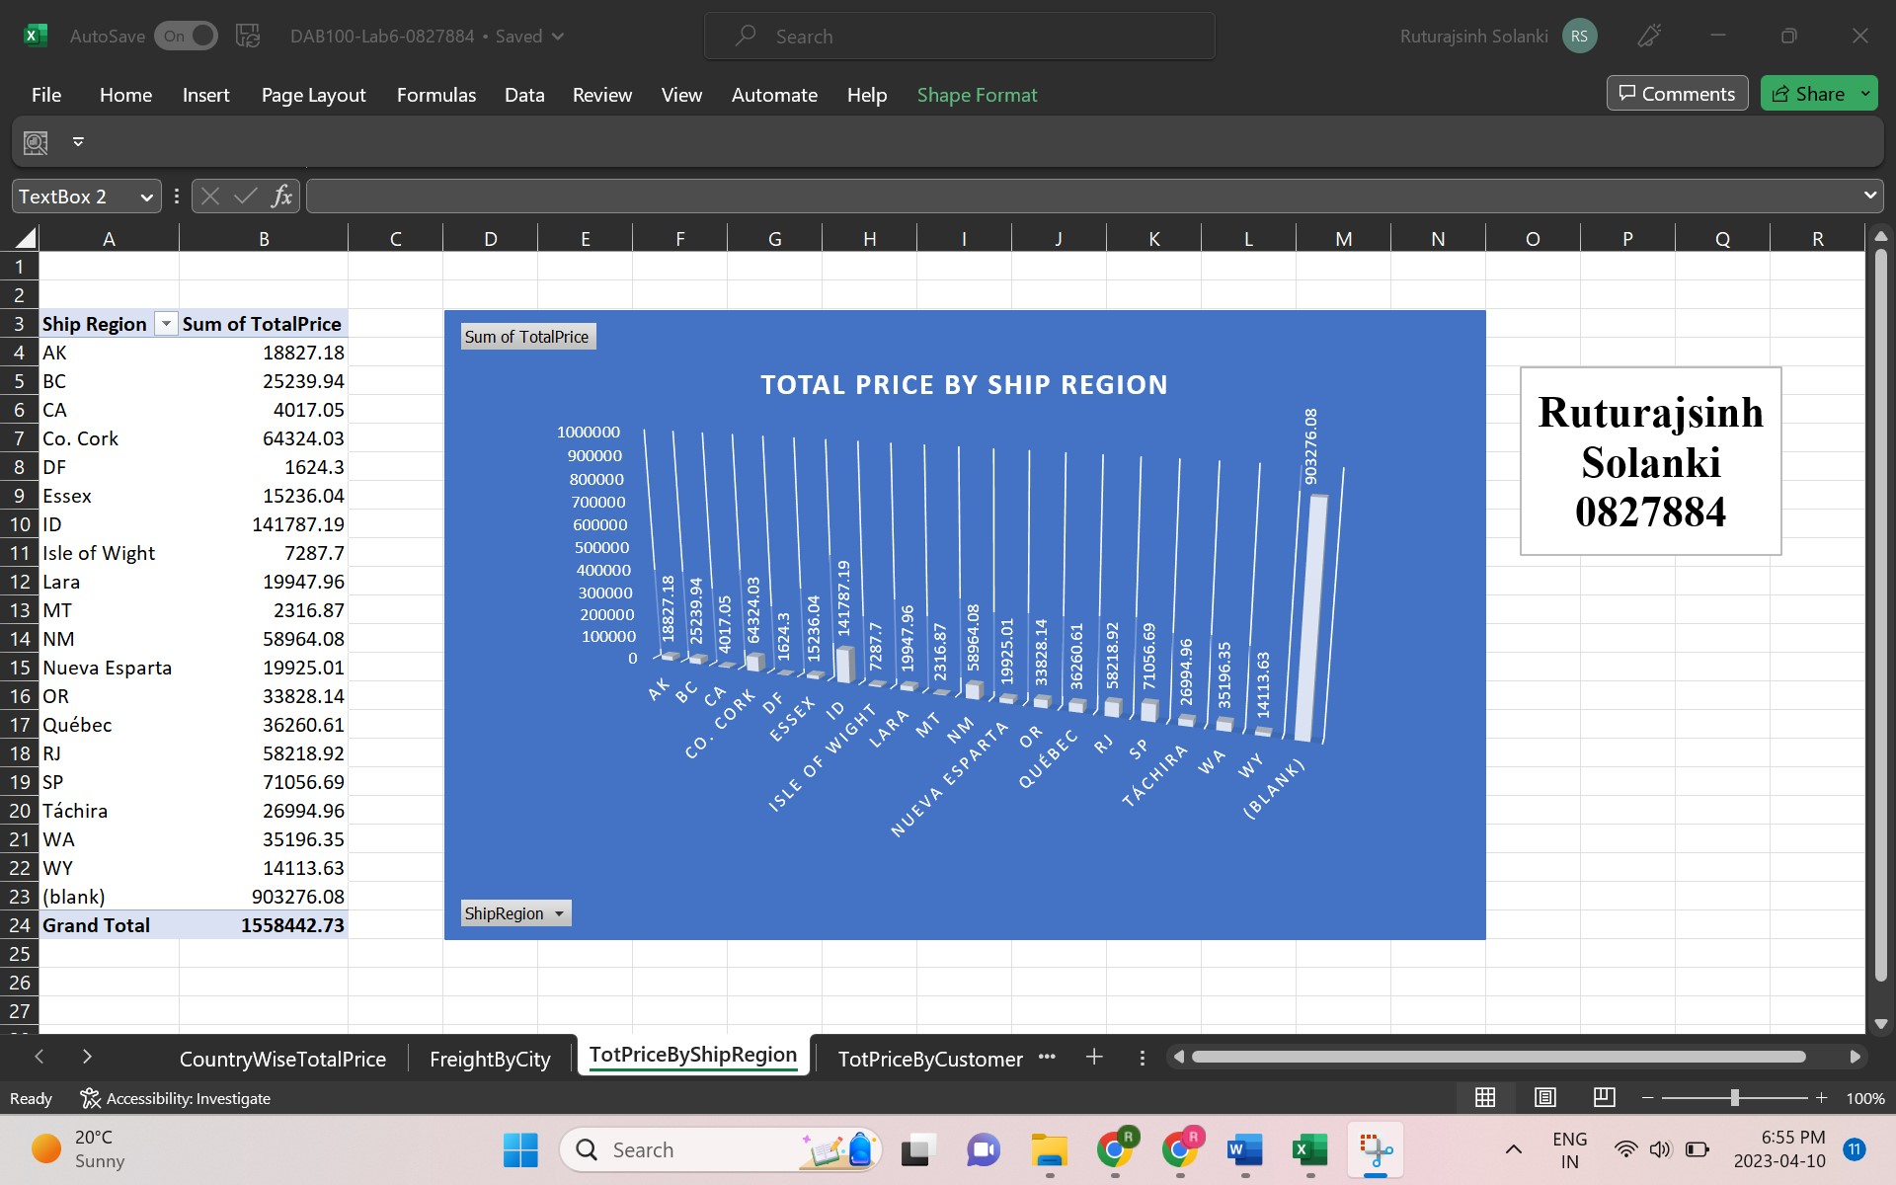

- Chart 4
