B.P.H.E.SOCIETYS

AHMEDNAGAR COLLE**GE**,

AHMEDNAGAR



A

PROJECT REPORT

ON

**HOTEL RESERVATION SYSTEM**

**SUBMITTED BY**

**Mr. VAIBHAV PATOLE**

**Mr.AKASH BHUJBAL**

**MR.SANKET PATIL**

UNDER THE GUIDENCE OF

**Prof. SAYYAD RAZZAK**

**(H.O.D)**

SUBMITTED TO UNIVERSITY OF PUNE

**2018-2019**

**CERTIFICATE**

Department of Computer Science

This is to certify that

Mr.

Mr.

Student of

B.P.H.E. SOCIETY’S AHMEDNAGAR COLLEGE

AHMEDNAGAR-414001.

Has successfully completed her project on

HOTEL RESERVATION SYSTEM

As a practical fulfilment of the course TYBCS affiliated to UNIVERSITY OF PUNE, during the academic year 2018-2019.

**HOD Examiner Project Guide**

**(Dr. Sayyed Razak Sir) (Mrs. Madhavi Dethe Maa’m)**

INDEX

* Problem Definition
* System Analysis
* Scope of the system
* Preliminary Investigation
* Requirement Analysis
* Feasibility Study
* Diagrams
  + - ER Diagram
    - UML Diagram
* System Design
* Input Design
* Output Design
* Database Design
* System Testing :
  + - Black Box Testing
    - White Box Testing
* Future Of Project
* Conclusion
* Reference and Bibliography

ACKNOWLEDGEMENT

First of all I would like to thank my Teacher Mrs MADHAVI DETHE MAM who taught me the basic of system development. She helped us to learn about different types of software

Development methodologies along with benefits. She also taught us the basic knowledge of UML

Design.

Lastly, I am very glad that I have successfully able to complete our assignment on time. I

Appreciate all the helpers for helping out along the way of this development. I thank all of them

Cordially for their helpful attitude.

PROBLEM DEFINITION

The definition of our problem lies in manual system and a fully automated system.

Manual system : The system is very time consuming and lazy. This system is more prone to

errors and sometimes the approach to various problems is unstructured.

Technical system : With the advent of latest technology if we do not update our system then

our business result in losses gradually with time. The technical systems contains the tools of latest

trend i.e. computers printers, fax, Internet etc. The systems with this technology are very fast,

accurate, user-friendly and reliable.

.

Need of Reservation system

A few factors that directs us to develop a new system are given below -:

1) Faster System

2) Accuracy

3) Reliability

4) Informative

5) Reservations and cancellations from any where to any place

OBJECTIVES OF SYSTEM

  This system will lead to increase in the  BUS reservation efficiency of the project **Employees** and passengers of the BUS RE SERVATION SYSTEM with little throughput.

 This system project is made as user friendly as possible so that anyone can use it with little knowledge of system computers.

 The BUS RESERVATION project will reduce the  BUS RESERVATION tedious job of system  paperwork by keeping all the project details of BUS RESERVATION.

  Up-to-date information of the system Performance status and other enquires.

We provide up to date information that is not possible manually.

  The objective of my project is to make easy the  BUS RESERVATION project system of BUS Agency simple, reliable, user friendly, and corrective. Moreover less time consuming as compared to manual work.

System Analysis

**Hardware Requirement :**

|  |  |
| --- | --- |
| Processor | Pentium(4) or more for optimum performance |
| RAM | Recommended 1GB |
| Hard Disk | Minimum 40 GB |

**Software Requirement :**

|  |  |
| --- | --- |
| Operating System | Windows 10 |
| Front end | JAVA |
| Back end | PostgreSql9.6 |

Scope of the System

It may help collecting perfect management in details. In a very short time, the collection will be obvious, simple and sensible. It will help a person to know the management of passed year perfectly and vividly. It also helps in current all works relative to BUS RESERVATION SYSTEM.. It will be also reduced the cost of collecting the management and collection procedure will go on smoothly. We have tried to computerize various processes of BUS RESERVATION SYSTEM.

* In computer system the person has to fill the various forms and number of copies of the forms can be easily generated at a time.
* To assist the staff in capturing the effort spent on their respective working areas.
* To utilize resources in an efficient manner by increasing their productivity through automation.
* The system generates types of information that can be used for various purposes.
* It satisfies the user requirements
* Be easy to understand by the user and operator
* Be easy to operate
* Have a good user interface
* Be expandable

Preliminary Investigation

* Identify problem or an opportunity
* Analysing the current system in the light of problem/opportunity
* Justification of a new system or a modification of the old to meet new needs of the user
* Observing the process
* Interviewing the participants
* Examining Reports and Documentation
* Means of transformation of information
* User of the system

REQUIREMENT ANALYSIS

* + Interview
  + Surveys
  + Direct Observation

FORMATION REQUIREMENT OF SYSTEM

* + - Data to be collected and processed.
    - Output to be produced.
    - To make available to the users.
    - Determining information requirement.

FOR PEOPLE

* + - Easy way of communication
    - Stimulates enthusiasm
    - Establishing trust

Feasibility Study

After doing the project BUS RESERVATION SYSTEM, study and analysing all the existing or required functionalities of the system, the next task is to do the feasibility study for the project. All projects are feasible – given unlimited resources and infinite time.

Feasibility study includes consideration of all the possible ways to provide a solution to the given problem. The proposed solution should satisfy all the user requirements and should be flexible enough so that future changes can be easily done based on the future upcoming requirements.

**A] Economical Feasibility**

This is a very important aspect to be considered while developing a project. We decided the technology based on minimum possible cost factor.

* All hardware and software cost has to be borne by the organization.
* Overall we have estimated that the benefits the organization is going to receive from the proposed system will surely overcome the initial costs and the later on running cost for system.

**B] Technical Feasibility**

This included the study of function, performance and constraints that may affect the ability to achieve an acceptable system. For this feasibility study, we studied complete functionality to be provided in the system, as described in the System Requirement Specification (SRS), and checked if everything was possible in different type of frontend and backend platforms.

**C] Operational Feasibility**

No doubt the proposed system is fully GUI based that is very user friendly and all inputs to be taken all self-

explanatory even to a layman. Besides, a proper training has been conducted to let know the essence of the system to the

users so that they feel comfortable with new system. As far our study is concerned the clients are comfortable and happy as the system has cut down their loads and doing.

DIAGRAMS

ER- DIAGRAM

MAKES

HAS

DECIDE

BOOK

RESERVATION

HAS

BUBUSBUS

PASSENEGER

EMPLOYEE

PAYMENT

DESTINATION

CLASS DIAGRAM

Bus Employee

-BID -Ecode

+Btype +Ename

+TotalSeat 1 * +Design

has

+Bcode +Bno

+Add() +Add()

+Update() +Update()

+Delete() +Delete()

1

has

*

Passenger Reservation

-Pcode -Rno

+Pname +Source

+Pno books +Destination

+Addresss 1 * +Date

+Add() +Time

+Update() +Save()

+Delete() +Search()

1 +Delete()

makes

*

Payment

+amt

+eid

OBJECT DIAGRAM

B : BUS E : EMPLOYEE

* BID :1 - ECODE:101

+ BTYPE: high + ENAME:pooja

+ TOTALSEAT:50 + DESIG:driver

- BCODE :10 - BNO:1

+ ADD() + ADD()

+ UPDATE() + UPDATE()

+ DELETE() + DELETE()

P : PASSENGER R : RESERVATION

- PCODE:20 - RNO: 112

+ PNAME:raj + SOURCE:A’nagar

+ ADDRESS:mirc + DEST:pune

+ ADD() + DATE:20-03-2019

+ UPDATE() +TIME:10:00AM

+ DELETE() + SAVE()

P : PAYMENT +SEARCH()

+ AMT:500

USE CASE DIAGRAM

**RESERVATION SYSTEM**

DATABASE

ADMIN

<<INCLUDE>>

SYSTEM USER

Passenger

ACTIVITY DIAGRAM START

CONFIRM SEATS

MAKE PAYMENTS

BBOOK TICKETS

CHECK RESERVED SEATS

REGISTER PASSENGER

NO YES

STOP

SEQUENCE DIAGRAM

B:BUS

P: PAYMENT

R: RESERVATION

P: Passenger

CHECK AVAILABILTY OF SEATS()

BUS INFORMATION()

MANAGE BOOKING DETAILS()

PAY AMOUNT()

()

MAINTAIN CUSTOMER DETAILS()

System Design

In this phase, a logical system is built which fulfils the given requirement. Design phase of software development deals with transforming the client’s requirements into a logically working system. Normally design is performed in the following two steps :-

1. **Primary Design Phase :**

In this phase, the system is designed at block level. The blocks are created on the basis of analysis done in the problem identification phase. Different blocks are created for different functions emphasis is put on minimising the information flow between blocks. Thus, all activities which require more interaction are kept in one block.

1. Secondary Design Phase :

In the secondary phase the detailed design of every block is performed.

**The general task involved in the design process are the following:-**

* Design various blocks for overall system processes.
* Design smaller, compact and workable modules in each block.
* Design various database structures.
* Specify details of programs to achieve desired functionality.
* Design the form of inputs, and outputs of the system.
* Perform documentation of the design.
* System reviews.

INPUT/

OUTPUT SCREEN

LOGIN FORM

LOGIN FORM SUCCESSFUL MESSAGE

MAIN MENU FORM

BUS DETAILS FORM

BUS RECORD UPDATED

PASSANGER DETAILS

EMPLOYEE DETAILS

RESERVATION DETAILS

BUS REPORT

EMPLOYEE REPORT

PASSANGER REPORT

RESERVATION REPORT

DATABASE SCREEN

Database Design

* A database design is a collection of interrelated data stored with minimum redundancy to serve many users quickly and effectively.
* After designing input and output, the analyst must concentrate on database design or how data should be organized around user requirements.
* Data independent
* Accurate and Integrating
* More Information at low cost
* Recovery from Failure
* Privacy and Security
* Performance

System Testing

System Testing is the testing of a complete and fully integrated software product. Usually, software is only one element of a larger computer-based system. Ultimately, software is interfaced with other software/hardware systems. System Testing is actually a series of different tests whole sole purpose is to exercise the fully computer-based system.

Two category of Software Testing :

* Black Box Testing
* White Box Testing

Black box Testing; it is a software testing method in which the internal structure/design implementation of the item being tested is Not known as tester. It is generally independent Programming knowledge is not required for black box testing.

White Box Testing: it is a software testing method in which the internal structure /design /implementation of the item being tested is known to the tester. It is mainly applicable to lower levels of testing: Unit Testing, Integration Testing. Programming Knowledge is required for White Box testing.

Future of System

In a nutshell, it can be summarized that the future scope of the project circles around maintaining information regarding:

* We can add printer in future
* We can give more advance software for BUS TICKET RESERVATION SYSTEM including more facilities.
* We will host the platform on online servers to make it accessible worldwide
* Integrate multiple load balancers to distribute the loads of the system.
* Create the master and slave database structure to reduce the overload of the database queries.
* Implement the backup mechanism for taking backup of codebase and database on regular basis on different servers.

The above mentioned points are the enhancements which can be done to increase the applicability and usage of this project. Here we can maintain the records of BUS DETAILS and TICKETS RESERVATION. Also, as it can be seen that now-a-days the players are versatile, i.e. so there is a scope for introducing a method a maintain the Medical Store Management System Enhancement can be done to maintain all the Medical store, Medicines, Stocks, etc.

We have left all the options open so that if there is any other future requirement in the system by the user for the enhancement of the system then it is possible to implement them.

Conclusion

* Our project is only a humble venture to satisfy the needs in an Institution.
* Several user friendly coding have also adopted.
* This package shall prove to be a powerful package in satisfying all the requirements of the organization.
* The objective of software planning is to provide a frame work that enables made within a limited time.
* All the necessary documentation has been done for the case of operating system.
* Thus the application has fulfilled with all the objectives of the “BUS RESERVATION SYSTEM”.

**Input /output Design**

**1)Login**

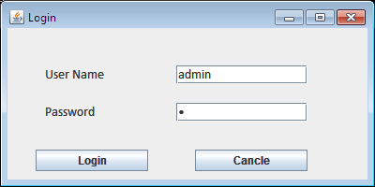

**2)Menu**

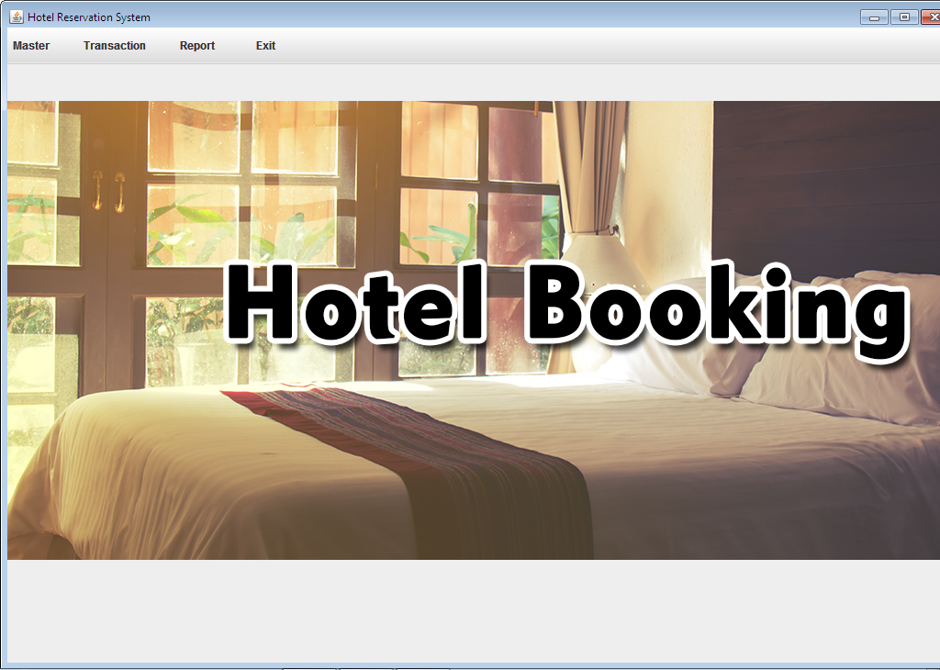

**3) Room Details**

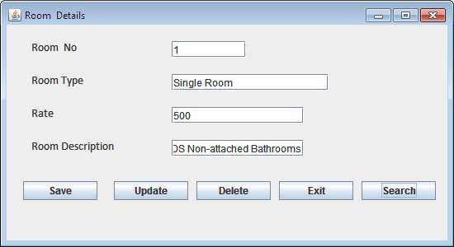

**3) Customer**

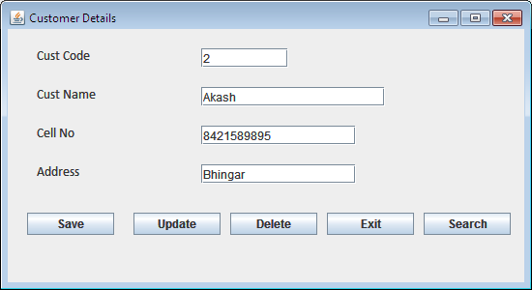

**4) Employee**

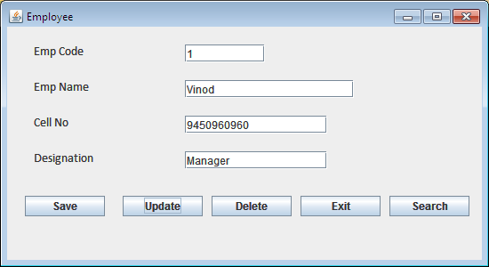

**5) Booking**

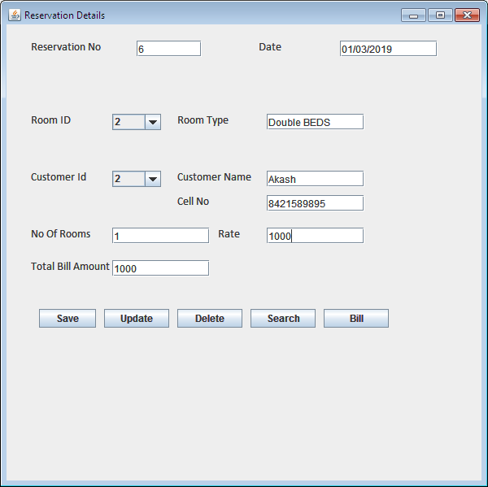

**Bill**

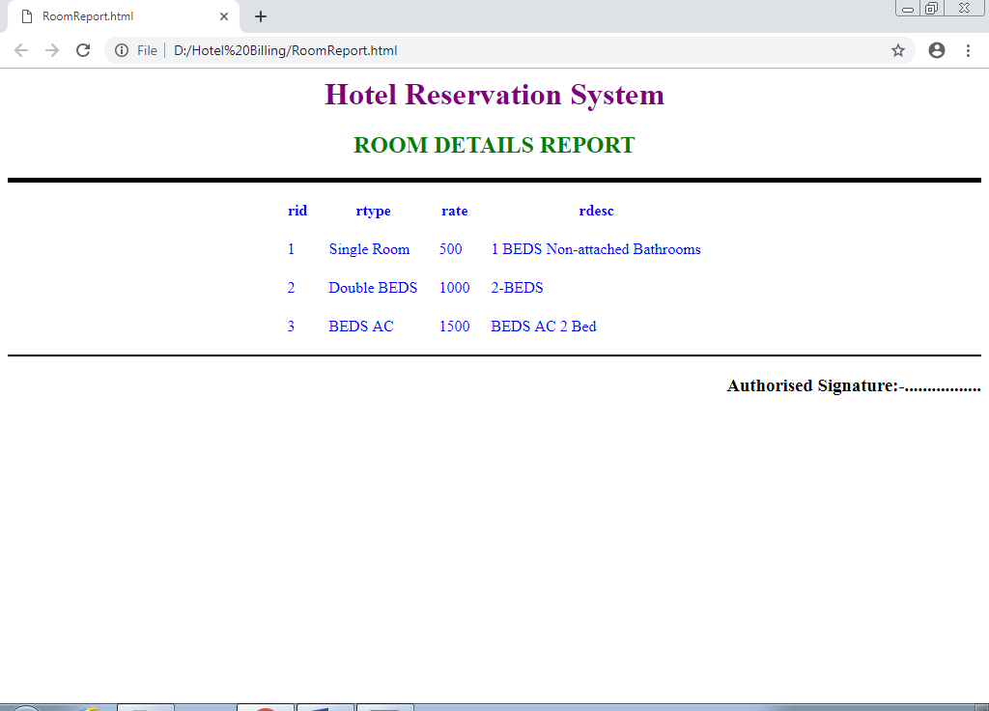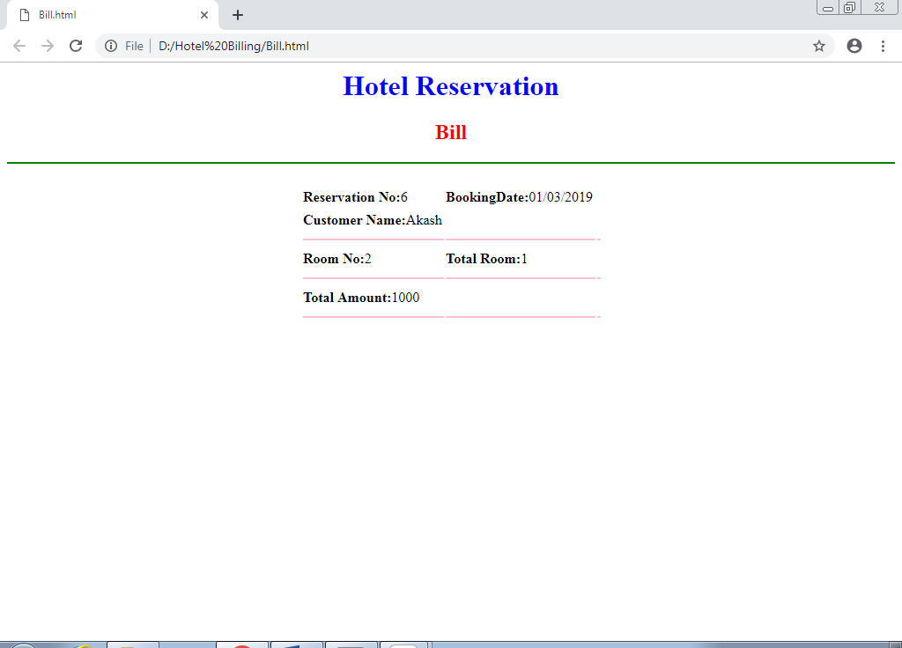

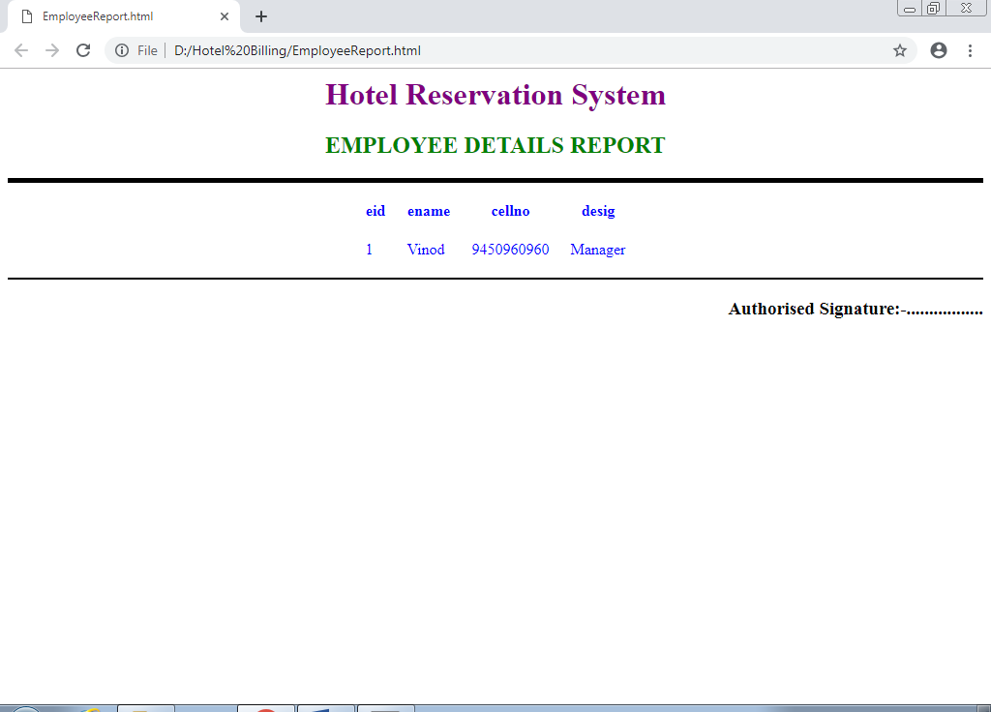

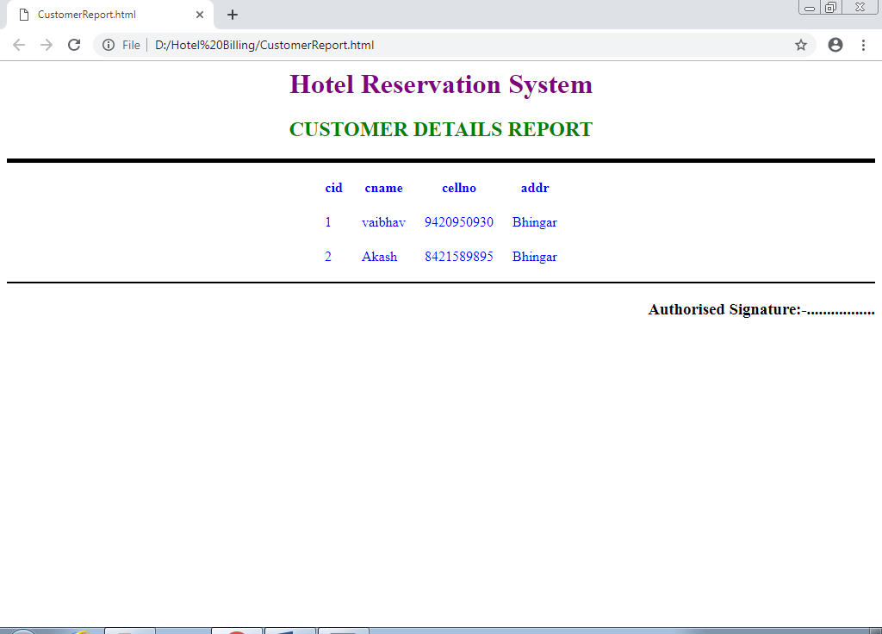

**Database Desgin**

1. CREATE TABLE public.customer

(

cid integer NOT NULL,

cname character varying COLLATE pg_catalog."default",

cellno character varying COLLATE pg_catalog."default",

addr character varying COLLATE pg_catalog."default",

CONSTRAINT customer_pkey PRIMARY KEY (cid)

)

WITH (

OIDS = FALSE

)

TABLESPACE pg_default;

ALTER TABLE public.customer

OWNER to postgres;

1. CREATE TABLE public.emp

(

eid integer NOT NULL,

ename character varying COLLATE pg_catalog."default",

cellno character varying COLLATE pg_catalog."default",

desig character varying COLLATE pg_catalog."default",

CONSTRAINT emp_pkey PRIMARY KEY (eid)

)

WITH (

OIDS = FALSE

)

TABLESPACE pg_default;

ALTER TABLE public.emp

OWNER to postgres;

CREATE TABLE public.login

(

username character varying COLLATE pg_catalog."default",

pass character varying COLLATE pg_catalog."default"

)

WITH (

OIDS = FALSE

)

TABLESPACE pg_default;

ALTER TABLE public.login

OWNER to postgres;

1. CREATE TABLE public.reservation

(

rid integer NOT NULL,

rdate character varying COLLATE pg_catalog."default",

rod integer,

rtype character varying COLLATE pg_catalog."default",

cid integer,

cname character varying COLLATE pg_catalog."default",

cellno character varying COLLATE pg_catalog."default",

qty integer,

rate integer,

totalamt integer,

CONSTRAINT reservation_pkey PRIMARY KEY (rid)

)

WITH (

OIDS = FALSE

)

TABLESPACE pg_default;

ALTER TABLE public.reservation

OWNER to postgres;

1. CREATE TABLE public.room

(

rid integer NOT NULL,

rtype character varying COLLATE pg_catalog."default",

rate character varying COLLATE pg_catalog."default",

rdesc character varying COLLATE pg_catalog."default",

CONSTRAINT room_pkey PRIMARY KEY (rid)

)

WITH (

OIDS = FALSE

)

TABLESPACE pg_default;

ALTER TABLE public.room

OWNER to postgres;