DA 218o – PML: Anime Dataset Probabilistic Analysis Report
Submitted By: Harshavardhan A, Karthik Subburaj, Ishwer Kumar, Sourav Kumar Tripathy

1. Introduction
The motivation is to investigate whether anime titles can be organized into meaningful patterns using features such as popularity, format, source, rating, and genres. The problem spans unsupervised learning, where the objective is to identify latent groups without ground-truth labels, as well as supervised learning tasks including classification (predicting categorical outcomes) and regression (predicting continuous variables such as ratings).

2. Data And Analysis Problem
The data is the 2023 MyAnimeList anime dataset from Kaggle. The analysis used 24,905 anime rows, with no rows dropped and no imputation applied after cleaning. The Kaggle data page describes common use cases such as rating analysis, popularity analysis, recommendation systems, and clustering. This project differs by building a reproducible pipeline, comparing full-space GMM with PCA-reduced GMM, using BIC/AIC for clustering.
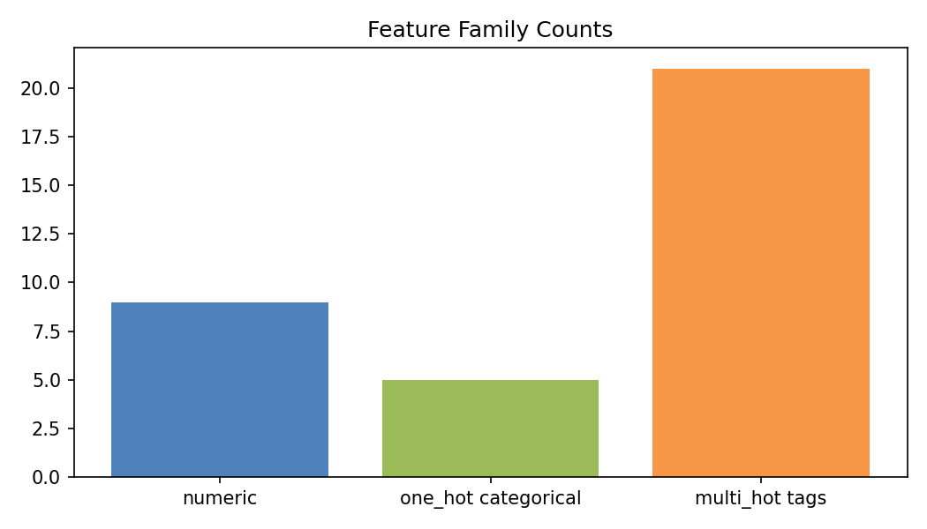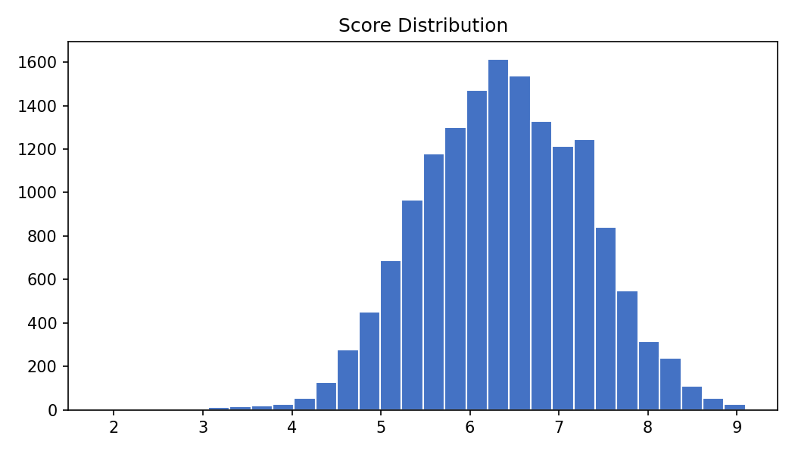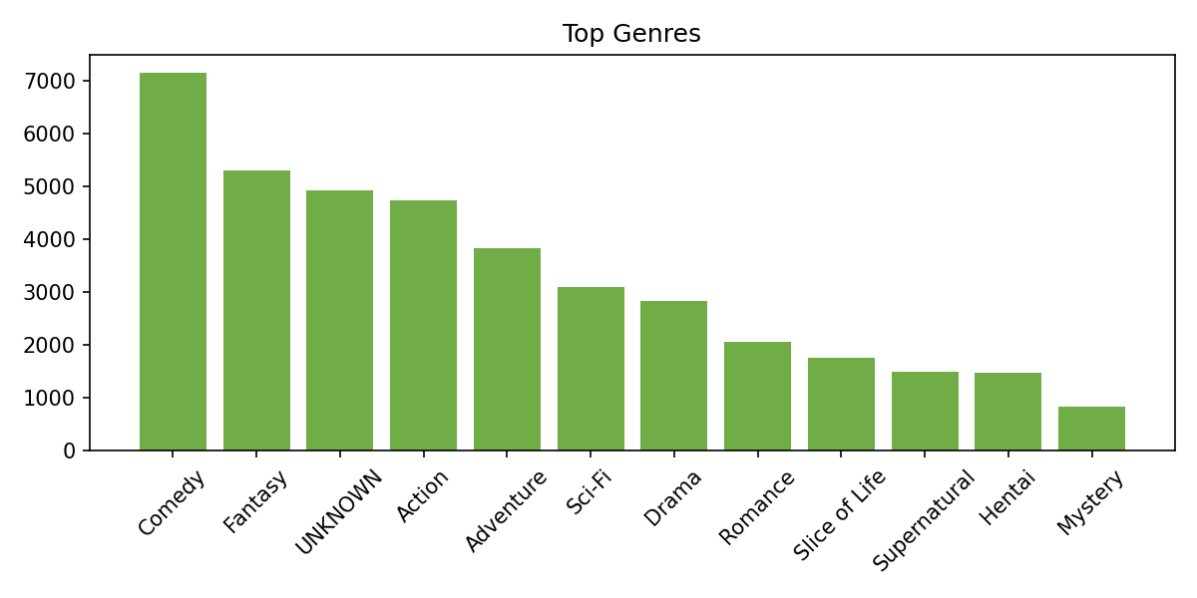
Figure 01: Exploratory Data Analysis

3. Classification Models

4. Regression Models

5. Clustering Models
Two clustering models were analyzed. Model 1 is a full-space GMM fit directly on the 63 engineered features. Model 2 is PCA-GMM: the same feature matrix is reduced with PCA before GMM fitting. PCA retained 21 components and 90.30% of variance. Both models are non-linear mixture models because each cluster has its own Gaussian component and full covariance was allowed.
Model | Representation | Selected K | Covariance | Main Role
GMM | 63 full features | 4 | full | stable high-level segmentation
PCA-GMM | 21 PCA components | 11 | full | finer exploratory segmentation

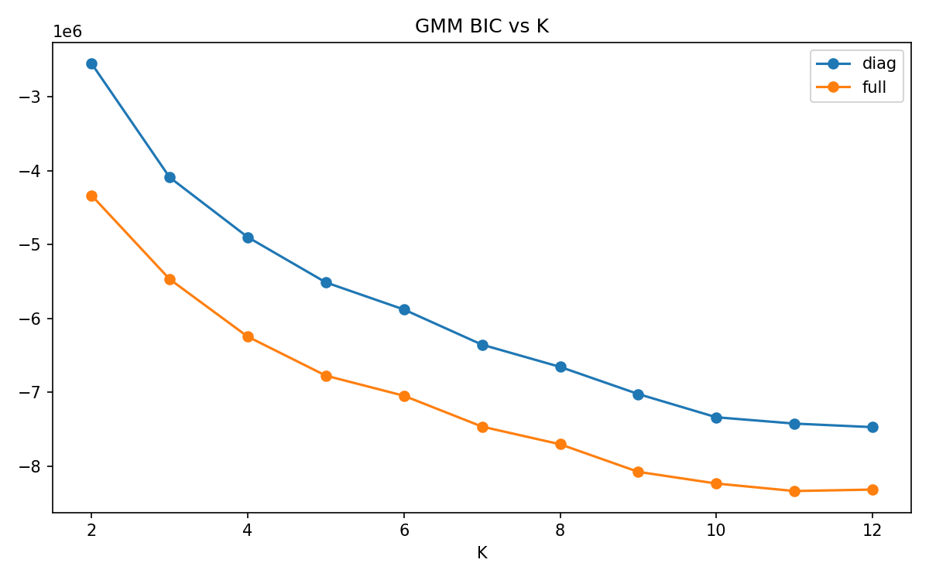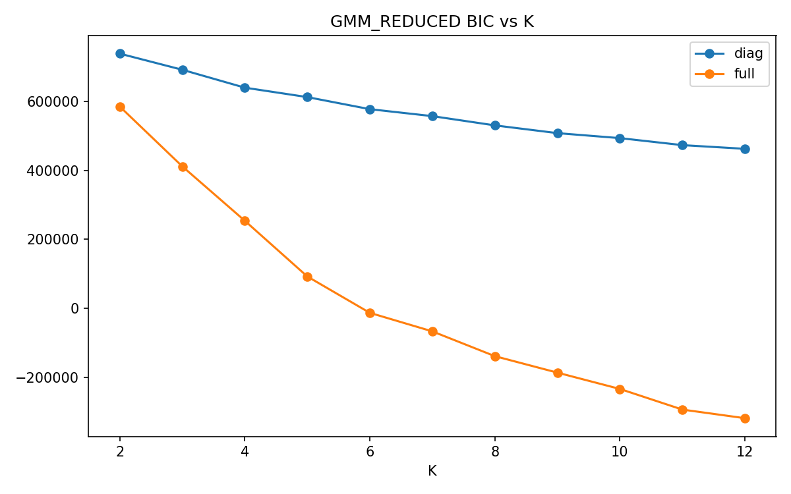
Figure 02: BIC vs K

5.1 Priors
No explicit Bayesian priors were used because “sklearn.mixture.GaussianMixture” is a frequentist estimator. Prior-like choices were weak and practical: covariance regularization reg_covar=1e-6, candidate K from 2 to 12, covariance types diag and full, and guardrails against tiny or degenerate components. These choices avoid singular covariance fits without strongly forcing a specific cluster structure.

5.2 Model Run Options
Both GMM variants used max_iter=300, tol=0.001, n_init=5, init_params=kmeans, and random seed 42. Model selection evaluated candidate K=2..12 with diagonal and full covariance. Stability was checked over five seeds: 42, 43, 44, 45, and 46. The primary selection metric was BIC, and the secondary metric was AIC, with guardrails for size, degeneracy, and stability.

5.3 Convergence Diagnostics
Both final models converged. The full-space GMM converged in 13 iterations with lower bound 127.70. The PCA-GMM converged in 31 iterations with lower bound 6.32. Assignment entropy was very low for both models, indicating decisive assignments. Diagnostics reported covariance_valid=false for both, but this check is conservative because full covariance matrices can contain negative off-diagonal entries; it should be interpreted as a prompt for covariance conditioning checks, not direct failure.

5.4 Performance and Practical Usefulness
This is unsupervised clustering, so classification accuracy is not applicable. Internal and practical metrics were used instead.
Metric | GMM | PCA-GMM
BIC | -6,246,947 | -293,013
AIC | -6,314,521 | -315,611
Silhouette | 0.0578 | 0.0514
Stability ARI | 0.8171 | 0.6264
Stability NMI | 0.7888 | 0.7397
Mean max probability | 0.99995 | 0.99199
Smallest cluster | 4.85% | 0.74%
Both models give confident assignments but low silhouette scores, so they are useful for exploratory metadata segmentation, not for claiming clean geometric separation.

5.5 Sensitivity Analysis
Sensitivity was checked through the K grid, covariance choices, and stability seeds. The full GMM selected K=4 because higher-K candidates had weak stability despite attractive raw BIC/AIC values. PCA-GMM selected K=11; it captured more substructure but had lower stability and one very small cluster. Results are therefore sensitive to the desired tradeoff between stability and granularity.

5.6 Model Comparison
The full GMM is the better reporting model when the goal is stable, high-level segmentation. It produced four broad groups: children’s/original/missing-label titles, prestige/suspense works, mainstream TV/action-romance titles, and a large mixed catalog-tail group.
PCA-GMM is better for exploratory interpretation. It found 11 finer groups, including adult OVAs, movie adventure/sci-fi, pure music entries, original TV/ONA children’s content, specials/OVAs, and small niche/outlier records. Its weakness is lower stability and a 0.74% cluster.

5.7 Issues and Improvements
Main issues are sparse binary features, low silhouette, format-driven clusters, broad residual groups, and imperfect Gaussian assumptions for mixed metadata. Improvements include testing Bayesian GMM, HDBSCAN, categorical-aware distance models, UMAP plus clustering, more robust covariance diagnostics, and external validation using user ratings or recommendation outcomes.

5.8 Conclusion and Insights
The analysis shows that anime metadata clusters strongly by format, source, rating, missingness, popularity, and broad genre mix. Full GMM gives a compact and stable summary. PCA-GMM reveals richer catalog substructure but should be treated as exploratory. The main insight is that the dataset contains meaningful catalog-structure segments, but these are not pure genre taxonomies.

