######################################### How to contribute to robocomp github repository###########################################

In brief the steps involved will be:
- Fork the robocomp repository
- Clone the repository
- Create a new branch
- Switch to the created branch
- Make suitable changes
- Test the changes
- Add the files you want to commit
- Commit the files
- Push to repository
- Compare changes
- Pull a request for the commit made
- Start a discussion regarding you commit

Now each and every step will be explained in detail:

- Forking the repository:

Open the robocomp github repository : https://github.com/robocomp/robocomp

Click on the fork option as shown below:
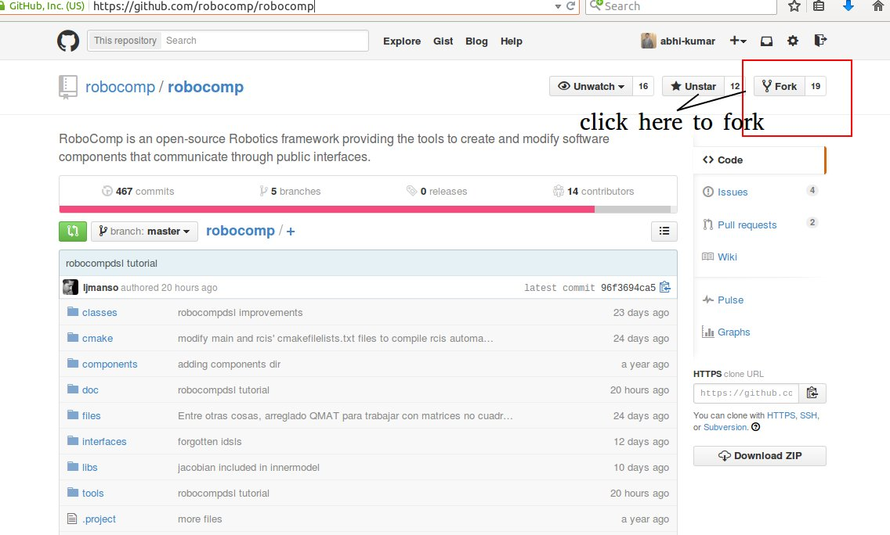

The indication that the repo is forked can be observed as follows:

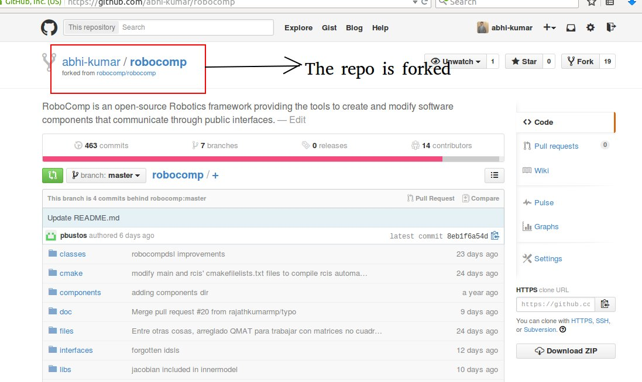

2. Cloning the the repository:

Open a terminal and move to home directory and type: git clone <link to the forked repository>

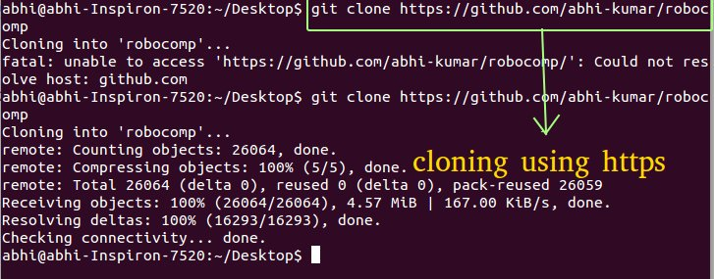

3. Creating a branch:

Open a terminal and move the “pwd” to the place where the forked repository is present.

- First command is “git branch -a”, it provides a list of all pbranches present and indicates the current working branch
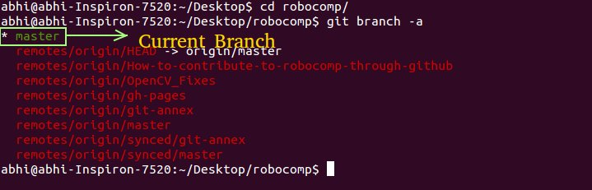

- To Create a new branch type “git branch <branch_name>”. There is no restriction to the <branch_name>, but it is desirable to be related to the changes being made.

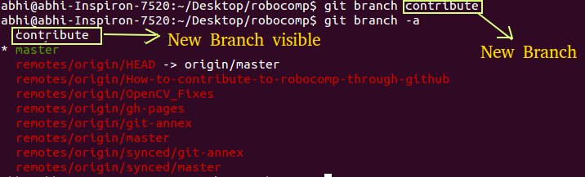

- Next step is to switch to that branch, so type “git checkout <branch_name>”

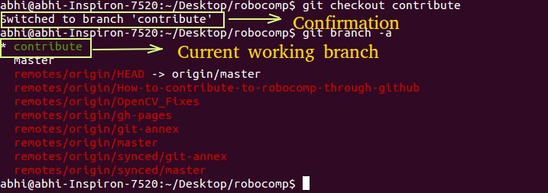

4. Making changes:

Demo : Lets make changes Readme.md

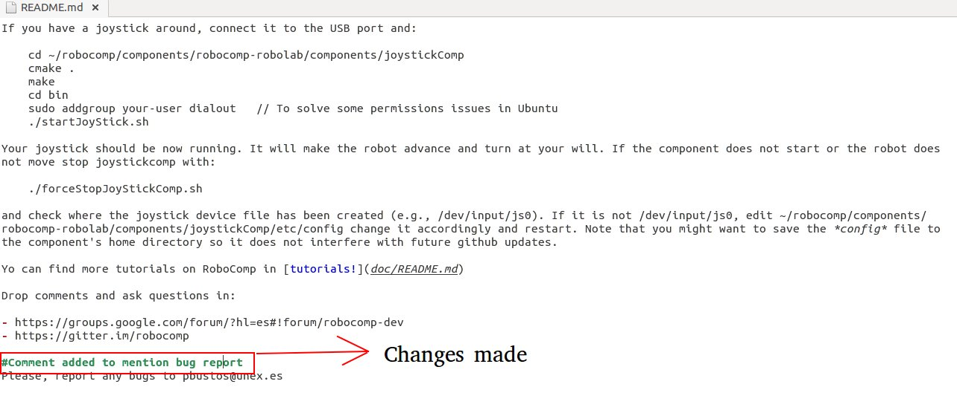
5. Commit the changes made

- First type “ git status”, this command lists all the files to which changes have been made

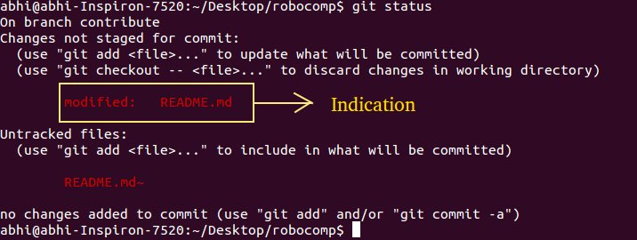
- Next step is to add only those files which we want to commit by typing “git add <filename>”

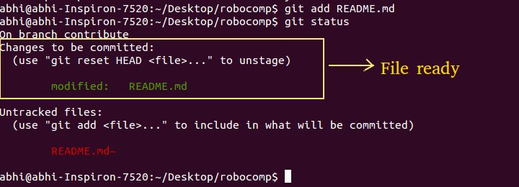

- Now its time to commit the changes, so use command “ git commit -m '<heading>'

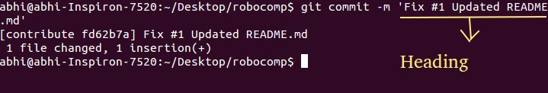

6. Push the commit to repository

Use the command “git push origin <current_working_braanch_name>”

7. Compare and pull request
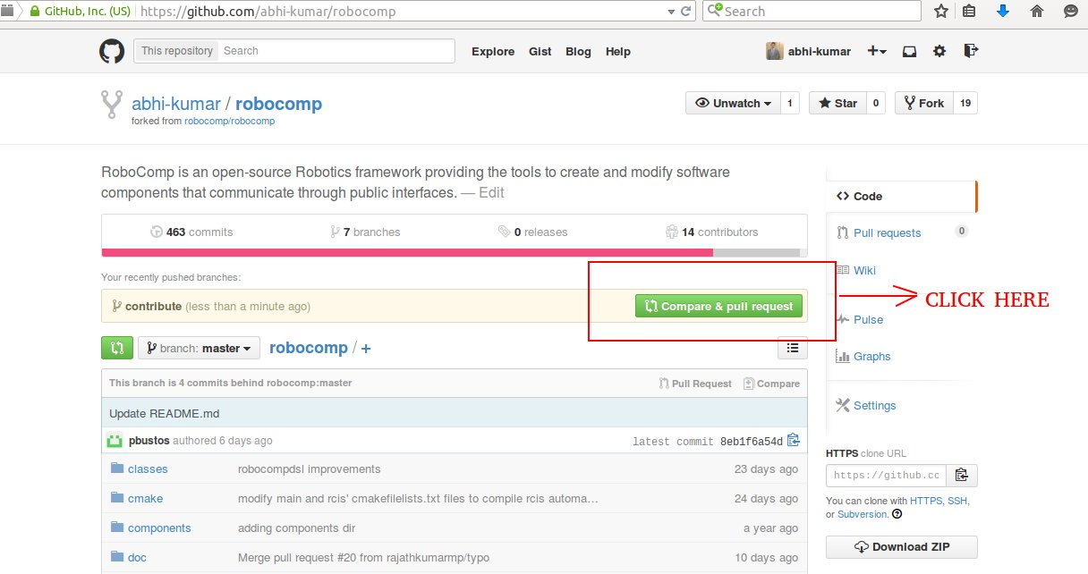

8. Now its time to discuss over the pull-request in detail with the rest of the contributing team

