KMC Hackathon 1.0 Project Report

Project Title: Smart Glasses for dementia patient’s
Team Name: Cosmic byte
Team Members: Rajat Pandey, Samip Khatiwada, Anupama Poudel
Mentor: __Santosh Sharma

1. Abstract
In the chaotic living hood of today’s world, the mental pressure has been significantly increasing
Although the world is getting advance. The outcome of this comes as an illness “dementia”, mostly in older people. Our project immediate A AI based smart glasses which helps people with dementia to recognize individuals. The glasses store details of individual and appear when encountered.

2. Problem Statement
The project “Smart Glasses for Dementia” aims to address these challenges by designing a wearable assistive device that helps dementia patients with orientation, memory support, and safety. By integrating features such as visual and voice reminders, person recognition, and location awareness, the smart glasses seek to enhance independence, reduce confusion, and improve the overall quality of life for people living with dementia while also supporting caregivers.

3. Existing System
Existing support systems and caregiving methods are often limited, expensive, or require constant human supervision, which may not always be available. Many technological solutions are either too complex for dementia patients to use or fail to address their real-time needs in a simple and non-intrusive way. Therefore, there is a need for an assistive solution that is user-friendly, portable, and capable of providing real-time guidance and reassurance.

4. Proposed Solution
The system will use visual and voice-based prompts to help users recognize familiar people, remember daily tasks such as taking medication, and understand their current location and time. Built-in sensors, a camera, and GPS technology will allow the glasses to detect surroundings, identify pre-registered faces, and alert caregivers in case of emergencies or unusual behavior.
The glasses are designed to be lightweight, aesthetically pleasing, and easy to use, minimizing confusion and discomfort for dementia patients. By enhancing independence, reducing anxiety, and supporting caregivers, the proposed solution seeks to improve the overall quality of life for people living with dementia.

5. Objectives
To help dementia patients recognize familiar people and surroundings
• To provide reminders for daily activities such as medication and schedules
• To enhance safety and independence while reducing dependence on caregiver.

To understand and apply AI, machine learning, and computer vision concepts in a real-world project.

To demonstrate that students can build assistive technology using basic hardware and programming skills.

To create a low-cost and accessible solution using open-source software.

6. Technology Used
Frontend:
- HTML: Structure for camera view, control panels, face info cards
- CSS: Styling for glasses-like overlay, animations, responsive design
- JavaScript: Face detection logic, UI interactions, backend API calls

Backend:
- Python (Flask): REST API for face recognition and storage
- OpenCV: Face detection and encoding
- API Endpoints: /recognize, /add_face, /get_faces

Database & Storage:
- Firebase / Firestore: Store face encodings, person metadata, usage logs
- Authentication: Secure user access management
- Real-time Sync: Immediate updates across devices

Additional Features:
- QR Code Tool: Generate QR codes for device pairing
- User Onboarding: Quick setup for new patients/caregivers
- Share Feature: Export face database via QR codes
Devices & Deployment:
- Development: Laptop for testing
- Deployment: Smartphone as portable glasses interface
- Future: Raspberry Pi for embedded glasses hardware

7. System Wireframe
The following wireframes show the basic layout of the system interfaces .
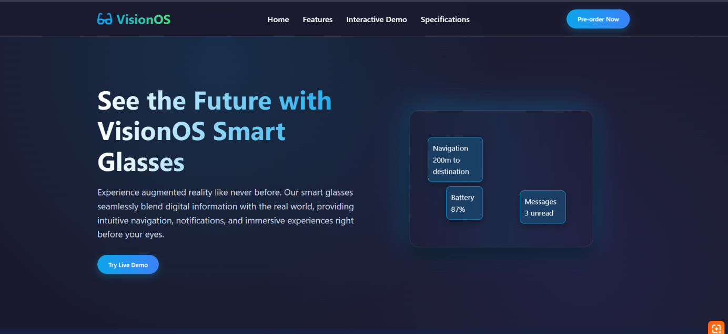Figure 1: The frontend of the system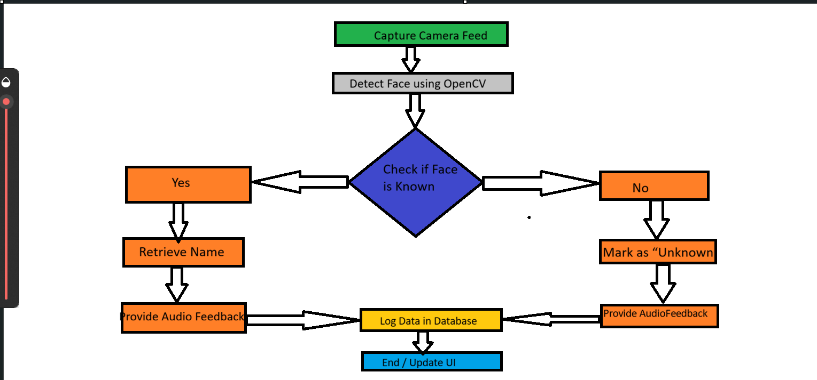
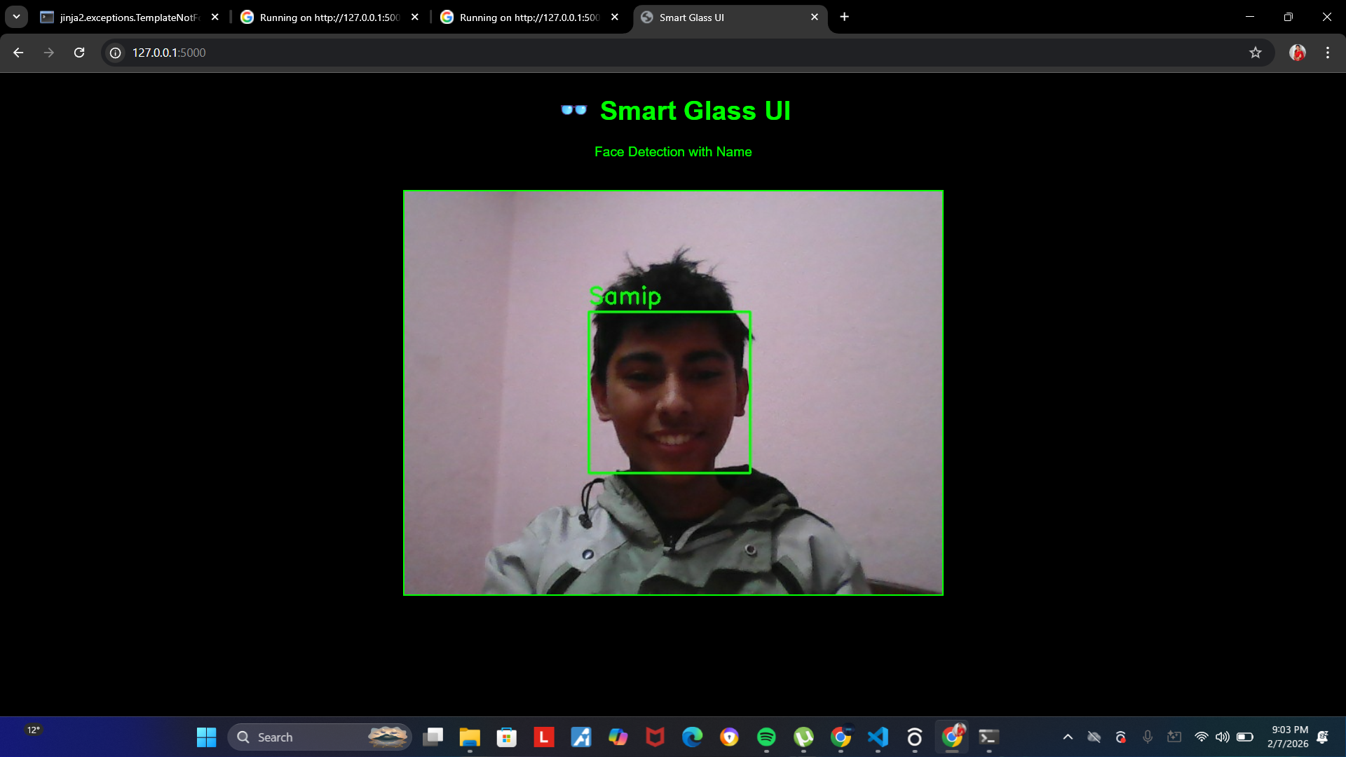
Figure 2: Working system for our group member samip khatiwada

8. Results
The smart glasses system detected human faces in real time and successfully recognized known individuals whose images were stored in the dataset, while identifying unknown people as “unknown.” It provided audio feedback by speaking the recognized person’s name through speakers or earphones. Face recognition performed best under good lighting and when the face was clearly visible.

9. Advantages
1.Helps dementia patients remember people, places, and daily tasks, reducing confusion
2. Improves safety and independence while lowering the burden on caregivers

10. Limitations
Accuracy decreases in poor lighting or when the face is partially hidden.
Performance may slow down with large datasets or multiple faces in view.

11. Future Improvements
Assist elderly and memory-impaired users by identifying family and friends.
Help visually impaired people recognize people nearby.
Improve personal safety by alerting users to unknown individuals.
Enable smart classrooms for automatic student identification and attendance.
Support hospitals in quickly recognizing patients.
Enhance workplace security through employee identification.
Aid police and security forces in identifying missing persons or suspects.

12. Conclusion
Dementia is an increasing global health challenge that affects memory, thinking, and daily functioning. The proposed Smart Glasses for Dementia offer an innovative and practical assistive solution by providing real-time reminders, person recognition, and safety support. Although there are some limitations such as cost and technological dependence, the smart glasses have the potential to improve independence, reduce confusion, and enhance the quality of life of dementia patients while supporting caregivers. With further development and accessibility, this technology can play an important role in dementia care in the future.

