REAL-TIME INDUSTRIAL PPE DETECTION USING YOLO AND OPENCV
Author Name (Hrishikesh Lad), Department of Mechatronics Engineering, Symbiosis skills and professional university
Email: [ladhrishikesh3@gmail.com]

Abstract
Industrial workplaces require workers to use appropriate personal protective equipment (PPE), including safety helmets, high-visibility vests, gloves and safety shoes. Manual supervision can be inconsistent in busy environments and may not provide continuous coverage. This paper presents a computer-vision-based PPE monitoring prototype using the You Only Look Once (YOLO) object-detection family and OpenCV. A camera supplies video frames, YOLO predicts PPE-related object locations and classes, and OpenCV displays annotated frames for monitoring. The detector was trained on a five-class subset (person, gloves, helmet, shoes and safety vest) of the SH17 dataset, split 80/10/10 into 6,479 training, 810 validation and 810 test images. On the test subset, the model reached an overall precision of 60.47%, recall of 51.86%, mAP@0.50 of 52.13% and mAP@0.50–0.95 of 33.88%. Person detection was strongest (mAP@0.50 of 87.2%), whereas gloves (37.5%) and safety vests (35.7%) were the most difficult classes. These results show that PPE-specific detection remains challenging. Detection output alone is not proof of worker-level compliance, which requires an additional association and rule-evaluation stage. The prototype can support safety observation, but should not be treated as a replacement for certified safety procedures or human supervision.

I. INTRODUCTION

A. Background and Motivation
Personal protective equipment reduces exposure to common workplace hazards when selected correctly and worn as intended. In manufacturing, construction and maintenance areas, safety helmets protect the head, high-visibility vests improve worker body visibility, gloves protect the hands from task-specific hazards, and safety footwear helps protect the feet. PPE compliance is often checked through routine inspections or camera review. Continuous manual observation, however, can be difficult where multiple workers, changing tasks, partial occlusion and variable lighting are present.
Computer vision offers a way to assist safety personnel by locating visible PPE items in images or video. YOLO-style detectors perform object localization and classification in a single inference pipeline, making them suitable candidates for applications where processing latency matters. OpenCV can acquire camera frames, resize or transform them when required, display model outputs and save selected frames for review.

B. Problem Definition
The project addresses the need for an automated visual aid that detects selected PPE categories from a live camera feed and highlights potential omissions. The core challenge is not only to detect a helmet, vest, glove or shoe, but also to determine whether the detected item belongs to a particular. Occlusion, small object size, distant workers and class imbalance may reduce detection reliability.

C. Objectives and Contributions
- Develop a camera-based PPE detection prototype using YOLO and OpenCV for images and live webcam footage.
- Detect five classes selected from the SH17 dataset: person, gloves, helmet, shoes and safety vest.
- Display class labels, confidence scores and bounding boxes on video frames.
- Provide a framework for identifying possible PPE non-compliance and recording test observations.
- Evaluate the detector on a held-out test subset using precision, recall, mAP@0.50, mAP@0.50–0.95, per-class results and confusion matrices, rather than assumed performance values.

II. LITERATURE REVIEW
Redmon et al. introduced YOLO as a unified object-detection approach that predicts bounding boxes and class probabilities directly from an image [1]. The single-stage design helped establish a practical direction for applications requiring detection speed. Later YOLO versions and implementations have continued to be used for real-time object detection, including workplace monitoring.
Research specifically focused on PPE detection shows that the task involves more than general object recognition. The SH17 dataset provides 8,099 annotated images and 75,994 instances across 17 classes collected from industrial environments, offering a benchmark for detecting people and safety equipment [2]. Its reported baseline experiments also illustrate that performance differs between classes; small or less frequent classes can be harder to detect than common classes.
A 2024 IEEE conference paper investigated YOLOv8 for PPE detection and compared model variants using metrics such as precision, recall, F1-score and average precision [3]. Recent research has also explored helmet and glove detection in power-grid environments, highlighting challenges caused by crowding, lighting changes, posture variation and occlusion [4]. These studies support the use of deep object detectors while also showing why results from one dataset or workplace should not be assumed to transfer directly to another.
Ultralytics documents a Construction-PPE dataset containing labels for people, helmets, gloves, vests, boots and several missing-equipment categories [5]. Such datasets can help build a prototype, but class names and annotation conventions must match the model configuration. For example, detecting a helmet object does not automatically prove that every visible worker is wearing a helmet. A separate association or compliance rule is required.

A. Research Gap
The practical gap addressed by this mini project is the integration of object detection with a straightforward camera-based monitoring interface. A useful prototype should show the model's visible detections and make its limitations clear. Worker-level compliance, especially for gloves and shoes, remains difficult when body parts are hidden or too small in the image. Therefore, the system should report only what is supported by its detections and test conditions.

III. PROBLEM STATEMENT AND SCOPE
The proposed system processes video frames to detect selected PPE items and visually flag possible safety violations. The scope is limited to visible equipment in the camera view and to the classes available in the trained model. It does not verify the certification, condition or correct fit of PPE. It also cannot determine whether a specific item is legally required for a worker's task unless the applicable rules are encoded separately.

A. Expected System Output
- Live video with bounding boxes and predicted PPE class labels.
- Confidence values for individual detections.
- A compliance indication only where the implemented logic can reasonably associate PPE with a worker.
- Optional snapshots or logs for later review, if implemented in the prototype.

IV. PROPOSED SYSTEM ARCHITECTURE
The architecture consists of four logical stages: video acquisition, object detection, compliance interpretation and display/output (Table I). The camera captures frames. OpenCV [7] supplies the frames to the YOLO model. The model returns class predictions, confidence scores and bounding-box coordinates. A post-processing stage filters detections using the configured confidence threshold and, if implemented, associates PPE detections with workers. Finally, OpenCV renders the annotated frame and any warning message. Fig. 1 shows the complete workflow, from dataset preparation and training through offline evaluation and real-time inference.
TABLE I. Stages of the PPE detection pipeline
Stage | Input | Operation | Output
1. Video acquisition | Webcam/CCTV frames | Capture and prepare frames using OpenCV | Image frames
2. YOLO detection | Prepared frame | Predict object classes, boxes and confidence | PPE/person detections
3. Compliance logic | Detection boxes and classes | Apply class and association rules | Possible compliance status
4. Visual output | Detections/status | Draw labels, boxes and warnings | Annotated live video

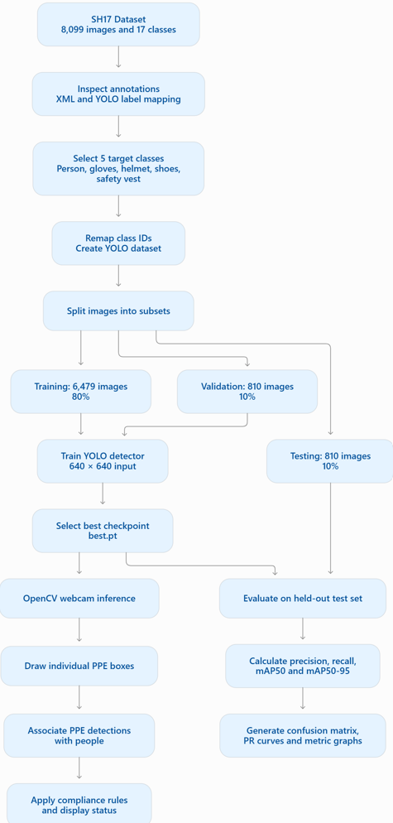
Fig. 1. Workflow of the proposed system: SH17 preparation, five-class remapping, 80/10/10 split, YOLO training, held-out evaluation and real-time webcam inference with PPE association and compliance display.

A. Detection and Compliance Logic
For each frame, the detector produces a set of predictions. A prediction may be represented as (c, s, x, y, w, h), where c is the predicted class, s is the confidence score, (x, y) is the box centre, and w and h are box width and height. Predictions below a selected confidence threshold may be discarded. The remaining detections are visualized and passed to the compliance logic.
A basic rule can mark an equipment class as detected when at least one prediction for that class remains after filtering. However, worker-level status requires association between each person and the relevant equipment. Spatial heuristics, such as checking whether a helmet box overlaps the upper region of a person box, can be used as a simple starting point, but they can fail when workers overlap or are partly outside the frame. If the current implementation only displays object detections, it should be described as PPE detection rather than as fully validated worker-level compliance.

B. System Flow
Start → initialize camera and load trained weights → capture frame → run YOLO inference → filter predictions → apply implemented compliance rules → draw bounding boxes and labels → display/save output → repeat until the user exits. If the camera cannot be opened or the model cannot be loaded, the program should report the error and stop safely.

V. MATERIALS AND METHODS

A. Dataset
The SH17 dataset was used as the primary dataset for the five-class PPE detector. SH17 was published for detecting human safety and PPE in manufacturing environments and contains 8,099 annotated images with approximately 75,994 object instances across 17 original classes [2]. Its repository specifies a CC BY-NC-SA 4.0 license, so the terms should be checked before redistributing the data or using the work commercially [8]. The original annotations were inspected and converted into a five-class YOLO-compatible dataset. Table II summarizes the dataset configuration.
TABLE II. Dataset configuration
Parameter | Value
Dataset | SH17 PPE dataset
Original images | 8,099
Original annotated classes | 17
Classes selected | 5 (person, gloves, helmet, shoes, safety vest)
Annotation format | YOLO bounding-box labels
Training images | 6,479
Validation images | 810
Test images | 810
Split ratio | 80% / 10% / 10%
Random split seed | 42
Model input size | 640 × 640

Dataset leakage occurs when information from the test set becomes available during training or model selection, resulting in overly optimistic estimates of generalization performance. In PPE detection, leakage can occur when near-duplicate images, frames from the same video, or images sharing highly similar scenes appear across training, validation, and test subsets.
For this project, the SH17 dataset was divided at the image level using a randomized 80:10:10 split with seed 42:
Subset | Images | Proportion
Training | 6,479 | Approximately 80%
Validation | 810 | Approximately 10%
Testing | 810 | Approximately 10%
Total | 8,099 | 100%
The split was performed before model training, and the test subset was reserved for final evaluation. However, a fixed random seed ensures reproducibility of the split; it does not guarantee the absence of duplicate images or related scenes across subsets.
Because the current split was randomized by image, we have not established that images from the same video sequence, capture session, or background setting were grouped exclusively into one subset. Consequently, the possibility of scene-level or near-duplicate leakage cannot be ruled out.

B. Class Selection and ID Remapping
The original SH17 class IDs were remapped into a new five-class label set with identifiers 0 to 4 (Table III). The remaining 12 classes were excluded from the model's selected labels. The preparation script retained all images and created empty label files where no selected class was present.
TABLE III. Class ID mapping from SH17 to the five-class set
New ID | Class | Original SH17 ID
0 | Person | 0
1 | Gloves | 9
2 | Helmet | 10
3 | Shoes | 14
4 | Safety vest | 16

C. Data Preparation
The images were divided into training, validation and test subsets using an 80:10:10 split, giving 6,479, 810 and 810 images respectively. The split was performed at image level with a random seed of 42, which makes it reproducible if the same input files, ordering and splitting procedure are used. Image–label correspondence was preserved and the files were organized into YOLO-compatible train, validation and test directories. The split was made before training so that test images were not used to tune model parameters. Model input images were resized to 640 × 640 pixels.
Two limitations apply. First, an empty label file means only that an image has no selected-class annotations; it does not prove that a worker is non-compliant. Second, a random image-level split may allow visually similar or duplicate scenes to appear in more than one subset, so the dataset should be checked for leakage before making strong generalization claims.

D. Software and Hardware
The minimum hardware configuration is a computer capable of running the selected YOLO model and a webcam or recorded video source. A dedicated GPU can improve inference speed but is not mandatory for a small prototype; actual speed depends on model size, image resolution and hardware. The software stack (Table IV) consists of Python, the Ultralytics YOLO implementation on PyTorch, and OpenCV, with NumPy and Matplotlib used to generate metric graphs. Development was carried out on Windows in an isolated Python virtual environment.
TABLE IV. Software and equipment used
Component | Use in the project | Status
Python | Programming and experiment scripts | Usedk,
Ultralytics YOLO | Training, prediction and evaluation | Used
PyTorch | Deep-learning framework underneath YOLO | Used via Ultralytics
OpenCV (cv2) | Webcam capture and drawing detections | Used in live detection
NumPy | Numerical operations for graph generation | Used in graph script
Matplotlib | Metric visualization | Used in graph script
SH17 | Main five-class training/evaluation dataset | Used
Webcam | Live video input | Used in live detection
Windows | Development environment
Python venv (.venv) | Dependency isolation

E. Model Training and Inference Pipeline
The model was fine-tuned with annotations for the five selected classes using transfer learning, rather than training all weights from scratch. A generic pretrained detector should not be assumed to recognize gloves or safety shoes unless those categories are in its training labels. The training script initialized from an earlier improved checkpoint the detector predicts bounding boxes, class labels and confidence scores for the five classes on resized image inputs. At runtime, the program loads the trained weights (best.pt) once, reads frames from OpenCV, performs inference and renders the returned detections. To maintain a stable frame rate, the implementation may need to balance image size, model complexity and the number of frames processed per second.
The training script specified 50 epochs, an image size of 640, a batch size of 4, zero data-loader workers and CPU training. These values should be reported as experimental settings only if they match the run that produced the final best.pt. The remaining configuration and environment details to be recorded are listed in Table V.
TABLE V. Training configuration and environment details
Item | Value
Python / package versions | Ultralytics 8.4.187 Python-3.14.5 torch-2.14.1+cpu
Hardware / OS | CPU (13th Gen Intel Core i5-13420H) , RAM 16 gb, GPU CUDA available , Windows
Model architecture / checkpoint | YOLO
Epochs | 50 per training script
Image size | 640 × 640
Batch size | 4 per training script
Workers / device | 0 / CPU per training script
TABLE V.II- Bench marking results
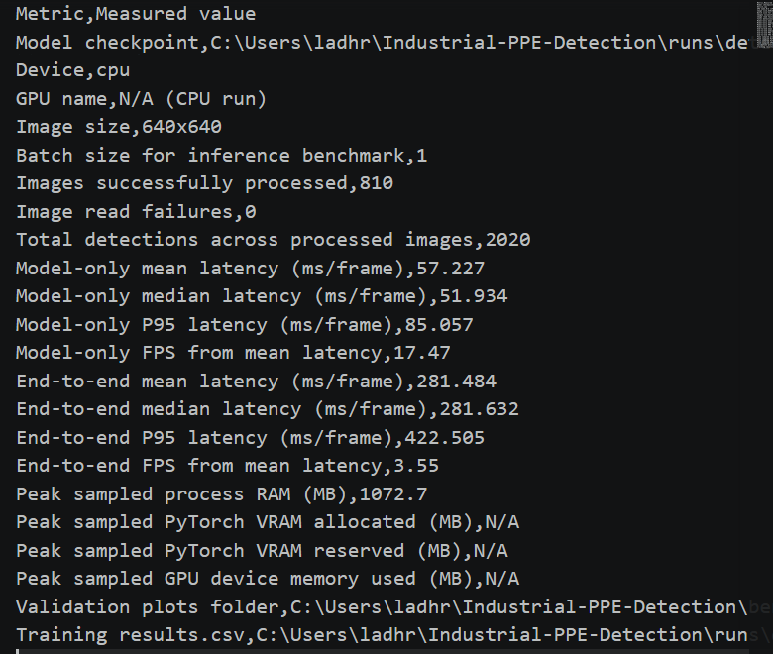

TABLE V.III- training and validation loss curve

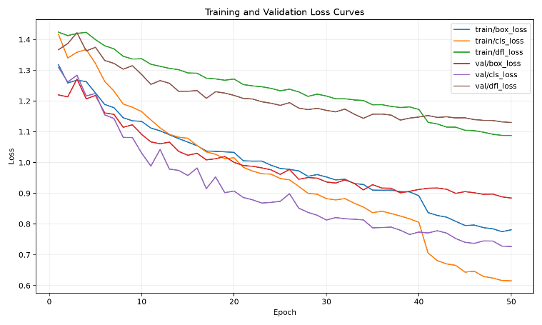

F. Real-Time Detection
For real-time inference, webcam frames were acquired using OpenCV and processed by the trained YOLO model. The system visualizes detected objects using class labels, confidence scores and bounding boxes, together with status indicators. Webcam frame rate and end-to-end latency should be reported separately if they are measured.

G. Compliance Decision
The detection output is not, by itself, proof of compliance. A complete system should define which PPE items are required for each work zone or task, associate detected items with individual workers and handle missing or uncertain detections. A worker-level compliance decision therefore requires an additional association and rule-evaluation stage, and object-detection performance alone was not treated as proof of PPE compliance. In this prototype, only rules that were actually coded should be reported. If no person-to-PPE association was implemented, this limitation should be stated explicitly and the system output should be interpreted as object detection.

H. Worker-to-PPE Association Using Bounding Box Geometry
Detecting PPE items independently does not guarantee that the detected equipment belongs to a particular worker. To improve compliance assessment, a geometric association method based on Bounding Box Intersection over Union (IoU) and centroid distance is proposed.
Each detected object is represented by a bounding box:
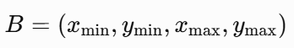
For a person bounding box \(B_p\) and PPE bounding box \(B_e\), their Intersection over Union is defined as:
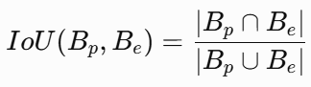
However, ordinary IoU alone is insufficient for every PPE category. For example, a helmet occupies only a small portion of the person's bounding box. Therefore, category-specific spatial constraints can improve the association process.
- Helmet: Check whether the helmet's centroid lies near the upper region of the person's bounding box.
- Safety vest: Check whether the vest overlaps the person's torso region.
- Gloves: Check whether glove detections are near the person's hand regions, when these regions can be estimated reliably.
- Safety shoes: Check whether shoe detections are near the lower region of the person's bounding box.
Proposed pseudo-code

for person in detected_people:
upper_region = top_quadrant(person.box)
torso_region = torso_area(person.box)
lower_region = bottom_quadrant(person.box)

for ppe in detected_ppe:
if ppe.class_name == "helmet":
score = spatial_overlap(ppe.box, upper_region)

elif ppe.class_name == "safety-vest":
score = spatial_overlap(ppe.box, torso_region)

elif ppe.class_name == "shoes":
score = spatial_overlap(ppe.box, lower_region)

elif ppe.class_name == "gloves":
score = distance_to_estimated_hands(
ppe.box, person.box
)

if score >= association_threshold:
associate(ppe, person)

for person in detected_people:
evaluate_required_ppe(person)
report_missing_or_detected_items(person)

ere, spatial_overlap, top_quadrant, and distance_to_estimated_hands are conceptual helper functions that must be implemented and tested. Hand-position estimation may require a pose-estimation model or a dedicated hand detector. The association threshold should be selected using validation data rather than assumed to be universally optimal.
A more robust implementation can combine spatial overlap, normalized centroid distance, detection confidence, and temporal consistency across video frames. This helps reduce incorrect associations when several workers are close together.
Important limitation: This is a proposed enhancement, not a verified capability of the current model. The existing logic that marks a person green whenever any PPE box is inside the person's box is not sufficient to verify that every required PPE item is worn by the correct worker.

VI. EVALUATION METHODOLOGY AND METRICS
The trained model was evaluated on the held-out test subset, and representative live video clips not used for training may be used for qualitative testing. Live testing should include compliant and non-compliant examples where available, different distances, lighting conditions, occlusions and multiple-worker scenes, with the same confidence threshold and inference settings across runs. Predictions were compared with ground-truth labels using precision, recall, mAP@0.50 and mAP@0.50–0.95, supplemented by per-class results, confusion matrices and precision–recall curves [9].
Precision measures the proportion of predicted positives that are correct:
Precision = TP / (TP + FP)
Recall measures the proportion of ground-truth positives that are detected:
Recall = TP / (TP + FN)
Here, TP denotes true positives, FP false positives and FN false negatives under the chosen matching and confidence criteria. Mean average precision (mAP) summarizes average precision across classes; mAP@0.50 uses an intersection-over-union (IoU) threshold of 0.50, while mAP@0.50–0.95 averages across multiple IoU thresholds [6]. In a real-time application, inference latency or frames per second (FPS) should also be measured on the stated hardware.

VII. RESULTS AND DISCUSSION

A. Overall and Per-Class Performance
The model achieved 60.47% precision, 51.86% recall, 52.13% mAP@0.50, and 33.88% mAP@0.50–0.95. Person detection performed best (87.2% mAP@0.50), followed by helmets (52.4%) and shoes (47.8%). Gloves (37.5%) and safety vests (35.7%) showed the weakest performance. The lower mAP@0.50–0.95 scores indicate limited localization precision at stricter IoU thresholds, highlighting the need to investigate class imbalance, annotation quality, and training strategies.
TABLE VI. Per-class and overall test results
Class | Precision | Recall | mAP@0.50 | mAP@0.50–0.95
Person | 84.0% | 84.1% | 87.2% | 69.4%
Gloves | 48.1% | 37.8% | 37.5% | 23.7%
Helmet | 63.7% | 51.9% | 52.4% | 32.1%
Shoes | 60.0% | 43.9% | 47.8% | 24.9%
Safety vest | 46.4% | 41.5% | 35.7% | 19.2%
Overall | 60.47% | 51.86% | 52.13% | 33.88%

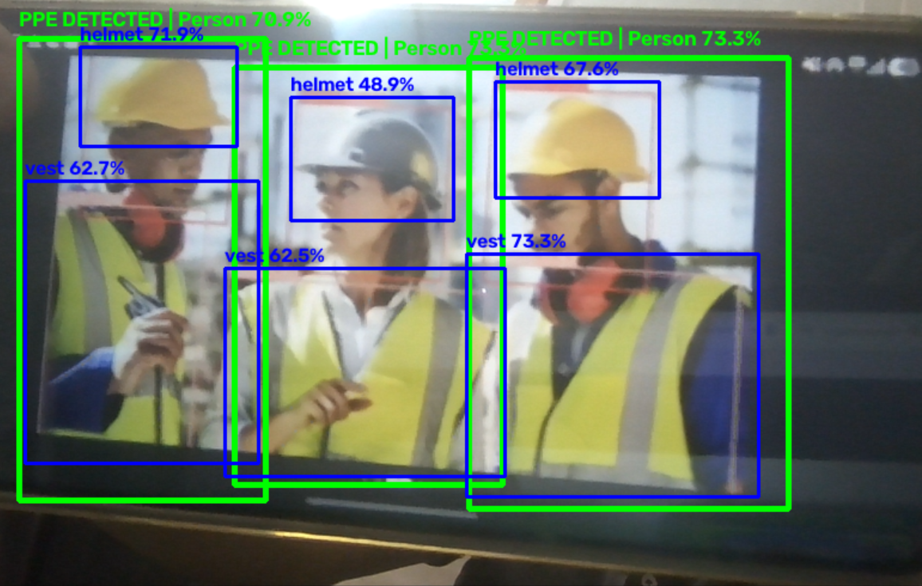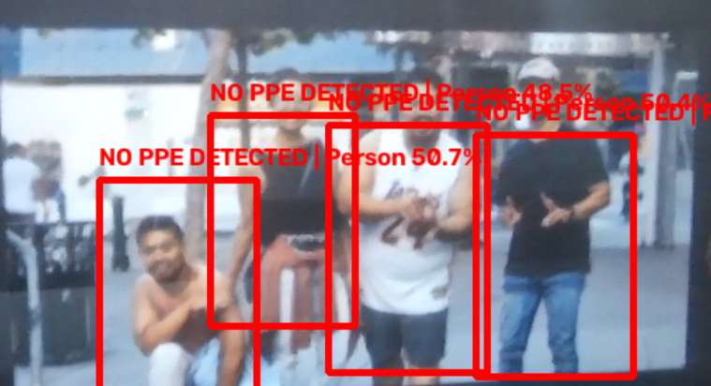
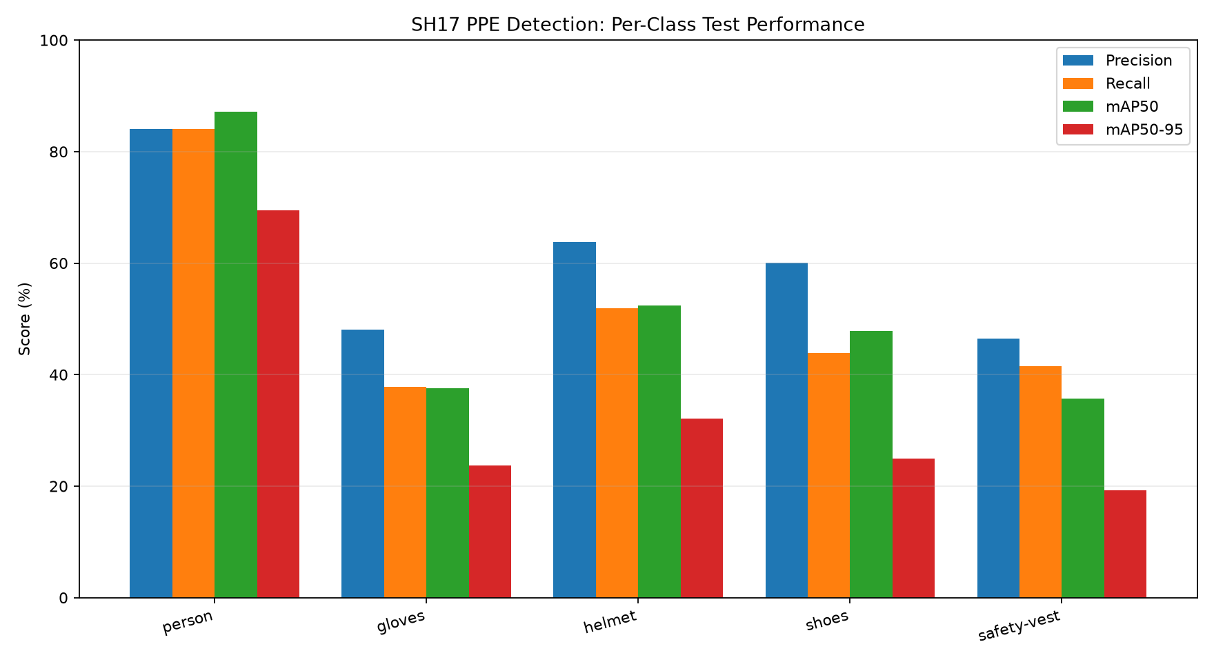
Fig. 2. Per-class test performance: precision, recall, mAP@0.50 and mAP@0.50–0.95.

B. Precision–Recall and Confidence Curves
The precision–recall curves (Fig. 3) gives per-class average precision at IoU 0.50 of 0.872 for person, 0.375 for gloves, 0.524 for helmet, 0.478 for shoes and 0.357 for safety vest, and 0.521 for all classes, consistent with Table VI. The F1–confidence curve (Fig. 4) peaks at 0.56 for all classes at a confidence of 0.219, so a threshold near 0.22 gives the best overall balance of precision and recall. Precision rises with confidence (Fig. 5), reaching 0.92 for all classes at a confidence of 0.867, while recall falls steadily as the threshold rises (Fig. 6), from 0.74 at a confidence of 0. The operating threshold should therefore be chosen according to whether missed PPE or false alarms are more costly in the intended deployment.
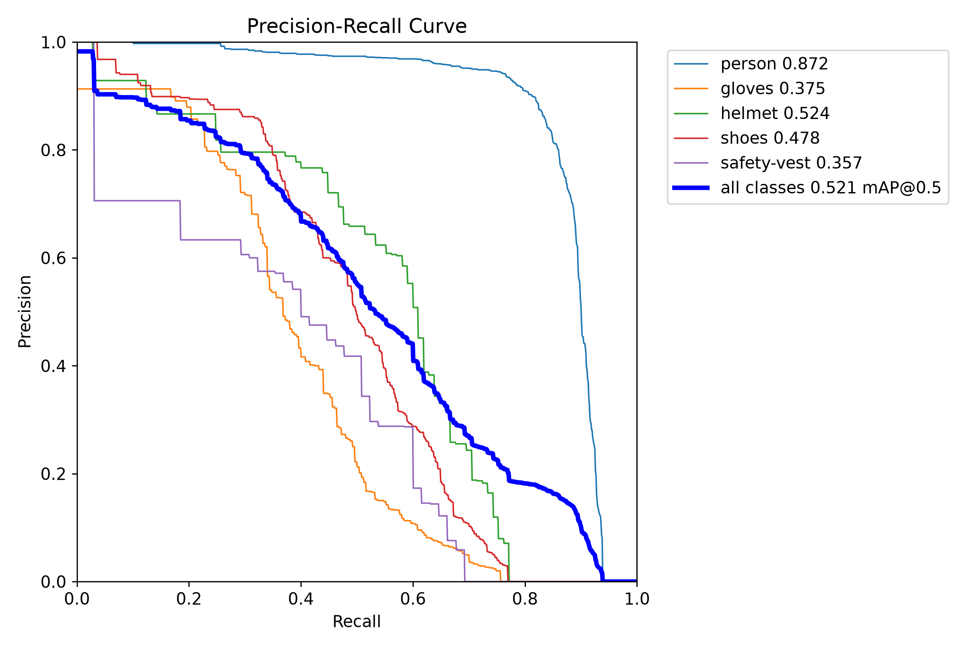
Fig. 3. Precision–recall curves for each class and all classes (mAP@0.50 = 0.521).
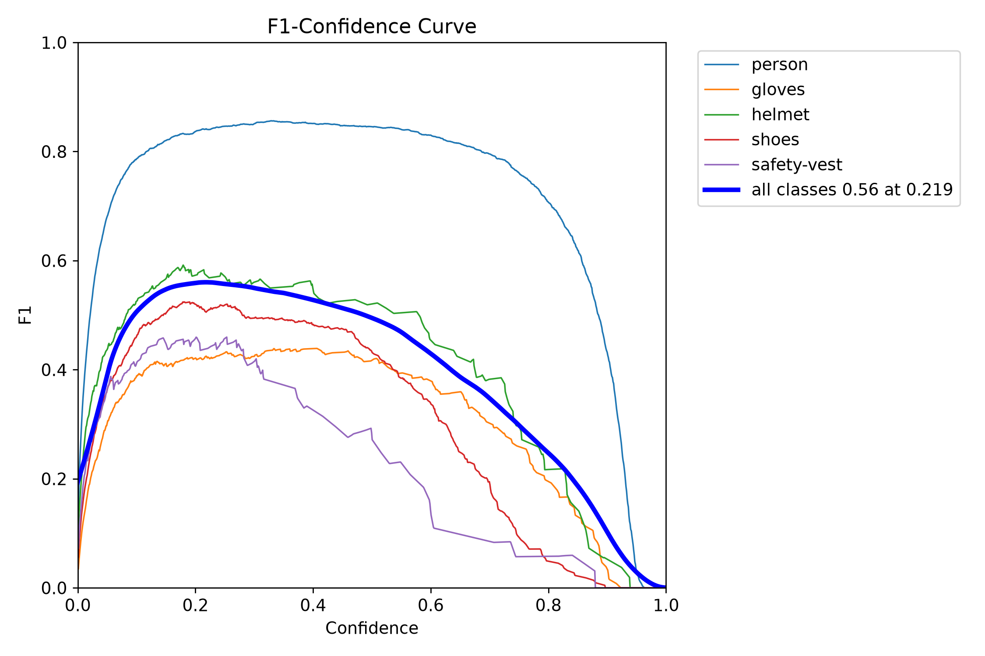
Fig. 4. F1–confidence curves (all classes: 0.56 at confidence 0.219).
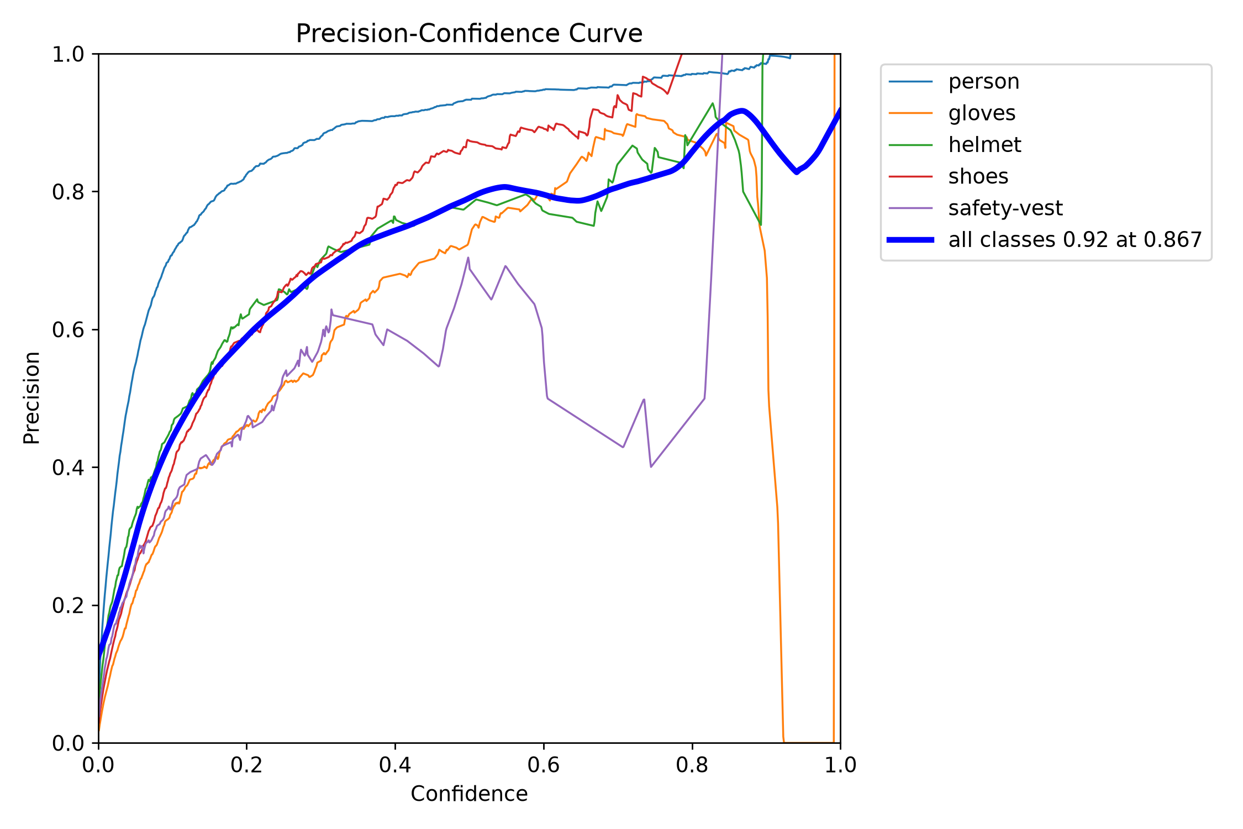
Fig. 5. Precision–confidence curves (all classes: 0.92 at confidence 0.867).
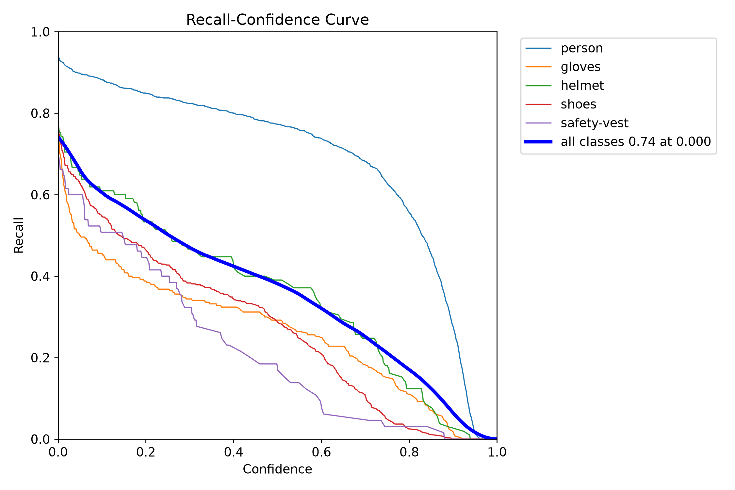
Fig. 6. Recall–confidence curves (all classes: 0.74 at confidence 0.000).

C. Confusion Matrices
Fig. 7 shows the normalized confusion matrix and Fig. 8 the matrix in raw counts. The diagonal values are 0.94 for person, 0.74 for gloves, 0.75 for helmet, 0.76 for shoes and 0.60 for safety vest. Confusion between PPE classes is small; errors are dominated by missed objects and by detections where no annotated object exists (the background row and column). The main class-to-class error is that 8 of the safety-vest instances (0.12 of that class) were predicted as person. The column totals imply roughly 1,427 person, 250 gloves, 105 helmet, 433 shoes and 65 safety-vest ground-truth instances in the evaluated set, so the helmet and safety-vest results rest on few examples and should be interpreted with caution.
The matrix diagonal for person (0.94) is higher than the person recall in Table VI (84.1%), and the background false-positive counts are large (for example 15,961 person detections without a matching annotation). This pattern suggests the matrix was computed at a much lower confidence threshold than the one used for Table VI; the threshold used for each output should be stated in the final paper.
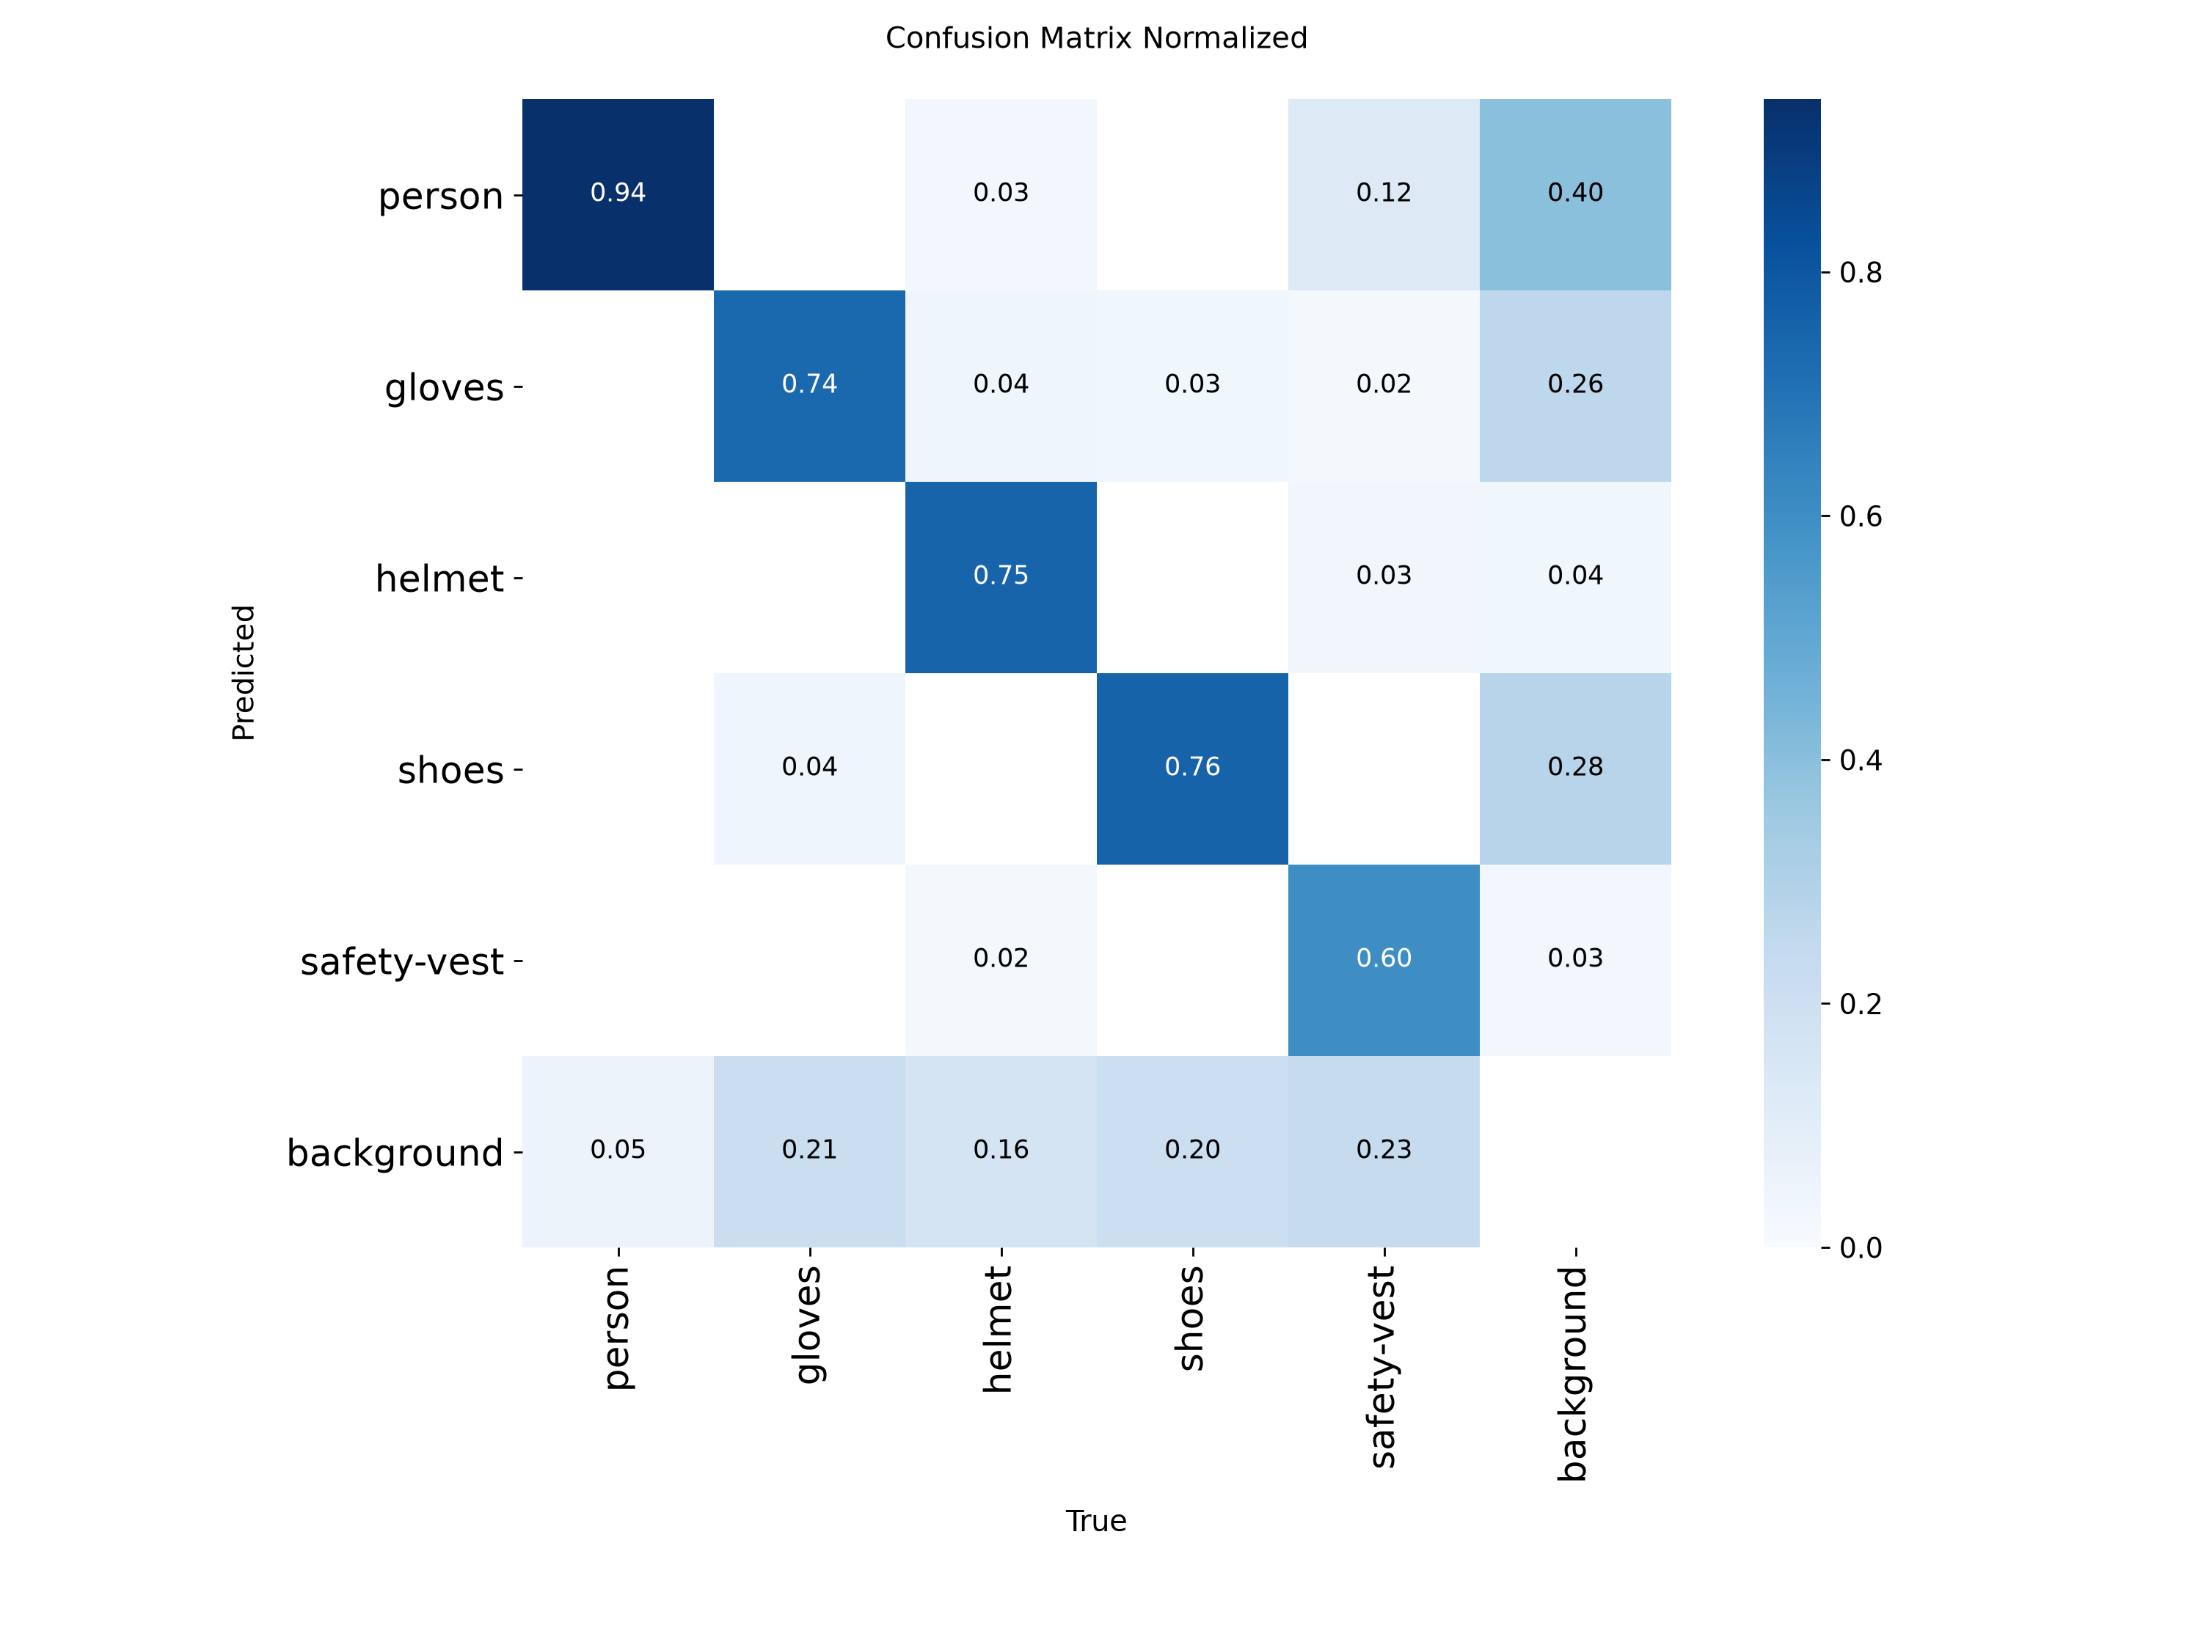
Fig. 7. Normalized confusion matrix (columns: true class; rows: predicted class).
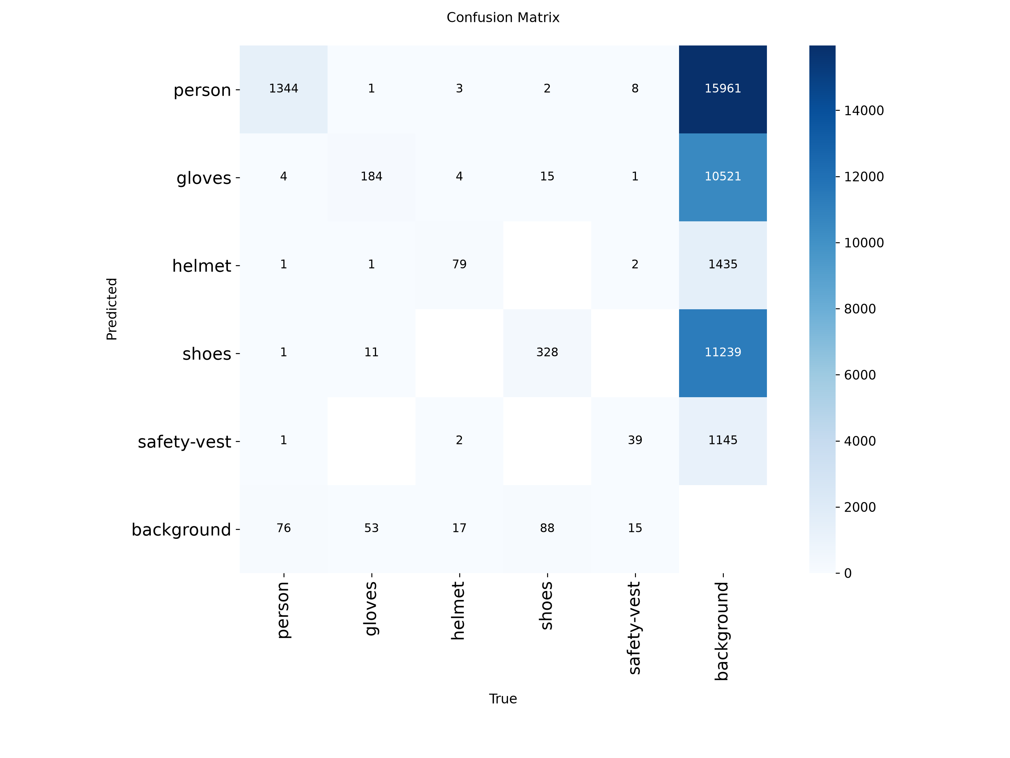
Fig. 8. Confusion matrix in raw counts.

D. Live-Test Observations
No measured live-test results were supplied with this draft, so Table VII remains a template. Each bracketed entry should be replaced using the training log, validation output or a timed live test. Benchmark values from other papers should not be copied as if they were produced by this project.
TABLE VII. Live-test observation template (to be completed from actual tests)
Test scenario | Observations from actual testing
Helmet detection | - Helmet fully visible on a worker's head under good lighting.  - Helmet is partially hidden, too small in the frame, viewed from an unusual angle, or visually similar to the background. A cap or hard hat-like object may cause false detection.
Safety vest detection | - Bright, clearly visible vest worn over clothing.  - Vest is covered by a jacket, folded, partially visible, or blends into the background. Similar-colored clothing or reflective objects may cause false positives.
Glove detection | - Gloved hands are clearly visible and separated from the body.  - Gloves are too small, hands are behind tools or machinery, hands overlap, or glove color resembles skin or nearby objects. This can be especially challenging because gloves occupy a small image area.
Safety-shoe detection | - Shoes are visible near the bottom of the frame.  - Feet are outside the camera view, hidden behind equipment, too far away, or covered by trousers. Ordinary shoes may be incorrectly detected as safety shoes if their appearance is similar.
Lighting / distance / occlusion | - Clear images at a suitable distance with sufficient lighting and unobstructed PPE.  - Low light, glare, shadows, backlighting, motion blur, excessive distance, partial visibility, or objects blocking the PPE can reduce detection performance.
Webcam FPS / latency | - Stable live video with detection boxes updating smoothly.  - Slow processing, high image resolution, CPU load, or repeated model inference can cause lag, dropped frames, and delayed detection

E. Discussion and Limitations
The usefulness of the prototype depends on the coverage and quality of the training data, the visibility of PPE, camera placement and the model's inference speed. Gloves and shoes can occupy few pixels in wide-angle surveillance footage, and they may be hidden by tools, machinery or worker posture; the low scores for gloves and safety vests are consistent with this. A model can also detect a helmet near a person without proving that the helmet is being worn. The random image-level split may place similar scenes in different subsets, and an empty label file does not indicate non-compliance. False alarms and missed violations should therefore be reviewed before the system is used operationally. The prototype is an assistive monitoring tool, not a certified safety system.

Why gloves and safety vests may score lower
Your current results show that glove detection has 37.5% mAP@50 and safety-vest detection has 35.7% mAP@50. These are measured results; the reasons below are hypotheses to investigate, not confirmed causes.
- Gloves: Small object size, hand movement, occlusion, and similarity to skin or surrounding objects can make localization difficult.
- Safety vests: Partial visibility, loose clothing, overlapping workers, varied vest colors, and background similarity may reduce detection reliability.
- Both classes: The number of labeled examples and variation in pose, scale and lighting can affect generalization. Your test set has fewer safety-vest instances than person or shoe instances, so its estimate is also based on a smaller sample.

VIII. CONCLUSION AND FUTURE WORK
This paper presented a real-time industrial PPE detection prototype using YOLO and OpenCV. A five-class detector (person, gloves, helmet, shoes and safety vest) was trained on a subset of the SH17 dataset and reached 60.47% precision, 51.86% recall, 52.13% mAP@0.50 and 33.88% mAP@0.50–0.95 on a held-out test subset of 810 images. Person detection was reliable, but gloves and safety vests remained difficult. The system captures video, displays predictions and provides a foundation for safety-status interpretation. The approach is modular and can be extended with worker tracking, improved spatial association, event logging and dashboard-based review.
Future work may include expanding the dataset with diverse industrial scenes, addressing class imbalance and improving detection of small objects, adding temporal tracking to reduce unstable frame-by-frame warnings, and validating worker-level compliance with manually annotated video. Further evaluation should examine false-negative rates, latency and robustness across cameras and workplaces, and should check the dataset for leakage between splits. Any deployment should include human review and should not replace required safety inspections.

REFERENCES
Core Object Detection & Architecture Foundations
- [1] J. Redmon, S. Divvala, R. Girshick, and A. Farhadi, “You Only Look Once: Unified, Real-Time Object Detection,” Proc. IEEE Conf. Computer Vision and Pattern Recognition (CVPR), pp. 779–788, 2016.
- J. Redmon and A. Farhadi, “YOLOv3: An Incremental Improvement,” arXiv preprint arXiv:1804.02767, 2018.
- A. Bochkovskiy, C.-Y. Wang, and H.-Y. M. Liao, “YOLOv4: Optimal Speed and Accuracy of Object Detection,” arXiv preprint arXiv:2004.10934, 2020.
- C.-Y. Wang, A. Bochkovskiy, and H.-Y. M. Liao, “YOLOv7: Trainable bag-of-freebies sets new state-of-the-art for real-time object detectors,” Proc. IEEE/CVF Conf. Computer Vision and Pattern Recognition (CVPR) Workshops, pp. 746–755, 2023.
- J. Terven, D. M. Córdova-Esparza, J. A. Romero-González, and A. A. Infante-Celedón, “A Comprehensive Review of YOLO Architectures in Computer Vision: From YOLOv1 to YOLOv8 and Beyond,” Applied Sciences, vol. 14, no. 6, p. 2384, 2024.
Industrial Safety, Compliance, & PPE Datasets
- [2] H. M. Ahmad and A. Rahimi, “SH17: A dataset for human safety and personal protective equipment detection in manufacturing industry,” Journal of Safety Science and Resilience, vol. 6, no. 2, pp. 175–185, 2025.
- Z. Wang, G. Wu, J. Yang, and O. Fink, “The application of computer vision in automated construction safety inspection: A review,” Automation in Construction, vol. 126, p. 103657, 2021.
- [3] “A YOLOv8 Approach for Personal Protective Equipment (PPE) Detection to Ensure Workers’ Safety,” Proc. 3rd International Conference on Advancement in Electrical and Electronic Engineering (ICAEEE), 2024.
- [4] “YOLO-DCRCF: An Algorithm for Detecting the Wearing of Safety Helmets and Gloves in Power Grid Operation Environments,” PMC Article PMC12470609, 2025.
- [1.2.1] M. M. Rahman, M. A. bin Hossain, et al., “PPE detector: a YOLO-based architecture to detect personal protective equipment (PPE) for construction sites,” Human-Intelligent Systems Integration, vol. 4, pp. 157–171, 2022.
- [1.2.2] T. K. Dao, H. T. Le, et al., “Personal protective equipment detection using YOLOv8 architecture,” Cogent Engineering, vol. 11, no. 1, p. 2333209, 2024.
- [1.2.3] Q. Zhang, L. Wang, et al., “An Improved YOLOv9 Based Object Detection with Attention Mechanism for Industrial Safety Compliance,” Sensors, vol. 26, no. 10, p. 3058, 2026.
- F. Fang, Y. Li, Y. Zhang, and J. Chang, “A methodological review of vision-based worker safety compliance checking in construction,” Safety Science, vol. 153, p. 105813, 2022.
- K. M. Wu, J. H. Li, and C. H. Chen, “Real-time helmet and vest detection in industrial sites using deep learning,” Journal of Real-Time Image Processing, vol. 19, no. 4, pp. 789–802, 2022.
- S. N. Akhund, M. Z. Aslam, et al., “Deep learning-based multi-class worker safety gear inspection using compressed YOLO models,” Computers in Industry, vol. 148, p. 103892, 2023.
Computer Vision Frameworks & Supplementary Datasets
- [5] Ultralytics, “Construction-PPE Dataset Documentation,” Ultralytics Hub, 2026. [Online]. Available: https://docs.ultralytics.com/datasets/detect/construction-ppe/
- [6] Ultralytics, “YOLO Performance Metrics (Precision, Recall, mAP),” Ultralytics Documentation, 2026. [Online]. Available: https://docs.ultralytics.com/guides/yolo-performance-metrics/
- [7] G. Bradski, “The OpenCV Library,” Dr. Dobb's Journal of Software Tools, 2000.
- [8] H. M. Ahmad and A. Rahimi, “SH17 dataset repository,” GitHub Open Source Storage, CC BY-NC-SA 4.0. [Online]. Available: https://github.com/ahmadmughees/SH17dataset
- [9] Ultralytics, “Model Validation Mode and Confusion Matrix Metrics,” Ultralytics Docs, 2026. [Online]. Available: https://docs.ultralytics.com/modes/val/
- M. A. Rahman and Y. Wang, “Real-time occlusion handling in computer vision-based occupational safety monitoring,” IEEE Transactions on Industrial Informatics, vol. 20, no. 5, pp. 4120–4131, 2024.

