Computer Graphics Lab Manual
Lab – 1: Installation and Basic Drawing using graphics.h

Objective
- To install and configure graphics.h library in C++.
- To understand pixel plotting using putpixel().
- To draw lines and basic 2D shapes (square, rectangle) using loops.

Software & Tools Required
- C++ Compiler (Turbo C++ / MinGW + Code::Blocks / Dev C++).
- Code Editor (Vs Code)
- graphics.h header file.
- winbgim.h & libbgi.a library.

Theory

- Pixel:
  - A pixel is the smallest unit of a display screen.
  - In computer graphics, an image is formed by plotting pixels at specific (x, y) coordinates.

- Coordinates in graphics.h:
  - Origin (0,0) is at top-left corner.
  - x increases → right side.
  - y increases → downwards.
- Important Functions:
  - initgraph(&gd, &gm, "") → Initializes graphics mode.
  - putpixel(x, y, color) → Plots a pixel at (x, y) with given color.
  - line(x1, y1, x2, y2) → Draws a line.
  - rectangle(left, top, right, bottom) → Draws a rectangle.

Procedure
- Install and configure graphics.h library.
- Write a program to test using putpixel() at different coordinates.
- Observe how x and y values affect pixel position.
- Write a loop to draw a line using consecutive pixels.
- Extend the logic to draw square and rectangle using multiple lines/loops.

Programs & Output
Program 1: Pixel Plotting Output: Different pixels plotted at given coordinates.
Green Pixel
Red Pixel
White Pixel
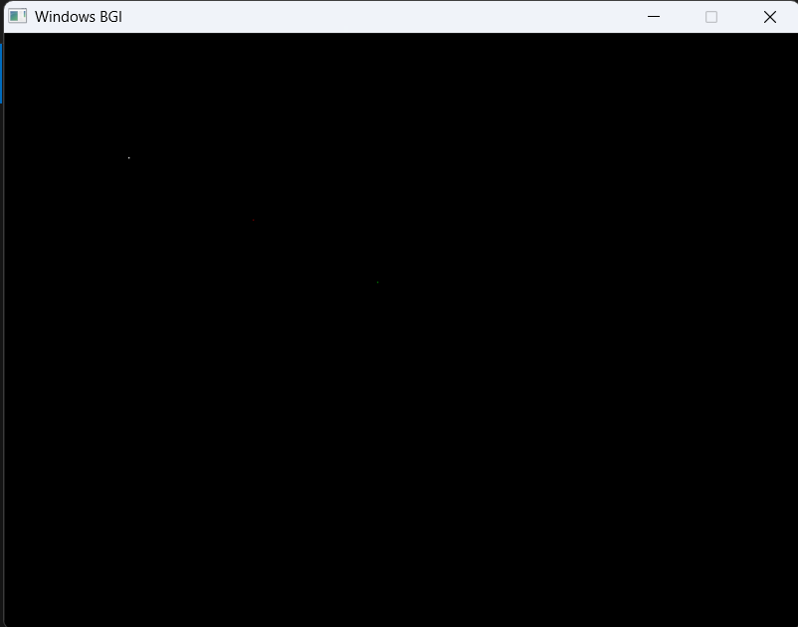
#include <graphics.h>
#include <conio.h>
int main() {
int gd = DETECT, gm;
initgraph(&gd, &gm, "");

putpixel(100, 100, WHITE);
putpixel(200, 150, RED);
putpixel(300, 200, GREEN);

getch();
closegraph();
return 0;
}

Program 2: Drawing a Line using putpixel()
#include <graphics.h>
#include <conio.h>

int main() {
int gd = DETECT, gm;
initgraph(&gd, &gm, "");

for (int x = 50; x <= 200; x++) {
putpixel(x, 100, YELLOW);
}
getch();
closegraph();
return 0;
}

Output: A horizontal line from (50,100) to (200,100).
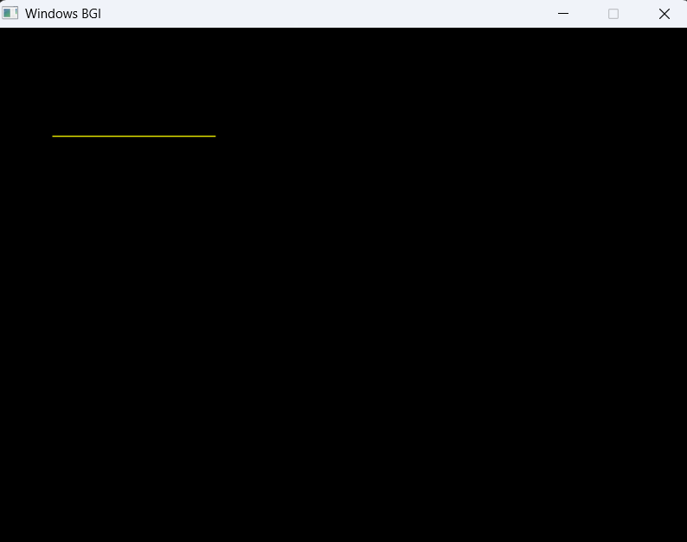
Program 3: Drawing a Square using Loops
#include <graphics.h>
#include <conio.h>
int main() {
int gd = DETECT, gm;
initgraph(&gd, &gm, "");
// Top line
for (int x = 100; x <= 200; x++) putpixel(x, 100, CYAN);
// Bottom line
for (int x = 100; x <= 200; x++) putpixel(x, 200, CYAN);
// Left line
for (int y = 100; y <= 200; y++) putpixel(100, y, CYAN);
// Right line
for (int y = 100; y <= 200; y++) putpixel(200, y, CYAN);
getch();
closegraph();
return 0;
}

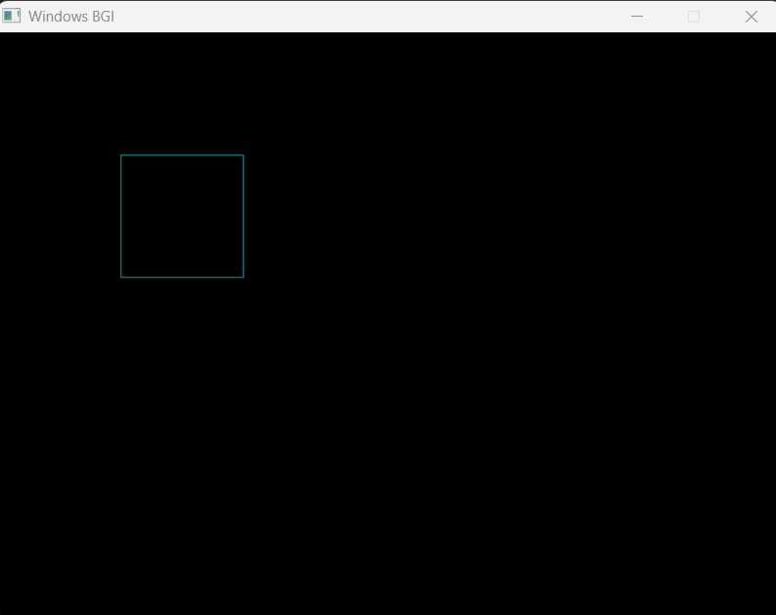
Output: A square of side length 100 pixels.
Program 4: Drawing Rectangle using Loops
#include <graphics.h>
#include <conio.h>
int main() {
int gd = DETECT, gm;
initgraph(&gd, &gm, "");
// Top line
for (int x = 150; x <= 300; x++) putpixel(x, 150, GREEN);
// Bottom line
for (int x = 150; x <= 300; x++) putpixel(x, 250, GREEN);
// Left line
for (int y = 150; y <= 250; y++) putpixel(150, y, GREEN);
// Right line
for (int y = 150; y <= 250; y++) putpixel(300, y, GREEN);
getch();
closegraph();
return 0;
}

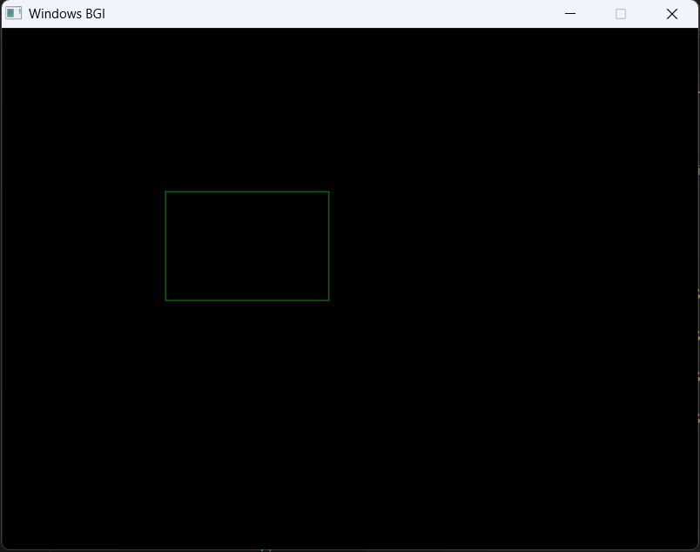
Output: A rectangle with width = 150 pixels and height = 100 pixels.

Observations
- Pixel coordinates (x, y) affect placement on the screen.
- x moves horizontally, y moves vertically.
- Shapes like lines, squares, rectangles can be constructed using loops of putpixel().

Conclusion
- Successfully installed and tested graphics.h.
- Understood pixel plotting and basic coordinate system.
- Implemented drawing of line, square, and rectangle using loops.

Lab – 2: (P1) Drawing Complex Figures and Creative Design

Objective
- To draw a given figure using basic graphics functions.
- To implement a creative design using graphics primitives and interactive controls.

Theory
- Rectangle: rectangle(x1, y1, x2, y2) draws a rectangle.
- Circle: circle(x, y, radius) draws a circle with given radius.
- Lines: line(x1, y1, x2, y2) draws a line segment.
- Fill: setfillstyle() and fillellipse() used for coloring regions.
- Interactivity: Arrow keys can be captured using getch() for moving shapes.

Procedure
- Initialize graphics mode using initgraph() / initwindow().
- Draw multiple nested rectangles and a circle at the center (as per given figure).
- For creative design:
  - Draw three concentric circles (target board).
  - Draw an arrow using lines (polygonal shape).
  - Allow arrow to move using arrow keys.
  - Detect arrow tip position relative to circles (collision detection).
  - Fill color dynamically when arrow hits a circle (scoring zones).

Programs & Output
Program 1: Given Figure (Nested Rectangles with Circle)

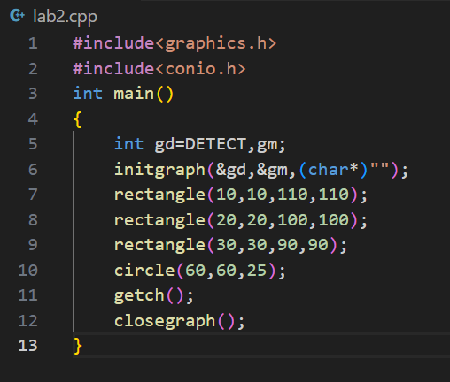
Output: Three nested rectangles with a circle at the center.
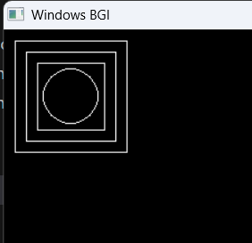
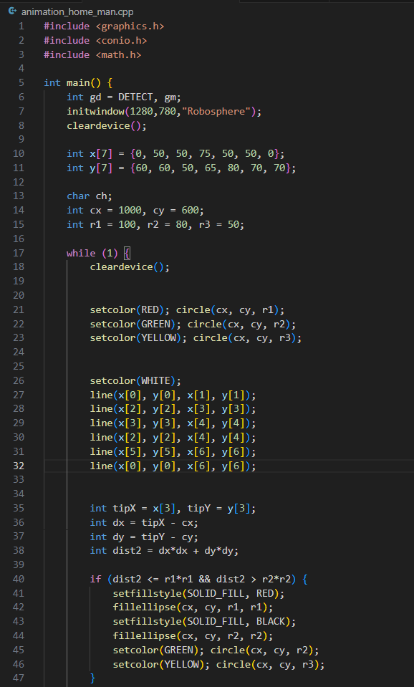
Program 2: Creative Design (Target Board with Arrow Control)

Output:
- A target board with concentric circles.
- An arrow shape can be moved using arrow keys.
- When arrow hits different zones, target fills with different colors (scoring zones).

