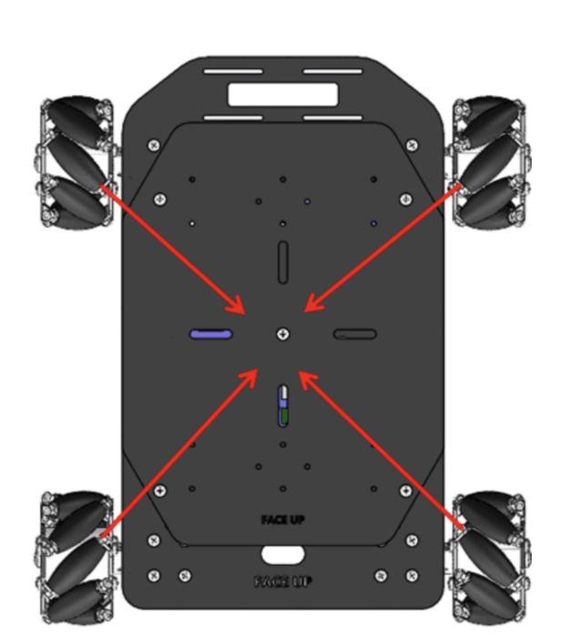

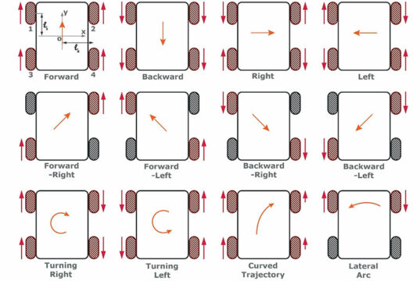

CONNECTIONS:

BATTERY HOLDER:

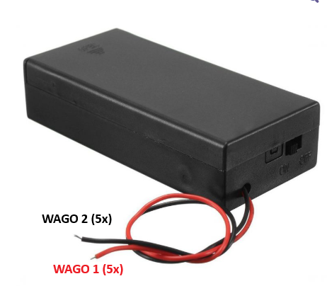

+ TERMINAL -> WAGO 1 (5x) BATTERY + CONNECTOR

- TERMINAL -> WAGO 2 (5x) BATTERY - CONNECTOR

Pololu Step-Down D30V30F5 CONNECTIONS:

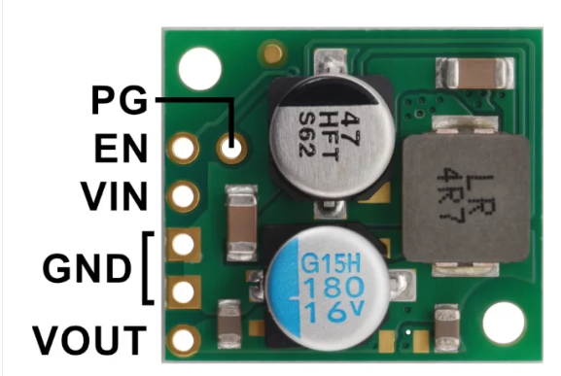

VIN -> WAGO 1 (5x) BATTERY + CONNECTOR

GND -> WAGO 2 (5x) BATTERY - CONNECTOR

GND -> PCA9685 SERVO DRIVER EXTERNAL POWESUPPLY CONNECTOR **-** TERMINAL

VOUT -> PCA9685 SERVO DRIVER EXTERNAL POWESUPPLY CONNECTOR **+** TERMINAL

BASE BOARD:

POWER SUPPLY:

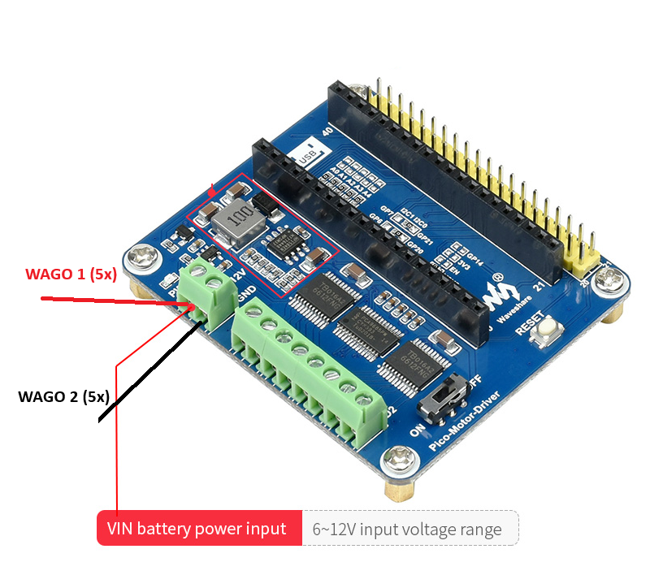

**+** TERMINAL -> Pololu Step-Down D30V30F5 VOUT

**-** TERMINAL -> WAGO 2 (5x) BATTERY - CONNECTOR

MOTOR CONNECTIONS:

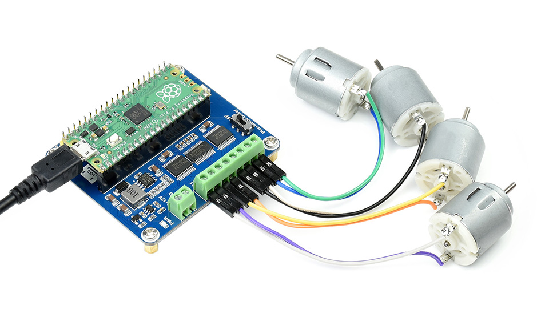

A1 -> Motor1/ FRONT LEFT MOTOR + (RED)

A2 -> Motor1 - (BLACK)

B1 -> Motor2/BACK LEFT MOTOR + (RED)

B2 -> Motor2 - (BLACK)

C1 -> Motor3/ FRONT RIGHT MOTOR+ (RED)

C2 -> Motor3 - (BLACK)

D1 -> Motor4/BACK RIGHT MOTOR + (RED)

D2 -> Motor4 - (BLACK)

Run the test code provided in:

front_left_wheel_forward.py

front_right_wheel_forward.py

back_left_wheel_forward.py

back_right_wheel_forward.py

!!! Make sure the wheels are spinning forward, if not switch the motor wires!

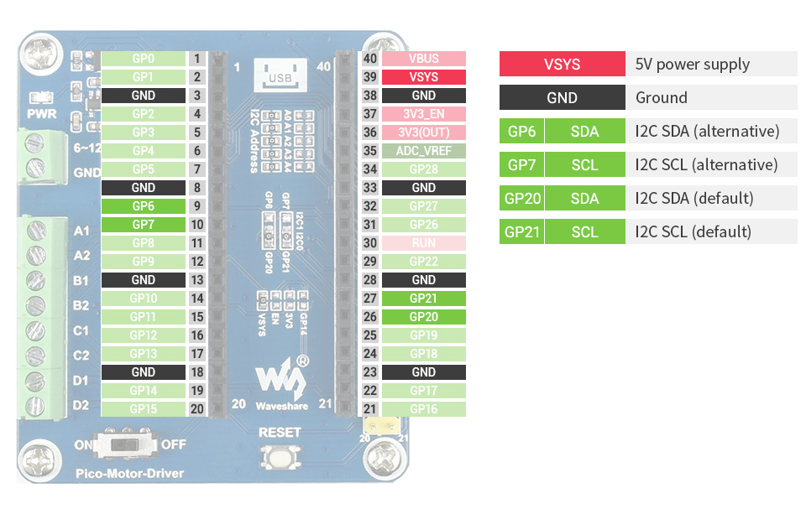

#PIN 1 (Rx) -> JDY-31 RXD

#PIN 2 (Tx) -> JDY-31 TXD

#PIN 3 (GND) -> JDY-31 GND

#PIN 4 (GP 2) SDA -> PIN PCA9685 SERVO MOTOR DRIVER SDA

#PIN 5 (GP 3) SCL -> PIN PCA9685 SERVO MOTOR DRIVER SCL

**PCA9685 SERVO MOTOR DRIVER CONNECTIONS:**

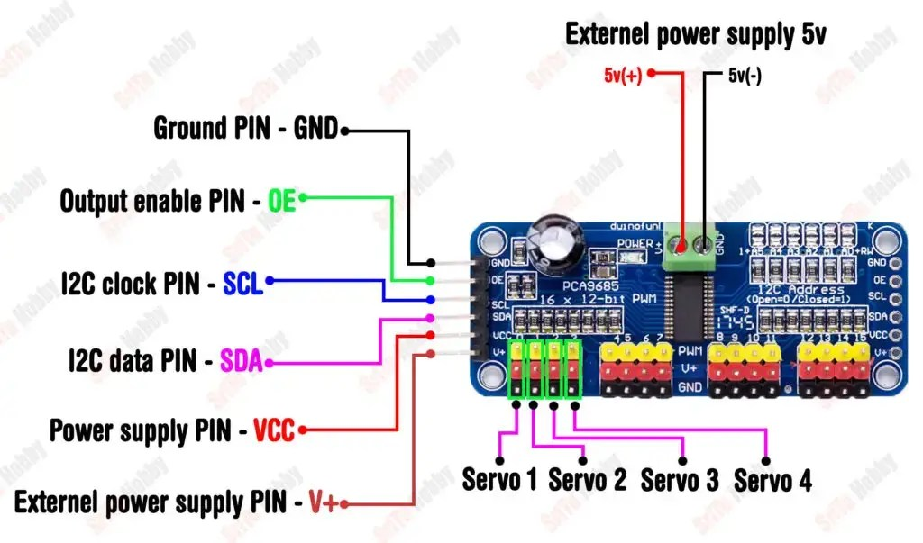

EXTERNAL POWESUPPLY CONNECTOR:

**+** TERMINAL -> Pololu Step-Down D30V30F5 VOUT

**-** TERMINAL -> WAGO 2 (5x) BATTERY - CONNECTOR

SIDE CONNECTOR:

VCC -> WAGO 3 (+ 3.3V)

GND -> WAGO 2 (5x) BATTERY **-** CONNECTOR

SCL -> BASE BOARD SCL #PIN 5 (GP 3)

SDA -> BASE BOARD SDA #PIN 4 (GP 2)

**SERVO MOTOR CONNECTIONS:**

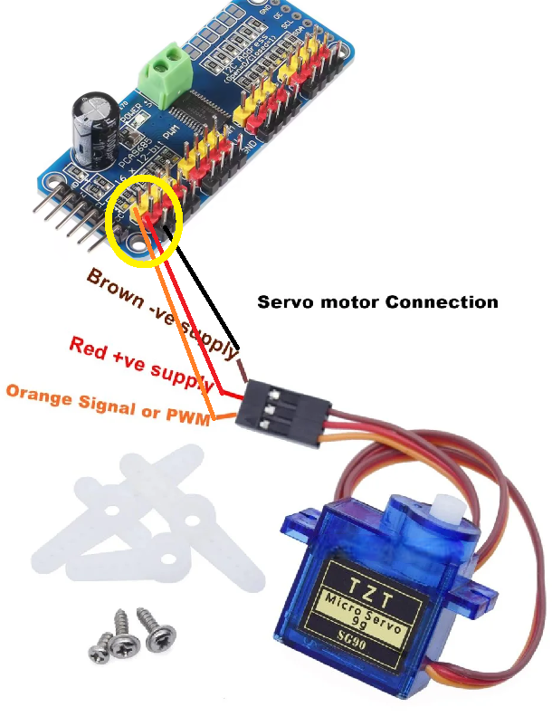

BROWN -> BLACK PIN ON

RED -> RED PIN ON

ORANGE -> YELLOW PIN ON

CONNECT THE SERVO MOTORS AS FOLLOWS:

FIRST SLOT (LEFT) - BASE SERVO

SECOND SLOT - ARM SERVO

THIRD SLOT - GRIPPER SERVO

USE THE CODE PROVIDED IN:

arm_gripper_servo_set_angle.py

arm_servo_set_angle.py

arm_base_servo_set_angle.py

TO SET THE PROPER SERVO ANGLES BEFORE ASSEMBLY!!!

HC-SR04

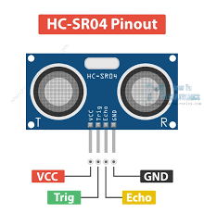

VCC -> WAGO 3 (+ 3.3V)

GND -> WAGO 2 (5x) BATTERY **-** CONNECTOR

Trig -> BASEBOARD #PIN 32 (GP 27)

Echo -> BASEBOARD #PIN 31 (GP 26)

JDY-31 BLUETOOTH MODULE:

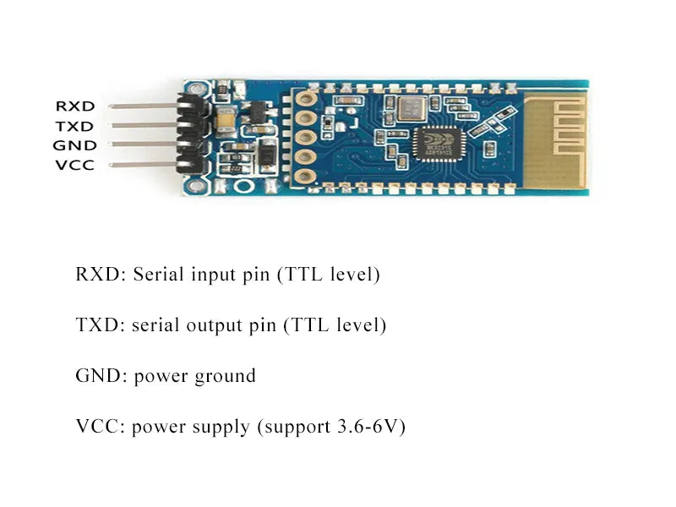

VCC -> WAGO 3 (+ 3.3V)

Ground -> BASEBOARD GND #PIN 3

TXD -> BASEBOARD #PIN 2 (Tx)

RXD -> BASEBOARD#PIN 1 (Rx)