Ice water harvesting
For KSP Kerbalism

rev 0.5 d
TOC
Introduction 2
Proposals 2
Environment 2
Research 2
Goals 2
Requirements and limitations 3
Approach 3
Significant parameters 3
Mapping Sol to Kerbol 4
Circumstellar Habbitable Zone of Kerbol 5
Water distribution model 5
System-wide distribution basics 5
Local distribution basics 6
Celestial bodies without atmosphere 8
Celestial bodies with atmosphere 8
What is water abundance exactly 9
Moho 9
Eve 11
Gilly 13
Kerbin 14
Mun 14
Minmus 15
Duna 15
Ike 15
Dres 15
Asteroids 15
The use case 15
Choosing the use case 15
Scenario “minimum” 17
Scenario “useful” (sufficient) 18
Scenario “overpowered” 19
Desired fuel production summary 20
How much water do we need 20
Desired harvester capability 22
Conclusion 24
Useful links 25

Introduction
“Water is in extreme abundance in the solar system from Mars to the moons of Jupiter and from asteroids to the rings of Saturn. Liquid water however is not the norm and Earth remains a special place in what is called the habitable zone. Owing to the low temperatures and pressures at many planetary locations, ice is the most ubiquitous form of water as many spacecraft have confirmed its abundance in shadowed craters on the Moon, over the polar regions of Mars, in asteroids, comets and the worlds orbiting Jupiter and Saturn. The Jovian moon Europa is covered with thick water ice hiding a suspected liquid ocean and Enceladus orbits Saturn while spewing water ice into space. Water is also critical in ISRU to electrolyze it to obtain hydrogen and oxygen. These elements can be used in chemical reactors processing soils or other gases and as fuel and oxidizer in propulsion engines.”
Water and Volatile Compounds (c) NASA

Proposals
Considering is Kerbalism v1.6.0.0
1. To keep ice water harvester output “as is” on 0.003/s
2. To start discussion on development for better water distribution model

Environment
This document contain information pertaining to the game called Kerbal Space Program. This means that there is an in-game environment, formed by a combination of elements of the game design. We do not pretend to make drastic changes in the basis of the game or its key elements. It also means that we are obliged to accept the existing state of things “as is”, even if they do not fit into the framework of scientific explanations. In that case, we should try to give the most realistic scientific explanation to the existing state of things, instead of changing them. If it is not possible to resolve a conflict between realism and gameplay, we should make a choice in favor of gameplay, leaving scientific explanations open for further discussion.

Research

Goals
- To provide a scientifically-based model of water distribution in the system of Kerbol
- To suggest possible ways of extracting water (and possible the other resources) for purposes of the KSP
- To propose parameters of realistic, universal and useful in situ ice water harvester for Kerbol

Requirements and limitations
- Keep away of complex formulas. Make it as easy as possible to let most people understand it.
- Do not apply calculations on solar irradiation power depending on distance to star. Use comparison with analogues to provide the opportunity to act by analogy “as in Sol”.
- Do not discuss producing the water from oxides, hydrates and other compounds.
- Do not consider the changing water abundance level with time under affection of natural causes.
- Do not consider production of monopropellant fuel.
- We assume there is unlimited amount of electric power and it's enough for all processes. Issues with an electric power production is out of scope this document.

Approach
- Determine what characteristics are important.
- Make mapping of real objects to model objects.
- Use existing scientific data of Sol to make realistic model of water distribution in Kerbol.
- Apply existing real scientific data to the model objects. Provide value range for each parameter which is important for the “water issue” for each model object.
- Determine the most useful basic use case.
- Determine three useful usage examples to define limits where is optimal balance between usefulness, realism and uselessness.
- Calculate desired output of for those three use cases.
- Make analyzed all three cases to detect best parameters, to provide most useful production rate for universal harvesting device to calculate its requirements.
- Propose design of in situ ice water harvester.

Significant parameters
What natural processes are matter in context of the water issue:
- Effect of temperature on state of aggregation
- Effect of pressure on state of aggregation
- Nuclear evaporation
- Natural chemical reactions
What body parameters are matter in context of the issue:
- Having magnetosphere reduces amount of radiation which is come to body’s surface.
- Having an atmosphere affects temperature and pressure ranges which determines what state of aggregation of water is possible here
- Mean orbital radius determines is this body inside CHZ or not
- Axial tilt determines how much insolation received by poles
- Albedo determines how much radiation is reflected back
If the specific details are not provided for some body of Kerbol, these parameters should be used to determine water abundance considering this body.

Mapping Sol to Kerbol
Kerbol system looks similar to Sol but there are differences. This paragraph is mapping celestial bodies of Solar system to bodies of Kerbol system. In case if Sol does not have suitable prototype for Kerbol’s body, there the most realistic model of significant characteristics should be provided. Any suitable bodies of Sol may be used as prototypes.
Here and below, if the body has a prototype, we will use either of two names to imply the same thing. For example speaking Mars, we mean Duna. Speaking Duna we mean Mars as well. Two names but same conditions, same situations.
KSP Name | SOL Name
Moho | Mercury
Eve | Venus
Gilly | 24 Themis
Kerbin | Earth
Mun | Moon
Minmus | ???
Duna | Mars
Ike | Phobos?
Dres | Ceres?

All bodies higher than Dres are not included and will not consider. Dres is the first body outer of CHZ. All bodies in the outer space outside of CHZ will basically have similar conditions of water presence. The distance from star matters (but less significant). There are possible deviations depending on astronomical "history" of the body. This document is about basic science and does not include much tales. Possible exception for guesses is Minmus as one of most significant body.
Maybe later we will back to describe the rest bodies.

Circumstellar Habbitable Zone of Kerbol
This document does not provide model of changing the distribution of water over time under the influence of natural causes. Therefore, assume that CHZ of Kerbol is inclusively from Eve to Duna. CHZ is quite important for “water” issue because it determines which aggregate state of water is natural for the given temperature range.
There is Dres between Duna and Jool (which looks like Jupiter). But Dres cannot be inside conservative CHZ because its orbit more than twice higher than Duna which is Mars and should be on the outer edge of CHZ.
Thus:
- Orbits lower than Eve are outside CHZ, closer to star and hotter. Natural state of water in this range is gaseous.
- Orbits inclusive from Eve to Duna are inside CHZ. Natural state of water in this temperature range is liquid.
- Orbits higher than Duna are outside CHZ, farther from the star and colder. Such bodies do not receive enough insolation to keep water in liquid state. Natural state of water for such bodies is solid or in other words it's ice (in case if there is no alternative thermal sources).

Water distribution model

System-wide distribution basics
Water is the combination of two atoms of hydrogen with one atom of oxygen. Assuming that Kerbol is similar to Sol there should be lot hydrogen. Oxygen also should present in sufficient quantities. It is on third position after helium. So there shouldn't be a problem with elements for water. The problem is to keep these elements coupled in a form of water and save it from decay or transformation under natural causes. Due to high temperature water is boil, transforms to gaseous form and may get away to space as vapor. Or water molecules may be broken by solar radiation and get away in form of atoms. Natural elements can enter into chemical reactions with water, resulting in the formation of new chemical compounds. This paragraph we consider in which form and which volumes water may present in scale of the system.
Regarding the system of any star and its planets, we can designate the three limits which are important for water issue. The first limit is the ice line. This is an orbit when it is cold enough to condense water into ice grains. It is space beyond CHZ. In case of KSP the ice line is somewhere between Duna and Dres. Exact numbers does not matter if do not consider changes of water abundance with time due to natural processes. Processing of ice looks most promising in issue of harvesting water for purposes of space programs. There should be lot of water ice beyond the ice line. Therefore we considered the ice line first.
The second one is having an atmosphere. Atmosphere means there is pressure. It is impossible to keep water in liquid form without pressure. However, having an atmosphere does not mean that there is liquid water. The state of aggregation of water depends on two parameters at same time: pressure and temperature.
This example demonstrates the dependency. Earth ASL pressure is about 101 kPA and water is liquid in temperature range 0C - +100C (exactly same on Kerbin). When it’s hotter than +100C then water becomes gas. When it's colder than zero then it becomes ice. The lower the pressure, the narrower the temperature range in which water will exist in liquid phase. There is the Triple Point of water when possibility of liquid state of water disappear and gas becomes ice and vice versa without passing through liquid state. The triple point of water is 611 PA and +0.01C. At the other side than more pressure then higher temperature of boiling and melting. But it grows non-linear. There is Critical Point of water is about 22MPA and +373C when water become a supercritical fluid where is no difference between liquid and gaseous states.
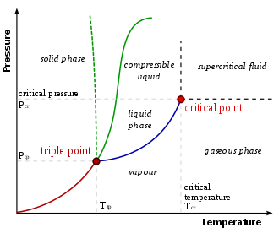
There are few more phases but it is easier to show all on chart

And the last one limit is the inner space between star and CHZ. This is the most hottest space in the system and there are low chances to find water. Strength of star in this zone makes having water in liquid or solid states almost impossible. With high probability it will pass to gaseous phase then will be blown out (but there are exceptions as always). The possible ways to keep a lot water here is having an anomaly which is not typical to Sol system. But we do not have such anomalies in Kerbol nor Sol. Therefore, such probabilities will not discussed.
Thus, we can get answers what celestial bodies what state of aggregation of water will have if there is some water depending on body’s location relative to star.

Local distribution basics
How much water possible at specific location of celestial body? If probability of having water is directly depending on amount of insolation this location receives, then it depends how surface is oriented relative to sun. The following diagram shows annual mean insolation for the Earth's top of atmosphere and the Earth’s surface
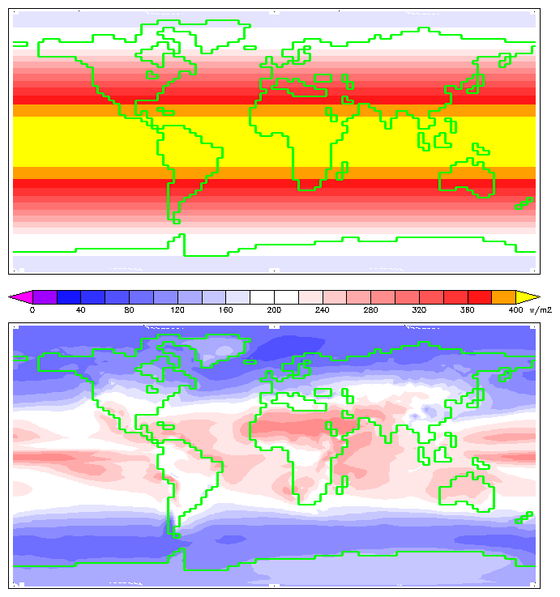
This diagram demonstrates that amount of insolation is dependent on what latitude is. At higher latitudes the surface is at an angle to the sun. And there are other conditions that may reduce insolation per unit of square of surface space: albedo. For Earth's surface (at the bottom diagram) albedo is varies (ice has higher albedo than dirt as well as clouds) and there was combination of factors. Any case, we see that the equatorial locations receive more insolation than the poles. It is mostly because different locations have different orientation relative to sun. It will receive less solar radiation, the sharper the angle between the normal to the surface and the direction to the sun. These diagrams may explain why do we have ice caps on Earth’s poles despite the fact that the earth has the dynamic atmosphere that can transfer heat from one part of the planet to another. Because the insolation level on poles is low enough despite all other circumstances.
There is possibility to get it changed. It's the axial tilt. Rotating body with axial tilt will bring the higher latitudes closer to the ecliptic plane on regular basis and thereby provide them with increased insolation. But even this case the diagram does not change cardinally. This will lead to an expansion and smoothing of the band of increased insolation from the equator to the poles. But generally it will look similar.

Celestial bodies without atmosphere
Such bodies are most common kind in KSP. As well they look pretty promising for ice harvesting.
Celestial bodies without an atmosphere can have water only in gaseous or solid state. If there is water in gaseous form (or as vapor) with time it will be blown away by solar wind. Than the body closer to the sun then more insolation it receives. If there is ice on surface then with time it will vapored under infrared radiation or disintegrated under bombardment by highly powered particles (nuclear evaporation). Surface ice can keep its state only if much time it is shaded and protected from direct sunlight exposure. Most possible location of such deposits are anomalies of the terrain like craters. Than closer to poles then bigger deposit. In case if there is significant axial tilt, then craters will get insolation even if they are on poles.
Nevertheless, there is a chance to find water under surface where it is protected of sunlight. Considering water which may came with impactors the question how’s dense surface of this celestial body is important. Than more dense surface then more energy needed to break it down. The more energy is needed the more water will lost on blast.
The one more explanation of having water under surface is a result of celestial body evolution. The history of Mars as for example.

Celestial bodies with atmosphere
Celestial bodies with atmosphere can have water in any state of aggregation. It strictly depends on body parameters and situation where exactly it is inside the atmosphere. Pressure go down than higher then lesser. Altitudes in this case does matter.
It is better to use phase diagram of water to determine possible states of aggregation under concrete circumstances on bodies with atmosphere
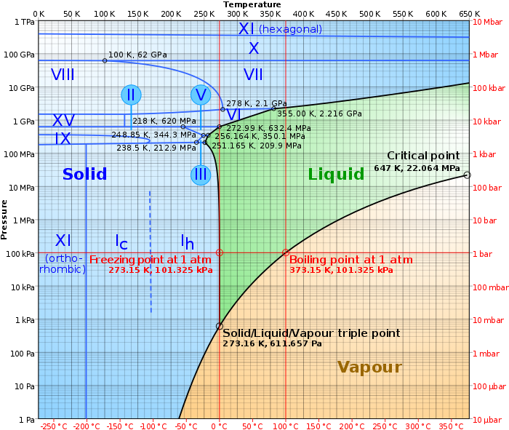

What is water abundance exactly
Water abundance is provided in percentages. It is quite easy to understand what is it exactly. For example if you take one kilogram of substance where is 50% of water then you will get 500 grams of water after separation. If there is 20% water abundance then you will get 200 grams of water after separation of one kilogram of substance. Here and below we will use this meaning while talking of water abundance.

Moho
Moho is the planet most closest to star. There's too hot to have lot water. Combination of extreme temperature and strong radiation flow makes the presence of big deposits of water unlikely. Than closer to equator then chances are lesser. But assuming Moho is Mercury and considering Moho’s topology there is still a chance to find some water in form of ice.
The image of Mercury’s North Pole shows which locations are permanently shaded on all images acquired by MESSENGER

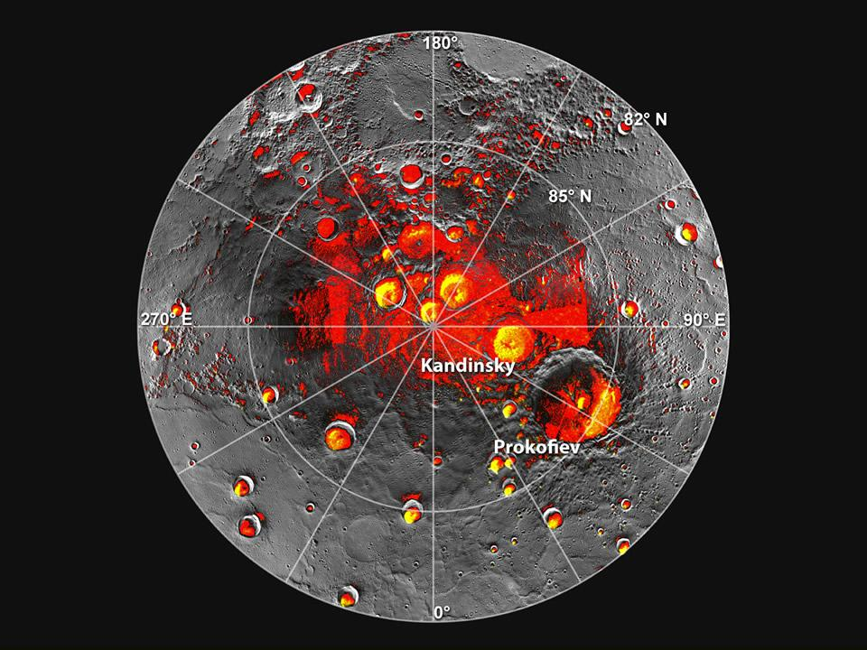
We can see that there are lot craters in the high latitudes. These craters may act as "ice traps". Because there is no atmosphere the temperature range in such places will definitely low and ice can be protected of the sunlight exposure.
To compare, this is Moho altimetry acquired by SCANSat
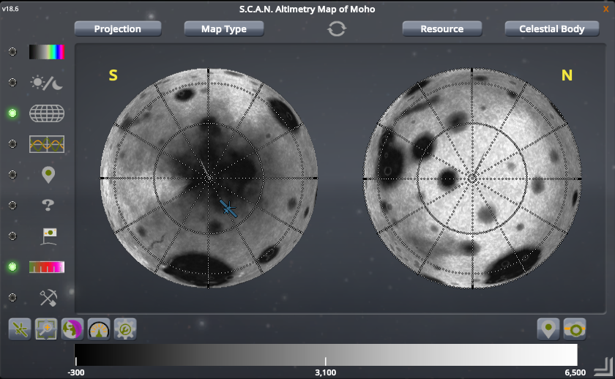
We can see some differences to Mercury. There isn’t a big amount of craters on the north. Just one which is called Mohole. Mohole is very promising place to find water ice because its depth is about 4.5km. But it's quite difficult to get there. It’s so risky.
Unlike the north pole, the south pole has different topology. It has lot of small craters or significant terrain elevations. Average terrain heights decrease (than closer to the south pole then lesser) from thousands of meters to tens. That's one more reason why there is increased probability to find water around Moho's south pole.
Thus, based on Mercury data calculations we can make the approximate estimating how much deep of ice is possible on each pole of Moho. There is possible to find hundreds maybe even thousands meters of ice in depth of Mohole and about few meters or tens in the darkness of south. How it can be expressed in the term of water abundance percentage? Considering this is special case for Mohole it is 80-90% and few dozens percents on the south pole. Actually we don’t know.

Eve
Assuming Eve is Venus, we see that they have different atmospheres. And there are lot differences. Therefore, there is no reason to make analogues relying on the parameters of the Venusian atmosphere. We have to build realistic model of water distribution on Eve using all we know about Eve.
We know that Kerbin is 101 kPA ASL and it is 0C-100C diapason for liquid water. ASL pressure on Eve's surface is about 500 kPA and that’s five times greater than on Kerbin. We know there is no significant changes on freezing point for given pressure range. This is still 0C. But boiling point of water under such pressure rises up to about +160C. Considering the Eve’s higher mountain peak is about 150 kPA then it is about +115C boiling point of water. The question is which is the temperature range in different locations of Eve.
The information of the KSP wiki about the temperature ranges on Eve contains a figure that looks quite strange for a very hot planet. There is possible minimum which is -113C. That not looks like a mistake because nearby is confirmation in Kelvins: 160K which is -113C. To make it clear we must go field observations.
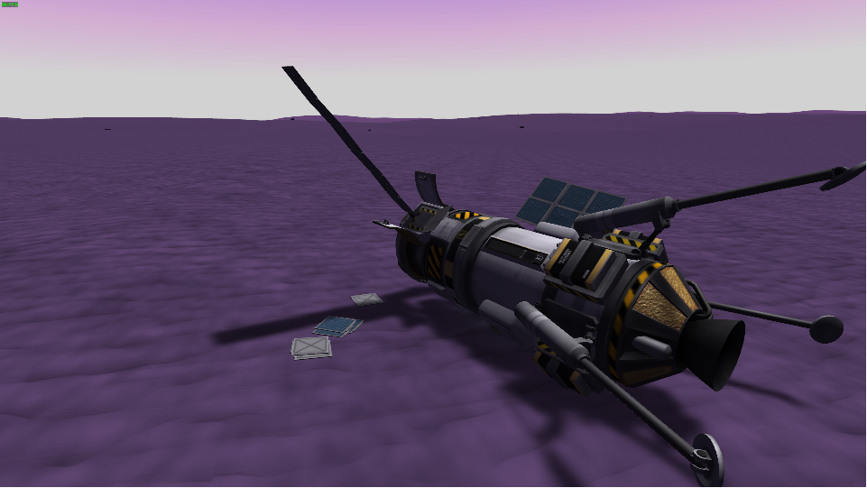
We sent two labs to record temperature ranges in equatorial and polar locations of Eve. Everything was fine but most critical time one of the KSC operators spilled his hot coffee on the keyboard. Because of this, few commands were sent prior planned time causes the ship deploying antenna during descent in the atmosphere. We lost the antenna immediately. That was look like we lost the lab because it keep descending uncontrolled and get crashed soon. But parachutes were open in time and well-tested software was able contact the satellite that performed surface mapping. Thereby, we were able to get wanted data about temperatures on Eve’s surface during the day.
This is the field data we acquired. On Eve’s equator under pressure 481 kPA temperature minimum was 412.36K at night and the maximum was 421.86K while sunlight. The second lab which landed pretty close to the north pole reported: at 335 kPA the daily minimum of 344.40K and maximum of 352.41K. These numbers give us the following ranges in celsius: from +138C to +147C on equatorial locations and from +70C to +78C on poles.
Moving the freezing point of water off zero is starting from about 7 MPA. 7 MPA is close to Venus pressure but is about 14 times greater than Eve ASL pressure. This is quite hard to imagine that there is surface or subsurface ice somewhere on Eve. There is still one possibility of having ice on Eve – if the number figured out in KSP wiki about Eve's daily temperature minimum is correct. But we cannot confirm or deny this statement. We just don’t know where is such place. We could assume that it may be the case when Eve crosses it's own orbital ascending and descending points. But Eve does not have axial tilt and both poles receive the same amount of daily insolation independently of Eve's position relative to ecliptic plane. Thus, we can't comfirm there could be ice somewhere on Eve.
But we definitely can say that is possible to find water in it’s liquid form in lowlands even in equatorial locations. It will be very hot water to drink but not enough to be vaporized.
Having water in atmosphere in its gaseous state is also very probably. The scientific data we acquired shows that there is lot places where it's so close to the boiling point of water to make probability of vaporization quite easy to appear. There is enough to get just a bit more darker surface to absorb more infrared radiation than usual and water will go over the local boiling point producing vapor.
That's quite possible that water vapor is transporting with atmospheric streams from hotter equatorial locations to colder polar. Then it condenses into large water droplets and fall to the surface in the form of hot rain. Due to high temperatures with a high probability, water geysers are also possible on Eve. If so, water should be widely distributed on Eve.
How much water may be here? That’s not a simple question. Any amount is possible. We cannot take Venusian atmosphere as prototype for Eve because they are quite different. Venusian atmosphere is 9 MPA supercritical fluid of about 95% carbon dioxide and 3.5% of nitrogen. The picture of Eve shows that there are lakes on surface, its atmosphere is transparent. This means its atmosphere isn't a supercritical fluid. At least this should be something different than on Venus. All we know is that Eve's lakes called "lakes of liquid fuel". That means there should be compounds of hydrogen, oxygen and carbon. This data tell us that water is possible here. How much depends on exact consistency on which depends how many hydrogen and oxygen atoms can remain in the form of water molecules.
Thus, the rest questions about water abundance on Eve is open to be written.

Gilly
Gilly looks like a pretty small asteroid accidentally captured by Eve. It’s indicated by its size, surface shape and also the nature of the orbit. There is no prototype of Gilly in Sol because Venus does not have natural satellites. Thus, we must use all we know about asteroids to determine how much water it may have.
Assume prototype of Gilly is 24 Themis – the real asteroid in the asteroid belt of Sol. The presence of water ice was confirmed on the surface of this asteroid using NASA’s Infrared Telescope Facility. What’s significant differences to Gilly? Gilly mass is about two orders less. 24 Themis is in asteroid belt which is beyond Mars and outside of CHZ but Gilly is on the front of CHZ. Why this matters? Gilly receives more solar irradiation. This means that all water ice must vaporized in a short astronomical time.
There are several hypotheses and observations that together can be used to construct the most scientific model of Gilly:
- Asteroid belt is between Mars (1.5AU semi-major axis, SMA) and Jupiter (5.2AU). Asteroid belt contains more dense rocky and metallic asteroids.
- Most Kuiper belt asteroids are composed of frozen volatiles. Kuiper belt is in range 30-55 AU away of star.
- Mostly known hypothesis of origin of water on Earth is that is water was brought to Earth by asteroids.
- Philae and its observations of 67P/Churyumov–Gerasimenko comet. This comet is 3.46 AU SMA and there is water vapor detected at 3.9AU.
- ESA Herschel Space Observatory and its observations of Ceres. Ceres is the largest object in the asteroid belt. It is composed of silicate core and an icy mantle. Ceres is 2.7 AU SMA with about 0.07 eccentricity and there is water vapor detected.
- 24 Themis observations by NASA’s Infrared Telescope Facility confirmed that there is water ice vaporized under starlight. 24 Themis is 3.1AU SMA.
- Many more confirmations that there is water ice on small celestial bodies but vaporization is started higher than Mars orbit even on massive asteroids like Ceres.
What's conclusion?
It should be especially noted that these facts indicate that the water evaporation from the surface of small celestial bodies begins already outside the CHZ, at distance of about 80% higher than the orbit of Mars. According to a conservative definition, Mars is on the outer boundary of the CHZ. And this all may look a bit unexpected.
Assuming Eve is Venus, Gilly cannot have much water. How much? It depends how long ago Gilly was captured, where is it came from and how’s water appear on the asteroids. According to LRO data on shaded Moon craters there is about 5-6% of water. Thus, The presence of 1-2% subsurface water ice is a very optimistic scenario for Gilly.

Kerbin
There is definitely water on Kerbin. It is represented in a big volumes and in any states of aggregation. Just open your eyes and look around.

Mun
Assuming Mun is Moon, by obvious reasons this celestial body should have most significant value in the space program.

Minmus
Из водных растворов кристаллизуется голубовато-зелёный гептагидрат FeSO4·7Н2О , сульфат железа, железный купорос (зеленый купорос)
Медный купорос, Так, медный купорос CuSO4·5H2O (синий) выше 105 °C переходит в тригидрат CuSO4·3H2O (голубой)
Кристаллогидраты содержат много воды.
Chromium, vanadium and nickel могут давать похожий цвет

Duna

Ike

Dres

Asteroids

The use case
The fuel is most valuable resource of a space program. Producing fuel in situ is the most important and realistic next phase of space exploration. Therefore, we assume the fuel production is the basic use case of in situ water utilization.

Choosing the use case
Considering the fuel production, we must formulate the minimum reasonable requirements, in which production of fuel makes sense. It is the reaching the low equatorial orbit. Because if you can’t reach it then you can’t reach space at all.
We know that amount of fuel to reach orbit isn’t a constant and depends of celestial body parameters. Thus, we have to choose most suitable celestial bodies to proceed modeling.
Let's consider these celestial bodies of Kerbol:
- Mun
- Minmus
- Duna
Most reasons why we choose these bodies are obvious. Mun and Duna should be chosen as primary targets because they are reflection of the real history of humanity. We should include Minmus as well because it is on the way between Mun and Duna to the deep space. That looks quite reasonable. if Sol had something like Minmus, no doubts that it would been chosen as the second goal after Moon.
The less obvious reason to choose the closest bodies is time. Saving time is as important as saving fuel. This is the bad idea to send people to the deep space without testing of all technologies. And if something does not work in near space with high probability it will not work in the deep space. Minmus is as such part of near kerbal space as Moon for humans. Minmus is a variant of distant environment. It should be used to test all technologies. Thus, Minmus must be considered as model object.
Amount of fuel required for ascending to an orbit is expressed in Delta-V. We will use data of KSPedia to determine how much Delta-V is basically needed to make ascent to an orbit. Ascending isn't an easy maneuver. It should be done precise and fast. Mistakes are quite possible. Therefore, we will correct given values for 10% more reserved to keep a chance to handle of unexpected situation.
Thus, we get the following numbers:
- For Mun is 638 Delta-V required to reach of 14 km Low Equatorial Orbit
- Minums – 198 Delta-V to reach of 10 km LEO
- Duna – 1595 Delta-V to reach of 60 km LEO
We see that for Minmus it requires lesser amount of fuel than for other two. This is one more confirmation that Minmus must be considered as the basic use case of this technology. Because If we unable to get fuel on Minmus, then it will not work everywhere except special cases. But we need the technology for common usage.
Delta-V is the change in velocity. But we want to determine how much fuel is it. Because Delta-V depends on spaceship characteristics, we have to choose the ship model. It should be small but useful ship to make it possible:
- to determine the reasonable minimum beyond which the technology will go too useless and it will make no sense to proceed its developing
- to easy imagine how this technology will be used in different cases for different ships
- to determine how this technology can be scaled
At same time, the ship should be able to meet all three cases of use. This means, the ship should have enough TWR and fuel to ascent the orbit of most massive planet Duna. We actually do not need to build something what's really can reach it. It is all to determine the minimum ship mass. Anyway, let’s introduce Kerby.
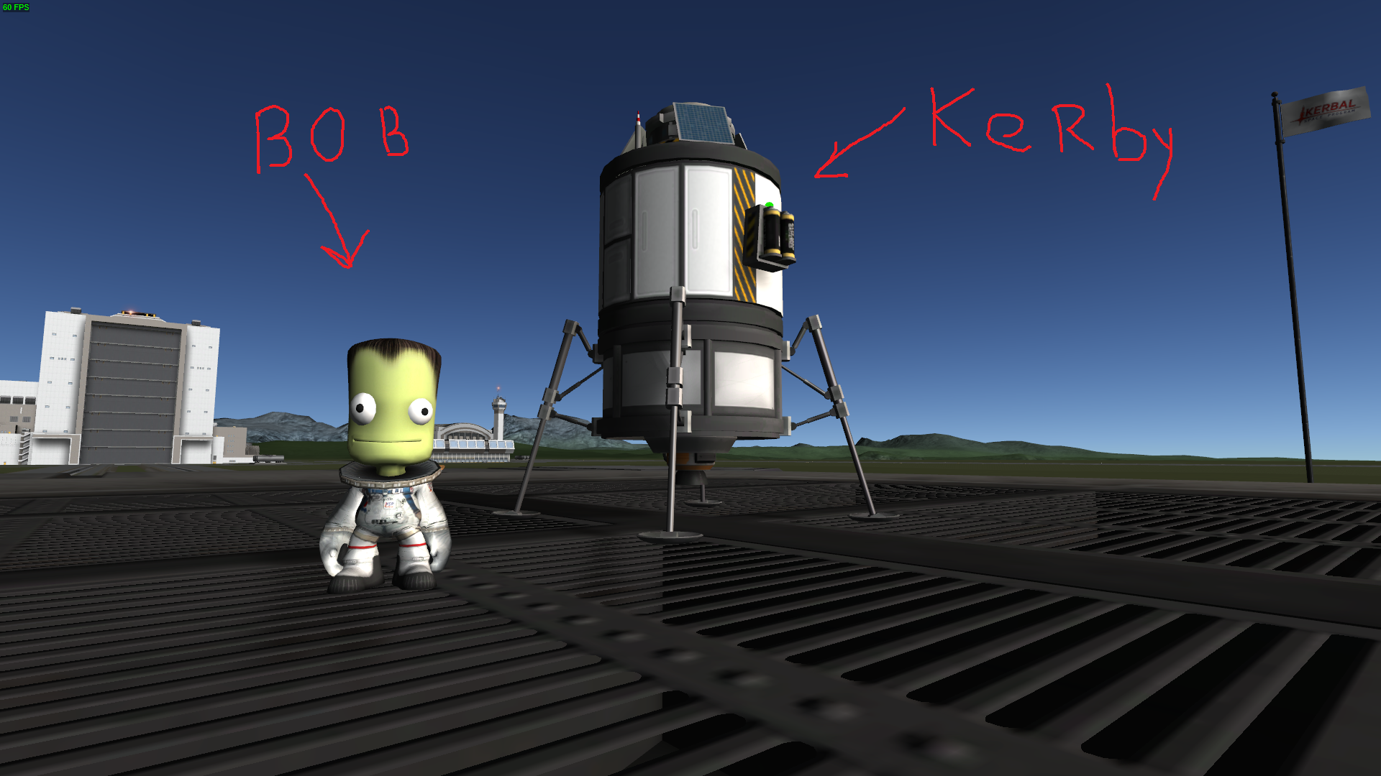
What's important on this photo that’s the FL-T100 Fuel Tank. The wet mass of the ship to be moved is about 1.06 ton. Thus, there are 45 units of liquid fuel and 55 oxidizer as calculation base.
But there is one more important question is what total time to produce will look reasonable? What case the fuel production will look reasonable by economic reasons? The money doesn’t matter so much in KSP. The fuel matters the more the farther away the Kerbin. But we’re talking of fuel production. What else? The time! About what time we speak in context of space program? The time to get reached a celestial body. The time is matters because most cases it's a big time.
Consider all three celestial bodies in the matter of time. Mun isn’t a best choice. Mun is so close to Kerbin that time isn’t matter. Most cases it’s easier to deliver things directly from Kerbin when needed. So, if there is insufficient fuel production for Mun it causes no big problems. Duna is far away of Kerbin. If there is insufficient fuel production on Duna, anyway it’s better than delivering fuel from Kerbin. Because it costs too much time to deliver. Thus, Minmus is the best target for the technology and should be chosen as primary target for fuel production technology requirements. At same time Minmus is far enough and requires less amount of fuel to ascent to LEO what make it possible to assume the use case which is actually in the middle of possible requirements range. Thus, the chosen scenario is Minmus.

Scenario “minimum”
How far is Minmus? It is an about 8 day flight. Let’s assume 52 hours. That’s mean that the fuel production on Minmus will make sense if it gives an advantage compare to moving fuel from Kerbin considering the time period of 52 hours.
We do not want to overload technology with unrealistic requirements. Let's make correction of the minimum requirements depending on the chosen scenario. We know that is about 200 Delta-V required to reach LEO of Minmus. But fully-loaded Kerby will have about 2000 Delta-V for Minmus. That's too big difference. We have to reduce amount of fuel to about of 10% of initial values to get it closer to the use case requirements. Given all the restrictions, it will be 4.5LF and 5.5OX. Thus, we determined the possible reasonable minimum of fuel production per hour:
- 4.5LF / 52h = 0.086538461~LF/h
- 5.5OX / 52h =0.105769230~OX/h
In order to define the boundaries of requirements, when the production is minimally justified, sufficient for typical usage or got overpowered, we will expand the minimum usage scenario to the three more. Produce such amount of fuel to make it possible:
- to do ascending to Minmus LEO one time each 8 days. Assign name of "minimum" for this scenario.
- to keep operational activity which includes regular ascending and descending to Minmus surface one time per 6 days. Let’s call it “useful” scenario.
- to make you forgotten there is the fuel and it is most valuable resource. The “overpowered” scenario.
These new scenarios requires some clarifications.

Scenario “useful” (sufficient)
Let’s assume scenario “useful” is when we want to make Minmus exploration more extensive rather than just send scientific robots from Kerbing and bring them back with data. In this case we would like to send an orbital laboratory to park it on Minmus LEO and assign a small robot like Kerby which on regular basis will gather data from Minmus surface and bring it back for analyzes by the lab. There are typical actions which are included to single operation: descent to the Minmus surface, gather scientific data, ascend to LEO, make match to lab's orbital plane, make rendezvous, then dock. All of them cost fuel.
It is impossible to provide accurate data on fuel usage, since the exact amount of fuel needed to execute an orbital maneuver is non linearly dependent on the initial situation. So, we will use approximated values of fuel usage based on most typical cases.
Getting down from LEO to surface and returning back will cost similar amount of fuel. Considering the minimum scenario is 200 + 200 = 400 Delta-V in total for descent and ascent.
Before start landing and after ascent it is typically needed to change the orbit inclination. Changing the inclination may cost much fuel. Its cost depends what angle is between initial and target orbits as well as what velocity is. Considering Minmus LEO is 10 km, then changing inclination at 5 degrees costs about 13.5 Delta-V, at 20 degrees is 54 Delta-V, at 30 is 80, at 45 is 119 Delta-V and so on. We know there is only one biome at high latitudes and these are poles. So, that's not look like that often changing of inclination at very big angles is typical for Minmus operations. Let's assume average is 25 degrees which is 67 Delta-V.
All other maneuvers aren’t costly. To simplify, we will assume 5% on top of most expensive maneuvers is quite enough to cover all.
Now we can get the total Delta-V amount which is required for this scenario. It is
(200 * 2 + 67 *2) * 1.05 = 560 Delta-V.
560 Delta-V for Kerby is about 11 units of liquid fuel and 13.5 units of oxidizer. Thus, we see that we have to increase production a bit more than twice to provide sufficient amount of fuel compared to scenario "minimum".

Scenario “overpowered”
Where is the limit when we can say that thing is overpowered? Isn’t easy question. We don't have much examples from real life because humans like things overpowered (more money, biggest car, bigger yacht, etc).
Let's try to discuss that issue in simple. The small things are for other small things and the big things are for other big things. Kerby is a small ship and our cases must be about small fuel processor. So, we can assume that the small fuel processor is overpowered if it can provide enough to refuel a big ship for doing similar job as the small ship. In this case you generally don't care of fuel producing. You just use it to refuel, thing become boring.
Meet Kerbig
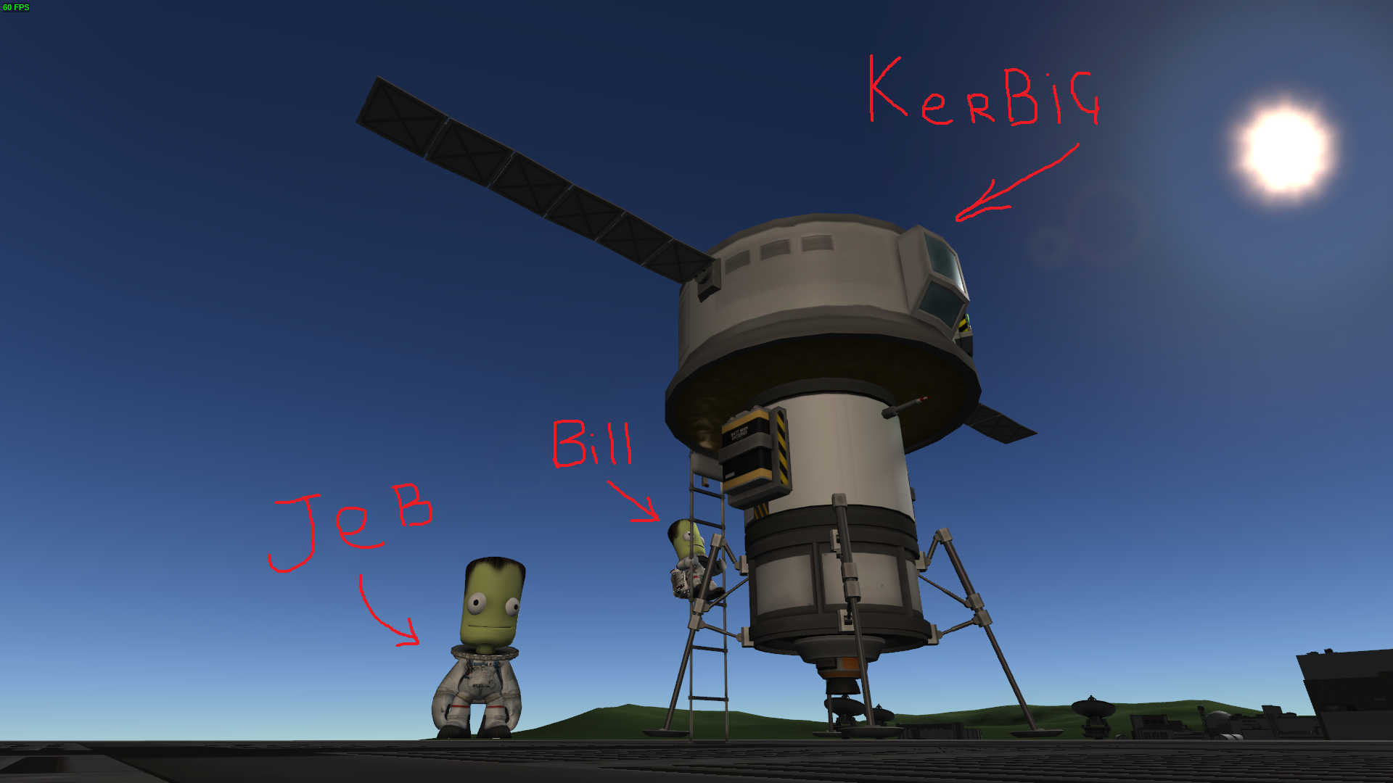
Kerbig is big. It’s designed especially for Minmus and meets our requirements for 560 Delta-V. But for Kerbig much more fuel is needed than for Kerby to do same job. Kerbig needs 57.6 LF and 70.4 OX so we forced to add one more small fuel tank on the top to meet all requirements.
To compare it’s about than five times greater than for Kerby. Note this five. The same difference is between small and big driller exactly 5 times. This is still in main conception of scalability: the small are for small, the big are for big. If you want to make Kerbig refueled on regilar basis it's time to switch to the big driller. Those things are pretty balanced as is.

Desired fuel production summary
Considering all, we can make more corrections on desired output to make it well-consistent to whole issue environment.
At first. We know there is 5 times output difference between small and big driller. And that all is pretty close what we have got considering two valuable scenarios. Thus, we can assume that scenario “useful” should consider 5 times less production than scenario “overpowered”. In other words we'll take “overpowered” production and divide it by 5 to calculate desired output for “useful” production. We chose this way, because Kerbig is under tighter requirements than Kerby.
Secondly. We know the ratio between liquid fuel and oxidizer usage. OX/LF is 55/45 = 1.222222222~. Let's make the final corrections on all output values because they are obtained based on data which has not enough precision. So, we'll get amount of oxidizer and divide it to 1.222222222 to get exact amount of liquid fuel to make that all pretty consistent with usage of fuel components.
The result summary table
Scenario | LF/h | OX/h
minimum | 0.086538461 | 0.105769230
useful | 0.221538461 | 0.270769230
overpowered | 1.107692307 | 1.353846153

How much water do we need
It’s time to determine how much water do we need to produce enough fuel for given requirements.
According to Kerbalism v1.6.0.0, the following processes are involved to the two-component fuel production:
- Water electrolysis (power + water = hydrogen + oxygen)
- Anthraquinone process (hydrogen + oxygen = oxidizer)
- Sabatier process (power + carbon dioxide + hydrogen = water + liquidfuel)
As we see, this chain is not completely closed due to carbon dioxide. We have got excess oxygen while processing but there is no possibility to join it with carbon. Because carbon isn't a separate resource in Kerbalism and there is no appropriate chemical processor to do such reaction. So, we will dump excess oxygen to the space (thanks Kerbalism 1.6 now it's possible). By the way, there is an assumption that the production of monopropellant fuel is more suitable for the purposes of Minmus. But we promised to not consider production of monopropellant fuel in this document.
Thus, the question is mostly about hydrogen. Let’s combine all processors in such to make it all zero hydrogen balance. In other words, to make hydrogen consumption so fast as it will be produced by electrolysis factory. Playing a bit with tables we got the following configuration:
- 2x Small ISRU for water electrolysis
- 1x Chemical Plant for water electrolysis
- 1x Chemical Plant for anthraquinone process
- 2x Small ISRU for sabatier process
This factory will have about 1.285 ratio between produced oxidizer and liquid fuel. That's pretty close to given usage ratio of fuel components which is about 1.2~. It will produce about 4.25 LF and 5.46 OX per hour, consuming about 12.46 units of water at same time. Quite effective hardware. To make the complete picture it also consumes 25560 units of electric charge, about 5975 units of carbon dioxide and the surplus of oxygen is about 10217 units per hour. Thus, we can calculate ratios of all resources needed per couple of produced 1 unit of liquid fuel and 1.285 units of oxidizer according to given production ratio. The coefficient we should apply all numbers is 1 / 4.25 = 0.235294118. Thus, we can calculate production/consumption coefficient to make it easy to scale for any desired values:
Resource/Product | Factory data | Consumption/production coefficient
Liquid Fuel | 4.25 | 1.000000000
Oxidizer | 5.46 | 1.284705884
Water | 12.46 | 2.931764710
Electric Charge | 25560.00 | 6014.117656080
Carbon Dioxide | 5975.00 | 1405.882355050
Oxygen | 10217.00 | 2404.000003606
Hydrogen | 0.00 | 0.000000000

Finally, we can calculate how much water do we need for each scenario
Scenario | LF/h | OX/h | Water/h needed | Water/m needed
minimum | 0.086538461 | 0.105769230 | 0.253710406 | 0.004228507
useful | 0.221538461 | 0.270769230 | 0.649498641 | 0.010824977
overpowered | 1.107692307 | 1.353846153 | 3.247493215 | 0.054124887

Assuming one unit of water equals to one kilogram, these numbers do not look very fantastic even for “overpowered” scenario.

Desired harvester capability
Calculating the harvester desired productivity we must consider the water abundance as well. We want to get it universal to make it possible to use in whole space of Kerbol system. Thus, we should consider the available data on water availability, in order to determine under what average conditions the harvester will work.
Let’s have a look on these three maps
Kerbol universe number 1
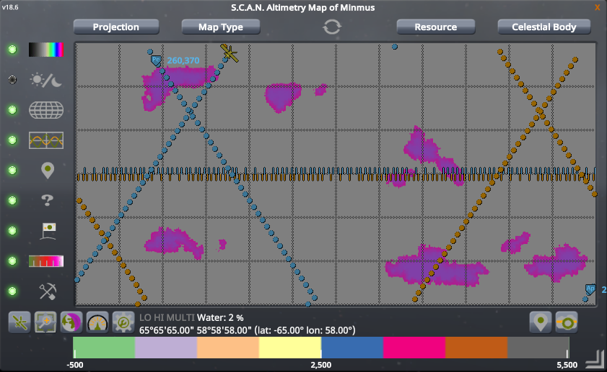
Kerbol universe number 2
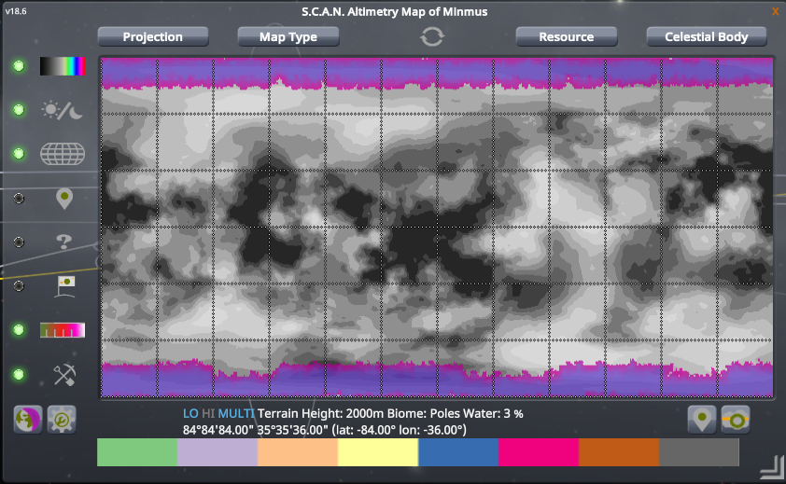
Kerbol universe number 3
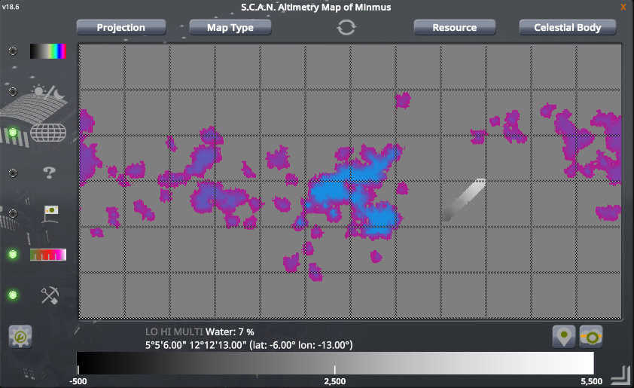
Considering all we discussed above about water distribution, these maps look quite strange except the second one. Perhaps the other two scanners just broke down. Let's hope these averages are correct. Thus, there is (7 + 3 + 2) / 3 = 4% average of water abundance. Assuming that harvester productivity depends on abundance, to determine desired productivity of harvester to meet given use case requirements we have to divide average abundance of water by desired amount of water. Thus, for given use cases:
Scenario | Desired amount of water | Required harvester capability substance per hour
minimum | 0.253710406 | 6.342760150
useful | 0.649498641 | 16.237466025
overpowered | 3.247493215 | 81.187330375
Wow! Looks scary.
Let’s calculate average of water abundance by values for whole Kerbol. Assume that data provided by Community Resource Kit is correct.
Celestial body | Max abundance %
Kerbin | 50
Laythe | 50
Duna | 20
Rest bodies x (16-3=13) | 10
There are 16 celestial bodies totally. And 13 of them have maximum 10% abundance of water. Thus, the maximum possible average is (13 * 10 + 20 + 50 +50) / 16 = 15.625%. This value is discussable, but let's assume it’s correct. Applying this value, we can get updated table of desired harvester capability
Scenario | Desired amount of water | Required harvester capability substance per hour
minimum | 0.253710406 | 1.623746598
useful | 0.649498641 | 4.156791302
overpowered | 3.247493215 | 20.783956576
These numbers look much better.

Conclusion
Assumed we choose “useful” scenario when ice water harvesting do make sense by economic reasons, adds to the game the ability to choose between different strategies, and therefore, makes the game more interesting. Thus, the final requirements for in-situ ice harvesting device are:
- 4.156791302 processed substance per hour or
- 0.069279855 per minute or
- 0.001154664 per second
In Kerbalism 1.6 the small drill is 64.8 production capability per day which is 10.8 per hour. That’s quite enough to meet 50% requirements of “overpowered” scenario. Decreasing capability of current harvester to make it more realistic seems unfounded to us at least until the Community Resource Kit had provide more precise model of water distribution.

Useful links
https://isru.nasa.gov/WaterVolatileCompounds.html
https://isru.nasa.gov/
https://wiki.kerbalspaceprogram.com/wiki/Category:Celestials
https://en.wikipedia.org/wiki/Circumstellar_habitable_zone
https://en.wikipedia.org/wiki/Abundance_of_the_chemical_elements
https://en.wikipedia.org/wiki/Frost_line_(astrophysics)
https://en.wikipedia.org/wiki/Triple_point
https://en.wikipedia.org/wiki/Phase_diagram
https://en.wikipedia.org/wiki/Solar_irradiance
https://en.wikipedia.org/wiki/Mercury_(planet)
https://www.nasa.gov/mission_pages/messenger/media/PressConf20121129.html
https://nssdc.gsfc.nasa.gov/planetary/ice/ice_mercury.html
https://www.hou.usra.edu/meetings/lpsc2017/pdf/2059.pdf
https://en.wikipedia.org/wiki/Venus
https://www.nasa.gov/topics/earth/features/water_ice_asteroid.html
https://en.wikipedia.org/wiki/24_Themis
https://en.wikipedia.org/wiki/Asteroid_mining
https://en.wikipedia.org/wiki/Asteroid_belt
https://en.wikipedia.org/wiki/Kuiper_belt
https://en.wikipedia.org/wiki/Philae_(spacecraft)
https://en.wikipedia.org/wiki/67P/Churyumov%E2%80%93Gerasimenko
https://en.wikipedia.org/wiki/Ceres_(dwarf_planet)
https://wiki.kerbalspaceprogram.com/wiki/Cheat_sheet
https://en.wikipedia.org/wiki/Delta-v
https://www.nasa.gov/sites/default/files/atoms/files/mars_ice_drilling_assessment_v6_for_public_release.pdf

