YOLO+ByteTrack upward-camera matrix15 performance report

1. 实验目的
本轮测试 YOLO+ByteTrack 固定上视相机闭环在 15 个距离、侧向、高度差和目标速度组合下的拦截性能。每个工况分别运行 TTC 与 VM，共 30 个 case；AirSim detect shadow 关闭，collision 作为成功标准。

2. 工况矩阵
case | 距离m | 侧向m | 高度差m | 目标速度m/s | speed ratio | stamp | status
M01 | 40 | -10 | 30 | 5.0 | 2.0 | upward_yolo_matrix15_20260701_202024_M01 | ok
M02 | 25 | -10 | 30 | 5.0 | 2.0 | upward_yolo_matrix15_20260701_202024_M02 | ok
M03 | 55 | -10 | 30 | 5.0 | 2.0 | upward_yolo_matrix15_20260701_202024_M03 | ok
M04 | 40 | 0 | 30 | 5.0 | 2.0 | upward_yolo_matrix15_20260701_202024_M04 | ok
M05 | 40 | -20 | 30 | 5.0 | 2.0 | upward_yolo_matrix15_20260701_202024_M05 | ok
M06 | 40 | 20 | 30 | 5.0 | 2.0 | upward_yolo_matrix15_20260701_202024_M06 | ok
M07 | 40 | -10 | 20 | 5.0 | 2.0 | upward_yolo_matrix15_20260701_202024_M07 | ok
M08 | 40 | -10 | 40 | 5.0 | 2.0 | upward_yolo_matrix15_20260701_202024_M08 | ok
M09 | 30 | -10 | 30 | 3.0 | 2.0 | upward_yolo_matrix15_20260701_202024_M09 | ok
M10 | 30 | -10 | 30 | 7.0 | 2.0 | upward_yolo_matrix15_20260701_202024_M10 | ok
M11 | 50 | -10 | 30 | 3.0 | 2.0 | upward_yolo_matrix15_20260701_202024_M11 | ok
M12 | 50 | -10 | 30 | 7.0 | 2.0 | upward_yolo_matrix15_20260701_202024_M12 | ok
M13 | 45 | -20 | 40 | 7.0 | 2.0 | upward_yolo_matrix15_20260701_202024_M13 | ok
M14 | 55 | 15 | 20 | 7.0 | 2.0 | upward_yolo_matrix15_20260701_202024_M14 | ok
M15 | 25 | 20 | 40 | 3.0 | 2.0 | upward_yolo_matrix15_20260701_202024_M15 | ok

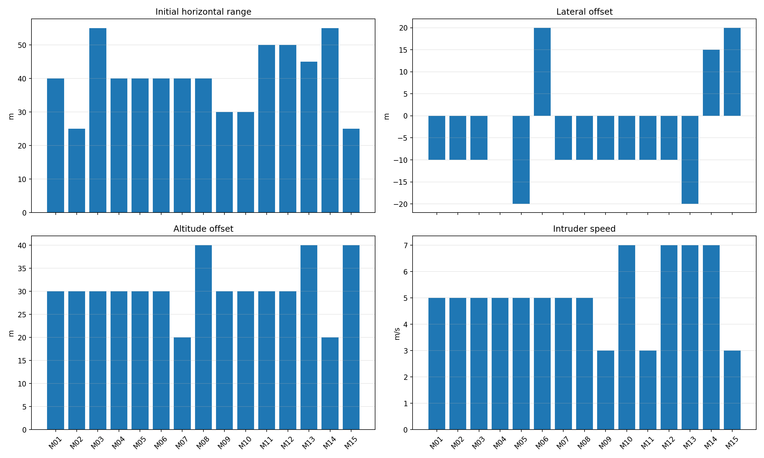
matrix15_parameters

3. 总体结果
算法 | collision命中 | near-hit | 完全未命中 | 最小距离范围m | 平均检测率 | 平均YOLO FPS
TTC | 12/15 | 8/15 | 3 | 0.95-58.43 | 70.5 | 9.27
VM | 5/15 | 3/15 | 10 | 1.19-9.42 | 53.3 | 8.84

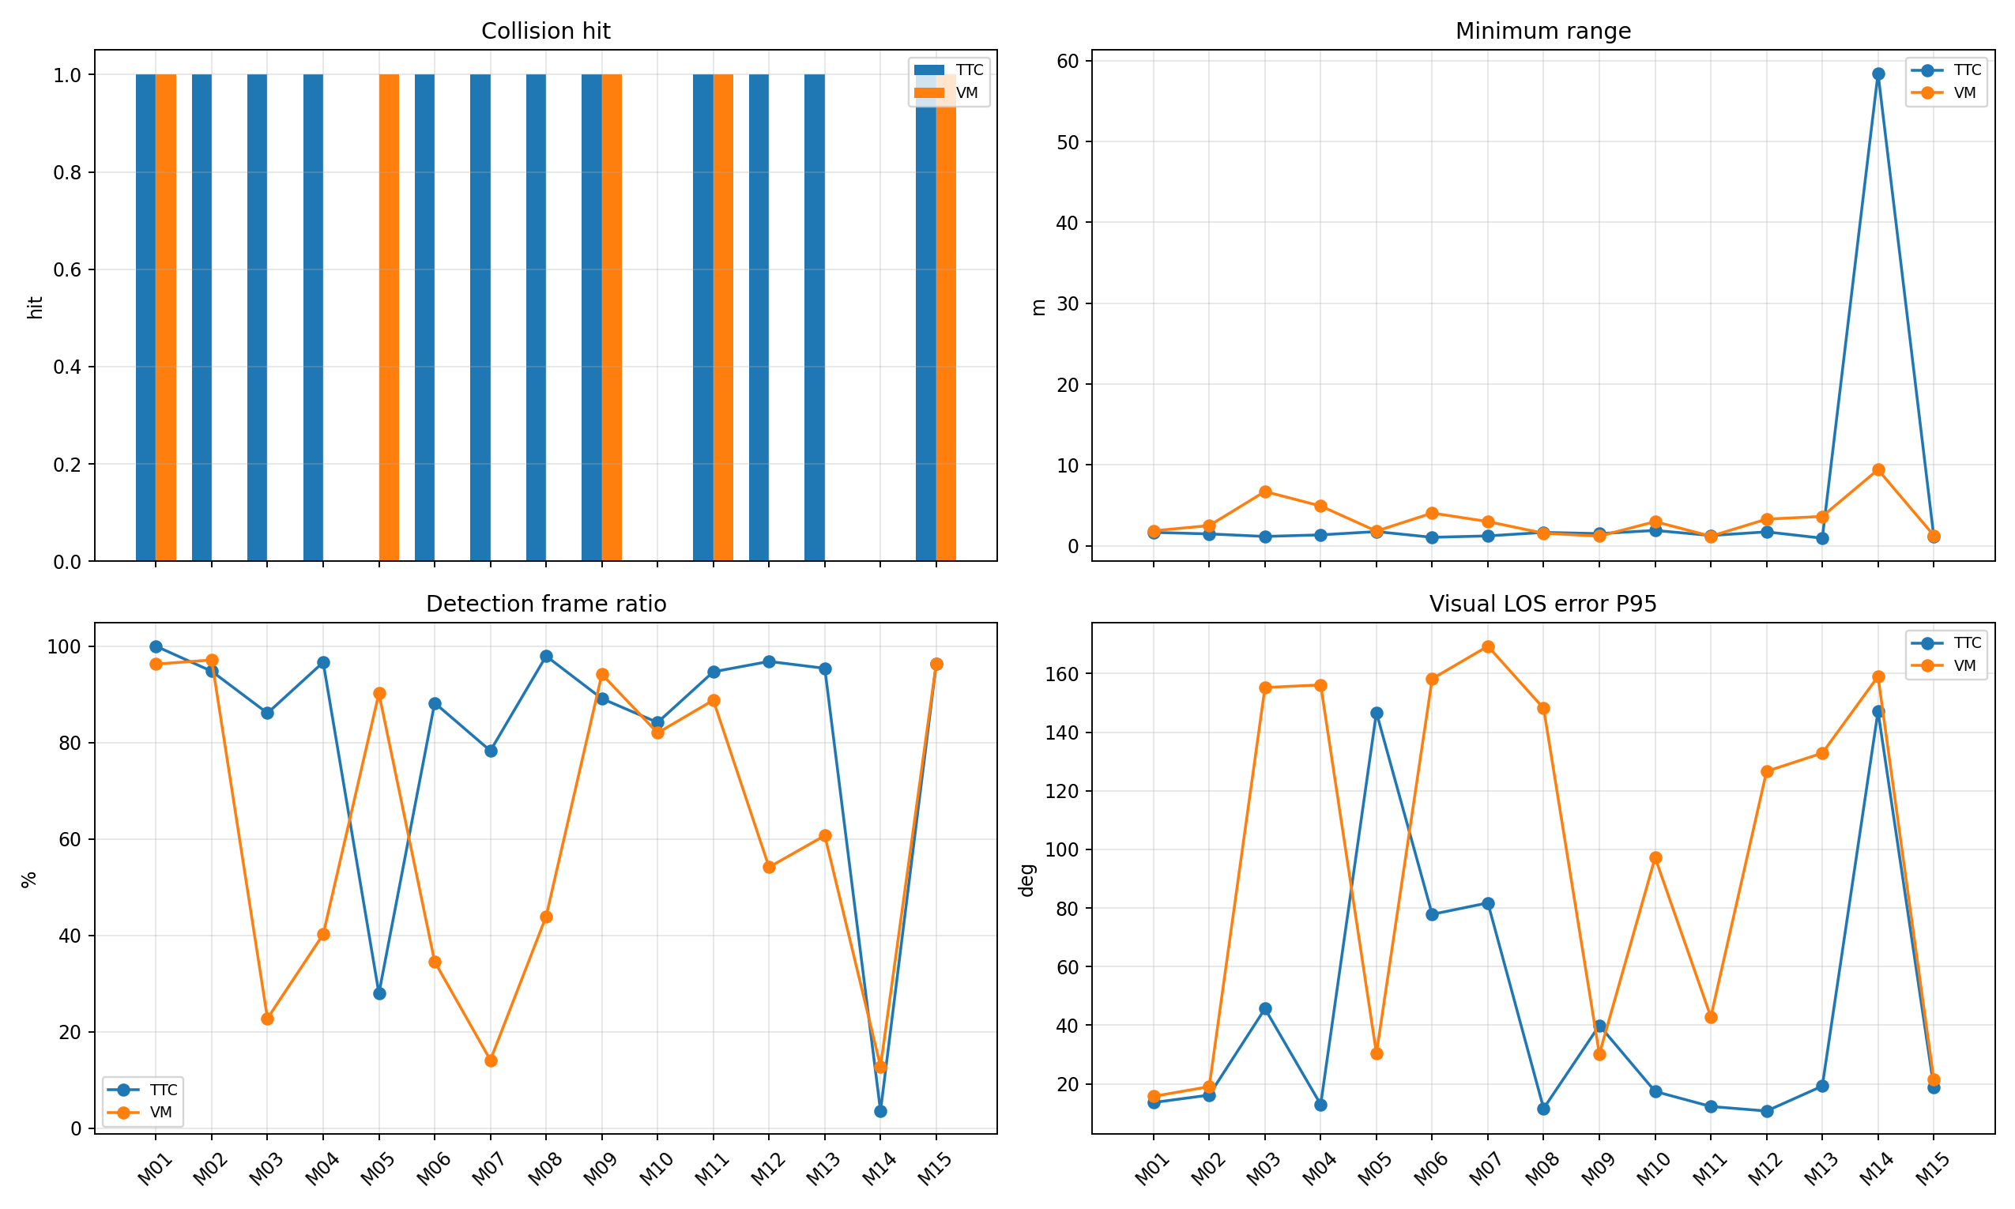
matrix15_summary

4. 明细结果
case | 算法 | 距离 | 侧向 | 高度差 | 目标速度 | 碰撞 | near | 最小m | 终点m | 检测率 | 有效率 | YOLO FPS | LOS P95 deg | 需用P95 g | 主要状态
M01 | TTC | 40 | -10 | 30 | 5.0 | 1 | 0 | 1.66 | 1.66 | 100.0% | 98.8% | 9.79 | 13.6 | 0.71 | valid:58, area_not_expanding:23, bbox_bottom_clipped:1
M01 | VM | 40 | -10 | 30 | 5.0 | 1 | 0 | 1.85 | 1.95 | 96.3% | 98.8% | 9.80 | 15.7 | 0.55 | valid:77, image_kf_predict:3, bbox_bottom_clipped:1
M02 | TTC | 25 | -10 | 30 | 5.0 | 1 | 1 | 1.47 | 1.47 | 94.8% | 96.1% | 9.79 | 16.2 | 1.58 | valid:51, area_not_expanding:19, terminal_lost:5
M02 | VM | 25 | -10 | 30 | 5.0 | 0 | 0 | 2.50 | 3.54 | 97.1% | 96.4% | 9.07 | 19.0 | 2.04 | valid:251, terminal_lost:23, image_kf_predict:3
M03 | TTC | 55 | -10 | 30 | 5.0 | 1 | 1 | 1.16 | 1.16 | 86.1% | 94.4% | 9.64 | 45.7 | 1.81 | valid:71, area_not_expanding:17, image_kf_predict:9
M03 | VM | 55 | -10 | 30 | 5.0 | 0 | 0 | 6.72 | 86.87 | 22.8% | 20.6% | 9.14 | 155.3 | 0.54 | no_detection:215, valid:55, bbox_bottom_clipped:9
M04 | TTC | 40 | 0 | 30 | 5.0 | 1 | 1 | 1.35 | 1.35 | 96.7% | 97.8% | 9.75 | 12.9 | 0.56 | valid:62, area_not_expanding:25, no_detection:2
M04 | VM | 40 | 0 | 30 | 5.0 | 0 | 0 | 4.92 | 69.72 | 40.2% | 38.8% | 9.20 | 156.1 | 0.65 | no_detection:146, valid:101, terminal_lost:25
M05 | TTC | 40 | -20 | 30 | 5.0 | 0 | 0 | 1.76 | 114.63 | 28.0% | 27.2% | 9.18 | 146.7 | 0.54 | no_detection:187, valid:54, area_not_expanding:19
M05 | VM | 40 | -20 | 30 | 5.0 | 1 | 0 | 1.82 | 1.82 | 90.2% | 90.2% | 8.77 | 30.4 | 1.98 | valid:70, terminal_lost:9, bbox_bottom_clipped:1
M06 | TTC | 40 | 20 | 30 | 5.0 | 1 | 1 | 1.05 | 1.05 | 88.2% | 91.2% | 9.27 | 77.9 | 2.04 | valid:82, area_not_expanding:31, terminal_lost:8
M06 | VM | 40 | 20 | 30 | 5.0 | 0 | 0 | 4.05 | 79.59 | 34.5% | 36.0% | 8.83 | 158.2 | 0.51 | no_detection:174, valid:92, image_kf_predict:6
M07 | TTC | 40 | -10 | 20 | 5.0 | 1 | 1 | 1.23 | 1.25 | 78.3% | 88.7% | 9.20 | 81.7 | 2.04 | valid:57, area_not_expanding:16, image_kf_predict:13
M07 | VM | 40 | -10 | 20 | 5.0 | 0 | 0 | 3.00 | 101.53 | 14.1% | 11.9% | 8.18 | 169.4 | 0.56 | no_detection:229, valid:29, bbox_bottom_clipped:9
M08 | TTC | 40 | -10 | 40 | 5.0 | 1 | 0 | 1.66 | 1.66 | 98.0% | 99.0% | 8.27 | 11.6 | 1.61 | valid:74, area_not_expanding:17, terminal_lost:3
M08 | VM | 40 | -10 | 40 | 5.0 | 0 | 0 | 1.56 | 183.88 | 43.9% | 35.6% | 8.02 | 148.2 | 0.86 | no_detection:141, valid:92, terminal_lost:20
M09 | TTC | 30 | -10 | 30 | 3.0 | 1 | 0 | 1.51 | 1.62 | 89.1% | 93.5% | 8.62 | 39.9 | 0.51 | valid:55, area_not_expanding:19, terminal_lost:13
M09 | VM | 30 | -10 | 30 | 3.0 | 1 | 1 | 1.20 | 1.20 | 94.2% | 97.7% | 8.29 | 30.2 | 1.57 | valid:78, terminal_lost:4, image_kf_predict:3
M10 | TTC | 30 | -10 | 30 | 7.0 | 0 | 0 | 1.90 | 61.42 | 84.2% | 81.7% | 8.82 | 17.4 | 2.02 | valid:133, area_not_expanding:83, no_detection:42
M10 | VM | 30 | -10 | 30 | 7.0 | 0 | 0 | 2.99 | 13.61 | 82.0% | 76.3% | 8.84 | 97.2 | 2.04 | valid:207, terminal_lost:44, no_detection:27
M11 | TTC | 50 | -10 | 30 | 3.0 | 1 | 1 | 1.28 | 1.28 | 94.7% | 97.3% | 9.35 | 12.3 | 0.41 | valid:98, area_not_expanding:7, no_detection:3
M11 | VM | 50 | -10 | 30 | 3.0 | 1 | 1 | 1.19 | 1.19 | 88.8% | 92.8% | 9.55 | 42.8 | 1.44 | valid:105, no_detection:9, image_kf_predict:5
M12 | TTC | 50 | -10 | 30 | 7.0 | 1 | 0 | 1.72 | 1.94 | 96.8% | 96.8% | 9.42 | 10.7 | 0.69 | valid:73, area_not_expanding:16, no_detection:3
M12 | VM | 50 | -10 | 30 | 7.0 | 0 | 0 | 3.30 | 64.38 | 54.2% | 54.5% | 8.66 | 126.7 | 1.90 | valid:141, no_detection:110, terminal_lost:19
M13 | TTC | 45 | -20 | 40 | 7.0 | 1 | 1 | 0.95 | 0.95 | 95.4% | 98.2% | 9.69 | 19.2 | 0.95 | valid:90, area_not_expanding:11, image_kf_predict:3
M13 | VM | 45 | -20 | 40 | 7.0 | 0 | 0 | 3.64 | 49.80 | 60.7% | 59.6% | 9.11 | 132.9 | 2.04 | valid:160, no_detection:90, terminal_lost:28
M14 | TTC | 55 | 15 | 20 | 7.0 | 0 | 0 | 58.43 | 498.80 | 3.6% | 4.3% | 9.12 | 147.1 | 0.00 | no_detection:269, area_not_expanding:5, valid:3
M14 | VM | 55 | 15 | 20 | 7.0 | 0 | 0 | 9.42 | 47.67 | 12.8% | 14.2% | 9.22 | 159.0 | 0.54 | no_detection:239, valid:33, image_kf_predict:6
M15 | TTC | 25 | 20 | 40 | 3.0 | 1 | 1 | 1.18 | 1.18 | 96.4% | 99.1% | 8.17 | 18.9 | 0.93 | valid:86, area_not_expanding:12, terminal_lost:5
M15 | VM | 25 | 20 | 40 | 3.0 | 1 | 1 | 1.29 | 1.41 | 96.4% | 98.2% | 8.27 | 21.5 | 0.68 | valid:107, image_kf_predict:2, no_detection:2

5. 验证
检查项 | 结果
CSV 数量 | 30/30
detector_source | yolo_bytetrack
shadow enabled frames | 0
YOLO raw frames | 3181
YOLO selected frames | 3181

6. 诊断要点
- infrastructure failed case: -。
- near-hit but no collision: -。
- full miss: M02-VM(2.50m), M03-VM(6.72m), M04-VM(4.92m), M05-TTC(1.76m), M06-VM(4.05m), M07-VM(3.00m), M08-VM(1.56m), M10-TTC(1.90m), M10-VM(2.99m), M12-VM(3.30m), M13-VM(3.64m), M14-TTC(58.43m), M14-VM(9.42m)。
- 本轮 shadow_airsim_enabled 总帧数应为 0；若非 0，说明实验不满足“无影子测试”条件。
- 低检测率或 LOS P95 高的失败工况优先分析 YOLO/ByteTrack 连续性、frame-centering、terminal image KF 和末端 bbox 裁切。

