Sensor Selection Precision Surface
Data before adjust the lamp

Pos. <1,1> Tape (inch): 4, 3.5
before (x,y,r) inch=4.46231769473505,4.18816650896995,0.487008640092268
Sample Num: 0:0 1:84 2:0 3:0 4:0 5:84 6:84 7:0 8:0 9:0 10:0 11:0 12:0 13:0 14:0
after (x,y,r) inch=4.45506502256768,4.19101549760795,0.256185453970511
after (x,y,r) inch=4.6540353448869,4.40627430682065,0.257395095724713
after (x,y,r) inch=4.65668120403549,4.40895188093147,0.257405905220162
after (x,y,r) inch=4.66224614273911,4.41459568022284,0.257427172062592
after (x,y,r) inch=4.66442843295473,4.41734809048499,0.257437615683848
after (x,y,r) inch=4.66679547833411,4.41969785793067,0.257446271408315
after (x,y,r) inch=4.66885725974448,4.42229785830135,0.257454996412049
after (x,y,r) inch=4.67084156043069,4.42430745748654,0.257462949173963
after (x,y,r) inch=4.67277200604767,4.42625800199514,0.257470114405613
after (x,y,r) inch=4.67464999345788,4.42815120289925,0.257477004458602

Pos. <1,2> Tape(inch): 8, 2.5
before (x,y,r) inch=8.83684864658662,2.94766065861515,0.482999944245906
Sample Num: 0:0 1:84 2:84 3:0 4:0 5:0 6:84 7:0 8:0 9:0 10:0 11:0 12:0 13:0 14:0
after (x,y,r) inch=8.57729727653431,2.97617241651689,0.256414367840355
after (x,y,r) inch=8.57627167786509,2.97301844293935,0.256409638659478
after (x,y,r) inch=8.57533921463936,2.97044199189392,0.256372324580598
after (x,y,r) inch=8.57433986256229,2.96759068977398,0.25634174945445
after (x,y,r) inch=8.57335406980693,2.96488998518064,0.256307983315797
after (x,y,r) inch=8.57225279286391,2.96248796435244,0.256275978721891
after (x,y,r) inch=8.57108798126476,2.95980128441634,0.256247250772495
after (x,y,r) inch=8.5699398660412,2.95725621922331,0.256215229818174
after (x,y,r) inch=8.56855789482855,2.954606624139,0.256184865183245
after (x,y,r) inch=8.56740714964105,2.95268925192868,0.256153041718369

Pos. <1,3> Tape(inch): 11.5, 3.25
before (x,y,r) inch=12.3107834704773,3.51980868047306,0.505840197008866
Sample Num: 0:0 1:122 2:127 3:0 4:0 5:0 6:0 7:5 8:0 9:0 10:0 11:0 12:0 13:0 14:0
after (x,y,r) inch=12.5379253826763,2.87340599774955,0.258255948574311
after (x,y,r) inch=12.5477578537362,2.85544384179942,0.25881290753998
after (x,y,r) inch=12.550265241139,2.85281916922498,0.258920718141012
after (x,y,r) inch=12.552052812011,2.84952590847416,0.258999604667303
after (x,y,r) inch=12.5538054939369,2.84630960197913,0.259103919269955
after (x,y,r) inch=12.5559976976497,2.84362067013999,0.259206072502707
after (x,y,r) inch=12.5578460568103,2.84122694752436,0.259288927146688
after (x,y,r) inch=12.5594645195289,2.83819363368692,0.259363228684668
after (x,y,r) inch=12.5607562479831,2.83504779377464,0.259460392718241
after (x,y,r) inch=12.5626866898613,2.83312136773305,0.25956295349551

Pos. <1,4> Tape(inch): 15.25,3.25
before (x,y,r) inch=16.644481976653,3.69225090794705,0.476752949307809
Sample Num: 0:0 1:0 2:84 3:84 4:0 5:0 6:0 7:84 8:0 9:0 10:0 11:0 12:0 13:0 14:0
after (x,y,r) inch=16.6062715939874,3.76626428840578,0.266236136973073
after (x,y,r) inch=16.6061763076696,3.76628774527524,0.266268583431369
after (x,y,r) inch=16.6064290417122,3.76620475841959,0.266268548698807
after (x,y,r) inch=16.6065633189739,3.76611475958357,0.266268363448459
after (x,y,r) inch=16.6067504332908,3.76565359894366,0.266267652171758
after (x,y,r) inch=16.6071651887286,3.76510181473097,0.266262181024178
after (x,y,r) inch=16.6072816222105,3.76431089233654,0.266256327937992
after (x,y,r) inch=16.6072888221953,3.76446209028892,0.266246199109535
after (x,y,r) inch=16.6073476700549,3.76408463808941,0.26624824230897
after (x,y,r) inch=16.6075214010812,3.76374169653661,0.26624342054716

Pos. <1,5> Tape(inch): 19.2, 3.75
before (x,y,r) inch=20.2262540417085,3.62432162812293,0.554398823067655
Sample Num: 0:0 1:0 2:84 3:84 4:0 5:0 6:0 7:0 8:84 9:0 10:0 11:0 12:0 13:0 14:0
after (x,y,r) inch=19.531623511431,4.26800616112689,0.24655990909163
after (x,y,r) inch=19.5656968564015,4.25235124228487,0.246907968850809
after (x,y,r) inch=19.5690685922379,4.25060367664505,0.246954294034571
after (x,y,r) inch=19.5909696921031,4.23959279426561,0.247244930537695
after (x,y,r) inch=19.5941201799024,4.23750689604754,0.247291598423642
after (x,y,r) inch=19.5971736335783,4.23548095181765,0.247338033808151
after (x,y,r) inch=19.6004201446584,4.23368845470725,0.247383022060371
after (x,y,r) inch=19.603068318702,4.23194794421795,0.247427449789067
after (x,y,r) inch=19.6061708723292,4.22973197011816,0.24746622027345
after (x,y,r) inch=19.6089914120419,4.22727654483976,0.247513219979706

Pos. <1,6> Tape(inch): 23.5, 3.75
before (x,y,r) inch=25.0610528750991,3.95175612442759,0.476196715761391
Sample Num: 0:0 1:0 2:0 3:119 4:119 5:0 6:0 7:0 8:16 9:0 10:0 11:0 12:0 13:0 14:0
after (x,y,r) inch=25.0716618789286,4.0945836289225,0.246840639584765
after (x,y,r) inch=25.1018552574222,3.85014661997733,0.245855598828028
after (x,y,r) inch=25.1019485888744,3.84677278663022,0.245843104861284
after (x,y,r) inch=25.1021429562244,3.84387661815002,0.245833401104421
after (x,y,r) inch=25.1022106180797,3.84076247897582,0.245824309519221
after (x,y,r) inch=25.1023657878676,3.83818931482827,0.24581555967944
after (x,y,r) inch=25.1025099533634,3.83495214103853,0.245807667944224
after (x,y,r) inch=25.1023901707011,3.83282320875034,0.245798134871187
after (x,y,r) inch=25.1026086661262,3.83024732071061,0.245793378278703
after (x,y,r) inch=25.1025024745809,3.82897262936959,0.245785125600143

Pos. <1,7> Tape(inch): 27.5, 3.5
before (x,y,r) inch=28.1570038600819,4.39351547955871,0.504462621682898
Sample Num: 0:0 1:0 2:0 3:0 4:84 5:0 6:0 7:0 8:84 9:84 10:0 11:0 12:0 13:0 14:0
after (x,y,r) inch=28.1488598764104,4.53116262953098,0.256424887366029
after (x,y,r) inch=28.4049905365803,4.93510801798127,0.258226365089247
after (x,y,r) inch=28.4068506267471,4.9384674489277,0.258232435503536
after (x,y,r) inch=28.4084792526155,4.94156073628721,0.258239262235473
after (x,y,r) inch=28.4102536679275,4.94474182256874,0.258245585182778
after (x,y,r) inch=28.4117038746519,4.9475971512484,0.258251819461935
after (x,y,r) inch=28.4132142425605,4.95043832700393,0.258257572412305
after (x,y,r) inch=28.4147769616557,4.95330808825323,0.258263101618309
after (x,y,r) inch=28.4161218831858,4.95549035157347,0.258268538656055
after (x,y,r) inch=28.4177116902578,4.95785154774778,0.258272333200925

After adjusting the sensors, redo
Pos. <1,1> Tape(inch): 3.8, 3
before (x,y,r) inch=4.0474831836304,3.98640937729381,0.530539616068237
Sample Num: 0:84 1:84 2:0 3:0 4:0 5:0 6:84 7:0 8:0 9:0 10:0 11:0 12:0 13:0 14:0
after (x,y,r) inch=3.69030219368631,4.53084046791177,0.245608597232329
after (x,y,r) inch=3.79360998078517,4.44047335771038,0.247284311837911
after (x,y,r) inch=3.79621500159606,4.43812979567396,0.247333701041882
after (x,y,r) inch=3.79900725974776,4.43551236073322,0.247378113526514
after (x,y,r) inch=3.80174302218333,4.43300988735921,0.247426551668037
after (x,y,r) inch=3.80420788178024,4.43078235024581,0.247473424908412
after (x,y,r) inch=3.80711507842732,4.42857523620138,0.2475153769021
after (x,y,r) inch=3.8097045499778,4.42617335224803,0.247561259612977
after (x,y,r) inch=3.81176453716081,4.42382284651583,0.24760574512124
after (x,y,r) inch=3.81405626047611,4.42173848606945,0.247644785685762

Pos. <1,2> Tape(inch): 7.6, 3.3
before (x,y,r) inch=8.04844648870563,4.10461796931969,0.474034178884049
Sample Num: 0:0 1:0 2:0 3:0 4:0 5:59 6:117 7:77 8:0 9:0 10:0 11:0 12:0 13:0 14:0
after (x,y,r) inch=7.78988705044351,3.26877842057838,0.218798813393424
after (x,y,r) inch=7.85778583557264,3.70231012279228,0.221532654441194
after (x,y,r) inch=7.86192679005886,3.72254326525508,0.221677350012992
after (x,y,r) inch=7.86268122779319,3.72599101036754,0.221704707275966
after (x,y,r) inch=7.86299442102457,3.72896057293481,0.221729475943818
after (x,y,r) inch=7.86372897760968,3.7322146762133,0.221751784546935
after (x,y,r) inch=7.86424004209608,3.73548455575158,0.221775182307836
after (x,y,r) inch=7.86498119492832,3.73878126829728,0.221799368202466
after (x,y,r) inch=7.86546919166884,3.741852517379,0.221823167916907
after (x,y,r) inch=7.86618793195867,3.74495644064239,0.221845942306571

Pos. <1,3> Tape(inch): 12, 2.8
before (x,y,r) inch=12.5301623430214,3.4021758557392,0.528036383294451
Sample Num: 0:0 1:74 2:125 3:0 4:0 5:0 6:0 7:55 8:0 9:0 10:0 11:0 12:0 13:0 14:0
after (x,y,r) inch=12.5294420397135,3.40524153336293,0.242459389292195
after (x,y,r) inch=12.7900441996901,3.0685666537424,0.244938500366456
after (x,y,r) inch=12.7928760010253,3.06620515984053,0.24495991350521
after (x,y,r) inch=12.8010155606284,3.04736388574673,0.245080711854237
after (x,y,r) inch=12.8038350664367,3.04584990716162,0.245104828795585
after (x,y,r) inch=12.8061397485558,3.04342702829233,0.245116957274766
after (x,y,r) inch=12.8078170282549,3.04069913993192,0.245134405943397
after (x,y,r) inch=12.8107497109872,3.03951915959153,0.245153243198329
after (x,y,r) inch=12.8129271275762,3.03667948673614,0.24516325582619
after (x,y,r) inch=12.8152575286711,3.0351250374991,0.245183184291676

Pos. <1,4> Tape(inch): 15.3, 3.1
before (x,y,r) inch=15.8323772861596,3.65729018727796,0.476469782144612
Sample Num: 0:0 1:100 2:121 3:33 4:0 5:0 6:0 7:0 8:0 9:0 10:0 11:0 12:0 13:0 14:0
after (x,y,r) inch=15.7879022162631,4.68445564682164,0.226131498088571
after (x,y,r) inch=15.6094905438954,4.34808463598548,0.226633922743073
after (x,y,r) inch=15.5944614710543,4.32868423969731,0.226655668424468
after (x,y,r) inch=15.5922960059422,4.32588507176634,0.226658829730532
after (x,y,r) inch=15.5899486989545,4.32304366225173,0.226662274784185
after (x,y,r) inch=15.587849219258,4.32040412899407,0.22666504665521
after (x,y,r) inch=15.5853176349295,4.31757584665639,0.226668107160708
after (x,y,r) inch=15.5830726106713,4.31496905726211,0.226669969841257
after (x,y,r) inch=15.581110799512,4.31218027172983,0.226672212266429
after (x,y,r) inch=15.5791772636353,4.30947082400796,0.226676968931825

Pos. <1,5> Tape(inch): 19.2, 3.2
before (x,y,r) inch=20.2149398942565,3.92034236110996,0.497836240088391
Sample Num: 0:0 1:0 2:84 3:84 4:0 5:0 6:0 7:0 8:84 9:0 10:0 11:0 12:0 13:0 14:0
after (x,y,r) inch=19.8041844512562,4.44360025388118,0.247456076130034
after (x,y,r) inch=19.8137229503216,4.42591174170551,0.247599608866044
after (x,y,r) inch=19.8352920332063,4.40095468039268,0.24800671934566
after (x,y,r) inch=19.8380717408332,4.3983204475248,0.248054573553278
after (x,y,r) inch=19.84124132214,4.39623280729016,0.248102097784305
after (x,y,r) inch=19.8441247815937,4.3939165385831,0.248148654855953
after (x,y,r) inch=19.8464684242864,4.39164588066321,0.248194386207589
after (x,y,r) inch=19.8475911944007,4.38871336871884,0.248234695550386
after (x,y,r) inch=19.8496789947044,4.38630470486163,0.248269122587239
after (x,y,r) inch=19.8514765997059,4.38371663964075,0.248308105433175

Pos. <1,6> Tape(inch): 23,3.3
before (x,y,r) inch=23.4269705135168,4.12908722018588,0.474318308701361
Sample Num: 0:0 1:0 2:2 3:0 4:0 5:0 6:0 7:125 8:126 9:0 10:0 11:0 12:0 13:0 14:0
after (x,y,r) inch=24.1851374508688,3.47794833112922,0.262776502012932
after (x,y,r) inch=24.2056483211575,3.9096396046454,0.262622132598746
after (x,y,r) inch=24.2264813432486,3.94906325937053,0.263038148207259
after (x,y,r) inch=24.2366940949596,3.96696274390946,0.263267420558916
after (x,y,r) inch=24.2384594543067,3.96973520112174,0.263312607391327
after (x,y,r) inch=24.2399539702703,3.97230541432262,0.263353172150807
after (x,y,r) inch=24.2401667566297,3.97419000623648,0.263387378212243
after (x,y,r) inch=24.2397707185921,3.9753254663463,0.26339083429375
after (x,y,r) inch=24.2389034355644,3.97659349865715,0.26338005871795
after (x,y,r) inch=24.2382601756784,3.97792301541945,0.263357603249006

Pos. <1,7> Tape(inch): 26.8, 3.6
before (x,y,r) inch=27.5725386207448,4.80468523153953,0.526022594967061
Sample Num: 0:0 1:0 2:0 3:19 4:0 5:0 6:0 7:0 8:126 9:109 10:0 11:0 12:0 13:0 14:0
after (x,y,r) inch=27.5733024278611,4.66731049947225,0.245229750431927
after (x,y,r) inch=27.5738603104731,4.66361680980554,0.24517038515931
after (x,y,r) inch=27.4633925778482,5.07147056596402,0.25262593132801
after (x,y,r) inch=27.4618030342764,5.07487018164453,0.252701019037374
after (x,y,r) inch=27.4601343301208,5.07826269715765,0.25277433985669
after (x,y,r) inch=27.4583153821469,5.08130138199575,0.252847446347764
after (x,y,r) inch=27.4568222667089,5.0840248556857,0.252912088257293
after (x,y,r) inch=27.4553609680044,5.08668047409301,0.252970565270152
after (x,y,r) inch=27.4778290153921,5.14803823223532,0.258296660822031
after (x,y,r) inch=27.4759928106581,5.15566491531472,0.25853433991981

Pos. <2,1> Tape(inch): 3.8, 7.6
before (x,y,r) inch=5.19247472077239,8.38626785551865,0.49245825836639
Sample Num: 0:0 1:0 2:0 3:0 4:0 5:84 6:84 7:0 8:0 9:0 10:0 11:84 12:0 13:0 14:0
after (x,y,r) inch=5.43855852814086,6.49575163166598,0.238726884130604
after (x,y,r) inch=5.5300084799918,7.10290308856285,0.24328769866985
after (x,y,r) inch=5.52910155290043,7.10647917238645,0.243327004516333
after (x,y,r) inch=5.52867208536207,7.1103902502845,0.243364510889071
after (x,y,r) inch=5.52815725289167,7.11405857387911,0.243402383757097
after (x,y,r) inch=5.52716529095717,7.11732101151381,0.243438544988974
after (x,y,r) inch=5.52659728528346,7.12070011516655,0.243473726119788
after (x,y,r) inch=5.52561928174833,7.12390084768421,0.243507584298037
after (x,y,r) inch=5.52431571702406,7.12715308779106,0.243542151471669
after (x,y,r) inch=5.52338333241307,7.1303280332901,0.243579043105776

Pos. <2,2> Tape(inch): 7.6, 7.2
before (x,y,r) inch=6.67513883405696,7.72722681915554,0.466843076324824
Sample Num: 0:0 1:84 2:0 3:0 4:0 5:84 6:84 7:0 8:0 9:0 10:0 11:0 12:0 13:0 14:0
after (x,y,r) inch=8.22366264764472,10.3609980899495,0.236710612800811
after (x,y,r) inch=8.2814483622038,10.3549291366142,0.237011476719458
after (x,y,r) inch=8.2487460478315,10.0341379728795,0.235782208807726
after (x,y,r) inch=8.24884419743042,10.0305143072049,0.235772188845213
after (x,y,r) inch=8.24931518972119,10.027766260672,0.23576281243081
after (x,y,r) inch=8.24951151237157,10.0248551996452,0.235757878106178
after (x,y,r) inch=8.24967363677024,10.0216219833796,0.235751044874253
after (x,y,r) inch=8.24986424683232,10.018732264488,0.235743189665594
after (x,y,r) inch=8.25041719796795,10.0164801426543,0.235736448507617
after (x,y,r) inch=8.2506962416579,10.0142500898031,0.235733400302218

Pos. <2,3> Tape(inch): 12,7.8
before (x,y,r) inch=13.0332486067588,8.36896213258173,0.481892552855084
Sample Num: 0:0 1:0 2:0 3:0 4:0 5:0 6:84 7:84 8:0 9:0 10:0 11:0 12:84 13:0 14:0
after (x,y,r) inch=13.37694558795,5.84901126912935,0.23574446193775
after (x,y,r) inch=13.385330026022,5.83086723576057,0.235670965036779
after (x,y,r) inch=13.3814646798402,6.35928780718348,0.237991363560798
after (x,y,r) inch=13.3729096596566,6.40876454040567,0.238348718599619
after (x,y,r) inch=13.3717712258983,6.41232463219872,0.238377510891037
after (x,y,r) inch=13.3705278504368,6.41501755104701,0.238406164349622
after (x,y,r) inch=13.3693399512292,6.4179963049203,0.238429520052295
after (x,y,r) inch=13.3682270607731,6.42114573756437,0.238454630806701
after (x,y,r) inch=13.3674003010124,6.42396289424061,0.238480650906703
after (x,y,r) inch=13.3666349917994,6.42694974147879,0.238503275068565

Pos. <2,4> Tape(inch): 15.5, 7.8
before (x,y,r) inch=14.4356781955664,9.13675562635047,0.470559229881083
Sample Num: 0:0 1:0 2:0 3:0 4:0 5:0 6:32 7:114 8:0 9:0 10:0 11:0 12:108 13:0 14:0
after (x,y,r) inch=14.1454778673083,9.01483418485509,0.248127537728326
after (x,y,r) inch=14.143358809858,9.01154854031136,0.248074608122404
after (x,y,r) inch=14.368104182344,8.95601449695197,0.249753138574824
after (x,y,r) inch=14.3718628056138,8.95582478389369,0.249794249846502
after (x,y,r) inch=14.3749876242079,8.95559282408547,0.24983990686404
after (x,y,r) inch=14.3780523281553,8.95513520343895,0.249877065358886
after (x,y,r) inch=14.3808979800278,8.95500626963005,0.249910451350276
after (x,y,r) inch=14.3840088741955,8.95469284110166,0.249945833614049
after (x,y,r) inch=14.386980268267,8.9544311250481,0.249982260932188
after (x,y,r) inch=14.3898950030945,8.95454994472526,0.250017790346692

Pos. <2,5> Tape(inch): 19.5, 7.5
before (x,y,r) inch=20.8715408008781,7.88007813823719,0.480274061779725
Sample Num: 0:0 1:0 2:0 3:100 4:0 5:0 6:0 7:0 8:123 9:0 10:0 11:0 12:0 13:31 14:0
after (x,y,r) inch=19.7766467180037,7.90031835501856,0.230224568977455
after (x,y,r) inch=19.7740648486673,7.90056936338291,0.230205511946842
after (x,y,r) inch=20.2711164479792,7.59689858755187,0.23118118443546
after (x,y,r) inch=20.2740859061849,7.59465458271047,0.231188390585385
after (x,y,r) inch=20.2764833105639,7.59219954845736,0.231197205167541
after (x,y,r) inch=20.2780255479161,7.58970730319232,0.231200907008055
after (x,y,r) inch=20.2795269056123,7.58726615144305,0.231198415148742
after (x,y,r) inch=20.2814949114178,7.5846904969913,0.231195982858905
after (x,y,r) inch=20.2836921022796,7.58243955755335,0.231196234462091
after (x,y,r) inch=20.2859220869828,7.58044548217516,0.231199936578724

Pos. <2,6> Tape(inch): 23,7
before (x,y,r) inch=22.9343652698559,7.16663498716318,0.466587149885802
Sample Num: 0:0 1:0 2:0 3:106 4:0 5:0 6:0 7:35 8:113 9:0 10:0 11:0 12:0 13:0 14:0
after (x,y,r) inch=23.9417596905372,10.0183569320007,0.281767325894251
after (x,y,r) inch=23.9456515104877,10.018737404193,0.281787365505226
after (x,y,r) inch=24.0797666741212,9.69257053769391,0.28120749295013
after (x,y,r) inch=23.9456573814271,10.0079788380873,0.312775271887772
after (x,y,r) inch=23.9495597315228,10.0076970370409,0.312796808560791
after (x,y,r) inch=24.0909773163021,9.64660746569972,0.311685139442621
after (x,y,r) inch=24.1049940972182,9.63177232700526,0.311602685278439
after (x,y,r) inch=24.1074701719241,9.62909721513838,0.31158555970138
after (x,y,r) inch=24.1102687930745,9.62726931580549,0.311568937569197
after (x,y,r) inch=24.1127206633113,9.62455331446482,0.311554193642546

Pos. <2,7> Tape(inch): 27.3, 8
before (x,y,r) inch=28.5928281003494,8.51380349863577,0.46953183590475
Sample Num: 0:0 1:0 2:0 3:0 4:0 5:0 6:0 7:0 8:112 9:0 10:0 11:0 12:0 13:67 14:74
after (x,y,r) inch=28.7191276728031,7.26318106148668,0.219098408199878
after (x,y,r) inch=28.2782765639044,7.64465664621348,0.220281684340674
after (x,y,r) inch=28.2761619143566,7.64781956109518,0.220293441637172
after (x,y,r) inch=28.2745972443569,7.65069776320583,0.220304983306441
after (x,y,r) inch=28.2726018200144,7.65376146955409,0.220314151541114
after (x,y,r) inch=28.2706706587754,7.65677468057445,0.220325323920195
after (x,y,r) inch=28.2688017692495,7.65973831911525,0.220336289276854
after (x,y,r) inch=28.2669932189114,7.66265328743853,0.220347050895101
after (x,y,r) inch=28.2648637221324,7.66555046382949,0.220357612057879
after (x,y,r) inch=28.2632847975459,7.66816781891551,0.22036953845711

Pos. <3,1> Tape(inch): 3.5, 11.7
before (x,y,r) inch=3.09687762311607,12.5689839394288,0.555780502598974
Sample Num: 0:0 1:0 2:0 3:0 4:0 5:88 6:0 7:0 8:0 9:0 10:124 11:41 12:0 13:0 14:0
after (x,y,r) inch=3.92359954309961,12.1001918512246,0.238470752046229
after (x,y,r) inch=3.94391559619304,12.0982973141513,0.238324441753265
after (x,y,r) inch=3.98799444479162,12.1067602577344,0.238054228823887
after (x,y,r) inch=4.02573235673257,12.120021143127,0.237853616152455
after (x,y,r) inch=4.06264798146971,12.1379265487523,0.237685400797833
after (x,y,r) inch=4.10684749231686,12.1647741912006,0.237518396400454
after (x,y,r) inch=4.1360872669641,12.1845313243231,0.237425067643203
after (x,y,r) inch=4.20268688562826,12.2259465660745,0.237231572809417
after (x,y,r) inch=4.417049431429,12.3516375693853,0.236817116445147
after (x,y,r) inch=4.41595406306127,12.3503609142533,0.236811748000578

Pos. <3,2> Tape(inch): 8, 11.2
before (x,y,r) inch=8.48182696704214,12.3442172791527,0.494885545009503
Sample Num: 0:0 1:0 2:0 3:0 4:0 5:0 6:84 7:0 8:0 9:0 10:0 11:84 12:84 13:0 14:0
after (x,y,r) inch=8.39393545173675,12.3407335754648,0.263934849712607
after (x,y,r) inch=8.39008436610658,12.3407959058925,0.263912542174231
after (x,y,r) inch=8.37423391186283,12.340764581803,0.263822614654134
after (x,y,r) inch=8.37042123269111,12.3411751518556,0.263799878451527
after (x,y,r) inch=8.36677627616588,12.3413320744812,0.263772673445137
after (x,y,r) inch=8.3631984259023,12.3426464193286,0.263749387885431
after (x,y,r) inch=8.35969718737714,12.3435065379197,0.263712345331416
after (x,y,r) inch=8.35627277542459,12.3439369450584,0.263681158070238
after (x,y,r) inch=8.35262690955769,12.3438715710763,0.26365551464843
after (x,y,r) inch=8.34928357483886,12.3443114512877,0.263634400596631

Pos. <3,3> Tape(inch): 12.1, 10.8
before (x,y,r) inch=12.1545258924819,12.14087220982,0.51969478800259
Sample Num: 0:0 1:0 2:0 3:0 4:0 5:0 6:0 7:93 8:0 9:0 10:0 11:34 12:127 13:0 14:0
after (x,y,r) inch=12.4587856607152,11.9086271237921,0.241023229865354
after (x,y,r) inch=13.086612409275,12.099189461058,0.250191524091398
after (x,y,r) inch=13.0164085332725,12.3474567130655,0.248734125918859
after (x,y,r) inch=13.0628151138377,12.3248090794699,0.24946032031902
after (x,y,r) inch=12.9751933397787,12.5444239460777,0.247800249333395
after (x,y,r) inch=13.2274154863334,12.3665948980713,0.252343481984132
after (x,y,r) inch=13.188742043957,12.5074728986228,0.251341392946569
after (x,y,r) inch=13.1565165908766,12.5726132698614,0.250615013478188
after (x,y,r) inch=13.155106399523,12.5746932480242,0.250576550664049
after (x,y,r) inch=13.1561131076997,12.5748755752769,0.250546945157326

Pos. <3,4> Tape(inch): 15.2, 11.6
before (x,y,r) inch=14.5526142604682,12.2590462449459,0.482024832778939
Sample Num: 0:0 1:0 2:0 3:0 4:0 5:0 6:0 7:123 8:0 9:0 10:0 11:0 12:120 13:11 14:0
after (x,y,r) inch=13.9351282158724,12.2989834503444,0.284945766294924
after (x,y,r) inch=14.142758115211,12.2412202647842,0.298551486143719
after (x,y,r) inch=14.146009875663,12.2403092631596,0.298838121625628
after (x,y,r) inch=14.149216411208,12.2394253841412,0.299083219504926
after (x,y,r) inch=14.1520822111325,12.2392461100974,0.299325613820961
after (x,y,r) inch=14.1549064064729,12.2390644044544,0.299540326352619
after (x,y,r) inch=14.1578374380442,12.2385410682676,0.299752537720442
after (x,y,r) inch=14.1607271037254,12.2380296811226,0.2999748162573
after (x,y,r) inch=14.1636071971757,12.2379378730859,0.30019456715541
after (x,y,r) inch=14.1665927789055,12.237500079389,0.300412446316843

Pos. <3,5> Tape(inch): 19.6, 11.2
before (x,y,r) inch=20.1759974569403,11.8348526478546,0.525240604622037
Sample Num: 0:0 1:0 2:0 3:0 4:0 5:0 6:0 7:44 8:127 9:0 10:0 11:0 12:0 13:83 14:0
after (x,y,r) inch=20.2625320853757,11.8436422478968,0.239340098732339
after (x,y,r) inch=20.2663230715709,11.8435260899923,0.2393690472123
after (x,y,r) inch=20.270001607495,11.8433639373404,0.239397353851925
after (x,y,r) inch=20.2738216285464,11.8433836763175,0.239425031959896
after (x,y,r) inch=20.0582650101058,12.0042005207837,0.25282291302391
after (x,y,r) inch=20.0593964397805,12.0028386822792,0.252843778237171
after (x,y,r) inch=20.0605120159667,12.0015030904996,0.252860489901919
after (x,y,r) inch=20.0616118527779,12.0001931721269,0.252876896153131
after (x,y,r) inch=20.0629365807236,11.9991452437586,0.25289300271723
after (x,y,r) inch=20.0639969143623,11.9978689664111,0.252908925627841

Pos. <3,6> Tape(inch): 23.2, 11.7
before (x,y,r) inch=23.4846773770936,11.5382439218389,0.509064474691748
Sample Num: 0:0 1:0 2:0 3:0 4:0 5:0 6:0 7:84 8:84 9:0 10:0 11:0 12:0 13:84 14:0
after (x,y,r) inch=21.8762578771636,11.2609032040768,0.237958967218237
after (x,y,r) inch=21.8645200178116,11.2593533383544,0.237910382266675
after (x,y,r) inch=22.5096328094069,11.4292824928717,0.242521309335636
after (x,y,r) inch=22.5254219585362,11.4316775433189,0.242672020616235
after (x,y,r) inch=22.5292323726247,11.4319665804909,0.242709373654655
after (x,y,r) inch=22.5327335891059,11.4322810493151,0.24274489418571
after (x,y,r) inch=22.5360419988418,11.4329655669318,0.24277783097317
after (x,y,r) inch=22.5393183392461,11.4336365374793,0.242810667766914
after (x,y,r) inch=22.5428296876474,11.4342765324582,0.242843240490338
after (x,y,r) inch=22.5504994926799,11.4361719522037,0.2429171495352

Pos. <3,7> Tape(inch): 26.4, 11.5

before (x,y,r) inch=27.3900942961187,11.601454487046,0.52302180705273
Sample Num: 0:0 1:0 2:0 3:0 4:0 5:0 6:0 7:0 8:126 9:22 10:0 11:0 12:0 13:105 14:0
after (x,y,r) inch=27.3883920167765,11.6024585113237,0.244532340543695
after (x,y,r) inch=26.8275215897316,11.4284901254502,0.254476312425801
after (x,y,r) inch=26.8180378780527,11.4209831453314,0.254681941268781
after (x,y,r) inch=26.8071181328237,11.4159366048291,0.254906896641411
after (x,y,r) inch=26.8041412341345,11.4149053971816,0.254984741434298
after (x,y,r) inch=26.8009465493263,11.4130126194084,0.255051584540131
after (x,y,r) inch=26.7981575167954,11.4115767621728,0.255120500091348
after (x,y,r) inch=26.7957080954625,11.4099972140854,0.255181611407412
after (x,y,r) inch=26.793318451826,11.4084582394704,0.255234152693239
after (x,y,r) inch=26.7909871520897,11.4069588622595,0.255285495600224

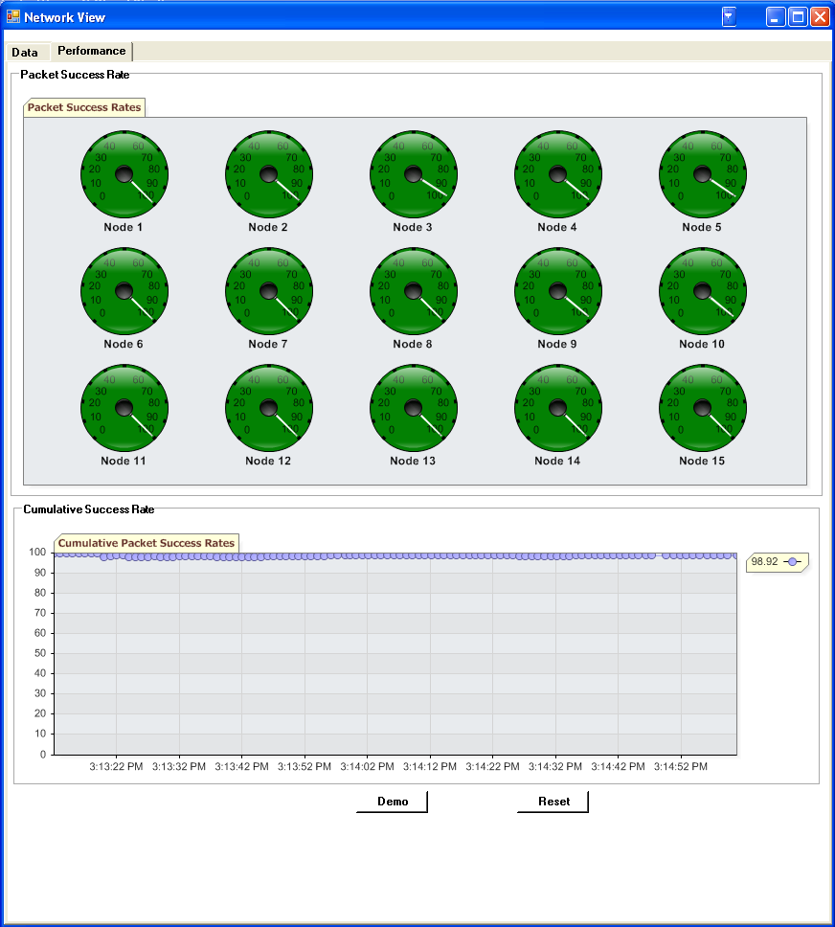
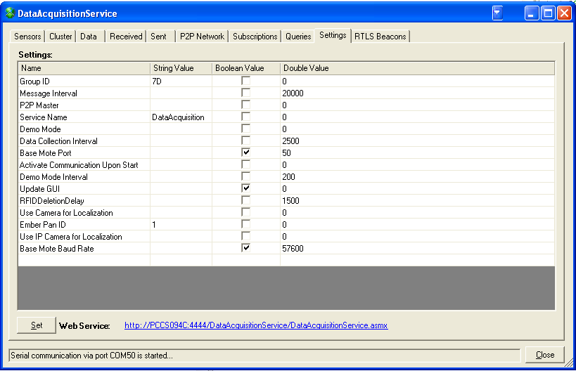
Sample of a real log
before (x,y,r) inch=16.644481976653,3.69225090794705,0.476752949307809
Sensor 8 is added
Sample Num: 0:0 1:0 2:84 3:84 4:0 5:0 6:0 7:84 8:0 9:0 10:0 11:0 12:0 13:0 14:0
Num of active sensors 3
Limited num. of sensors. (case after)
Limited num. of sensors. (case after)
Limited num. of sensors. (case after)
after (x,y,r) inch=16.6062715939874,3.76626428840578,0.266236136973073
Limited num. of sensors. (case after)
Limited num. of sensors. (case after)
Limited num. of sensors. (case after)
after (x,y,r) inch=16.6061763076696,3.76628774527524,0.266268583431369
Limited num. of sensors. (case after)
after (x,y,r) inch=16.6064290417122,3.76620475841959,0.266268548698807
Limited num. of sensors. (case after)
Limited num. of sensors. (case after)
Limited num. of sensors. (case after)
after (x,y,r) inch=16.6065633189739,3.76611475958357,0.266268363448459
Limited num. of sensors. (case after)
Limited num. of sensors. (case after)
Limited num. of sensors. (case after)
after (x,y,r) inch=16.6067504332908,3.76565359894366,0.266267652171758
Limited num. of sensors. (case after)
Limited num. of sensors. (case after)
Limited num. of sensors. (case after)
after (x,y,r) inch=16.6071651887286,3.76510181473097,0.266262181024178
Limited num. of sensors. (case after)
Limited num. of sensors. (case after)
Limited num. of sensors. (case after)
after (x,y,r) inch=16.6072816222105,3.76431089233654,0.266256327937992
Limited num. of sensors. (case after)
Limited num. of sensors. (case after)
Limited num. of sensors. (case after)
after (x,y,r) inch=16.6072888221953,3.76446209028892,0.266246199109535
Limited num. of sensors. (case after)
Limited num. of sensors. (case after)
Limited num. of sensors. (case after)
after (x,y,r) inch=16.6073476700549,3.76408463808941,0.26624824230897
Limited num. of sensors. (case after)
after (x,y,r) inch=16.6075214010812,3.76374169653661,0.26624342054716
Limited num. of sensors. (case after)
Limited num. of sensors. (case after)
Limited num. of sensors. (case after)
after (x,y,r) inch=16.6076926454739,3.7634189067911,0.266239475860208
Limited num. of sensors. (case after)
Limited num. of sensors. (case after)
Limited num. of sensors. (case after)
after (x,y,r) inch=16.6076711172982,3.76264746295298,0.26623579050899
Limited num. of sensors. (case after)
Limited num. of sensors. (case after)
Limited num. of sensors. (case after)
after (x,y,r) inch=16.6080674845031,3.76226967810337,0.266225422416549
Limited num. of sensors. (case after)
Limited num. of sensors. (case after)
Limited num. of sensors. (case after)
after (x,y,r) inch=16.6082291605781,3.7620324887944,0.266221817251944
Limited num. of sensors. (case after)
Limited num. of sensors. (case after)
Limited num. of sensors. (case after)
after (x,y,r) inch=16.6082751181014,3.76193995840659,0.266219237688012
Err1 =

1.0170 0.9211 0.8023 0.7707 1.2446 0.9326 1.4311
1.5991 1.0646 1.1795 1.7087 1.4232 1.0354 1.3912
0.9579 1.2415 1.3420 0.9238 0.8572 0.3274 0.9953

>> Err2

Err2 =

1.4409 0.4617 0.8269 1.2959 1.3595 1.3742 1.5689
1.8026 2.9627 2.0361 1.6507 0.6947 1.8997 1.0853
0.7884 1.2000 1.8446 1.2469 0.9168 0.8544 0.4672
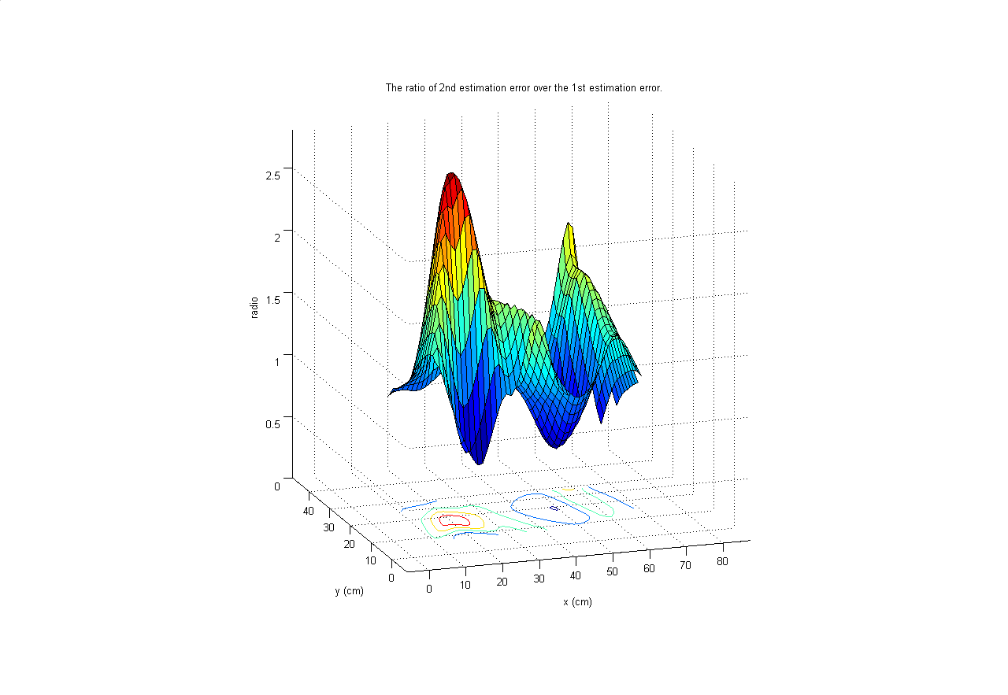
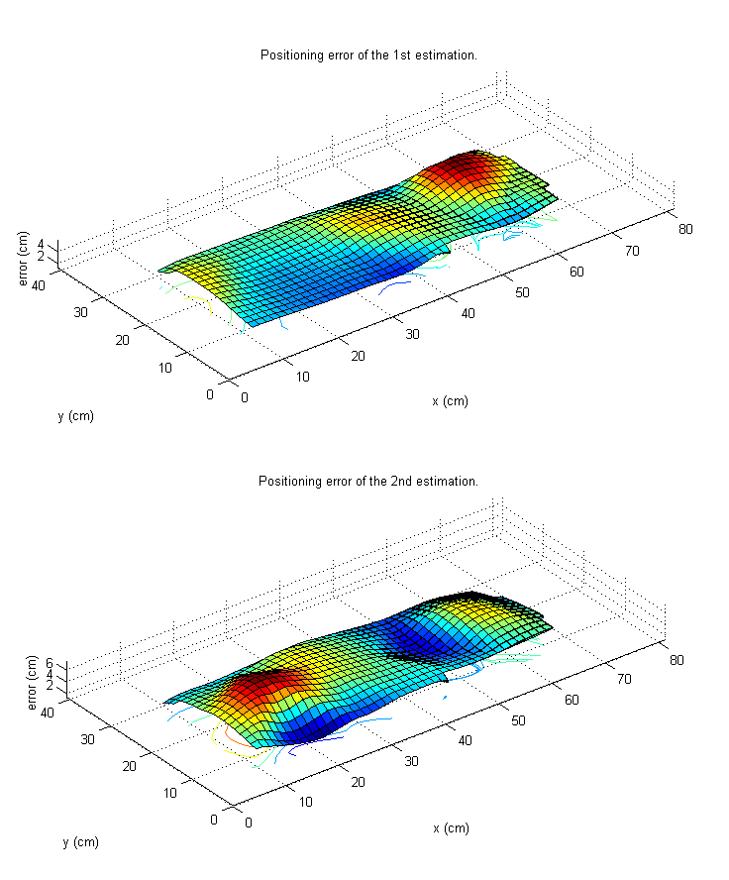
mean 1st error= 1.1032

std 1st error = 0.3171

mean 2nd error = 1.3228

std 2nd error = 0.5950

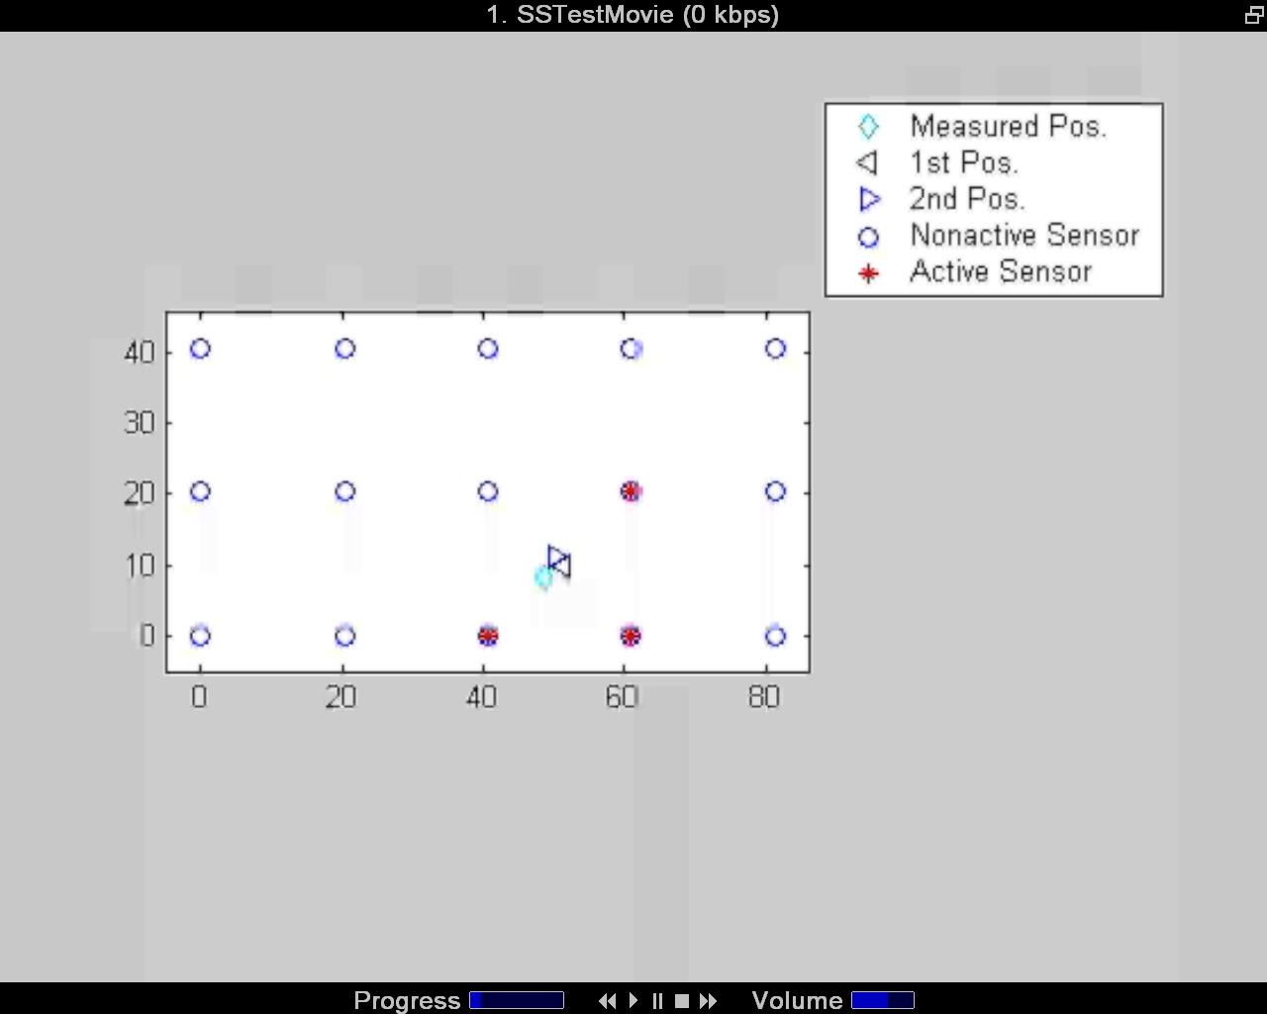
Jan 19, New Data

(2,2)
7 | 6.9
before (x,y,r) inch=7.10351390415587,8.32211001953104,0.464904533379217
Sample Num: 0:0 1:0 2:0 3:0 4:0 5:84 6:84 7:0 8:0 9:0 10:0 11:84 12:0 13:0 14:0
after (x,y,r) inch=7.09131262087992,7.2554386028169,0.23626064828166
after (x,y,r) inch=7.04588829045246,7.71837183698774,0.239454026071859
after (x,y,r) inch=7.04518147964838,7.72218286752515,0.239476836274018
after (x,y,r) inch=7.04446875842448,7.72594293632048,0.239497629139189
after (x,y,r) inch=7.0433738340172,7.7419728070872,0.239575090596243
after (x,y,r) inch=7.04253675693438,7.74545167873637,0.239593382648254
after (x,y,r) inch=7.04124341296261,7.7487642276587,0.239611972979637
after (x,y,r) inch=7.04031124217408,7.75228932892047,0.239631773136892
after (x,y,r) inch=7.03906564388669,7.75552739139764,0.239650603090459
after (x,y,r) inch=7.03768523759128,7.75860358114261,0.23966950681079

(2,3)
11.2 | 7.3

before (x,y,r) inch=12.7244546498609,7.91581685936649,0.474274559157398
Sample Num: 0:0 1:0 2:88 3:0 4:0 5:0 6:0 7:121 8:0 9:0 10:0 11:0 12:45 13:0 14:0
after (x,y,r) inch=12.5944366152738,7.85704092796102,0.231102058331098
after (x,y,r) inch=12.591537434999,7.85563722171299,0.23106004344745
after (x,y,r) inch=12.5886320314792,7.85404592076225,0.231025323588074
after (x,y,r) inch=12.585908215043,7.85271958407035,0.23098980925528
after (x,y,r) inch=12.5827664259719,7.85118631665943,0.230957258695373
after (x,y,r) inch=12.5797194670246,7.84969279228447,0.230919757107458
after (x,y,r) inch=12.5772644430512,7.84847946835278,0.230883419758822
after (x,y,r) inch=12.5749837136277,7.84706766596286,0.23085414324467
after (x,y,r) inch=12.5726716650092,7.845922008459,0.230825809168539
after (x,y,r) inch=12.5708351814446,7.84482436471876,0.230798297213902

(2,6) 23.5 | 7
before (x,y,r) inch=23.2291287259428,8.52600994778599,0.464769169249906
Sample Num: 0:0 1:0 2:0 3:0 4:0 5:0 6:0 7:84 8:84 9:0 10:0 11:0 12:0 13:84 14:0
after (x,y,r) inch=24.1919734328888,6.19244286700353,0.234933041834163
after (x,y,r) inch=24.2185858725472,6.49483621453919,0.234684813943579
after (x,y,r) inch=24.2202262258969,6.49799063581697,0.234688540982829
after (x,y,r) inch=24.2218764542288,6.50078961639374,0.234694268612303
after (x,y,r) inch=24.2232078501157,6.50397743826536,0.234700348734883
after (x,y,r) inch=24.2247957811767,6.50720445733702,0.234704580980775
after (x,y,r) inch=24.2261369592064,6.51034059285691,0.234710095874418
after (x,y,r) inch=24.2274975456499,6.51289674726909,0.234714484578506
after (x,y,r) inch=24.2295032681051,6.51455788136657,0.234719417957237
after (x,y,r) inch=24.2314938776745,6.51638141608923,0.234728222249876

(3,6) |  | 23.8 | 11.5
before (x,y,r) inch=25.4209886143985,12.2126252022009,0.500049229713879
Sample Num: 0:0 1:0 2:0 3:0 4:0 5:0 6:0 7:0 8:33 9:0 10:0 11:0 12:0 13:116 14:105
after (x,y,r) inch=25.4333491965396,12.0772573192592,0.2474726875701
after (x,y,r) inch=25.4602379287259,12.2715976242901,0.24656359758152
after (x,y,r) inch=25.4609098737801,12.275270820689,0.24654718352942
after (x,y,r) inch=25.4613058889895,12.2786174745469,0.246530483425011
after (x,y,r) inch=25.4616768785831,12.2817953217742,0.246516357548666
after (x,y,r) inch=25.4619037089963,12.284459772763,0.246503020026926
after (x,y,r) inch=25.4620899920182,12.2877058887874,0.246492272070595
after (x,y,r) inch=25.4622770874241,12.2900742340604,0.246479644524678
after (x,y,r) inch=25.4625684007942,12.292676863969,0.246470221876805
after (x,y,r) inch=25.4626979111883,12.2955108497618,0.246459498137656

With new data
Unit Inch
Err1

ans =

1.2357

Std 1

ans =

0.3218

Err2

ans =

1.1917

Std2

ans =

0.4310

