Fit by quadratic

Linear model Poly2:
f(x) = p1*x^2 + p2*x + p3
Coefficients (with 95% confidence bounds):
p1 = 16.28 (14.54, 18.03)
p2 = -548.6 (-584.9, -512.4)
p3 = 6720 (6564, 6876)

Goodness of fit:
SSE: 6.297e+004
R-square: 0.9975
Adjusted R-square: 0.9969
RMSE: 88.72
95% confidence region
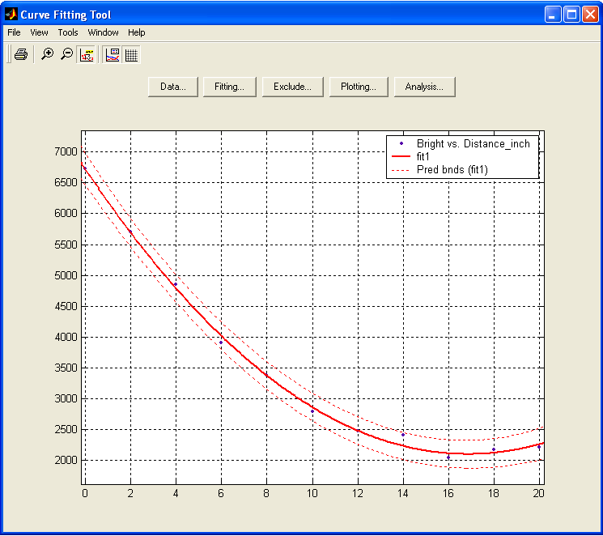

Fit by cubit

Linear model Poly3:
f(x) = p1*x^3 + p2*x^2 + p3*x + p4
Coefficients (with 95% confidence bounds):
p1 = -0.1355 (-0.471, 0.2)
p2 = 20.35 (10.12, 30.57)
p3 = -579.6 (-665, -494.2)
p4 = 6759 (6571, 6946)

Goodness of fit:
SSE: 5.571e+004
R-square: 0.9978
Adjusted R-square: 0.9969
RMSE: 89.21
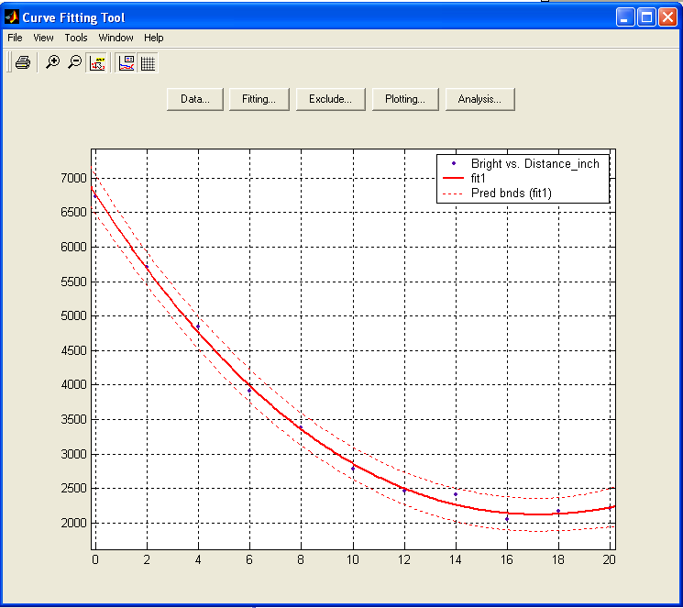

c/(b^2+dist^2) fitting
General model:
f(x) = a/(b+x^2)
Coefficients (with 95% confidence bounds):
a = 6.08e+005 (5.507e+005, 6.654e+005)
b = 100 (fixed at bound)

Goodness of fit:
SSE: 2.838e+006
R-square: 0.8891
Adjusted R-square: 0.8891
RMSE: 532.7
Constraints: a>=0, b \in [7 10] inch.
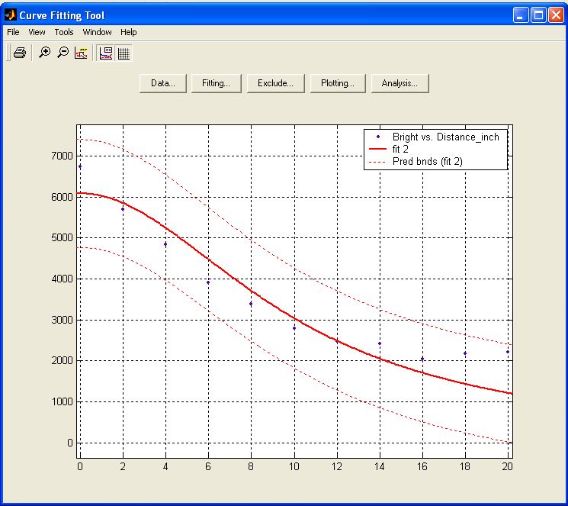
With constraints
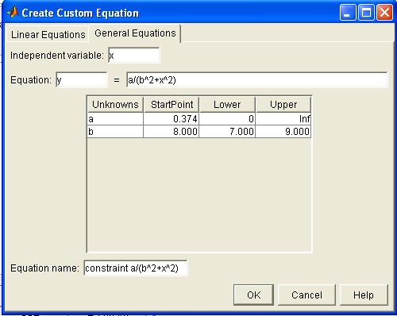
Fit computation did not converge:
Maximum number of function evaluations exceeded. Increasing
MaxFunEvals (in fit options) may allow for a better fit, or
the current equation may not be a good model for the data.

Fit found when optimization terminated:

General model:
f(x) = a/(b^2+x^2)
Coefficients (with 95% confidence bounds):
a = 1.478e+005 (3150, 2.924e+005)
b = 7 (fixed at bound)

Goodness of fit:
SSE: 5.634e+007
R-square: -1.202
Adjusted R-square: -1.202
RMSE: 2374
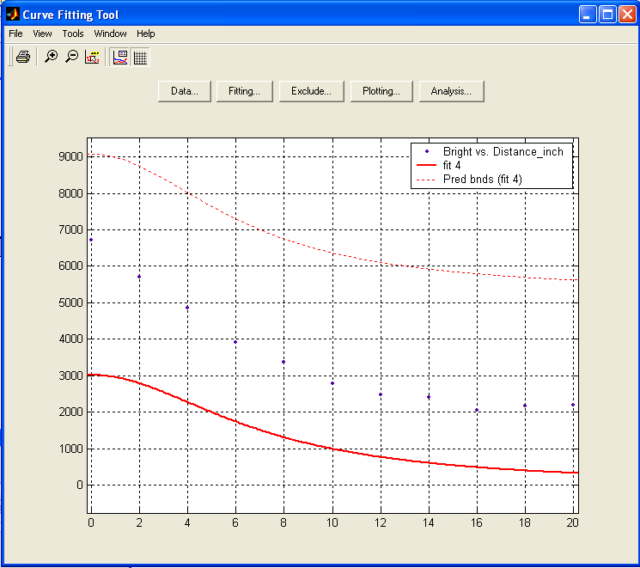

Without fitting, the sensitivity/std is as the following
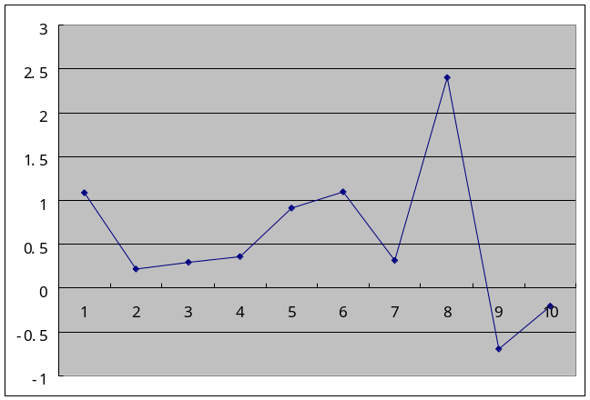

Desirable fitting
Mean Bright | 6726.16 | 5701.66 | 4845.5 | 3907.15 | 3381.05 | 2786.98 | 2466.81 | 2230 | 2166.34 | 2166.34 | 2166.34 |  | 2410.24
d(Bright)/Std | 33.35116 | 13.60916 | 16.49853 | 13.63727 | 23.23056 | 18.73849 | 17.7389 | 5.160381 | 0 | 0 |  |  | 195.3779

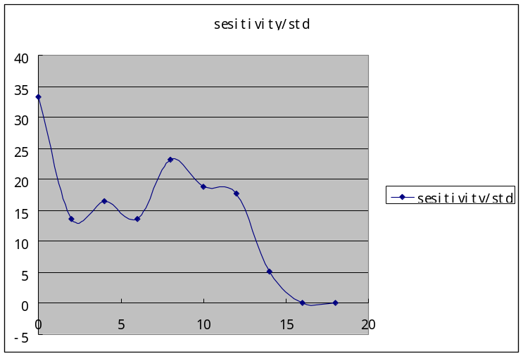
Study the correlation
Before:
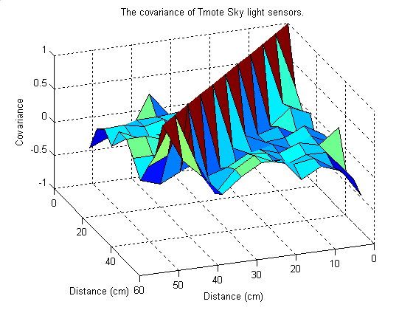
Case 1: cos vs. sin noise
addnoise=30*cos(noisex/50*pi);
addnoise2=30*sin(noisex/50*pi);
DatNoisy=[DatNoisy; dat(cnt,:)+ones(1,size(dat,2))*addnoise(cnt)];
DatNoisy2=[DatNoisy2; dat(cnt,:)+ones(1,size(dat,2))*addnoise2(cnt)];
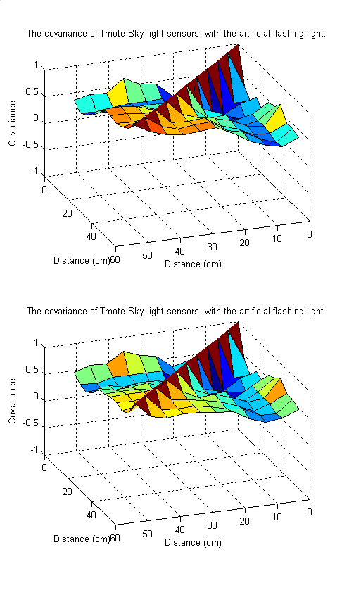
>> mean(mean(Mcov2))
0.5000
>> mean(mean(Mcov2b))
0.5260

case 2: saw noise
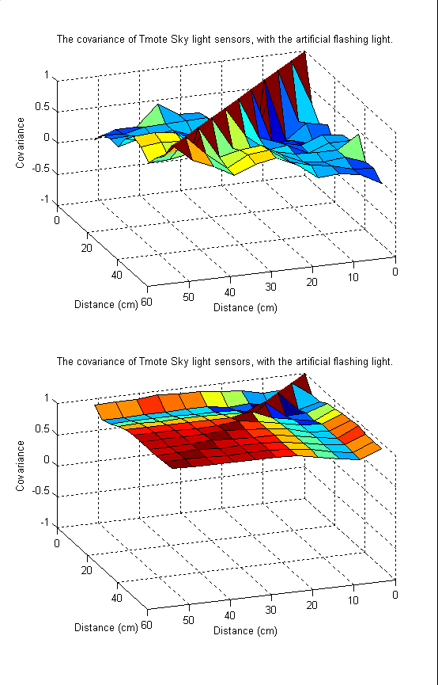
ind=mod(noisex,2);
addnoise=30*ind;
ind=mod(noisex,10);
addnoise2=30*ind;
DatNoisy=[DatNoisy; dat(cnt,:)+ones(1,size(dat,2))*addnoise(cnt)];
DatNoisy2=[DatNoisy2; dat(cnt,:)+ones(1,size(dat,2))*addnoise2(cnt)];
>> onSensorDatCor

ans =

0.3510

ans =

0.8958
Case 3: Gaussian noise

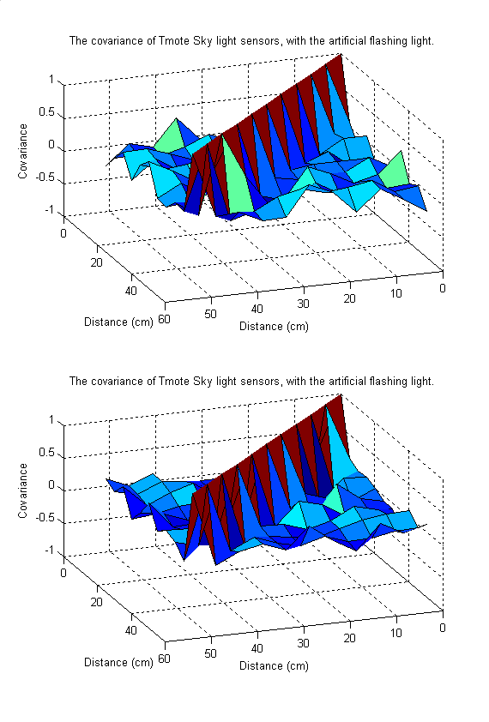
DatNoisy=[DatNoisy; dat(cnt,:)+randn(1,size(dat,2))*addnoise(cnt)];
DatNoisy2=[DatNoisy2; dat(cnt,:)+randn(1,size(dat,2))*addnoise2(cnt)];
ans =

0.0719

ans =

0.0747
case 4: uniform noise
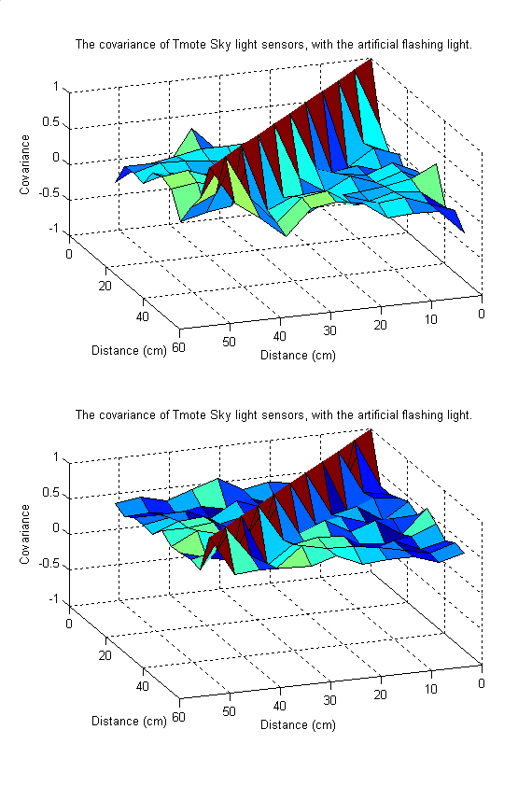
DatNoisy=[DatNoisy; dat(cnt,:)+rand(1,size(dat,2))*addnoise(cnt)];
DatNoisy2=[DatNoisy2; dat(cnt,:)+rand(1,size(dat,2))*addnoise2(cnt)];
ans =
0.1569
ans =
0.4482

case 5 flashing light
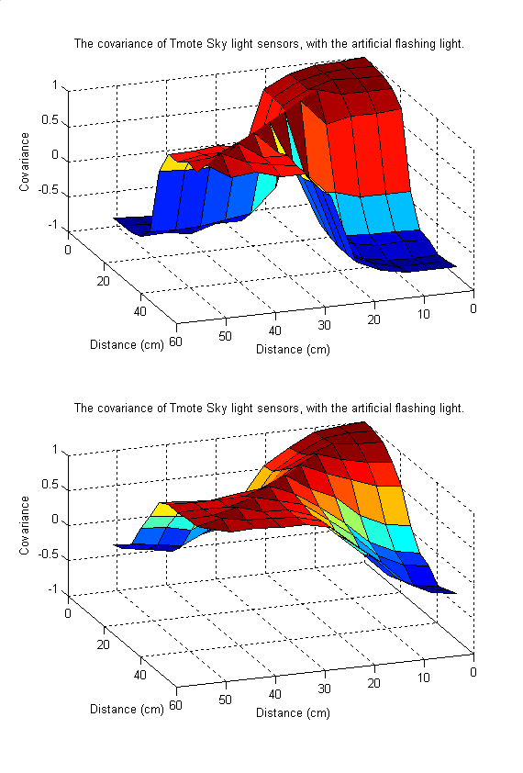
DatNoisy=[DatNoisy; dat(cnt,:); ltOff(cnt,:)];
DatNoisy2=[DatNoisy; dat(cnt,:); ltOff2(cnt,:)];
ltOff=rand(size(dat))*1000+2500;
ltOff2=rand(size(dat))*1000+10000;
>> mean(mean(abs(Mcov2)))

ans =

0.7289

>> mean(mean(abs(Mcov2b)))

ans =

0.5918

case 6: range shadow
% DatNoisy=[DatNoisy; dat(cnt,:) + rgShadow]; % range shadow
% DatNoisy2=[DatNoisy2; dat(cnt,:) + rgShadow2]; % range shadow
no effects! The same as the original

