GTernal 1.1
User’s Guide

Paden Davis, Maxwell Chen, Nathan Yam,
Soobum Kim, Sean Wilson, Samuel Coogan

October, 2024
Table of Contents
1 Purpose 3
2 Printed Circuit Board (PCB) 3
2.1 On/Off Switch 3
2.2 Status LEDs 3
2.3 5V Regulation 3
2.4 6V Regulation 3
2.5 Charging Circuitry 3
2.6 Power Sensor 3
2.7 Teensy 4.0 4
2.8 H-Bridge Motor Driver 4
2.9 I²C Mux and Qwiic Connectors 4
2.10 Inertial Measurement Unit (IMU) 4
2.10 Pi Power & Communication 4
3 Other Electronics and Components 4
3.1 Distance Sensors 4
3.2 Raspberry Pi 4
3.3 Pi Camera 5
3.4 Motors 5
3.5 Battery 5
4 Assembly 6
4.1 Cut Acrylic Pieces 7
4.2 Assembly with an Assembled Circuit Board 10
5 Uploading Code and Using the GTernal 1.0 14
6 Future Changes 15
7 Links and References 15
7.1 Bill of Materials 15
7.2 GitHub 15
7.3 Robotarium 15

1 Purpose
The purpose of this document is to explain the general design elements, assembly, and usage of the GTernal 1.1 robot.

2 Printed Circuit Board (PCB)
The printed circuit board (PCB) houses most of the electronics on the robot and features circuitry for power and sensors. Some of the circuitry is taken from the GRITSBot 2.0 PCB while other components are copied and modified versions of circuitry from breakout boards.
The top side of the PCB includes an On/Off switch, status LEDs, and an area for mounting a Teensy 4.0 microcontroller.
This section will detail the core components of the GTernal 1.0 PCB.

2.1 On/Off Switch
The On/Off switch turns on and off the 5V and 6V power circuits of the robot. The On/Off switch has no connection to the charging circuitry.

2.2 Status LEDs
Status LED | Description
PWR | On when On/Off switch is on and receiving power from battery/charger
LBO | Low battery indicator
CHRG | On when battery is charging or only charger connected.
DONE | On when batter is done charging.

2.3 5V Regulation
The 5V Regulation circuitry is taken and modified from Adafruit’s PowerBoost 1000C board.
The circuitry takes power from the battery/charger and regulates it to 5V to power the Teensy, motor encoders, and motor driver.

2.4 6V Regulation
The 6V Regulation circuitry is taken from the GRITSBot 2.0 PCB.
The circuitry takes power from the battery/charger and regulates it to 6V for motor power.

2.5 Charging Circuitry
The charging circuitry is taken and modified from Adafruit’s PowerBoost 1000C board.
The circuitry handles charging the robot battery and load-sharing between charger and battery.

2.6 Power Sensor
The power monitor is taken and modified from Adafruit’s INA260 Breakout Board.
The INA260 power sensor is wired in series with the VBAT line directly after the charging circuitry and measures VBAT voltage/current and power usage.
If undesired, the PCB features pads for a jumper on the VBAT line to bypass the power sensor.

2.7 Teensy 4.0
The Teensy 4.0 is a low-level microcontroller board that handles sensor and motor driver communications and control.
The Teensy takes in 5V and provides 3.3V for sensor power. The Teensy can be connected to microUSB for programming.
WARNING: There is potential for damage to the 5V regulation circuitry if the Teensy is connected to microUSB without battery/charger power. The cause is unknown at the moment but may be due to pre-biasing the output of the TPS61030 chip. Ensure that the robot is fully powered through battery/charger first before connecting the Teensy with microUSB that has external power.

2.8 H-Bridge Motor Driver
The H-Bridge Motor Driver takes power from 5V regulation and uses 6V for motor power. The driver is controlled by the Teensy.

2.9 I²C Mux and Qwiic Connectors
The I²C is taken and modified from Sparkfun’s Qwiic Mux Breakout.
The GTernal 1.0 features seven distance sensors with the same, unmodifiable I²C address, so I²C mux circuitry is needed to properly access all of them.
The GTernal 1.0 PCB includes Qwiic connectors for wiring to the distance sensors and holes for distance sensor mounts.

2.10 Inertial Measurement Unit (IMU)
The I²C is taken and modified from Adafruit’s BNO055 Breakout Board.

2.10 Pi Power & Communication
The PCB features 4 pins for providing power and serial communication to a Raspberry Pi.

3 Other Electronics and Components
This section details other electronics and components not on the PCB.

3.1 Distance Sensors
The GTernal 1.0 features seven Adafruit VL53L0X Time of Flight Distance Sensors.
These distance sensors are connected to the PCB through a Qwiic cable and should be held using 3D-printed or laser-cut mounts that can be bolted to the PCB.

3.2 Raspberry Pi
The GTernal 1.0 supports Raspberry Pi 3, 3b, 3b+, and 4.
The Raspberry Pi receives power from the Pi power pins on the PCB.
The Raspberry Pi serves as the main processor for the robot and communicates with the Teensy either through serial pins on the PCB or through USB

3.3 Pi Camera
The intended camera is a Raspberry Pi Camera V2, but the GTernal 1.1 should support any camera that connects to a Raspberry Pi through the CSI connector.

3.4 Motors
The GTernal 1.0 uses two geared motors with encoders from DFRobot.

3.5 Battery
The GTernal 1.0 uses a 3.7V LiPo Battery from Adafruit

4 Assembly
This section’s purpose is to walk through the steps involved in putting together a working robot once all of the parts have been purchased or manufactured. To this end, the assembly process will require:
- 1x GTernal 1.0 assembled printed circuit board (PCB)
- 1x Set of cut acrylic pieces (see 4.1)
  - Bottom plate
  - Pi mount plate
  - Top plate
  - Battery plates
  - 2x Back plates
  - 7x Distance sensor mount plates
  - Camera mount plate
- 1x 3.7V LiPo Battery
- 1x Teensy 4.0 board with pins soldered
- 1x Raspberry Pi (3B, 3B+, 4)
- 1x JST SH Jumper Wire
- 7x Time of Flight (ToF) distance sensors
- 7x 50mm or shorter Qwiic connector cables
- 1x Front Caster Pack
- 3x Small Caster Springs
- 3x M3x20mm Screws
- 3x M3 Locknuts
- 2x 100:1 Motors
- 1x Pack of two motor mounts
- 1x Pack of two wheels
- 4x M2.5x15mm brass male to female standoffs
- 4x M2.5x10mm brass male to female standoffs
- 4x M2.5x6mm nylon male to female standoffs
- 4x M2.5x10mm nylon male to female standoffs
- 4x M2.5x20mm nylon male to female standoffs
- 4x M2.5 Locknuts
- 4x M2.5x6mm Screws
- 14x M2 nylon Screws
- 14x M2 nylon Nuts

4.1 Cut Acrylic Pieces
.svg and .pdf files for laser cutting acrylic pieces can be found in the GTernal GitHub repository under “GTernal/Lasercutting Files”.
Piece label is given inside square brackets.
Images in this section are not to scale.

4.1.1 Bottom Plate [A1]
Thickness: 1/8” (3 mm)
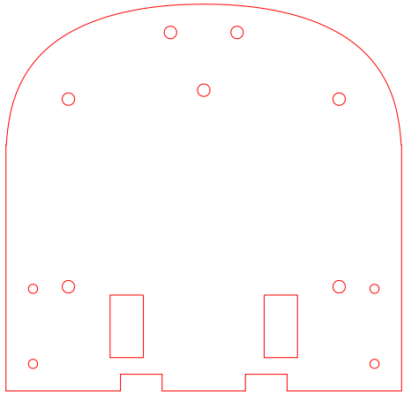

4.1.2 Pi Mount Plate [A2]
Thickness: 1/8” (3 mm)
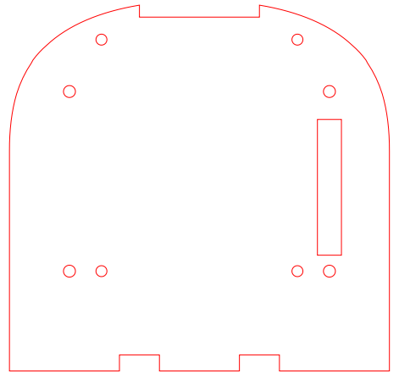

4.1.3 Top Plate [A3]
Thickness: 1/16” (1.5 mm)
Left: base top plate.
Right: example top plate with holes for mounting Vicon trackers
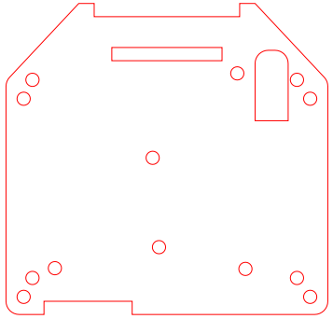

4.1.4 Battery Plates [A4b, A4t]
Bottom Plate [A4b] Thickness: 1/8” (3 mm)
Top Plate [A4t] Thickness: 1/16” (1.5 mm)
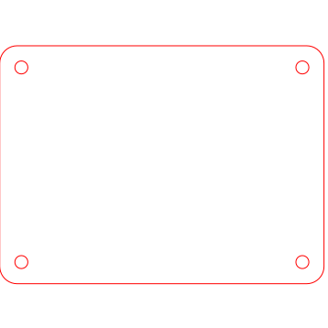

4.1.5 Back Plates [A5]
Thickness: 1/16” (1.5 mm)
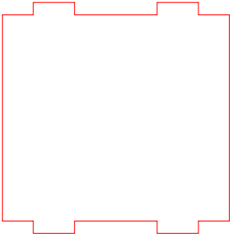

4.1.6 Distance Sensor Mount Plates [A6a, A6b]
Thickness: 1/8” (3 mm)
Number: 7x
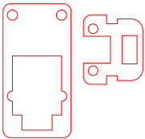

4.1.7 Camera Mount Plate [A7]
Thickness: 1/8” (3 mm)
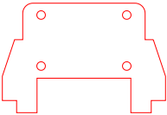

4.2 Assembly with an Assembled Circuit Board
For this process, the steps are much simpler than without a circuit board (PCB), as all connections except the motor connections will involve no soldering.
- Mount the teensy onto the top of the PCB by putting the pins through the holes in the marked section on the silkscreen then soldering the pins to the PCB.

- Solder the motor connectors that come with each motor into the holes marked motorR and motorL respectively. Review pinouts for the motor, motor cable, and PCB to ensure correct connection.

- The distance sensor mounts are made of two acrylic plates [A6a] and [A6b].
  - Take the smaller plate [A6b] and insert it diagonally through the center hole of the larger plate [A6a].
  - Rotate and shift [A6b] until it snaps into place horizontally near the edge of plate [A6a].
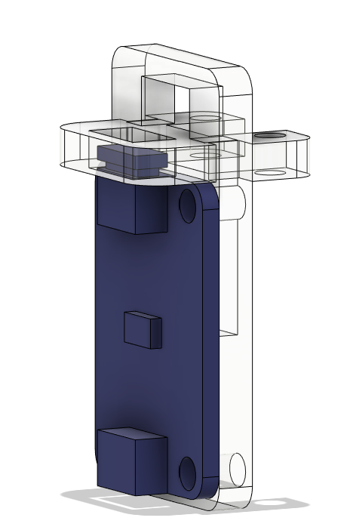
- Repeat step (3) six more times to obtain seven total distance sensor mounts.

- Mounting a distance sensor onto a distance sensor mount.
  - Take a 50mm or shorter Qwiic connector cable and plug it into the connector on the side with the LED. When facing distance sensor with top silkscreen text upright, this is the left connector.
  - Thread the Qwiic connector cable through the upper donut hole in piece A6a in the distance sensor mount.
  - With the cable through the hole, align the right-side distance sensor holes with the bottom holes on the larger plate [A6a] of the distance sensor mount.
  - Secure the distance sensor using 2x M2x8mm nylon screws and 2x M2 nylon nuts on the bottom holes of the distance sensor mount.
- Repeat step (5) six more times to obtain seven total mounted distance sensors with Qwiic jumpers out the back of the mount.

- Mounting distance sensors to PCB
  - With the Qwiic connector cable plugged into the distance sensor, plug the free connector on the cable into the Qwiic connector on the PCB.
  - Using 2x M2x8mm nylon screws and 2x M2 nylon nuts, secure the distance sensor mount into the PCB through the screw holes on acrylic piece [A6b].

- Repeat step (7) for all seven distance sensors. Set the PCB to the side gently once all seven are mounted.

- Begin with the bottom acrylic plate [A1]. This one has two rectangular holes near the bottom side and three screw holes in the front. Screw 4 M2.5x10mm brass standoffs into lock nuts through the four rectangularly spaced holes in the plate. Use pliers to hold them while screwing into the locknut if necessary.
- Place the motors into their mounting brackets, making sure the flat panel at the end of the gearbox lines up with the edge of the bracket. Mount the brackets and motors to the bottom side (opposite side to the standoffs) of the acrylic plate [A1] using the screws provided with the brackets.
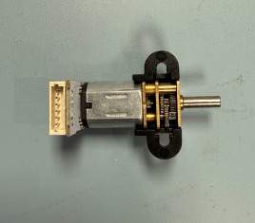 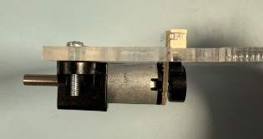
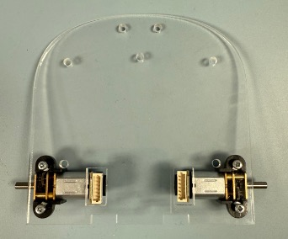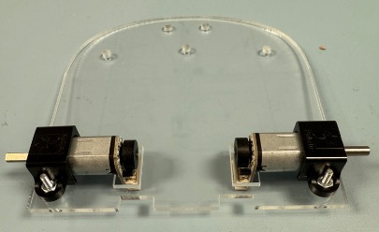

- Place the wheels onto the motor shafts and make sure the wheels are angled straight and do not rub against the acrylic. Place the rubber ring on the outside to tighten them and lock them in place.

- Mounting the caster wheel to the bottom plate [A1].
  - Clip the caster wheel components out of the injection molded sprue. Set aside the mounting base since it will not be used.
  - Place the metal marble in the bottom holder.
  - Place three metal pins on top of the ball in each of the edge locations.
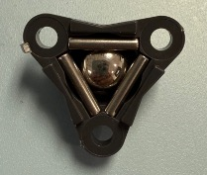
  - Place the top onto the caster assembly.
  - Thread 3x M3x20mm screws into the three holes on the caster.
  - Place the caster springs and the 2mm spacers that come with the casters onto the screws.
  - Carefully slot all three screws through the holes in the front of the bottom plate [A1]. Secure the screws in place with 3x M3 Locknuts.
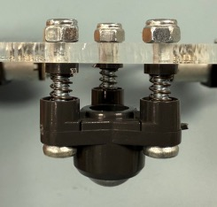 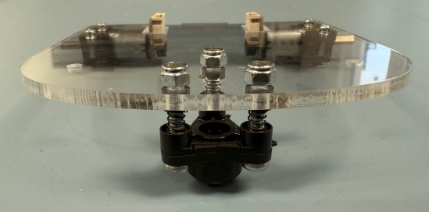
  - Check if the bottom plate is level. Adjust the 3x M3 Locknuts if necessary.
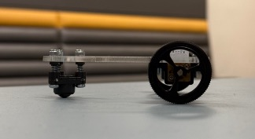

- Place the bottom battery plate [A4b] (rectangle with rounded corners) onto the standoffs and attach 4x 10mm nylon standoffs through it into the brass standoffs of the bottom plate [A1] to secure it in place.

- On top of the bottom battery plate [A4b], place the battery.

- With the top battery plate [A4t] close, take the battery wires and place them under the plate [A4t] in a way that will hold them and leaves about 2cm of wire free.

- Press the top battery plate [A4t] down and attach 4x 6mm nylon standoffs to secure it in place.

- Mounting the PCB
  - Ensure the power switch is switched off (towards the bottom of the board).
  - Bring the PCB with the teensy attached close.
  - Route the motor wires under the PCB (careful to go around the teensy pins) and across each other.
  - Place the PCB on the standoffs and secure it with 4x 20mm standoffs.
  - Plug the motor connectors into their corresponding motor
  - Plug the battery cable into the battery connector. All lights should be off if the switch is in the off position.

- Place the JST SH connector into the Pi Communication connector on the PCB

- Screw the Raspberry Pi onto the Pi mount plate [A2], which looks similar to the bottom plate of the robot, using 4x M2x8mm nylon screws and nuts.

- Thread the four wires through the slot on the right side of the plate and connect them to pins 2,3,4,5 (5v, GND, Tx, Rx) from the top on the right column of pins in the same order they are on the PCB.

- Attach the Pi mount plate [A2] to the standoffs from the PCB using 4x M2.5x15mm brass standoffs.

- If using Vicon Trackers, attach the screws used for the tracking balls into the top plate

- Securing the top plate [A3]
  - If using the camera, route the camera cable through the plate and into the connector on the Pi before screwing the plate in
  - Screw on the top plate [A3] using 4x M2.5x6mm screws.

- If using the camera, press fit the camera mount plate into the front slots. Then mount the camera to the camera mount plate.

- Backplates and Qi Charger
  - Press fit one back plate [A5] into the grooves
  - Plug the Qi Charger into the charging microUSB port on the side of the PCB
  - Place the flat side against the back plate [A5] that was mounted in step (25i).
  - Place another back plate [A5] into the same grooves, sandwiching the Qi charger between two plates to hold it in place.

5 Uploading Code and Using the GTernal 1.0

Upload the Teensy code found in the GitHub Gritsbot3/Firmware/teensyCode folder into the Teensy on the PCB through its microUSB port. Remember to have the board powered on and connected to the battery or charge port before plugging in the Teensy. This will require the Gritsbot3/Library folder to be placed in your Arduino libraries and the Arduino IDE set up to work with Teensy 4.0 which can be done following this guide.
Image the Raspberry Pi SD card with the image provided in the GitHub repository and plug that into the Pi. Power the Pi by turning on the GTernal robot and connect the Pi to a monitor through the HDMI port or USB C port depending on which version you are using. Plug a mouse and keyboard into the rear USB A ports and use this to complete the setup of the Pi and add a Wi-Fi connection. A Wi-Fi antenna can optionally be connected into the rear USB A ports for better signal.

6 Future Changes

- Add additional pinout headers to the PCB or a Qwiic header to allow extra I2C connections for breakout boards.
- Mosfet for cutting power to the Pi for charging timeouts
- Move PCB components to improve ground/power connections and heat characteristics.

7 Links and References

7.1 Bill of Materials
GTernal 1.0 BOM: https://docs.google.com/spreadsheets/d/1fcbRilmKaX-AO9ylUm2N9gINN3ZsyIf4CjUE0T1iR2c/edit?usp=sharing

7.2 GitHub
GTernal 1.0: https://github.com/robotarium/GTernal
GRITSBot 2.0 Hardware: https://github.com/robotarium/GRITSBot_hardware_design

7.3 Robotarium
Robotarium at Georgia Tech: https://www.robotarium.gatech.edu/

