Daniel Dalmas & Nathan White

March 11th, 2019

Data were collected from 264 countries by the World Bank from 1990 to 2015, recording for their respective energy intensity level of primary energy. The measure of energy intensity level provides an indicator of energy usage within a nation relative to their economic output. More specifically, the World Bank defines energy intensity of primary energy as “the ratio between energy supply and gross domestic product measured a purchasing power parity” (World Bank, 2015). For this analysis the average for all 264 nations per year is used to assess how energy intensity is changing between 1990 and 2015 across the planet. Using this indicator we may begin to develop an analysis of how countries with a lot of economic power have changed (if they have at all) their energy usage over the last 25 years.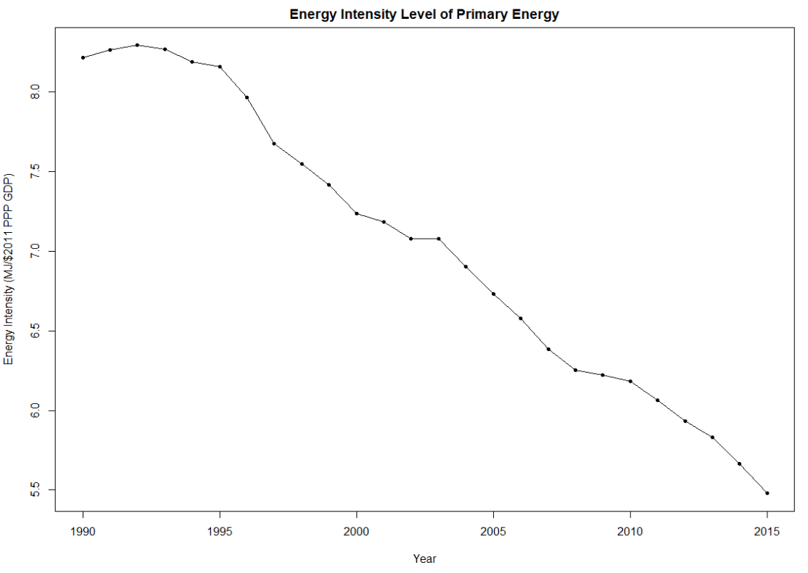

**References**

World Bank. “Energy intensity level of primary energy (MG/$2011 PPP GDP),” *The World*

*Bank* (2015), https://data.worldbank.org/indicator/EG.EGY.PRIM.PP.KD?view=chart.