Daniel Dalmas & Nathan White

March 25th, 2019

The data were collected from all automobile factories in the United States from January 1, 1993 to January 1, 2019, recording the aggregate autos assembled in the U.S. The U.S. Bureau of Economic Analysis collects this data as part of its mission to compile, study and publish relevant economic information. Using this time-series we may begin to develop an analysis of how domestic auto production has evolved over the last 25 years, along with the seasonal and cyclical patterns which dictate the production cycle.

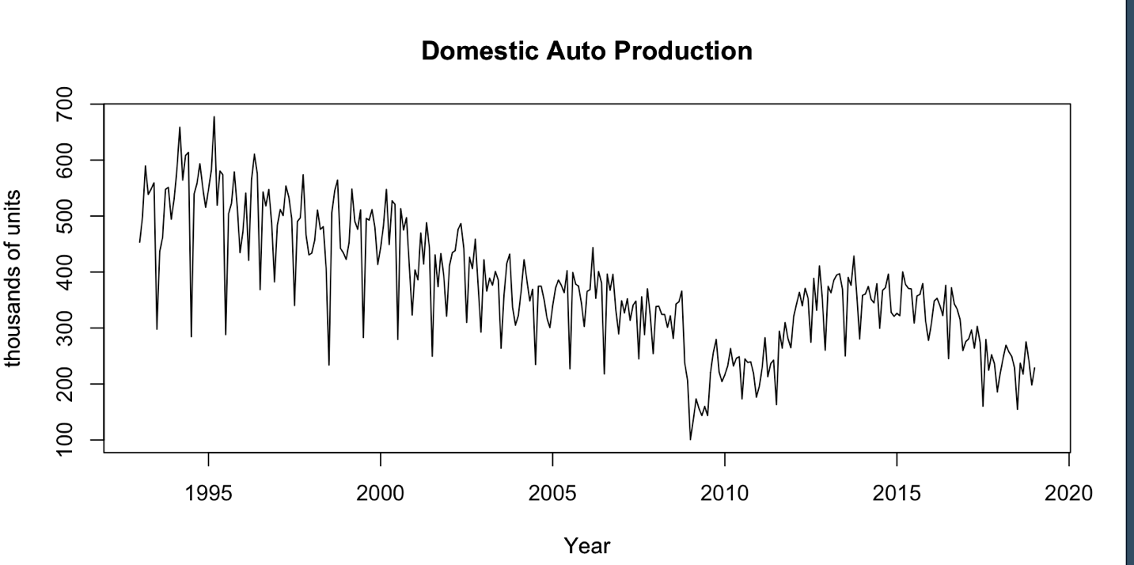

**References**

U.S. Bureau of Economic Analysis, Domestic Auto Production [DAUPNSA], retrieved from FRED, Federal Reserve Bank of St. Louis; https://fred.stlouisfed.org/series/DAUPNSA, March 25, 2019.