## Pins on the Pi Zero W

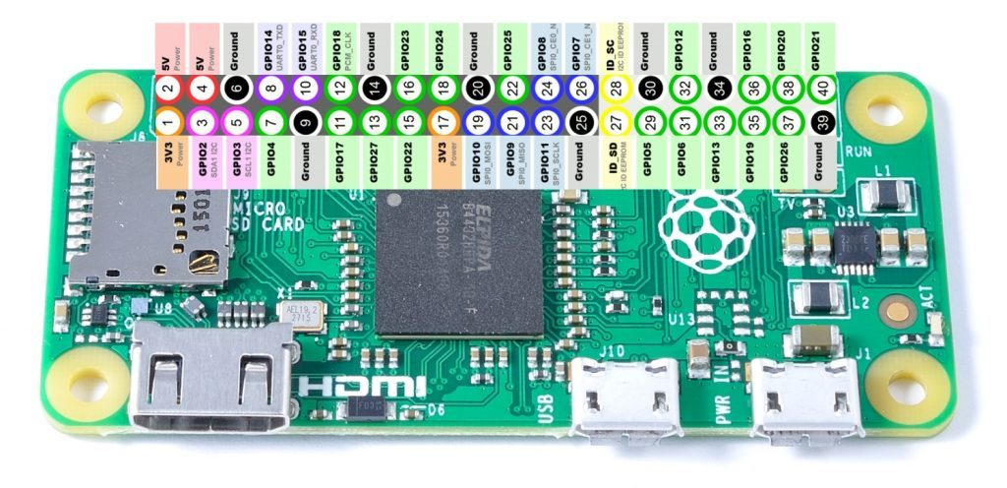

## Notes on the installation

1. SPI (“Spy”) and I2C (“Eye Squared See”) – These are two different types of communications bus. Devices are daisy-chained along the communication wires, making it easy to hook up many devices at once. The bus allows devices to connect to the controller and communicate both ways. Each allows only one device at a time to talk, so they take turns communicating.
2. Python – the controller will get its instructions from a python script that will run automatically when the controller starts up. You will be using Python version 3, so make sure the commands you use below include a ‘3’ at the end.
   1. pip3 – Pip installs add-on modules into Python. So when you need a library that someone else created, you can use pip3 to install it for you.
   2. idle3 – Idle is the program used to edit python script files.
   3. python3 – Python is the application used to run your python script files (always use the extension ‘.py’ for these python files).
3. Blinka – This is a version of python that runs on the Raspberry Pi controller.
4. GPIO – General Purpose Inputs/Outputs. If you look at the pins on your Pi controller, you will notice several named GPIO#. These pins can be used as either inputs or outputs. Unlike the communications bus above, these pins typically connect to one device only.

## Hardware

(part numbers & names come from adafruit.com)

Pi Zero W - <https://www.adafruit.com/product/3400>

3 pole micro switch - <https://www.amazon.com/Uxcell-a12013100ux0116-Position-Vertical-Switch/dp/B007QAJUUS/ref=sr_1_11?keywords=3+pole+micro+switch&qid=1583447732&sr=8-11>

Power Boost 500 - <https://www.adafruit.com/product/1944>

Battery (500-1200 mAh) - <https://www.adafruit.com/product/258>

Pi Zero Spy Camera - <https://www.adafruit.com/product/3508>

SD Card with NOOBS 3.0 - <https://www.adafruit.com/product/1583>

USB Microphone - <https://www.amazon.com/gp/product/B078J9BTMF/ref=ppx_yo_dt_b_asin_title_o04_s00?ie=UTF8&psc=1>

Inertial Measurement Unit (LSM6DS33+LIS3MDL) - <https://www.adafruit.com/product/4485>

Altitude Sensor (MPL3115A2) - <https://www.adafruit.com/product/1893>

Temperature & Humidity Sensor (Si7021) - <https://www.adafruit.com/product/3251>

Adafruit Jewel NeoPixels - <https://www.adafruit.com/product/2226>

Adafruit Mini GPS PA1010D - <https://www.adafruit.com/product/4415>

Circuit board spacers - <https://www.amazon.com/gp/product/B07D78PFQL/ref=ppx_yo_dt_b_asin_title_o01_s00?ie=UTF8&psc=1>

## Wiring

Pi Zero W

P2(5V)

P6(GND)

P12(GPIO18)

P3(I2C SDA)

P5(I2C SCL)

P8(UART_TX)

P8(UART_RX)

Humidity

vin

gnd

sda

scl

Altitude

vin

gnd

sda

scl

IMU

vin

gnd

sda

scl

GPS

vin

gnd

sda

scl

NeoPixel

vin

gnd

DataIn

Microphone

vin

gnd

TX

RX

## Enable the Interfaces

Open a command prompt and run the configuration application

sudo raspi-config

Select Interfacing Options

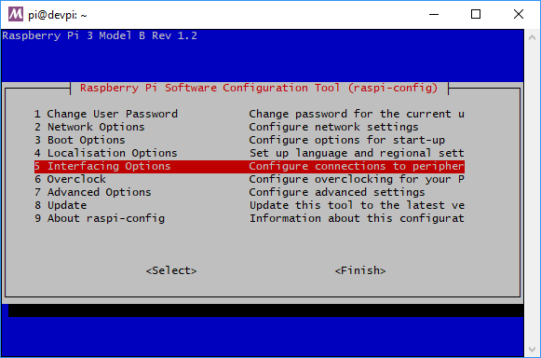

Enable the Camera, SPI, and I2C

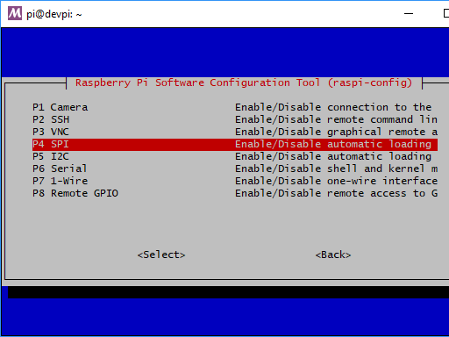

Save your configuration, exit, and reboot the Pi by running the following in the command line.

sudo reboot

## Update Your Pi Software

Open a command prompt and type the following

sudo apt-get update

sudo apt-get upgrade

sudo reboot

## Install Circuit Python onto your Linux Python

<https://learn.adafruit.com/circuitpython-on-raspberrypi-linux/installing-circuitpython-on-raspberry-pi>

sudo pip3 install --upgrade setuptools

## Enable SPI

<https://learn.adafruit.com/adafruits-raspberry-pi-lesson-4-gpio-setup/configuring-spi>

sudo apt-get install -y python-smbus

sudo reboot

ls -l /dev/spidev*

you should see two 'devices' one for each SPI bus

[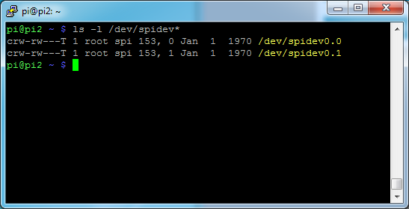](https://learn.adafruit.com/assets/22836)

## Enable I2C

<https://learn.adafruit.com/adafruits-raspberry-pi-lesson-4-gpio-setup/configuring-i2c>

sudo apt-get install -y i2c-tools

sudo reboot

sudo i2cdetect -y 1

If you don’t have any devices hooked up yet, you will see all 0’s here. Once you connect your devices up to the I2C bus, they will appear in the table below (like the 40 and 70).

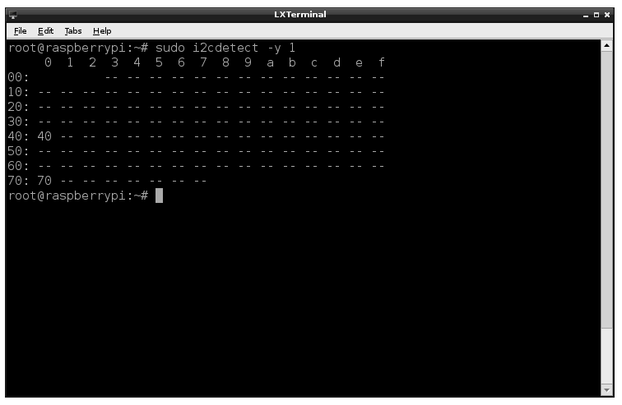

## Install PI GPIO

Sudo pip3 install RPI.GPIO

## Install adafruit_blinka

Sudo pip3 install adafruit-blinka

Test your install of blinka

Idle3 blinkatest.py

Add the following python code to your file (do not include the line numbers)

1. import board
2. import digitalio
3. import busio
5. print("Hello blinka!")
7. # Try to great a Digital input
8. pin = digitalio.DigitalInOut(board.D4)
9. print("Digital IO ok!")
11. # Try to create an I2C device
12. i2c = busio.I2C(board.SCL, board.SDA)
13. print("I2C ok!")
15. # Try to create an SPI device
16. spi = busio.SPI(board.SCLK, board.MOSI, board.MISO)
17. print("SPI ok!")
19. print("done!")

From the **File** menu select **Save**, then from the **Run** menu select **Run**. If it runs without error, things are working correctly.

## SI7021 Temp & Humidity

<https://github.com/adafruit/Adafruit_CircuitPython_SI7021>

<https://learn.adafruit.com/adafruit-si7021-temperature-plus-humidity-sensor/circuitpython-code>

sudo pip3 install adafruit-circuitpython-si7021

Test your install of the Si7021 temperature sensor

Idle3 temperature.py

Add the following python code to your file (do not include the line numbers)

1. import board
2. import busio
3. import adafruit_si7021
4. i2c = busio.I2C(board.SCL, board.SDA)
5. sensor = adafruit_si7021.SI7021(i2c)
6. print('Temperature: {} degrees C'.format(sensor.temperature))
7. print('Humidity: {}%'.format(sensor.relative_humidity))

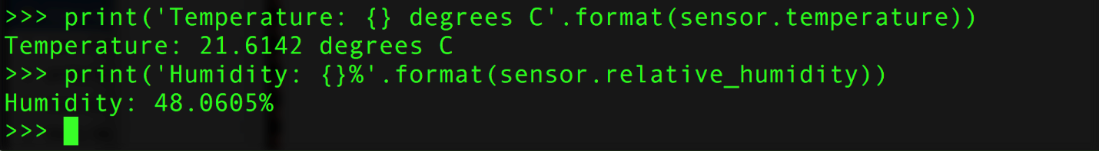

## Altimeter barometric pressure

<https://github.com/adafruit/Adafruit_CircuitPython_MPL3115A2>

Run the following in the command line (note that the name of the device MPL, so that is a lower case “L” before the number ‘3’ and not the number ‘1’).

sudo pip3 install adafruit-circuitpython-mpl3115a2

For altimeter you must set the value as close as possible at that moment for most accurate reading.

<https://forecast.weather.gov/product.php?issuedby=BOU&product=OSO&site=bou>

Test your install of the MPL3115A2 altitude sensor

Idle3 altitudetest.py

Add the following python code to your file (do not include the line numbers, you don’t have to include the comments that start with ‘#’)

1. import time
2. import board
3. import busio
4. import adafruit_mpl3115a2
5. # Initialize the I2C bus.
6. i2c = busio.I2C(board.SCL, board.SDA)
7. # Initialize the MPL3115A2.
8. sensor = adafruit_mpl3115a2.MPL3115A2(i2c)
9. # You can configure the pressure at sealevel to get better altitude estimates.
10. # This value has to be looked up from your local weather forecast or meteorlogical
11. # reports. It will change day by day and even hour by hour with weather
12. # changes. Remember altitude estimation from barometric pressure is not exact!
13. # Set this to a value in pascals:
14. sensor.sealevel_pressure = 102250
15. pressure = sensor.pressure
16. print('Pressure: {0:0.3f} pascals'.format(pressure))
17. altitude = sensor.altitude
18. print('Altitude: {0:0.3f} meters'.format(altitude))
19. temperature = sensor.temperature
20. print('Temperature: {0:0.3f} degrees Celsius'.format(temperature))

## Magnetometer (compass direction)

<https://github.com/adafruit/Adafruit_CircuitPython_LIS3MDL>

sudo pip3 install adafruit-circuitpython-lis3mdl

Test your install of the LIS3MDL magnetometer sensor

Idle3 compasstest.py

Add the following python code to your file (do not include the line numbers, you don’t have to include the comments that start with ‘#’)

1. import time
2. import board
3. import busio
4. import adafruit_lis3mdl
5. i2c = busio.I2C(board.SCL, board.SDA)
6. sensor = adafruit_lis3mdl.LIS3MDL(i2c)
7. while True:
8. mag_x, mag_y, mag_z = sensor.magnetic
9. print('X:{0:10.2f}, Y:{1:10.2f}, Z:{2:10.2f} uT'.format(mag_x, mag_y, mag_z))
10. print('')
11. time.sleep(1.0)

## IMS (gyroscope and accelerometers):

[https://github.com/adafruit/Adafruit_CircuitPython_LSM6DS](https://github.com/adafruit/Adafruit_CircuitPython_LSM6DS/blob/master/examples/lsm6ds33_simpletest.py)

sudo pip3 install adafruit-circuitpython-lsm6ds

Test your install of the LSM6DS rotation and acceleration sensor

Idle3 acceltest.py

Add the following python code to your file (do not include the line numbers, you don’t have to include the comments that start with ‘#’)

1. import time
2. import board
3. import busio
4. import adafruit_lsm6ds
5. i2c = busio.I2C(board.SCL, board.SDA)
6. sox = adafruit_lsm6ds.LSM6DSOX(i2c)
7. while True:
8. print("Acceleration: X:%.2f, Y: %.2f, Z: %.2f m/s^2"%(sox.acceleration))
9. print("Gyro X:%.2f, Y: %.2f, Z: %.2f degrees/s"%(sox.gyro))
10. print("")
11. time.sleep(0.5)

## PI CAM

<https://github.com/iizukanao/picam>

Make sure the camera has been enabled on your Pi.

Install dependencies

sudo apt-get install libharfbuzz0b libfontconfig1

Create a file that will set up the directories and environment for recording video.

idle3 make_dirs.sh

Add the following to your file, then save and close the file.

#!/bin/bash

DEST_DIR=~/picam

SHM_DIR=/run/shm

mkdir -p $SHM_DIR/rec

mkdir -p $SHM_DIR/hooks

mkdir -p $SHM_DIR/state

mkdir -p $DEST_DIR/archive

ln -sfn $DEST_DIR/archive $SHM_DIR/rec/archive

ln -sfn $SHM_DIR/rec $DEST_DIR/rec

ln -sfn $SHM_DIR/hooks $DEST_DIR/hooks

ln -sfn $SHM_DIR/state $DEST_DIR/state

EOF

Make the file above executable and run it.

chmod +x make_dirs.sh

./make_dirs.sh

Install picam application

wget https://github.com/iizukanao/picam/releases/download/v1.4.7/picam-1.4.7-binary.tar.xz

tar xvf picam-1.4.7-binary.tar.xz

cp picam-1.4.7-binary/picam ~/picam/

Test your installation

Start picam

cd ~/picam

./picam --alsadev hw:1,0

In another command line window

Start recording

touch hooks/start_record

Stop recording

touch hooks/stop_record

Play your recording

sudo apt-get install vlc

cd ~/picam/archive

ls *.ts

vlc <name>.ts

Test your picam install in python. Edit the make_dirs.sh file to include the line that starts your camera.

idle3 make_dirs.sh

Add the very last line to your file, then save and close the file.

#!/bin/bash

DEST_DIR=~/picam

SHM_DIR=/run/shm

mkdir -p $SHM_DIR/rec

mkdir -p $SHM_DIR/hooks

mkdir -p $SHM_DIR/state

mkdir -p $DEST_DIR/archive

ln -sfn $DEST_DIR/archive $SHM_DIR/rec/archive

ln -sfn $SHM_DIR/rec $DEST_DIR/rec

ln -sfn $SHM_DIR/hooks $DEST_DIR/hooks

ln -sfn $SHM_DIR/state $DEST_DIR/state

./picam --alsadev hw:1,0

EOF

The create a test python script for the camera.

Idle3 camtest.py

Add the following python code to your file (do not include the line numbers, you don’t have to include the comments that start with ‘#’)

1. import board
2. import subprocess
3. from pathlib import Path
4. import time
5. import os
6. #start the camera
7. home_dir = ‘/home/pi/picam’
8. os.chdir(home_dir)
9. camera=subprocess.Popen(‘./make_dirs.sh’)
10. #give it time to wake up
11. time.sleep(3)
12. #Start recording
13. Path(‘./hooks/start_record’).touch()
14. print(‘started recording’)
15. subs = ‘./hooks/subtitle’
16. start_time=time.time()
17. while (time.time() – start_time)< 15:
18. if os.path.isfile(subs):
19. os.remove(subs)
20. With open(subs) as subtitle:
21. subtext = ‘text={}’.format(time.time())
22. subtitle.write(subtext)
23. print(subtext)
24. time.sleep(1)
25. #Stop recording
26. Path(‘./hooks/stop_record’).touch()
27. camera.kill()

## NeoPixels

<https://learn.adafruit.com/neopixels-on-raspberry-pi/python-usage>

sudo pip3 install rpi_ws281x adafruit-circuitpython-neopixel

Test your install of the LSM6DS rotation and acceleration sensor

Idle3 pixeltest.py

Add the following python code to your file (do not include the line numbers, you don’t have to include the comments that start with ‘#’)

1. import board
2. import neopixel
3. pixels = neopixel.NeoPixel(board.D18, 7)
4. pixels[0] = (255, 0, 0)
5. pixels.fill((0, 0, 255))
6. pixels.fill((255, 0, 0))
7. pixels.fill((255, 255, 255))

## Logging your data

Add the following to your python code at the top of your python file.

1. **import logging**
2. **import time**
3. **logging.basicConfig(filename='Launch-{}.log'.format(time.time()),format='%(asctime)s,%(relativeCreated)s,%(message)s',level=logging.DEBUG)**

Example use case for logging your data

**logging.info('{},{}'.format(‘name’,42))**

Final Python Program (note you have to run this as sudo to make the pixels work). Save this file in /rocket/rocket.py

import logging

import time

import board

import neopixel

import digitalio

import busio

import adafruit_si7021

import adafruit_mpl3115a2

import adafruit_lis3mdl

import adafruit_lsm6ds

from pathlib import Path

import subprocess

logging.basicConfig(filename='Launch-{}.log'.format(time.time()), format='%(asctime)s,%(relativeCreated)s,%(message)s', level=logging.DEBUG)

pixels = neopixel.NeoPixel(board.D18, 7)

# Flash the pixels to show we've started

pixels.fill((0, 0, 255))

time.sleep(0.5)

pixels.fill((255, 0, 0))

time.sleep(0.5)

pixels.fill((255, 255, 255))

time.sleep(0.5)

logging.info('Log your data {}'.format(42))

# Try to get a Digital input

pin = digitalio.DigitalInOut(board.D4)

logging.info("IO ok!")

# Try to create an I2C device

i2c = busio.I2C(board.SCL, board.SDA)

tempSensor = adafruit_si7021.SI7021(i2c)

altSensor = adafruit_mpl3115a2.MPL3115A2(i2c)

altSensor.sealevel_pressure = 102250

magSensor = adafruit_lis3mdl.LIS3MDL(i2c)

soxSensor = adafruit_lsm6ds.LSM6DSOX(i2c)

logging.info("I2C ok!")

# Try to create an SPI device

spi = busio.SPI(board.SCLK, board.MOSI, board.MISO)

logging.info("SPI ok!")

# Green light for launch

logging.info("All systems go! Ready for launch")

pixels.fill((0, 255, 0))

## Log initial values ##

# Log temperature and humidity

logging.info('Temperature1, {}, C'.format(tempSensor.temperature))

logging.info('Humidity, {}, %'.format(tempSensor.relative_humidity))

# Log pressure, altitude, and temperature

logging.info('Pressure, {0:0.3f}, pascals'.format(altSensor.pressure))

logging.info('Altitude, {0:0.3f}, meters'.format(altSensor.altitude))

logging.info('Temperature2, {0:0.3f}, C'.format(altSensor.temperature))

# Log magnetic compass settings

mag_x, mag_y, mag_z = magSensor.magnetic

logging.info('Compass, X, {0:10.2f}, Y, {1:10.2f}, Z, {2:10.2f}, uT'.format(mag_x, mag_y, mag_z))

# Log the acceleration and gyro

logging.info("Acceleration, X, %.2f, Y, %.2f, Z, %.2f, m/s^2"%(soxSensor.acceleration))

logging.info("Gyro, X, %.2f, Y, %.2f, Z, %.2f, degrees/s"%(soxSensor.gyro))

picam_dir = '/home/pi/picam/'

startCamera = './make_dirs.sh'

startRecord = './hooks/start_record'

sub_path = "./hooks/subtitle"

stopRecord = './hooks/stop_record'

# Start picam

os.chdir(picam_dir)

camera = subprocess.Popen([startCamera])

time.sleep(3)

# Start recording the video

Path(startRecord).touch()

startTime = time.time()

pixels.fill((255, 255, 255))

# video will record for 10 minutes

while (time.time() - startTime) < 600:

pixels.fill((0, 255, 0))

# Log temperature and humidity

logging.info('Temperature1, {}, C'.format(tempSensor.temperature))

logging.info('Humidity, {}, %'.format(tempSensor.relative_humidity))

# Log pressure, altitude, and temperature

logging.info('Pressure, {0:0.3f}, pascals'.format(altSensor.pressure))

altitude = altSensor.altitude

logging.info('Altitude, {0:0.3f}, meters'.format(altitude))

logging.info('Temperature2, {0:0.3f}, C'.format(altSensor.temperature))

# Log magnetic compass settings

mag_x, mag_y, mag_z = magSensor.magnetic

logging.info('Compass, X, {0:10.2f}, Y, {1:10.2f}, Z, {2:10.2f}, uT'.format(mag_x, mag_y, mag_z))

# Log the acceleration and gyro

logging.info("Acceleration, X, %.2f, Y, %.2f, Z, %.2f, m/s^2"%(soxSensor.acceleration))

logging.info("Gyro, X, %.2f, Y, %.2f, Z, %.2f, degrees/s"%(soxSensor.gyro))

# set the subtitle on the video with time and height

pixels.fill((255, 255, 255))

if os.path.isfile(sub_path):

os.remove(sub_path)

with open(sub_path, 'a') as subtitle:

subtitle.write('text={} seconds {} meters'.format((time.time()-startTime), altitude))

# Stop recording the video

Path(stopRecord).touch()

camera.kill()

# flash the lights so we can be found

while True:

pixels.fill((255, 255, 255))

time.sleep(0.25)

pixels.fill((255, 0, 0))

time.sleep(0.25)

pixels.fill((0, 255, 0))

time.sleep(0.25)

pixels.fill((0, 0, 255))

time.sleep(0.25)

## GPS

<https://github.com/adafruit/Adafruit_CircuitPython_GPS>

sudo pip3 install adafruit-circuitpython-gps

# Simple GPS module demonstration.

# Will print NMEA sentences received from the GPS, great for testing connection

# Uses the GPS to send some commands, then reads directly from the GPS

import time

import board

import busio

import adafruit_gps

# Create a serial connection for the GPS connection using default speed and

# a slightly higher timeout (GPS modules typically update once a second).

# These are the defaults you should use for the GPS FeatherWing.

# For other boards set RX = GPS module TX, and TX = GPS module RX pins.

uart = busio.UART(board.TX, board.RX, baudrate=9600, timeout=10)

# for a computer, use the pyserial library for uart access

#import serial

#uart = serial.Serial("/dev/ttyUSB0", baudrate=9600, timeout=10)

# If using I2C, we'll create an I2C interface to talk to using default pins

#i2c = busio.I2C(board.SCL, board.SDA)

# Create a GPS module instance.

gps = adafruit_gps.GPS(uart) # Use UART/pyserial

#gps = adafruit_gps.GPS_GtopI2C(i2c) # Use I2C interface

# Initialize the GPS module by changing what data it sends and at what rate.

# These are NMEA extensions for PMTK_314_SET_NMEA_OUTPUT and

# PMTK_220_SET_NMEA_UPDATERATE but you can send anything from here to adjust

# the GPS module behavior:

# https://cdn-shop.adafruit.com/datasheets/PMTK_A11.pdf

# Turn on the basic GGA and RMC info (what you typically want)

gps.send_command(b'PMTK314,0,1,0,1,0,0,0,0,0,0,0,0,0,0,0,0,0,0,0')

# Turn on just minimum info (RMC only, location):

#gps.send_command(b'PMTK314,0,1,0,0,0,0,0,0,0,0,0,0,0,0,0,0,0,0,0')

# Turn off everything:

#gps.send_command(b'PMTK314,0,0,0,0,0,0,0,0,0,0,0,0,0,0,0,0,0,0,0')

# Tuen on everything (not all of it is parsed!)

#gps.send_command(b'PMTK314,1,1,1,1,1,1,0,0,0,0,0,0,0,0,0,0,0,0,0')

# Set update rate to once a second (1hz) which is what you typically want.

gps.send_command(b'PMTK220,1000')

# Or decrease to once every two seconds by doubling the millisecond value.

# Be sure to also increase your UART timeout above!

#gps.send_command(b'PMTK220,2000')

# You can also speed up the rate, but don't go too fast or else you can lose

# data during parsing. This would be twice a second (2hz, 500ms delay):

#gps.send_command(b'PMTK220,500')

# Main loop runs forever printing data as it comes in

timestamp = time.monotonic()

while True:

data = gps.read(32) # read up to 32 bytes

# print(data) # this is a bytearray type

if data is not None:

# convert bytearray to string

data_string = ''.join([chr(b) for b in data])

print(data_string, end="")

if time.monotonic() - timestamp > 5:

# every 5 seconds...

gps.send_command(b'PMTK605') # request firmware version

timestamp = time.monotonic()

## Set up for Auto-Start

<https://www.linux.com/tutorials/setting-timer-systemd-linux/>

Sometimes it is nice to have your device boot up and start doing something. This will show you how to make your PI run your python script on startup. There are numerous ways to accomplish this, I’m showing you the **systemd** option.

1. Create a “Unit File”:
   1. Type in the command prompt “**sudo nano /lib/systemd/system/rocket.service**”
   2. In the editor make sure your file looks like the following:

[Unit]

Description=My Model Rocket Service

After=multi-user.target

[Service]

Type=idle

ExecStart=/usr/bin/python3 ./rocket/rocket.py

[Install]

WantedBy=multi-user.target

* 1. Exit and save the file
     1. **CTRL x**, **Y** to save the changes, and press **Enter** to write to the unit file.

1. Configure ***systemd***
   1. Enable the unit file via system control
      1. Type “**sudo systemctl daemon-reload**”
      2. Then type “**sudo systemctl enable rocket.service**”
   2. Reboot the machine by typing “**sudo reboot**”
   3. Upon reboot, your pi should light up and be running your code

## Troubleshooting

"TypeError: unsupported operand type(s) for -=: 'Retry' and 'int'"

Means your PI Zero has lost its network connection