Digital One-Celled Organism

(DOCO) Simulation

Programming Assignment 1 (PA-1)
Fall 2020, CS-307

Table of Contents
Preliminary Class Diagram 3
System Overview 4
Class Outline UML Diagram 5
Class Outline Written 6
1 - WorldBoard 6
1.1 - Summary 6
1.2 - Properties 6
1.3 - Methods 6
2 - Viewer 7
2.1 - Summary 7
2.2 - Properties 7
2.3 - Methods 7
3 - DOCO 7
3.1 - Summary 7
3.2 - Properties 7
3.3 - Methods 7
4 - Cell 8
4.1 - Summary 8
4.2 - Properties 9
4.3 - Methods 9
5 - GridSize 9
5.1 - Summary 9
5.2 - Properties 9
5.3 - Methods 9
6.1 - Summary 9
6.2 - Properties 10
6.3 - Methods 10
7 - DataParser 10
7.1 - Summary 10
7.2 - Properties 10
7.3 - Methods 10
8 - Simulator 11
8.1 - Summary 11
8.2 - Properties 11
8.3 - Methods 11
Class Outline PlantUML Text 12
Appendix 19
Naming: 19
Tools: 19
Guides: 19

Preliminary Class Diagram
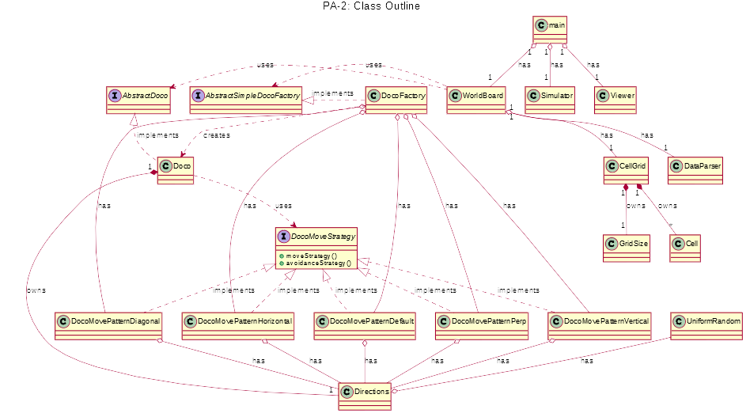
Last Updated: 10/23/2020

System Overview
Last Updated: 10/23/2020 – 11:58 AM CST, UTC-6

This is a console program that will run a simulation of a world where single celled organisms are spawned in. They will run around eating the food nearby and avoiding walking past the edge of the world. They will avoid walking into each other too. They now also avoid running into obstacles. Additionally strategy pattern and factory pattern have been implemented to allow for different types of DOCOs. The initial world specifications (height, width, DOCO’s and positions, and food locations) will be read in from a provided file in XML format. As part of version two, the DOCO strategy is also read in. There are a lot of details involved and they are specified below.

Class Outline UML Diagram
Last Updated: 10/23/2020 – 12:03 PM CST, UTC-6
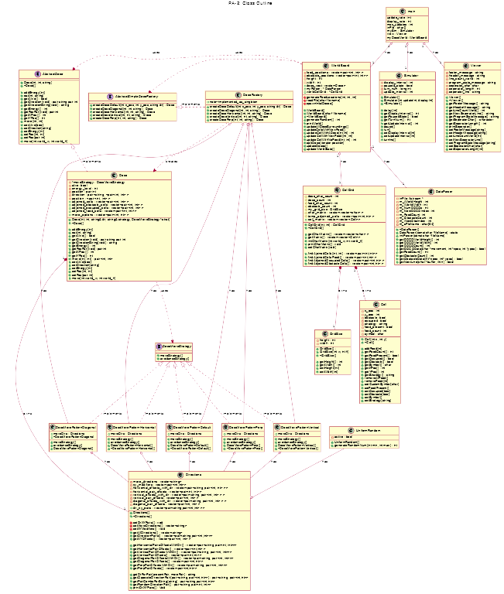

Class Outline Written
Last Updated: 9/20/2020 - 3:40 PM CST, UTC-6

Important Note: Return value specified in brackets. Arguments shown inside function. Actions performed explained.
- WorldBoard
  - Summary
    - The world board is responsible for holding all the entities of the DOCO simulation. Creating it will create the other objects.
  - Properties
    - private:
      - [CellGrid] cellGrid – will hold the CellGrid Object which contains all the Cells and GridSize
      - [matrix] startDOCOs – will hold a matrix that will populate from the readFile() function with the starting positions, directions, etc of DOCOs. (Alternatively could add them to the vector as your reading… maybe)
      - [matrix] startFood – will hold a matrix that will populate from the readFile() function with the positions on the CellGrid and amounts for some food particles. (Alternatively could add them to the vector as your reading… maybe)
    - public:
      - vector<DOCO> DOCOVect – will hold a vector of all the current DOCO’s on the board. These will be able to be iterated over and removed as part of the vector class functionality.
      - [DataParser] dataParser – the DataParser obejct for the class. DatParser = DataParser(char *filename). This filename will be DOCOData01.xml
      - [Simulator] mySim – containers the DOCOSim Object
  - Methods
    - public:
      - readFile()
      - spawnOneDOCOAtPos(x_pos, y_pos) – this is a helper function for spawning a DOCO in a cell and updating the cell after the location has been picked. The DOCO will also be added to the DOCO vector, and it’s position attributes will be updated to the correct position.
      - spawnOneFoodAtPos(x_pos, y_pos) – this is a helper function for spawning a food particle in a cell and updating the cell after the location has been picked.
      - initialDOCOSpawn()
      - initialFoodSpawn()
      - spawnFood() - spawns a random number of food pellets between 1 and 10 into the world at random locations. Can spawn on top of other food pellets, but if chosen to spawn X items, will choose new spot for a spawn if it already contains 3 food pellets (the maximum).
      - UpdateWorldState() - this function will update all of the DOCO’s movements and spawn more food into the world and anything else that needs to be updated for each turn.
        - PrintWorld() - this print the Cell Board and use the CellGrid built in function to do it.
- Viewer
  - Summary
    - the viewer class is just to hold some data for what will be output to the console.
  - Properties
    - private:
      - [string] header_message – holds the start message at the top of the console.
      - [int] line_count_range – keeps the total line count, basically number of matrix rows.
      - [string] footer_message – text at bottom of console.
      - [string] program_state_message – information related to the simulation
  - Methods
    - public:
      - [constructor] viewer() - create a viewer object
      - [destructor] ~viewer – destroy the the viewer object
      - setHeaderMessage(string) – update header_message
      - setLineCountRange(int) – update line_count_range
      - setFooterMessage(string) – update bottom_text
      - setProgramStateMessage(string) – update program_state_message
      - [string] getHeaderMessage() - return header_message
      - [int] getLineCountRange() - return line_count_range
      - [string] getFooterMessage() - return end_message
      - [string] getProgramStateMessage() - return program_state_message
- DOCO
  - Summary
    - A DOCO is an organism object that moves around on the CellGrid based off it’s own desires and what is immediately around it.
  - Properties
    - private:
      - [bool] alive – whether or not the DOCO is alive or dead, if it’s dead it should be removed or become invisible on the screen.
      - [int] x_pos – the x position of the DOCO
      - [int] y_pos – the y position of the DOCO
      - [int] energy_level – the amount of energy the DOCO has. It will be initialized to 500 by default.
      - [string] direction – A direction that the DOCO is currently heading. It will be be one of the following strings “N”, “NE”, “E”, “SE”, “S”, “SW”, “W”, “NW”.
      - [matrix] adjoined_cells – this will contain the matrix of adjoining cells to a DOCO. Adjoining means only the cells are touching, diagonal included.
      - [matrix] adjoined_occupied_cells – this will contain the matrix of adjoining cells that are occupied.
      - [matrix] adjoined_food_cells – this will contain the matrix of adjoining cells that contain food. This is why the Cell object has a food_present boolean property.
      - [matrix] move_options – this will contain the matrix of movement options that are available to the DOCO based on it’s movement preferences and requirements.
  - Methods
    - public:
      - [constructor] DOCO(x_pos, y_pos, direction) – creates a DOCO object with set position and direction specified. These will come out of the xml file that the DataParser reads.
      - [destructor] ~DOCO() - deletes the DOCO
      - setPos(x_pos, y_pos) – updates the x and y position of the DOCO.
      - setDirection(string) – sets the direction of the DOCO, this will be one of the following strings “N”, “NE”, “E”, “SE”, “S”, “SW”, “W”, “NW”. Upon initialization this will be random or taken from the read in file.
      - setAlive(bool) – updates the alive status of the DOCO.
      - setEnergy(int) – set the energy_level of the DOCO to a specified amount.
      - addEnergy(int) – add the specified amount of energy to the DOCO’s energy_level
      - eat(x_pos, y_pos) – the DOCO regenerates 50 energy for each pellet eaten, and it eats all the pellets at this location. This call the CellGrid.Matrix.SpecificCell.setFoodPresent(bool) and setSymbol(char), removeAllFood() commands for the cell being eaten off of.
      - setAdjoininedCells(matrix) – tell a DOCO what it’s adjoined cells are. Update the DOCO’s private adjoined_cells matrix with this information.
      - setAdjoinedOccupiedCells(matrix) - tell a DOCO what it’s adjoined occupied cells are. Update the DOCO’s private adjoined_occupied_cells matrix with this information.
      - setAdjoinedFoodCells(matrix) - tell a DOCO what it’s adjoined occupied cells are. Update the DOCO’s private adjoined_food_cells matrix with this information.
      - setMoveOptions() - will set the possible move options for the DOCO based off of the adjoined cell information it gathered.
      - move() - using it’s private information about direction, adjoining_cells, adjoining_occupied_cells, adjoining_food_cells, return a new x and y position for it to jump to from it’s available options. It will prioritize it’s current direction, but if it’s compromised and the DOCO would run into another one or the end of the world it will pick a new random direction to move. If there are no cell_options available, it will move to it’s current location for this turn. Moving will also subtract 10 units of energy from the DOCO.
      - [bool] getAlive() - returns whether the DOCO is alive or dead.
      - [int, int] getPos() - returns the current position of the DOCO
      - [string] getDirection() - returns the current direction of the DOCO
      - [int] getEnergy() - returns the energy_level of the DOCO
      - [matrix] getAdjoinedCells() – returns the object’s adjoined_cells data
      - [matrix] – getAdjoinedOccupiedCells() - returns the object’s adjoined_occupied_cells data
      - [matrix] – getAdjoinedFoodCells() - returns the object’s adjoined_food_cells data
      - [matrix] – getMoveOptions() - returns the object’s move_options data

- Cell
  - Summary
    - Cells are rigid objects on the board, they don’t move or change positions. There will be many of these mapped onto a Cell Grid.
  - Properties
    - private:
      - [int] x_pos – this will store the x position of a cell
      - [int] y_pos – this will store the y position of a cell
      - [bool] occupied – this will store whether a cell is currently occupied by a DOCO or other organism.
      - [bool] food_present – this will store whether there is food present in a cell so that the DOCO can smell it and go to it when nearby
      - [int] food_count - this will store the food count in the cell
      - [char] symbol – will store the symbol to print to the board for the location
  - Methods
    - public:
      - [constructor] Cell(x_pos, y_pos) – create the cell object, it can not be created without a position on the board.
      - [destructor] ~Cell – de-allocate memory for the Cell when program ends.
      - [int] getXPos() - return the x_pos of the Cell
      - [int] getYPos() - returns the y_pos of the Cell
      - [bool] getOccupied() - returns whether or not the cell is occupied by a DOCO
      - [bool] getFoodPresent() - returns whether food is present or not in the cell
      - [bool] getFoodCount() - returns the number of food pellets in the cell
      - [char] getSymbol() - gets the character symbol for this cell
      - setXPos(int) – set the x_pos of the cell
      - setYPos(int) – set the y_pos of the cell
      - setOccupied(bool) – set whether the cell is occupied or not by a DOCO
      - setSymbol(char) – set character symbol for the cell to the char provided.
      - setFoodPresent(bool) – set whether there is any food in the Cell
      - addFood(int) – add food to the Cell with the amount specified
      - removeFood(int) – remove food pellets from cell with amount specified
      - removeAllFood() - set the food count to zero
- GridSize
  - Summary
    - GridSize contains your grid shape info.
  - Properties
    - private:
    - [int] height – this is for the height of the grid
    - [int] width – this for the width of the grid
  - Methods
    - public:
      - [constructor] GridSize(int width, int height) – in order to make a grid object it should be required that the width and height are there.
      - [destructor] ~GridSize() - want to de-allocate memory when this is destroyed
      - [int] getHeight() - returns height
      - [int] getWidth() - returns width
      - setHeight(int) – sets [private] height
      - setWidth(int) – sets [private] width
- CellGrid
  - Summary
    - Is a grid of cell object in the form of a matrix
  - Properties
    - private
      - [GridSize] gridShape – holds the height and width of the grid
      - [Cell] cell_matrix – holds the matrix of cell objects
      - [matrix] temp_adjoined_cells – holds temporary adjoined cells for each time findAdjoinedCells(x_pos, y_pos) is called.
      - [matrix] char_matrix – holds the matrix of cells in character format.
  - Methods
    - public
      - [constructor] CellGrid(height, width) – creates the gridShape to the specified height and width, then populates the cell_matrix with cell_objects initialized to each position.
      - [destructor] ~CellGrid() - de-allocates memory for CellGrid object
      - [matrix] setCharMatrix() - set the char_matrix to their appropriate characters based on the status of the cells.
      - [matrix] findAdjoinedCells(x_pos, y_pos) – using the x and y position provided in conjunction with its data on the cell matrix, finds the cells within one space of it (N, E, S, W, NE, SE, SW, NW).
      - [matrix] findAdjoinedccupiedCells() – using the temporary adjoining cell matrix part of CellGrid, it returns a new matrix of just the cells that are occupied around it. Using this temp variable allows removing some error checking here.
      - [matrix] findAdjoinedCellsFood() – checks each of the temp_adjoining_cells and returns the matrix of cells that contain food. Using the temp variable eliminates some error checking.
      - [matrix] getMatrix() - returns the cell_matrix private variable
      - [matrix] getCharMatrix() - returns the char_matrix private variable
      - [void] printCharMatrix() - returns the character matrix in printed form based off of the char_matrix class property.
- DataParser
  - Summary
    - The data parser will read in the provided file and it will specify the number of DOCOs to spawn and the number of food pellets to spawn. Sample file to read in is in an XML format. This class is fully written and supplied already, so no code / pseudo code is necessary or required. It is in here for simple reference.
  - Properties
    - private:
      - [ifstream] *inFile – DOCO world definition file
      - [int] m_iWorldWidth – number of cells wide for DOCO grid read in
      - [int] m_iWorldHeight – number of cells high for the DOCO grid read in
      - [int] m_iNumDOCOs – Number of DOCOs in the world
      - [int] m_iNextDOCOIndex – Index of next DOCO to read
      - [char[64]] m_sFileName – Data File name string
      - [int] m_FoodCount – Number of initial food pellets
  - Methods
    - public:
      - [constructor] DataParser(char *fileName) – creates the object an initializes from a file provided
      - [destructor] ~DataParser() - destroys the object with delete
      - [int] getDOCOWorldWidth() - returns the width of the world
      - [int] getDOCOWorldHeight() - returns the height of the world
      - [int] getDOCOCount() - returns how many DOCOs are to be spawned in
      - [bool] getDOCOData(char *movement, int *xpos, int *ypos) – Reads to the current DOCO count. Returns true or false based on whether data for another DOCO is present.
      - [int] getFoodCount() - returns amount of food to spawn in.
      - [bool] getNextLine(char *buffer, int n) – Reads lines from a file and places them in buffer, removing any leading white space. Skips blank lines. Ignores comments starting with <!-- and ending with →. Returns true for a successful read, false if the end of file was encountered.
- Simulator
  - Summary
    - Responsible for maintaining the changing game state and status.
  - Properties
    - private:
      - [int] turns_processed – number of iterations of update the world gone through
      - [int] turn_num – the current update of the world
      - [int] update_interval - the update interval for the world
      - [int] display_interval - the update interval for displaying the world
      - [bool] paused – whether the world is supposed to be running or not
  - Methods
    - public:
      - [constructor] Simulator() - creates simulator object with default settings
      - [constructor] Simulator(int gameInterval, int displayInterval) – creates the simulator with specific intervals for game updates and display updates.
      - [destructor] ~Simulator() - de-allocates space for the simulator object
      - Pause() - set paused to True
      - Run() - set paused to False
      - setUpdateInterval(int) – change the rate at which the World is updating. Adjust update_interval to the value provided.
      - setDisplayInterval(int) – change the rate at which the World is updating on the screen. Adjust display_interval to the value provided.
      - [int] getTurnNum() - return turn_num
      - [int] getTurnsProcessed() - return turns_processed
      - [int] getUpdateInterval() - return update_interval
      - [int] getGisplayInterval() - return display_update_interval
      - [bool] getPausedState() - return paused

Class Outline PlantUML Text
Edit and Recreate Diagram with: https://www.planttext.com
Last Updated: 10/23/2020 – 12:04 PM CST, UTC-6

@startuml
title PA-2: Class Outline
interface DocoMoveStrategy
{
+moveStrategy()
+avoidanceStrategy()
}
class Doco
{
-*moveStrategy : DocoMoveStrategy
-alive: bool
-energy_level : int
-position : pair int
-direction : pair<string, <pair<int, int> >
-position : <pair<int, int> >
+adjoined_cells : vector<pair<int, int> >
+adjoined_obstacle_cells : vector<pair<int, int> >
+adjoined_occupied_cells : vector<pair<int, int> >
+adjoined_food_cells : vector<pair<int, int> >
+move_options : vector<pair<int, int> >
+Doco(int, int, string& dir, string& strategy, DocoMoveStrategy* strat)
+~Doco()
+addEnergy(int)
+eat(int, string)
+getAlive() : bool
+getDirection(void) : pair string pair int
+getDirectionString(void) : string
+getEnergy() : int
+getPosPair(void) :pair int
+getXPos() : int
+getYPos() : int
+move(int, int) : pair<int, int>
+setAlive(bool)
+setDirection(string)
+setEnergy(int)
+setPos(int, int)
+setPos(pair int)
+move(int world_w, int world_h)
}
interface AbstractSimpleDocoFactory
{
+createDocoDefault(int x_pos, int y_pos, string dir) : Doco
+createDocoDiagonal(int, int, string) : Doco
+createDocoHorizontal(int, int, string) : Doco
+createDocoVertical(int, int, string) : Doco
+createDocoPerp(int, int, string) : Doco
}
class DocoFactory {
+note--implemented_as_singleton
+createDocoDefault(int x_pos, int y_pos, string dir) : Doco
+createDocoDiagonal(int, int, string) : Doco
+createDocoHorizontal(int, int, string) : Doco
+createDocoVertical(int, int, string) : Doco
+createDocoPerp(int, int, string) : Doco
}
class CellGrid
{
#doco_char_count : int
#doco_count : int
#food_char_count : int
#obstacle_count : int
#my_grid_size : GridSize
#char_matrix : vector<vector<char> >
#temp_adjoined_cells : vector<pair<int,int> >
+cell_matrix : vector<vector<Cell> >
+CellGrid(int, int) : CellGrid
+~CellGrid()
+getCharMatrix() : vector<vector<char> >
+getMatrix() : vector<vector<Cell> >
+initCharMatrix(int world_w, int world_h)
+printCharMatrix() : void
+setCharMatrix(void)
+findAjoinedCells(int, int) : vector<pair<int,int> >
+findAjoinedCellsFood() : vector<pair<int,int> >
+findAdjoinedOccupiedCells() : vector<pair<int,int> >
+findAdjoinedObstacleCells() : vector<pair<int,int> >
}
class WorldBoard
{
-food_positions : vector<pair<int, int> >
-obstacle_positions: vector<pair<int, int> >
-height : int
-width : int
+doco_vect : vector<Doco>
+myParser : * DataParser
+worldCellGrid : * CellGrid
-generateFoodLocations(int, int, int)
-readFile(char filename)
-spawnInitalDocos()
+WorldBoard()
+WorldBoard(char* filename)
+~WorldBoard()
+generateRandom() : int
+printWorld()
+updateAllDocoSurroundings()
+updateCellsWithNewFood()
+updateCellWithADoco(int,int) : int
+updateCellWithNewFood(int, int)
+updateCellWithNoFood(int, int) : int
+splitDoco(iterator position)
+updateDocos()
+updateWorldState()
}
class main {
update_rate : int
display_rate : int
max_updates : int
inFile : char[]
mySim : Simulator
view : Viewer
myDocoWorld : WorldBoard
}
class DataParser {
-inFile: ifstream *
-m_iWorldHeight : int
-m_iWorldWidth : int
-m_iNumDOCOs : int
-m_iNextDOCOIndex : int
-m_FoodCount : int
-m_iObstacleCount : int
-m_iNextObsIndex : int
-m_sFileName : char[64]
+~DataParser()
+DataParser(const char *fileName) : static
+initParser(const char *fileName)
+getDOCOWorldHeight() : int
+getDOCOWorldWidth() : int
+getDOCOCount() : int
+getDOCOData(char *movement, int *xpos, int *ypos) : bool
+getFoodCount() : int
+getObstacleCount() : int
+getObstacleData(int* xpos, int* ypos) : bool
+getNextLine(char *buffer, int n) : bool
}
class Directions {
-move_directions : vector<string>
-xy_modifiers : vector<pair<int,int>>
-horizontal_offsets_with_dir : vector<pair<string, pair<int, int> > >
-horizontal_pair_offsets : vector<pair<int, int> >
-vertical_offsets_with_dir : vector<pair<string, pair<int, int> > >
-vertical_pair_offsets : vector<pair<int, int> >
-diagonal_offsets_with_dir : vector<pair<string, pair<int, int> > >
-diagonal_pair_offsets : vector<pair<int, int> >
+dir_xy_pairs : vector<pair<string,pair<int,int> > >
+Directions()
+~Directions()
-setDirXYPairs() : void
-setMoveDirections() : vector<string>
-setXYModifiers() : void
+getAllDirections() : vector<string>
+getDirectionPairs() : vector<pair<string,pair<int,int>>>
+getXYOffsets() : vector<pair<int, int> >
+getHorizontalPairsOffsetsWithDir() : vector<pair<string, pair<int, int>>>
+getHorizontalPairOffsets() : vector<pair<int,int> >
+getVerticalPairOffsetsWithDir() : vector<pair<string, pair<int, int>>>
+getVerticalPairOffsets() : vector<pair<int,int> >
+getDiagonalPairOffsetsWithDir() : vector<pair<string, pair<int, int>>>
+getDiagonalPairOffsets() : vector<pair<int,int> >
+getPerpPairOffsetsWithDir() : vector<pair<string, pair<int, int>>>
+getPerpPairOffsets() : vector<pair<int,int> >
+getDirForPair(presentPair, movePair) : string
+getOppositeDirectionPair(pair<string, pair<int,int>>) : pair<string, pair<int,int>>
+getPairComboForString(string) : pair<string,pair<int,int>>
+getRandomDirectionPair() : pair<string, pair<int, int>>
+printDirXYPairs() : Void
}
class Simulator {
-display_interval : int
-paused_state : bool
-turn_num : long int
-update_interval : int
+Simulator()
+Simulator(int updateInt, displayInt)
+~Simulator()
+delay(int)
+getDisplayInterval() : int
+getPausedState() : bool
+getTurnNum() : int
+getUpdateInterval() : int
+pause()
+run()
+setDisplayInterval(int)
+setUpdateInterval(int)
+turnInc()
}
class GridSize {
-height : int
-width : int
+GridSize() ;
+GridSize(int w, int h)
+~GridSize()
+getHeight() : int
+getWidth() : int
+setHeight(int)
+setWidth(int)
}
class Cell {
-x_pos : int
-y_pos : int
-obstacle : bool
-occupied : bool
-strategy : string
-food_present : bool
-food_count : int
-symbol : char
+Cell(int x, int y)
+~Cell()
+addFood(int)
+getFoodCount() : int
+getFoodPresent() : bool
+getOccupied() : bool
+getObstacle() : bool
+getSymbol() : char
+getXPos() : int
+getYPos() : int
+getStrategy() : string
+removeAllFood()
+removeFood(int)
+setCustomSymbol(char)
+setFoodPresent()
+setOccupied(bool)
+setObstacle(bool)
+setSymbol()
+setStrategy(string)
}
class Viewer {
-footer_message : string
-header_message : string
-line_count_world : int
-program_state_message : string
-seperator_char :char
-seperator_length : int
-seperator_line : string
+Viewer()
+~Viewer()
+getFooterMessage() : string
+getHeaderMessage() : string
+getLineCountWorld() : int
+getNewSeperatorLine() : string
+getProgramStateMessage() : string
+getSeperatorChar() : character
+getSeperatorLength() : int
+printSeperator()
+setFooterMessage(string)
+setHeaderMessage(string)
+setLineCountWorld(int)
+setNewSeperatorLine()
+setProgramStateMessage(string)
+setSeperatorChar(char)
+setSeperatorLength(int)
}
interface AbstractDoco {
+Doco(int, int, string)
+~Doco()
+addEnergy(int)
+eat(int, string)
+getAlive() : bool
+getDirection(void) : pair string pair int
+getDirectionString(void) : string
+getEnergy() : int
+getPosPair(void) :pair int
+getXPos() : int
+getYPos() : int
+move(int, int)
+setAlive(bool)
+setDirection(string)
+setEnergy(int)
+setPos(int, int)
+setPos(pair int)
+move(int world_w, int world_h)
}
class DocoMovePatternDiagonal {
+moveDirs : Directions
+moveStrategy()
+avoidanceStrategy()
+DocoMovePatternDiagonal()
+~DocoMovePatternDiagonal
}
class DocoMovePatternHorizontal {
+moveDirs : Directions
+moveStrategy()
+avoidanceStrategy()
+DocoMovePatternHorizontal()
+~DocoMovePatternHorizontal()
}
class DocoMovePatternVertical {
+moveDirs : Directions
+moveStrategy()
+avoidanceStrategy()
+DocoMovePatternVertical()
+~DocoMovePatternVertical()
}
class DocoMovePatternDefault {
+moveDirs : Directions
+moveStrategy()
+avoidanceStrategy()
+DocoMovePatternDefault()
+~DocoMovePatternDefault()
}
class DocoMovePatternPerp {
+moveDirs : Directions
+moveStrategy()
+avoidanceStrategy()
+DocoMovePatternPerp()
+~DocoMovePatternPerp()
}
class UniformRandom
{
-active : bool
+UniformRandom()
+generateRandomNum(int min, int max) : int
}
CellGrid "1" *-down- "*" Cell : owns
CellGrid "1" *-down- "1" GridSize : owns
WorldBoard "1" o-down- "1" CellGrid : has
WorldBoard "1" o-down- "1" DataParser : has
DocoMovePatternDefault .up.|> DocoMoveStrategy : implements
DocoMovePatternDiagonal .up.|> DocoMoveStrategy : implements
DocoMovePatternHorizontal .up.|> DocoMoveStrategy : implements
DocoMovePatternVertical .up.|> DocoMoveStrategy : implements
DocoMovePatternPerp .up.|> DocoMoveStrategy : implements
Doco .down.> DocoMoveStrategy : uses
AbstractSimpleDocoFactory <|.right. DocoFactory : implements
DocoFactory ..> Doco : creates
Doco "1" *-left- "1" Directions : owns
Doco .left.|> AbstractDoco : implements
WorldBoard .left.> AbstractDoco : uses
WorldBoard .left.> AbstractSimpleDocoFactory : uses
DocoMovePatternDiagonal
--o DocoFactory : has
DocoMovePatternHorizontal --o DocoFactory : has
DocoMovePatternVertical --o DocoFactory : has
DocoMovePatternPerp --o DocoFactory : has
DocoMovePatternDefault --o DocoFactory : has
DocoMovePatternDiagonal o-down- Directions : has
DocoMovePatternHorizontal o-down- Directions : has
DocoMovePatternVertical o-down- Directions : has
DocoMovePatternPerp o-down- Directions : has
DocoMovePatternDefault o-down- Directions : has
UniformRandom --o Directions : has
main "1" o-down- "1" Simulator : has
main "1" o-down- "1" Viewer : has
main "1" o-down- "1" WorldBoard : has
@enduml

Appendix

Naming:
- Class Specific Variables: member variables, properties, attributes
- Class Specific Functions: member functions, methods, behaviors

Tools:
- https://www.planttext.com

Guides:
- https://plantuml.com/class-diagram
- http://ogom.github.io/draw_uml/plantuml/

