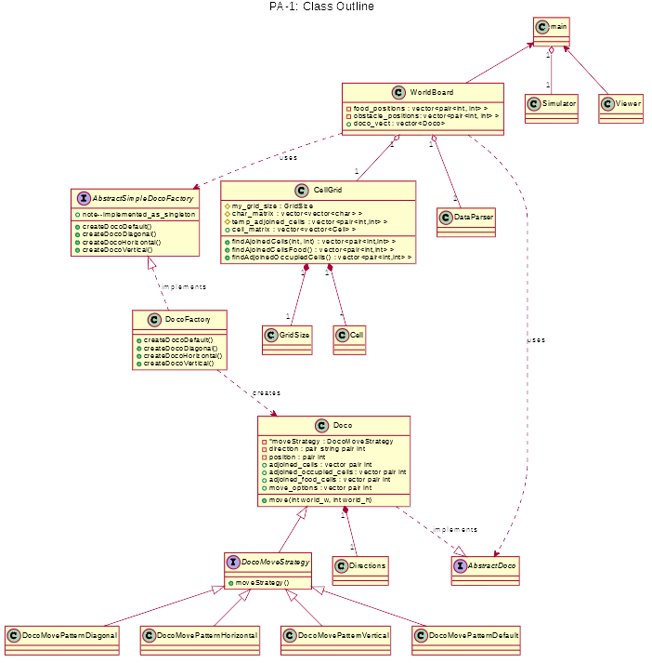

@startuml
title PA-1: Class Outline
interface DocoMoveStrategy
{
+moveStrategy()
}
class Doco
{
-*moveStrategy : DocoMoveStrategy
-direction : pair string pair int
-position : pair int
+adjoined_cells : vector pair int
+adjoined_occupied_cells : vector pair int
+adjoined_food_cells : vector pair int
+move_options : vector pair int
+move(int world_w, int world_h)
}
interface AbstractSimpleDocoFactory
{
+note--implemented_as_singleton
+createDocoDefault()
+createDocoDiagonal()
+createDocoHorizontal()
+createDocoVertical()
}
class CellGrid
{
#my_grid_size : GridSize
#char_matrix : vector<vector<char> >
#temp_adjoined_cells : vector<pair<int,int> >
+cell_matrix : vector<vector<Cell> >
+findAjoinedCells(int, int) : vector<pair<int,int> >
+findAjoinedCellsFood() : vector<pair<int,int> >
+findAdjoinedOccupiedCells() : vector<pair<int,int> >
}
class WorldBoard
{
-food_positions : vector<pair<int, int> >
-obstacle_positions: vector<pair<int, int> >
+doco_vect : vector<Doco>
}
class main
class DataParser
class Directions
class Simulator
class GridSize
class Cell
class Viewer
class DocoFactory {
+createDocoDefault()
+createDocoDiagonal()
+createDocoHorizontal()
+createDocoVertical()
}
interface AbstractDoco
class DocoMovePatternDiagonal
class DocoMovePatternHorizontal
class DocoMovePatternVertical
class DocoMovePatternDefault
CellGrid "1" *-down- "*" Cell
CellGrid "1" *-down- "1" GridSize
WorldBoard "1" o-down- "1" CellGrid
WorldBoard "1" o-- "1" DataParser
main "1" o-- "1" Simulator
Doco "1" *-- "1" Directions
Doco ..|> AbstractDoco : implements
class DocoMovePatternDiagonal extends DocoMoveStrategy
class DocoMovePatternHorizontal extends DocoMoveStrategy
class DocoMovePatternVertical extends DocoMoveStrategy
class DocoMovePatternDefault extends DocoMoveStrategy
interface DocoMoveStrategy extends Doco
AbstractSimpleDocoFactory <|.. DocoFactory : implements
DocoFactory ..> Doco : creates
WorldBoard ..> AbstractDoco : uses
WorldBoard ..> AbstractSimpleDocoFactory : uses
main <-- Viewer
main <-- WorldBoard
@enduml

