(3) M3 x 10 grub screws

(21) M3 x 4 threaded inserts

(16) M4 x 4 threaded inserts

(12) M3 x 6 standoffs

(4) M2 x 12 screws

(4) M2 nuts

(12) M3 x 6 screws

(8) M3 x 8 screws

(6) M3 x 12 screws

(12) M3 x 16 screws

(8) M3 x 25 screws

(17) M4 x 8 screws

(1) panel mount DC jack, 12mm hole size, 3A minimum current rating

(1) pH meter kit with isolated ADC board

(1) Keyestudio nano CNC shield

(1) Arduino Nano 33 IOT

(1) TB6612 DC motor driver

(3) NEMA 17 stepper motors

(3) TMC2208 stepper motor drivers

(1) 5V linear regulator (1A minimum current rating)

(4) 6mm rare earth magnets

(1) 24mm DC motor

(1) button, momentary, normally open, 12mm hole size

(1) I2C OLED screen (see note 1 below)

(12) HK0408 needle roller bearings

(12) 4mm x 14mm steel dowels

(2) 10 KOhm resistors (see note 2 below)

(1) ~4.7 KOhm resistor (optional, only if you are using a liquid level sensor)

(1) ~390 Ohm resistor (optional, only if you are using a liquid level sensor)

assorted jumper wires

threadlocker (I use Loctite 248)

small piece of perfboard (optional)

0.8mm ID/4mm OD tubing, length = distance to reagent container

1.6mm ID/4mm OD tubing, length = distance to skimmer/waste cup plus distance to tank

(1) 600x300mm sheet of 4mm thick acrylic

PLA and PETG filament, about 100g each

Notes:

1: The .96" OLED screens available on eBay, Aliexpress, etc have some slight variation in dimensions, including distances between mounting holes. Try to find one that matches the following:

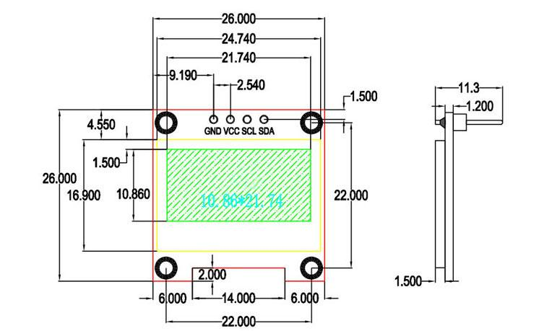

2. The 10K resistors may or may not be necessary. Some OLED screen modules have these built in; for others, you will need to wire them between the VCC and SCL/SDA pins as below. The best way to tell whether this is necessary for your screen is to try the sample sketch that comes with the Adafruit OLED display library; if you connect the screen and can't get an image from it, try it with the resistors.

