Warszawa, dn. 12.09.2016

LIDAR 3D

BLDC and driver connection scheme

# Driver

A BLDC driver - [*M542*](http://www.leadshine.com/UploadFile/Down/M542d.pdf) is used for controlling LIDAR 3D. It has several input ports and some settings like microstep number or current limits can be set through small switches.

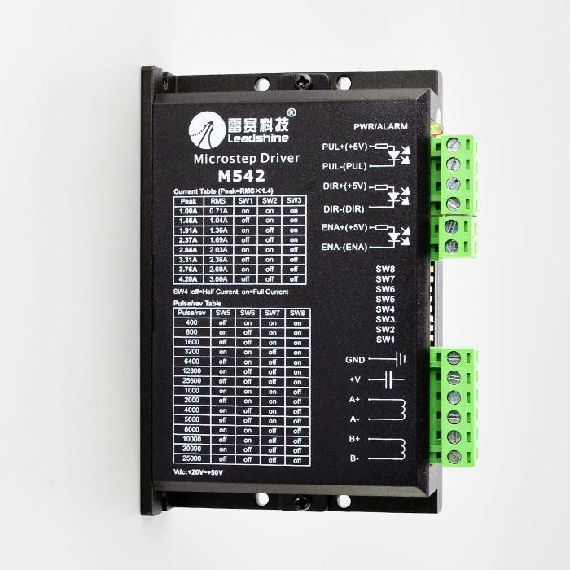

# Connection scheme

The M542 driver can be connected to any board (like Raspberry Pi or Arduino) with 2 or 3 output ports. The best are *open drain* ports. They gives you possibility to enable/disable driver (default, without connection it is enabled) and following 2 ports are for controlling rotation direction and rotation angle.

As mention before controller gives control of a number of microsteps per motor revolution (standarized for motor with 1.8 degrees step) from 400 to over 25000.

|  |  |
| --- | --- |
| **Pin sterownika** | **Podłączenie** |
| PUL+(+5V) | 5V |
| PUL-(PUL) | Input - controlles motor rotation - on impuls is one microstep |
| DIR+(+5V) | 5V |
| DIR-(DIR) | Input - rotation direction |
| GND | Motor ground |
| +V | Motor power supply 20 - 25V |
| A+ | Motor phases (phases A and B) |
| A- |
| B+ |
| B- |