Dbot Site Visit Assessment | Area: <<Area>> |  | Date: <<Date>>
Assessor |  | <<Assessor>>
Assessor contact |  | <<AssessorContact>>
Building contact |  | <<BuildingContact>>

<<Tower>>
Executive Summary
<<ExecutiveSummary>>

Checklist
Item | Done | Notes
Choose elevator(s) to be used (service/resident) | <<Check0>> | <<Check0Note>>
Test connectivity at elevator (Wi-Fi / LTE) | <<Check1>> | <<Check1Note>>
Confirm elevator compatibility (door/space) | <<Check2>> | <<Check2Note>>
Identify docking location(s) | <<Check3>> | <<Check3Note>>
Confirm power availability at docking | <<Check4>> | <<Check4Note>>
Confirm access doors or obstacles along robot route | <<Check5>> | <<Check5Note>>

Building Overview
Total floors | Operational Floors | Excluded Floors | Notes
<<TotalFloors>> | <<OpFloors>> | <<ExcludedFloors>> | <<BuildingNotes>>

<<D1Title>>
Access point | Elevator type | Elevator ID | Elevator Connectivity:
<<D1Access>> | <<D1ElevType>> | <<D1ElevID>> | <<D1Conn>>

Elevator Door width | Elevator Cabin depth | Provider/type | Comments
<<D1Width>> cm | <<D1Depth>> cm | <<D1Provider>> | <<D1Comments>>

Site changes required (to be ready):
Change | Owner | Notes
<<D1Ch1>> | <<D1Ch1Owner>> | <<D1Ch1Note>>
<<D1Ch2>> | <<D1Ch2Owner>> | <<D1Ch2Note>>

<<D2Title>>
Access point | Elevator type | Elevator ID | Elevator Connectivity:
<<D2Access>> | <<D2ElevType>> | <<D2ElevID>> | <<D2Conn>>

Elevator Door width | Elevator Cabin depth | Provider/type | Comments
<<D2Width>> cm | <<D2Depth>> cm | <<D2Provider>> | <<D2Comments>>

Site changes required (to be ready):
Change | Owner | Notes
<<D2Ch1>> | <<D2Ch1Owner>> | <<D2Ch1Note>>
<<D2Ch2>> | <<D2Ch2Owner>> | <<D2Ch2Note>>
<<D2Ch3>> | <<D2Ch3Owner>> | <<D2Ch3Note>>

Site Images
Insert photos and label them. Keep captions short.
[ Image Placeholder ]  <<ImgCaption0>>  Image Requirements:  - Must show full surrounding area (wide-angle view)  - Must show power source.  - Avoid close-up images.  Annotation Guidelines:  - Use green rectangle to point to docking location.  - Use red lines to show power cable routes (extension or power source installation is required).  - Label key elements: "Docking Area", "Power Source", "Cable Route"  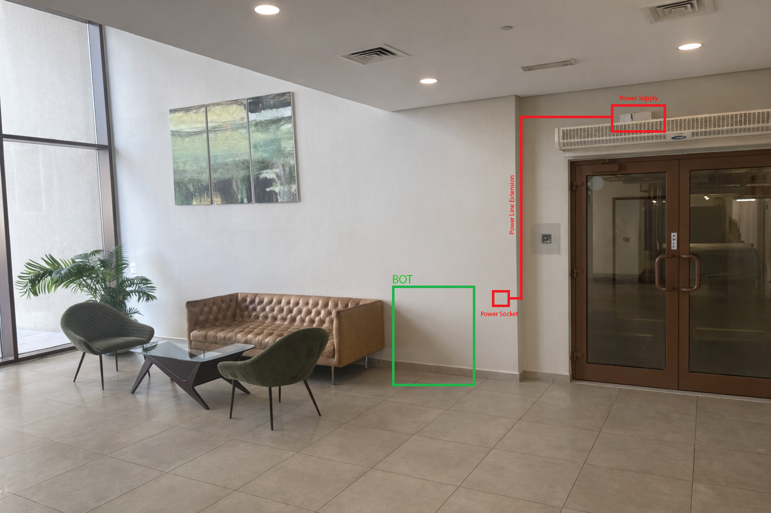 | [ Image Placeholder ]  <<ImgCaption1>>  Image Requirements:  - Must show full elevator entrance (door + surrounding area).  Annotation Guidelines:  - Red rectangle for the chosen elevator (if multiple exist)  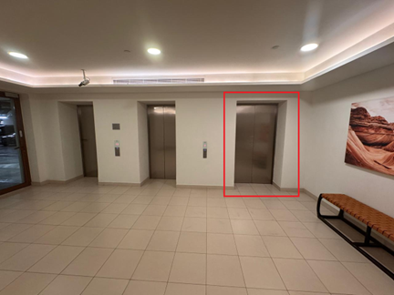
[ Image Placeholder ]  <<ImgCaption2>> | [ Image Placeholder ]  <<ImgCaption3>>

Delivery Flow
Delivery Flow Description:
1. Robot starts from docking.
2. Moves to elevator point/lobby.
3. Calls and enter elevator.
4. Travels to destination floor (Inside elevator).
5. Navigates corridor to apartment door.
6. Places delivery package at door.
7. Returns to docking/home station.

