Priloga 1

Naslov : AVTOMATSKI MERILNI SISTEM ZA SPREMLJANJE STANJA OKOLJA
Oprema : Senzor za merjenje globalnega sončnega obsevanja: KippZonnen, SMP3
vrsta dokumentacije : tehnične specifikacije
datum : 16.08.2017
revizija : 05.09.2017
arhiv: : 0000.doc

 | 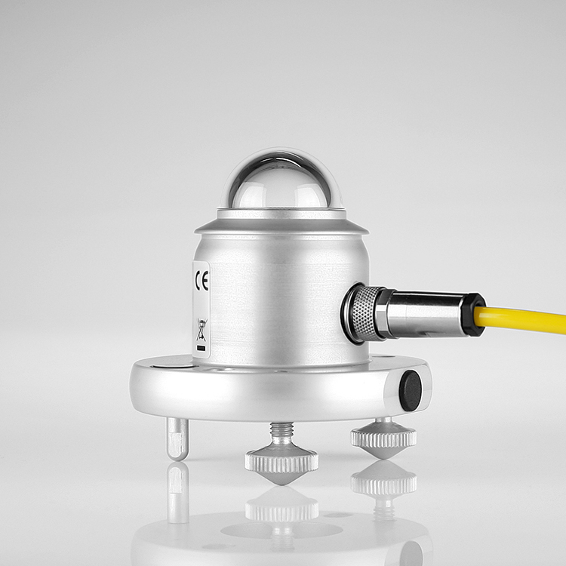
 | proizvajalec | Kipp & Zonen
 | Tip | SMP3-V (voltage output version)
 | KODA ZA NAROČANJE | 0374900-102
 | programsko jedro (firmware) | -
 | merjene veličine ( measured quantities)
 | Sončno sevanje (solar radiation)
 | SENZOR (sensor) | thermophile,
 | Classification to ISO 9060:1990 | Second Class Pyranometer
 | enote (units) | W/m2
 | točnost meritve(measurement accuracy) | serial output range: -400 to 2000W/m_  response time (63%): < 1.5 s  response time (95%): < 12 s  spectral range (20 % points): 285 to 3000nm  spectral range (50 % points): 300 to 2800nm  spectral selectivity (350 to 1500nm) : < 1%  daily total uncertainty < 2% (95% confidence level)  non-stability (change/year) < 1 %  mean time between failures: > 10 years  non-linearity: < 1.5 % (100 … 1000 W)  zero offsets (unventilated):  - termal radiation(200 W/m^2): < 15 W/m^2  - temperature change (5 K/hr): < 4 W/m^2  temperature response (percentage deviation due to change in ambient temperture within an interval of 70K): < 3%  tilt response (0 ° to 90 ° at 1000W/m_): < 1%  field of view: 180 °  accuracy of bubble level : < 0.2°
 | merilno območje (measurement range) | - 400 … 2000 W/m2
 | spektralno območje (spectral range) | spectral range (20 % points): 285 .. 3000 nm  spectral range (50 % points): 300 .. 2800 nm
 | resolucija (resolution) | 1W
 | odzivni čas (response TIME) | < 1.5s @63%  < 12 s @95%
 | temperaturna odvisnost občutljivosti (temperature dependence of sensitivity) | < 3 %
 | specifikacija merjenih podatkov (measured data specification)
 | obdelava podatkov (data processing) | -
 | merjene veličine (measured quantities) | main measurements:  - global_solar_radiation [IO_SENSOR1_DATA]  auxiliary measurements:  - smp3_body_temperature [IO_BODY_TEMP_K]  - smp3_supply_voltage [IO_EXT_POWER_SENSOR]  - smp3_status [IO_STATUS_FLAGS]  smp3_status:  - void signal,1=unstable signal, temperature too low or too high [IO_VOID_DATA_FLAG]  - overflow, signal out of range [IO_OVERFLOW_ERROR]  - underflow signal out of range [IO_UNDEFLOW_ERROR]  - general hardware error (set if one of the h/w error flags is set) [IO_ERROR_FLAG]  - hardware error a/d converter [IO_ADC_ERROR]  - hardware error d/a converter [IO_DAC_ERROR]  - calibration checksum error [IO_CALIBRATION_ERROR]  - update calibration parameters failed [IO_UPDATE_FAILED]
 | format izhodnih podatkov v telegramu merilnika  (output data format) | See document smp3_data_telegram.doc.pdf
 | tehnični podatki za merilnik (technical data)
 | ogrevanje merilnika (heating)
 |  | -
 | komunikacijski vmesnik (communication interface)
 | serijski vmesnik (serial interface) | number of COM ports: 1  COM1 [maintenance, configuration, data]:  RS-485 2w (half duplex)
 | UART nastavitve (uart config) | BAUD: 19200  PARITY: even  DATA BITS: 8  STOP BIT: 1  The factory default Modbus address: 1
 | protokol (protocol) | modbus RTU
 | namestitev (installation)
 | priklop (connection wiring) | connector: pre-wired waterproof connector  cable: 10 m cable with connector
 | NAPAJANJE (power supply) | 5 ... 30 VDC
 | MOČ (power consumption) | 55mV at 12VDC
 | PRIPOMOČKI ZA NAMESTITEV (Installation accessories) | 10 m cable with connector
 | ACcessories
 | dodatki (Accessories) | - Smart Explorer Software  - Shadow ring CM121B for a SMP3 or an unventilated SMP  - SOLYS2 sun tracker + shading ball assembly  - SOLYS Gear Drive sun tracker + shading ball assembly  - Mounting rod for SMP3  - 25 m cable with connector  - 50 m cable with connector  - Loose connector without cable
 | SPLOŠNI PODATKI ( general data)
 | dimenzija (dimension) | Housing:  - diameter: 110 mm  - height: 68 mm  glass dome:  - diameter: 32 mm
 | teža ( weight) | 300 g
 | material ( material) | -
 | okoljski pogoji (environmental conditions) | Operating temperature -40 ... +80 °C  Storage temperature -40 ... +80 °C  Relative humidity 0 ... 100 %RH  IP rating IP67 (without mounting kit)
 | Elektromagnetna kompatibilnost (electromagnetic compatibility) | Complies with the EMC standard EN61326-2-1, EN61326-2-3

• Zahteve po kompatibilnosti s strojno opremo naročnika:

 | opis | dokument
1. | 3d načrti montaže na vezalni plošči in montaže razdelilnih doz | 3d_m-deg-3000.easm  3d_A2-2_smp3.easm
2. | Dokumentacija za izvedbo montaže /ožičenja merilnega sistema | mo_m-deg-3000.pdf  mo_A2-2_smp3.pdf
3. | Blok sheme merilno komunikacijske topologije merilnega sistema xoberl in senzorike | bs_m-deg-3000.pdf  bs_A2-2_smp3.pdf

• Zahteve za kompatibilnost s programsko opremo naročnika:

 | opis | DOKUMENT / PROGRAMSKA OPREMA
1. | Zagon sensord programskega vmesnika | ./smp3d start
2. | nastavitveni xml senzorskega programskega modula | smp3d.xml  smp3d.h.xml
3. | Specifikacija konfiguracije senzorja  Specifikacija zajema in obdelave podatkov | cf_mdeg-3000.tgz
4. | Specifikacija izbranega Izhodnega telegrama senzorja | smp3_data_telegram.doc.pdf
5. | Specifikacija procesiranih podatkov senzorja | smp3d_data_format.doc.pdf
6. | Specifikacija delovanja senzorskega programskega modula | um_smp3d.pdf

• Ostale reference:
 | opis | dokument
1. | Legenda za naročniško kodo senzorja | Order_code_specification_SMP3.pdf

Opomba:

Vsi navedeni dokumenti so del interne dokumentacije naročnika [cf], [3d], [mo], [bs] in bodo v času trajanja razpisa na vpogled pri naročniku!

