Project Management
Intelligent Financial Insight System for Claims & Commission Analytics
Author: Robotiyee
Date: October 2025

1. Project Overview 3
2. Requirement and Prioritization Frameworks 3
2.1 RACI 3
2.2 Stakeholder Priority Matrix 3
2.3 MoSCoW — Prioritizing Requirements 4
2.4 SWOT — Strategic Alignment 4
2.5 Root-Cause Analysis: 4
2.6 SMART 4
2.7 INVEST 5
2.8 Requirements Traceability Matrix (RTM) 5
3. Stakeholder Management 5
3.1 Identifying Stakeholders 5
3.2 Structured Conflict-Resolution Approach 6
3.3 Managing Changing Requirements & Scope Creep 7
4 Change Impact Analysis (CIA) 7
4.1 Functional & Technical Impact Assessment 7
4.2 Risk Register (Change Management Log) Risk Matrix 8
4.3 Governance & Communication Overview 8
5 Requirement Gathering 8
5.1 Source Relationships: 8
5.2 What Is a BR and How Is It Defined? 8
5.3 What Is a UR (User Requirement)? 9
5.4 What Is an FR (Functional Requirement)? 9
5.5 BR ↔ UR ↔ FR Mapping 9
5.6 Natural Differences Between BRD and FRD 10
5.7 UC& US 10
5.8 In the BABOK Approach: 11
5.9 Jira Hierarchy Design 11
5.10 The Financial Insight System & Commission Analytics Project 11
6 Estimation and Resource Allocation 11
6.1 Work Effort and Story Points: 11
6.2 Story Point Estimation (Fibonacci Scale) 12
6.3 Project Sizing and Effort Estimation 12
6.4 Product Ownership and Backlog Management 13
6.4.1. PRD (Product Requirements Document) 13
6.4.2. Value-Effort 13
6.4.3. RICE 14
6.4.4. Cost of Delay (CoD) 14
6.4.5. Combined Prioritization Matrix (Value–Effort + RICE + CoD) 14
6.4.6. Jira Management 14
7 Confluence and Documentation 15
8 Agile Meetings (Ceremonies) 16
8.1 Scrum 16
Key characteristics: 16
When to use Scrum? 16
8.2 Kanban 16
Key characteristics: 16
When to use Kanban? 16
9 Release Management: 17
Production Release 17
Managing Scope Freeze (Sprint / Release freeze) 17
Versioning and Tracking 17
Ensuring Test Scenarios Are Ready for the Release 17
Risk & Impact Analysis (Change Impact Analysis – CIA) 17
Preparing Release Notes / Deployment Notes 18
Live Monitoring 18
Announcement 18
10 Project Closure Phase 18

Project Overview
Project Title:
Intelligent Financial Insight System for Claims & Commission Analytics
Project Summary:
This project modernizes the insurance company’s financial and compliance reporting ecosystem by integrating CRM, SAP, and advanced analytics systems.
It introduces two primary solution streams:
- FCA Compliance Field Integration: A new mandatory “Risk Exposure Category” parameter across CRM–SAP–Power BI systems for regulatory compliance.
- AI-Augmented Financial Insight Platform: ML and LLM-powered analytics to generate real-time, automated financial insights for decision-makers.

Requirement and Prioritization Frameworks
These frameworks are used to support requirement elicitation, prioritization, and stakeholder management, ensuring that business needs are systematically captured, evaluated, and aligned with project objectives.

RACI
Helps resolve who has authority when stakeholder priorities conflict.
It doesn’t decide what should be prioritized — it clarifies who should decide and who should be consulted.
Role | Meaning | Example
Responsible (R) | Person(s) doing the work | BA drafting requirement
Accountable (A) | Final decision maker / owner | Product Owner / Sponsor
Consulted (C) | Provides input before decision | Compliance Officer, Finance Lead
Informed (I) | Kept updated on progress | Operations Team
Use in Conflicts:
When two departments (e.g., Compliance vs. Marketing) disagree on a feature’s priority, your RACI matrix ensures that only the Accountable stakeholder (A) has final say — while the others are consulted. This prevents scope creep and political tension.

Stakeholder Priority Matrix
The Stakeholder Priority Matrix is a combined and simplified analysis tool designed to evaluate and rank stakeholders based on three key dimensions:
- Power/Influence – How much control or authority the stakeholder has over the project.
- Interest/Impact – How much the stakeholder is affected by or cares about the project outcomes.
- Urgency/Legitimacy – How immediate or valid their needs or concerns are.
Total Score | Priority Level | Recommended Engagement Strategy
12–15 | Key Players | Manage closely — involve frequently in decision-making and communication.
8–11 | Important Supporters | Keep satisfied — maintain regular contact and consult on major issues.
5–7 | Moderate Stakeholders | Keep informed — provide updates and monitor their interest level.
1–4 | Low Priority | Monitor with minimal effort — occasional updates as necessary.

MoSCoW — Prioritizing Requirements
Purpose:
MoSCoW helps stakeholders agree on requirement priorities and manage conflicts by clarifying what’s essential versus optional.
Category | Meaning | Example
Must have | Non-negotiable, legally or operationally critical. | FCA data field (compliance).
Should have | Important but not mandatory. | Reporting enhancement.
Could have | Nice to include if resources allow. | Custom report filter.
Won’t have this time | Deferred for later phases. | Experimental analytics view.
In Conflict Management:
- Provides a neutral structure for prioritizing competing requests.
- Helps balance stakeholder expectations and reduce tension.
- Example: “Compliance’s FCA rule is a Must have; Marketing’s personalization idea is a Could have — we’ll revisit it later.”
In Requirement Prioritization:
- Turns opinions into objective categories.
- Ensures focus on high-value or risk-critical needs.

SWOT — Strategic Alignment
Purpose:
SWOT supports MoSCoW by aligning priorities with business strategy and risk management.
Factor | Example Insight
Strength | Compliance improves reputation.
Weakness | Complex approvals delay delivery.
Opportunity | Automating reports boosts efficiency.
Threat | Non-compliance may cause penalties.
In Conflict Management:
- Brings objectivity to debates by focusing on business impact.
- Shows why addressing threats or weaknesses (Must-haves) outweighs pursuing opportunities (Could-haves).
In Requirement Prioritization:
- Justifies MoSCoW rankings using strategic logic.
- Ensures priorities align with organizational goals.

Root-Cause Analysis:
It is used to identify the underlying cause of a defect, issue, or conflict — not just the visible symptom.
It ensures corrective actions are focused on preventing recurrence, not merely fixing immediate problems.
Technique | Description | Example
5 Whys | Repeatedly ask “Why?” to drill down to the root cause. | The report failed → Why? Data missing → Why? API not called → Why? ETL job failed → Why? Server config error.
Fishbone (Ishikawa) Diagram | Visual tool that categorizes causes under areas such as People, Process, Technology, or Policy. | Helps analyze why a requirement was misunderstood or delayed.
Pareto Analysis (80/20 Rule) | Focus on the small number of causes that generate most issues. | Identify top 20% of requirements causing 80% of defects.
Failure Mode and Effects Analysis (FMEA) | Quantitatively assess the impact and likelihood of failures. | Prioritize corrective actions for high-risk processes.

SMART
The SMART framework ensures that requirements or objectives are well-defined and practical:
- Specific: Clearly describes what needs to be achieved.
- Measurable: Includes quantifiable success indicators.
- Achievable: Realistic given resources and constraints.
- Relevant: Aligned with project and business goals.
- Time-bound: Has a defined deadline or timeframe.
SMART goals improve focus, accountability, and project tracking.

INVEST
The INVEST model provides a quality checklist for User Stories in Agile methodologies.
- Independent: Each story should stand alone to enable flexible prioritization.
- Negotiable: The story is not a contract—it invites discussion and collaboration.
- Valuable: It must deliver clear business value to the user or customer.
- Estimable: The effort to complete it should be measurable and predictable.
- Small: The scope should fit within one iteration or sprint.
- Testable: The story should have clear acceptance criteria for validation.

Requirements Traceability Matrix (RTM)
It used to track each requirement throughout the project lifecycle, ensuring that every business need is addressed through design, development, testing, and deployment.
It establishes a clear link between:
- Business Requirements (BRD) → Functional Requirements (FRD) → Test Cases → Deliverables.
- To ensure no requirement is missed or out of scope.
- To provide visibility and control over requirement changes.
- To support compliance and auditability (especially critical for FCA/IFRS environments).
- To validate that each deliverable aligns with Business Objectives (BOs) and KPIs.

Requirement ID | Requirement Description | Source / Stakeholder | Functional Design Reference | Test Case ID | Status | Comments / Risk
BR-01 | Capture “Risk Exposure Category” in CRM | Compliance | FRD-1.1 | TC-001 | In Progress | Required for FCA reporting
BR-02 | Synchronize Risk Category to SAP FI/CO | Finance | FRD-1.2 | TC-002 | Pending | Dependent on API integration

Stakeholder Management

Identifying Stakeholders
Identifying stakeholders is the first and foundational step in business analysis. It ensures that all individuals, teams, and external parties who influence or are impacted by the project are recognized early, enabling effective communication, requirement gathering, and decision-making.
Phase | Tools / Methods | Purpose | Description
1. Identification | Brainstorming / Workshops, Stakeholder Register / Database, RACI Matrix | Identify and document all stakeholders and define their roles. | Conduct brainstorming sessions or workshops to list individuals or groups involved; record their details (names, roles, interests, and influence) in a stakeholder register or database; use a RACI Matrix to clarify who is Responsible, Accountable, Consulted, and Informed for key project tasks.
2. Analysis | Stakeholder Priority Matrix Stakeholder Mapping | Assess and prioritize stakeholders based on power, interest, and urgency, and understand relationships. | Use the combined Stakeholder Priority Matrix to rate stakeholders (1–5) for Power, Interest, and Urgency, producing a total priority score that guides engagement level; complement with Stakeholder Mapping to visualize connections, alliances, and influence networks among stakeholders.
3. Planning / Engagement | Communication Plan / Matrix, Surveys & Feedback Forms, Workshops & Focus Groups, Stakeholder Forums / Advisory Committees, CRM / Stakeholder Management Software, Collaboration Platforms | Plan, structure, and execute stakeholder communication and engagement activities. | Develop a Communication Plan defining what, when, and how to communicate with each stakeholder; collect insights using Surveys and Focus Groups; sustain dialogue through Forums or Advisory Committees; use CRM or management software to log and track interactions; and leverage collaboration tools (Teams, Slack, Asana, Trello) to facilitate transparent coordination and document sharing.
4. Monitoring / Evaluation | Engagement Log / Tracker, Performance Dashboards, Lessons Learned Reviews, Social Network Analysis Tools, AI-Based Sentiment Analysis Tools, Data Visualization Tools (Power BI, Tableau) | Track, measure, and improve stakeholder relationships and communication effectiveness. | Maintain an Engagement Log to record communications and follow-ups; use Performance Dashboards to monitor KPIs; conduct Lessons Learned Reviews for continuous improvement; apply Social Network Analysis to assess relationship dynamics; use AI Sentiment Analysis to gauge stakeholder perceptions; and visualize insights with tools like Power BI or Tableau for reporting and decision-making.

Structured Conflict-Resolution Approach
A structured conflict-resolution approach is used to proactively manage and resolve disagreements that arise during the analysis phase or throughout the project lifecycle. This method ensures that stakeholder concerns are addressed objectively, decisions are documented, and alignment is maintained across business and technical teams.
Step | Description / Key Activity | Tools & Techniques | Deliverables / Artefacts | Expected Outcome
1. Conflict Identification & Root-Cause Analysis | Identify and analyze the underlying reasons for stakeholder disagreements (e.g., scope, compliance, or resource priorities). | • Root-Cause Analysis (5 Whys) • Stakeholder Interviews / Workshops | Conflict Log Issue Register | Clear understanding of conflicts, drivers, and affected objectives.
2. Communication & Transparency | Establish open, fact-based communication channels; ensure that each stakeholder understands the project goals, KPIs, and constraints. | • Stakeholder Meetings • Active Listening • Transparent Reporting | Communication Plan Meeting Minutes | Trust built among stakeholders through transparency and openness.
3. Expectation Alignment | Facilitate workshops to align all parties on shared Business Objectives (BOs) and KPIs; focus on desired outcomes rather than individual preferences. | • Alignment Workshops • KPI Mapping • BO Review Sessions | Updated Stakeholder Alignment Matrix | Shared understanding of project outcomes and measurable success indicators.
4. Prioritization & Analytical Resolution | Apply structured prioritization to balance business value, regulatory needs, and operational feasibility. | • MoSCoW Prioritization (Must, Should, Could, Won’t) • SWOT Analysis (to justify MoSCoW results) | Prioritized Requirements List SWOT Justification Report | Balanced and defensible prioritization of conflicting requirements.
5. Decision Governance & Accountability | Define who has authority to approve or reject each decision; clarify involvement roles. | • RACI Matrix (Responsible, Accountable, Consulted, Informed) | RACI Decision Matrix Decision Log | Transparent accountability and efficient decision-making.
6. Documentation & Traceability | Record all decisions, rationales, and stakeholder approvals for auditability and project governance. | • Requirements Traceability Matrix (RTM) • Decision Log | Updated BRD / RTM Change History | Ensures traceability and compliance with internal QA and audit processes.
7. Continuous Engagement & Monitoring | Maintain ongoing communication, provide updates, and re-evaluate priorities as business or compliance conditions evolve. | • Regular Check-ins • Retrospectives • Feedback Loops | Engagement Tracker Status Reports | Sustained stakeholder collaboration and prevention of future conflicts.

Managing Changing Requirements & Scope Creep

Changing requirements and scope creep are managed through a structured, traceable process to keep objectives, timelines, and compliance fully controlled. Each change request is first analyzed to identify its root cause—whether regulatory, business-driven, user feedback, or technical constraints. A formal Change Impact Analysis (CIA) is performed to evaluate effects on CRM, integrations, SAP FI/CO, reporting, data models, timelines, and testing.

All changes are logged through a formal Change Request (CR) workflow in Jira and Confluence and governed by the RACI model, ensuring only the Accountable owner can approve scope changes. Approved changes trigger updates to BRD, FRD, user stories, acceptance criteria, and RTM to maintain end-to-end traceability. The backlog is reprioritized using MoSCoW, business value, and regulatory urgency.

Continuous communication, stakeholder alignment, and sprint-level scope-freeze practices prevent uncontrolled requirement expansion and help maintain stable delivery. This disciplined approach ensures changes are evaluated objectively, transparently approved, and integrated without increasing project risk.

Method / Tool | Purpose | When Used | Key Outcome
Change Impact Analysis (CIA) | Assess impact on systems, timelines, integrations, compliance | For every new or changed requirement | Clear understanding of technical & business impacts
Change Request (CR) Workflow – Jira & Confluence | Formalize and log all change requests | Whenever a stakeholder proposes a change | Full traceability and auditability
Root-Cause Analysis (RCA) | Identify why a change is requested | At start of CR evaluation | Prevents unnecessary scope expansion
RACI Governance | Ensure proper approval and accountability | During decision-making | Only authorized stakeholders approve scope changes
MoSCoW Prioritization | Reprioritize backlog items | After CIA and CR approval | Balanced and justified prioritization
Backlog Reprioritization (Jira) | Integrate approved changes into roadmap | After prioritization | Updated sprint/release plan
BRD / FRD / US / AC Updates | Maintain consistent documentation | After any approved change | Full functional and technical traceability
Requirements Traceability Matrix (RTM) | Link BR → FR → UC → US → Test | After requirement updates | Ensures no missing or conflicting requirements
Stakeholder Communication Plan | Keep stakeholders aligned | Throughout change lifecycle | Transparency & reduced conflict
Scope Freeze (per Sprint) | Prevent changes during active development | During each sprint | Stable delivery and predictable velocity

Change Impact Analysis (CIA)
The Change Impact Analysis outlines how the planned developments affect CRM, integration interfaces, SAP FI/CO, and reporting processes. It identifies required UI updates, integration and ABAP changes, reporting adjustments, and operational impacts, while also assessing associated risks and mitigation needs. This ensures that all system and process changes are clearly understood and effectively managed before implementation.

Functional & Technical Impact Assessment
This assessment highlights the functional and technical impacts of introducing the new field across CRM, integration, SAP FI, reporting, and operational processes. It outlines high- and medium-impact areas along with mitigation actions to ensure a controlled and reliable implementation.
Area | Impact | Description | Mitigation
CRM UI / Code | High | New field required; risk of user input errors | Validation rules + mandatory field
Integration Layer (API/ETL) | High | API mapping updates required | Regression testing of ETL scripts
SAP FI Module (ABAP) | High | ABAP code changes for new parameter | Dual testing in sandbox
Reporting & Data Warehouse | Medium | Additional joins in Power BI/DW may affect performance | Query/index optimization
Operations / User Processes | Medium | New data entry step increases input time | User training + UI optimization
Compliance | Low | Field mandatory for reporting compliance | Data completeness checks
Operational Block Risk | High | Incorrect ABAP integration may block SAP posting | Backup plan + code versioning

Risk Register (Change Management Log) Risk Matrix
The register summarizes critical and high-priority risks related to CRM–SAP integration, SAP posting logic, reporting performance, user errors, and operational continuity. Mitigation measures and ownership are defined to support effective change management and reduce project exposure. A Risk Matrix is a structured tool used to evaluate and prioritize risks by measuring their Severity (Impact) and Probability (Likelihood).
Risk ID | Description | Severity | Probability | Mitigation | Owner
R-001 | CRM field not properly integrated with SAP | High | Medium | Integration test & validation | BA / Dev
R-002 | New field causes SAP posting errors | High | Medium | ABAP sandbox test before release | SAP Dev
R-003 | Power BI performance degradation | Medium | High | Query optimization & partitioning | Data Eng
R-004 | Incorrect parameter entry by users | Medium | High | Mandatory validation + dropdown options | BA / QA
R-005 | Daily operational block due to SAP sync failure | Critical | Medium | Rollback mechanism + error logging | PM / IT Ops

Governance & Communication Overview
A formal governance model, supported by structured testing, CAB oversight, and documentation management, ensures controlled delivery and mitigates risks.
Governance Element | Description
Project Steering Committee | CFO (Sponsor), COO, Head of Data, Compliance Director
Core Delivery Team | Business Analyst, PM, Data Engineers, CRM/SAP Developers, QA
Communication Cadence | Weekly sprint reviews; monthly stakeholder reports; CAB reviews for major changes
Documentation Repository | Confluence + SharePoint for BA artifacts & version control
Quality Gate Reviews | Conducted at SDLC milestones: Requirements → Build → UAT → Go-Live → Post-Implementation Review

Requirement Gathering
This section outlines the key sources used in requirement gathering, linking business needs, objectives, and risks to the creation of Business Requirements and User Requirements. It clarifies how each element contributes to defining clear, actionable requirements for the solution

Source Relationships:
Source Element | Purpose | Example
Business Need | Identifies the “why” (problem or opportunity). | “Financial reporting is manual and delayed.”
Business Objective | Defines the measurable “what” (goal or outcome).  Should be SMART and would include KPI’s | “Automate FCA reporting; achieve 70% faster reporting speed.”
Business Risk | Highlights the potential threat or challenge; helps refine the BR to mitigate it. | “Regulatory non-compliance due to missing Risk Exposure Category.”
→ Business Requirement (BR) | A statement of what the business must achieve to meet the need and objective, while managing risk. | “The system must capture and synchronize ‘Risk Exposure Category’ across CRM and SAP to ensure FCA compliance.”
→ User Requirement (UR) | A User Requirement defines what the user must be able to perform or achieve within the system to support the business requirement | “Users must be able to enter and validate mandatory FCA fields in CRM.”

KPIs are defined at the Business Objective level because they measure the strategic success of the solution. Each KPI represents the measurable outcome expected after implementing the related Functional Requirements. These KPIs then flow down into the FRs, Use Cases, and Acceptance Criteria to ensure full end-to-end traceability.
KPIs are used across stakeholder management, change management, and project approval to define measurable success criteria, prevent scope creep, and ensure alignment on expected outcomes. They guide decisions, validate requirements, and serve as benchmarks throughout the SDLC.

What Is a BR and How Is It Defined?
A Business Requirement (BR) defines the organization’s strategic business objective or the problem that needs to be solved.
A BR is typically derived from one or more of the following sources:
Source | Description | Example
Business Need | Problem or opportunity in the current system  A-IS | “FCA reporting is invalid, version is old.”
Business Objective | Strategic goal defined by top management  TO-BE | “FCA report should be up to date and New mandatory Risk Exposure Category field should be added .”
Business Risk / Constraint | Regulatory, operational, or financial risk, AS-IS | “Risk of FCA penalties due to incorrect reporting.”
Therefore:
Business Need + Objective + Risk → form a BR
Example:
“To comply with FCA regulations, all policy data must include a mandatory Risk Exposure Category field.”
BR-01: Comply with FCA regulatory reporting standards.

What Is a UR (User Requirement)?
A User Requirement (UR) translates the Business Requirement into a user-level statement that answers the question “What?” —
In other words: What does the user need to do to achieve that business goal?
Formula:
BR = Why
UR = What
FR = What+How
Example:
- BR-01: Comply with FCA regulatory reporting standards. (Why)
- UR-01: Capture “Risk Exposure Category” in all policy records. (What)
- FR-01: Add mandatory “Risk Exposure Category” dropdown in CRM policy creation form. (What+How)

What Is an FR (Functional Requirement)?
A Functional Requirement (FR) defines how the system must behave to fulfill the User Requirement.
It answers: “How should the system operate? What data and workflows should it use?”
At this stage, the focus shifts to technical implementation (UI, API, ETL, Dashboard, LLM, etc.).
Each FR is typically derived from one or more URs — but the relationship does not have to be one-to-one.
SMART method can be used in FR definition.
Example:
ID | Requirement | Layer
FR-01 | CRM must allow entry of “Risk Exposure Category.” | UI / Front-End
FR-02 | The field must be validated and mandatory. | Validation
FR-03 | CRM sends validated data to SAP via API. | Integration
FR-04 | SAP stores the value in FI/CO posting. | Backend
These four FRs together satisfy one UR (UR-01), and all contribute to achieving BR-01.

BR ↔ UR ↔ FR Mapping
This structure makes the Traceability Matrix (BR→UR→FR→UC→US) fully traceable top to bottom.
Level | Relationship | Explanation
BR → UR | 1 : N | Each business goal may generate several user requirements.
UR → FR | 1 : N | Each user requirement may be fulfilled by several functional components.
FR → UC / US | 1 : N | Each functional element may appear in one or more Use Cases or User Stories.
Example:
- BR-01 → 2 URs (capture field, validate field)
- UR-01 → 3 FRs (create, validate, sync)
- FR-01 → UC-1.1 + US-1.1

Natural Differences Between BRD and FRD
Dimension | BRD (Business Requirements Document) | FRD (Functional Requirements Document)
Focus | Business goals, problems, value | System behavior, technical details
Key Question | Why & What | What & How
Ownership | Business team, senior management | IT, system analysts, developers
Format | Broad and strategic | Detailed and testable
Measurement | KPI, ROI, Compliance | Test Cases, Acceptance Criteria

- Combine the “Business Objective” and “Business Need” sections in your BRD to form measurable and concrete BRs.
- For each BR, define User Requirements (URs) by asking “What must the user do to achieve this?”
- In your FRD, relate each FR to the relevant UR(s) using a 1:N mapping logic.
- Maintain the linkage FR → Use Case → User Story consistently.

UC& US
Each Functional Requirement (FR) is broken down into one or more Use Cases (UC), and each Use Case is further translated into one or more User Stories (US) with clearly defined Acceptance Criteria. This structure ensures that every requirement is fully analyzed, modeled, implemented, and tested.

Functional Requirement (FR) → Use Case (UC)
In this project each FR is decomposed into Use Cases, which describe how the system will behave step-by-step to fulfill the requirement.
The Use Case contains:
- Main Flow (Basic Flow / Happy Path)
The primary, ideal sequence of steps where everything goes as expected and the user successfully reaches the goal.
- Alternative Flow
Valid variations from the main flow where the process still completes, but with a different path or choice (e.g., different input, optional step).
- Exception Flow
Error or failure scenarios where something goes wrong (invalid data, system error), and the system must handle it gracefully.
- Business Rules (Constraints, Formula, Rule)
Policies, conditions, or calculations that control or constrain system behavior. Include constraints, formulas, mandatory fields, validation logic, and regulatory. Examples: eligibility rules, interest formulas, validation rules.
- Non-Functional Requirements (NFR)
Requirements about how the system works, not what it does: performance, security, availability, usability, scalability, compliance, etc.
- Assumptions: Conditions you expect to be true (but cannot fully control).
- Dependencies: Other systems, teams, or components that must exist or work correctly for this feature to function.
- Use Case UML Diagram
A visual diagram showing actors and their interactions with the system as bubbles (use cases), used to illustrate scope and high-level functionality.
These elements ensure that the FR is fully understood in functional and technical depth before moving to development.
Use Case (UC) → User Story (US)
- Each Use Case generates one or more User Stories, which define what the user must be able to do within the system.
- User Stories are written in user-centric format (As a … I want … so that …).
- Every User Story is directly linked to the parent Use Case, ensuring alignment between detailed process flows and development-level deliverables.
- For each User Story, Acceptance Criteria (AC) are defined to specify the exact conditions required for completion.
This ensures that development teams can build features incrementally while maintaining business logic defined at the Use Case level.
Acceptance Criteria (AC)
Clear, testable conditions that must be met for a User Story / Use Case to be considered “done” and accepted. INVEST method is used

In the BABOK Approach:
BABOK Level | Question | Typical Jira Issue Type | Purpose | Example
Business Requirement | WHY | Epic | Captures the business goal or initiative that drives the project | “Reduce order processing time by 20%”
Stakeholder / High-Level Requirement | WHAT (User Perspective) | Feature or Capability (optional level in some Jira setups) | Describes what a user or stakeholder group needs | “Sales reps can place and confirm orders in one step”
Functional Requirement (Solution Requirement) | WHAT (System Perspective) | User Story | Describes what the system must do to satisfy the stakeholder need | “As a sales rep, I want to validate order details before submission so I can avoid data errors.”
Non-Functional Requirement (Quality Attribute) | WHAT (Quality/Constraint) | Technical Story or NFR Story / Subtask | Describes constraints such as performance, security, scalability | “Order validation must complete within 2 seconds.”
Design / Implementation Detail | HOW | Task / Subtask | Defines technical activities or configurations that implement the story | “Implement validation logic in OrderService.java”

Jira Hierarchy Design
Hierarchy Question | BABOK Level | Jira Artifact
WHY | Business Requirement | Epic
WHAT (User) | Stakeholder Requirement | Feature
WHAT (System) | Functional / NFR | User Story
HOW | Design / Implementation | Task / Subtask

The Financial Insight System & Commission Analytics Project
Example Transformation
Level | ID | Description
BR | BR-03 | Automate compliance report generation.
UR | UR-03 | Generate FCA reports automatically using CRM & SAP data.
FR | FR-05–FR-06 | ETL consolidates CRM & SAP nightly; Power BI dashboard generates FCA-compliant reports.
UC | UC-1.2 | FCA Report Generation and Synchronization
US | US-1.2 | As a Compliance Officer, I want automated FCA reports integrating CRM and SAP data…

Team Type | Recommended Mapping
Regulated, documentation-heavy (e.g., Insurance, FCA, IFRS) | IIBA-Structured (FR = Story) because auditors and compliance officers will trace FRDs and Use Cases directly in Jira.
Agile or DevOps-oriented (Scrum, Kanban) | Agile-Optimized (UR = Story, FR = Task) because developers and testers think in terms of user value → technical task.

Jira Level
Epic | BR | Business outcome (FCA compliance, data automation, AI insights) | BR-01 – Ensure FCA/IFRS compliance
Story | UR + FR | Functional capability delivering user value | FR-01 / UR-01 – Unified Risk Data Sync
Task | UC / NFR | Implementation of work items (flows, validations) | UC-1 – CRM integration, API schema, ETL job
Sub-task | AC + Technical detail | Acceptance checks, performance, logging, testing | Validate SAP sync ≤10s, retry queue handling

Estimation and Resource Allocation
You may assign story points to each story and assign them relatively to the number of related tasks.

Work Effort and Story Points:
In Jira, relative effort is used instead of person-days. When assigning story points, the Fibonacci sequence can be applied.

Field | Use Case | Add to Jira?
Story Points | Sprint velocity, backlog prioritization | Yes
Person-Days / Hours | Effort tracking, PMO reporting | Optional (only if your org requires effort logging)

FR / Module | Description | Complexity | Estimated Effort (Person-Days) | Dependencies | Priority (MoSCoW)
FR-01: Unified Data Capture & Integration Layer | Capture Risk Exposure Category, sync CRM ↔ SAP ↔ DW | Medium | 18 | CRM UI, SAP API | Must Have
FR-02: Automated ETL & Data Quality Framework | Nightly ETL + validation + recovery | High | 20 | Data Warehouse, Airflow | Must Have
FR-03: AI-Driven Financial Analytics Engine | ML-based KPI forecasting and anomaly detection | High | 25 | Data Science Models, DW | Should Have
FR-04: LLM-Augmented Narrative Intelligence | Generate and embed natural-language summaries | Medium | 18 | ML Engine, Power BI | Should Have
FR-05: Compliance, Audit & Security Module | RBAC, audit trail, FCA field validation | Medium | 12 | Azure AD, Security Logs | Must Have
FR-06: Performance & Continuity Management | SLA monitoring, ETL recovery, uptime | Medium | 12 | DataOps, Grafana | Could Have
Total Effort |  |  | ≈ 105 Person-Days

Story Point Estimation (Fibonacci Scale)
Issue Type | ID | Summary | Story Points | Priority
Story | FR-01 | Unified Data Capture & Integration Layer | 13 | High
Story | FR-02 | Automated ETL and Data Quality Framework | 21 | High
Story | FR-03 | AI-Driven Financial Analytics Engine | 21 | Medium
Story | FR-04 | LLM-Augmented Narrative Intelligence | 13 | Medium
Story | FR-05 | Compliance, Audit & Security Module | 8 | High
Story | FR-06 | Performance & Continuity Management | 8 | Low

As the total project effort is approximately 105 person-days, the expected effort for each task can be estimated based on its assigned story points.
Effort per Story Point= Total Effort (e.g., 105 person-days)/ Total Story Points
Then the expected effort for a task is: "Expected Effort (p/d)"=Story Points × Effort per Story Point

Project Sizing and Effort Estimation
Project sizing and effort estimation are performed using story points to assess the complexity, scope, and technical workload across user stories and supporting tasks. This approach helps the team forecast delivery effort, allocate resources effectively, and plan releases based on the relative size and priority of each item
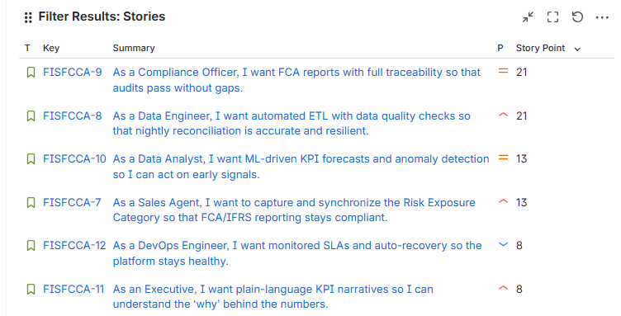

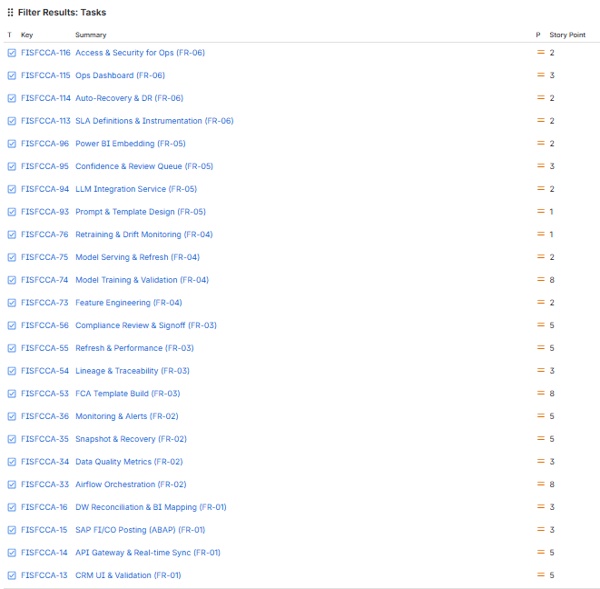

Product Ownership and Backlog Management
Product Ownership focuses on defining the product vision, translating business needs into clear user stories, prioritizing the backlog, and ensuring that delivered features create measurable business value.

PRD (Product Requirements Document)
Defines what the product should do.
Includes the product vision, user needs, key features, user scenarios, and acceptance criteria.
- Product-focused
- User experience–oriented
- Value, problem, and business goals
- Intended for business stakeholders + product team
- Answers the question: “What do we want?”

Backlog management is the process of organizing, prioritizing, and continuously refining product requirements to ensure the team delivers the highest business value in each iteration. Besides the MoSCoW method, the following techniques can also be used:

Value-Effort
Criteria:
- Value: Business impact, regulatory importance, operational efficiency, user adoption
- Effort: Development complexity, integrations, data pipelines, testing effort
- Scale: 1–5
Value–Effort Interpretation
- Quick Wins (High Value / Medium Effort):
✔ FR-04 LLM Narrative Intelligence
✔ FR-05 Compliance & RBAC
- Mandatory High-Value / High-Effort Items:
✔ FR-01 Unified Data Sync
✔ FR-02 ETL + Data Quality
- Later Enhancements:
✔ FR-03 & FR-06

RICE
Formula: RICE = (Reach × Impact × Confidence) / Effort
RICE Criteria for Your Project
- Reach: Internal users across Compliance, Finance, Operations, Data teams
- Impact: FCA compliance, reporting accuracy, decision-making speed
- Confidence: Clarity of requirements & stability of data model
- Effort: Development complexity (1–5)

Cost of Delay (CoD)
Cost of Delay measures the economic and operational impact of NOT delivering a feature on time.
It combines:
- Business Value Loss — revenue, efficiency
- Regulatory Risk — FCA/IFRS penalties, audit findings
- Operational Cost — manual workload, error rates
- Customer/Stakeholder Impact — delayed insights, slow reporting
Formula (simple practical version):
CoD = (Business Value + Time Criticality + Risk Reduction) Score
1. Business Value (1–5):
Does delaying the feature block financial reporting, decision-making, or analytics?
2. Time Criticality (1–5):
Is this urgent (e.g., FCA deadline, audit window, or quarter-end reporting)?
3. Risk Reduction / Opportunity Enablement (1–5):
Does delaying it increase operational risk, compliance issues, or data errors?

Combined Prioritization Matrix (Value–Effort + RICE + CoD)

Feature | Value–Effort Priority | RICE Score | CoD Score | Final Priority
FR-05 Compliance | High Value / Medium Effort | 41.66 | 15 | ⭐ #1 Must-Have
FR-01 CRM–SAP Sync | High Value / High Effort | 31.25 | 14 | ⭐ #2 Must-Have
FR-02 ETL + DQ | High Value / High Effort | 20.00 | 13 | ⭐ #3 Must-Have
FR-04 LLM Intelligence | Quick Win | 26.66 | 8 | #4 Enhancement
FR-06 Performance | Medium | 12 | 9 | #5 Stability
FR-03 AI Forecasting | High Effort / Medium Value | 9.60 | 6 | #6 Long-Term

Jira Management
Backlog Management in Jira provides a structured and transparent view of all Epics, User Stories, NFRs, Tasks, and Test Cases. By applying MoSCoW prioritization and using Jira dashboards—such as issue-type charts and priority statistics—teams can easily identify high-value items, balance workload, and support efficient sprint planning and delivery.

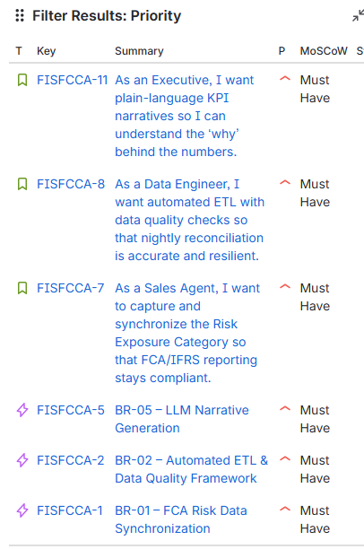

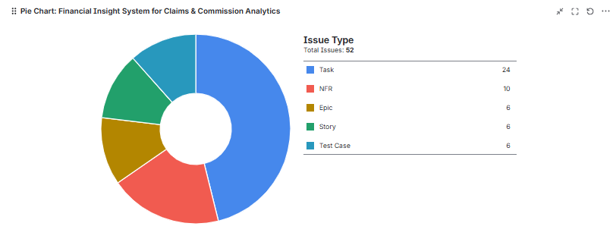

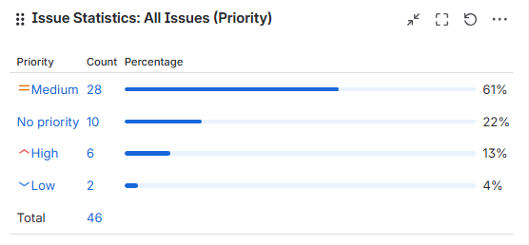

Confluence and Documentation
All the BRD, FRD, PM, QA, and Technical Development documents are stored on the Confluence page.

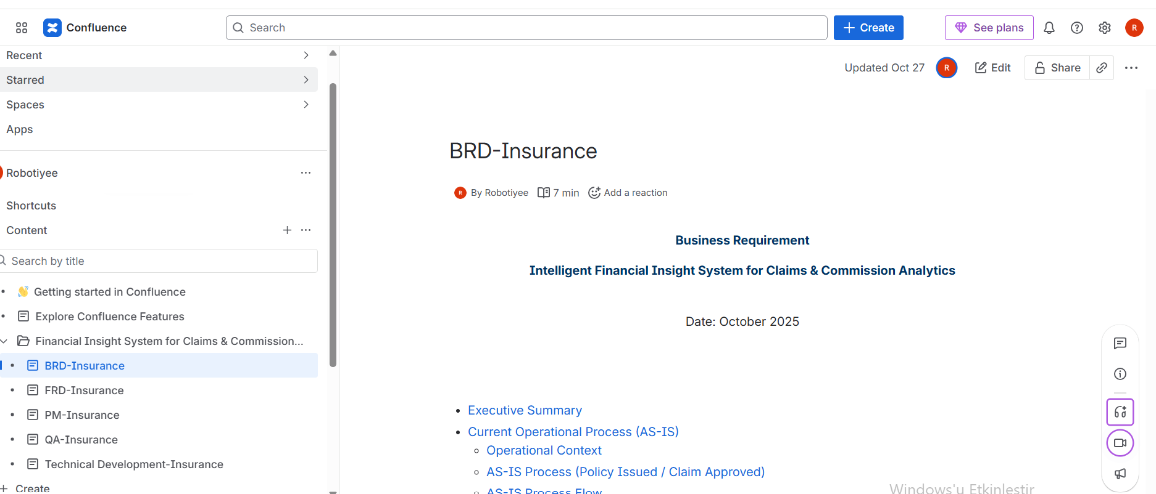

Agile Meetings (Ceremonies)
This project applies a full Agile delivery discipline combining structured documentation (BRD, FRD), well-formed user stories with acceptance criteria, MoSCoW prioritization, INVEST standards, and story-point estimation to ensure clarity and traceability. Agile ceremonies—including Backlog Refinement, Sprint Planning, Daily Stand-ups, Sprint Reviews, Retrospectives, Release Planning, and Stakeholder Workshops—provide continuous alignment, rapid feedback, and iterative improvement. Supported by Jira boards and QA test scenarios, this framework enables the Business Analyst to maintain requirement quality, manage dependencies, validate business outcomes, and ensure that each increment delivers measurable value.

Scrum
Scrum is a time-boxed Agile framework with clearly defined roles, ceremonies, and deliverables.

Key characteristics:
- 2–4 week Sprint cycles
- Roles: Product Owner, Scrum Master, Development Team
- Ceremonies: Daily Stand-up, Refinement, Sprint Planning, Sprint Review, Retrospective
- Scope is fixed during the sprint (Scope Freeze)
- Each sprint ends with a potentially shippable product increment

When to use Scrum?
- When deliverables need clear structure
- When dependencies are high
- When rhythm and planning discipline are important

Kanban
Kanban is a continuous-flow Agile method without time-boxed iterations.

Key characteristics:
- Work moves through a Kanban board (To-Do → In Progress → Done)
- WIP (Work In Progress) limits balance team workload
- Priorities can be updated at any time
- Supports continuous delivery (no sprint boundaries)

When to use Kanban?
- When work arrives continuously
- When urgent requests are common
- In support, maintenance, data/analytics, or operational teams
Scrum works in fixed sprints with structured ceremonies; Kanban uses continuous flow with flexible prioritization.

Ceremony / Activity | Category | Main Purpose | Key Steps | Actors Involved | Timing | Techniques / Tools | Frequency / Duration | Why It Matters / Key BA Value | BA Priority Level
Product Backlog Refinement (Grooming) | Preparation | Prepare and prioritize backlog items for upcoming sprints. | Review, clarify, and split backlog items into user stories; estimate (story points); define acceptance criteria. | Product Owner, Scrum Master, Development Team, BA | 3–4 days before Sprint Planning | MoSCoW, INVEST, Acceptance Criteria, RTM | Weekly or bi-weekly | Ensures clarity, prioritization, and readiness for Sprint Planning; BA defines acceptance criteria and verifies INVEST. | (Critical)
Sprint Planning | Execution | Define Sprint Goal and plan work for next Sprint. | Set Sprint Goal; select backlog items; estimate effort; assign ownership; identify risks; finalize Sprint Backlog. | Product Owner, Scrum Master, Development Team, BA | Start of each Sprint | SMART, MoSCoW, Risk Analysis, RACI | Every Sprint (2–4 weeks) | Aligns business goals, defines scope, validates feasibility; BA ensures stories meet DoR and map to KPIs. | (Critical)
Daily Stand-Up (Daily Scrum) | Monitoring | Synchronize progress and identify blockers. | Share updates on completed / upcoming tasks; raise impediments. | Development Team, Scrum Master, BA | Every working day | Task Board, Jira / Azure DevOps | Daily (15 minutes) | Provides visibility on blockers; BA monitors requirement dependencies or unclear stories. | (Low–Medium)
Sprint Review (Demo) | Validation | Demonstrate completed increment and collect feedback. | Present increment; gather stakeholder feedback; update backlog. | Product Owner, Scrum Team, Key Stakeholders, BA | End of each Sprint | KPI Review, Progress Report, Feedback Loop | End of Sprint | Validates business outcomes, captures stakeholder feedback; BA ensures deliverables meet requirements and KPIs. | (High)
Sprint Retrospective | Improvement | Reflect on process and identify improvement areas. | Discuss what went well / not well; define improvement actions; assign owners. | Scrum Master, Product Owner, Development Team, BA | After Sprint Review | SWOT, Root-Cause Analysis, Parametric Estimation, MoSCoW, SMART | End of Sprint (max 3 hrs for 1-month sprint) | Enables continuous improvement; BA contributes analytical insights, RCA, and measurable enhancements. | (Medium)
Release Planning / PI Planning | Coordination | Align teams on release goals, dependencies, and roadmap. | Define release goals; plan capacity; identify cross-team dependencies. | Product Owner, Release Train Engineer, BAs, Teams | Between major releases | Value Stream Mapping, Dependency Matrix, RACI | Every few sprints | Provides roadmap visibility; BA ensures alignment with business objectives and dependencies. | (High for scaled agile)
Stakeholder Alignment Workshop | Governance / Strategy | Resolve conflicts and realign scope and priorities. | Identify conflicts; apply SWOT, MoSCoW, and RACI; document decisions. | BA (facilitator), Product Owner, Stakeholders | As needed | SWOT, RACI, MoSCoW, RTM, SMART, RCA | Ad-hoc | Ensures stakeholder consensus, transparency, and documented traceability. | (High Strategic Value)

Release Management:
Release Management is the end-to-end process of planning, versioning, coordinating, packaging, testing, approving, and deploying functionalities to production in a controlled and seamless manner. As a BA, my core responsibilities in the release cycle are:

Production Release
Tracking the entire chain:
BRD/US → Dev tasks → QA testing → UAT → Release preparation → Go-Live

Managing Scope Freeze (Sprint / Release freeze)
If a last-minute requirement emerges, I perform CIA / RACI analysis and support the decision whether it should be included in the release.

Versioning and Tracking
- Which story/requirement will be released in which version?
- Are there dependencies in the release plan?
- Are there any impacts from parallel sprints?

Ensuring Test Scenarios Are Ready for the Release
- QA → Functional tests
- BA → UAT
- Prod → Smoke tests
Checking that all tests align with the defined requirements.

Risk & Impact Analysis (Change Impact Analysis – CIA)
Before each release, I review:
- Impacted modules
- Impacted customer groups
- Impacted GL / risk / allocation functionalities
- Potential risks (performance, data quality, financial impact)

Preparing Release Notes / Deployment Notes
Including:
- Technical summary of the delivered functionality
- Required parameter changes
- DB changes
- Configuration items
- Rollback plan

Live Monitoring
After deployment, I monitor:
- T+1 processes
- Accounting entries
- Limit allocation / scoring / API responses
- System performance

Announcement
- User communication
- Guide

Project Closure Phase
The Project Closure Phase ensures that the solution is safely validated, deployed, and formally completed. A Pilot—though not mandatory for every project—is often recommended or required for high-risk, multi-system, or regulatory initiatives. During the pilot, the solution is released to a limited user group to confirm performance, usability, data quality, and compliance in a controlled environment. If successful, the project moves to Production Go-Live, followed by a Hypercare period to stabilize operations and resolve early issues.
After deployment, KPI evaluation measures whether compliance, performance, operational efficiency, and predictive accuracy targets have been achieved. If critical KPIs are not met, the team performs root-cause analysis and adjusts scope, timelines, or technical design as needed. Compliance-related KPIs must be met before full-go-live, whereas business-value KPIs may be refined or delivered in later phases. All KPI gaps are handled through formal governance and change management.
Once KPIs, acceptance criteria, and quality gates are fulfilled, the project is formally closed, lessons learned are documented, and the solution is handed over to operations for ongoing support.

