Project Management
Intelligent Financial Insight System for Claims & Commission Analytics
Author: Robotiyee
Date: October 2025

1. Project Overview 3
2. Change Impact Analysis (CIA) 3
3. Risk Register (Change Management Log) 3
4. Governance & Communication Overview 3
5. JIRA Mapping 4
Source Relationships: 4
What Is a BR (Business Requirement) and How Is It Defined? 4
What Is a UR (User Requirement)? 4
What Is an FR (Functional Requirement)? 4
BR ↔ UR ↔ FR Mapping 5
Natural Differences Between BRD and FRD 5
6. The Financial Insight System for Claims & Commission Analytics Project 6
7. Estimation and Resource Allocation 7
Work Effort and Story Points: 7
Story Point Estimation (Fibonacci Scale) 7
Project Sizing and Effort Estimation 7
Backlog Management 8
8. Confluence and Documentation 9
9. Requirement and Prioritization Frameworks 9
9.1 RACI 9
9.2 MoSCoW — Prioritizing Requirements 9
9.3 SWOT — Strategic Alignment 10
9.4 Root-Cause Analysis: 10
9.5 SMART 10
9.6 INVEST 10
9.7 Requirements Traceability Matrix (RTM) 11
9.8 Structured Conflict-Resolution Approach 11
10. Agile Meetings (Ceremonies) 12

Project Overview
Project Title:
Intelligent Financial Insight System for Claims & Commission Analytics
Project Summary:
This project modernizes the insurance company’s financial and compliance reporting ecosystem by integrating CRM, SAP, and advanced analytics systems.
It introduces two primary solution streams:
- FCA Compliance Field Integration: A new mandatory “Risk Exposure Category” parameter across CRM–SAP–Power BI systems for regulatory compliance.
- AI-Augmented Financial Insight Platform: ML and LLM-powered analytics to generate real-time, automated financial insights for decision-makers.

Change Impact Analysis (CIA)
Area | Impact | Description | Mitigation
CRM UI / Code | High | New field required; risk of user input errors | Validation + mandatory field rules
Integration Layer | High | API mapping updates required | Regression testing of ETL scripts
SAP FI Module | High | ABAP code changes for new parameter | Dual testing in sandbox
Reporting Performance | Medium | Additional joins in Power BI/DW | Optimize queries, indexes
Operations | Medium | New data entry step increases input time | User training & UI optimization
Compliance | Low | Mandatory for reporting | Ensure data completeness checks
Risk: Daily Usage Block | High | Incorrect ABAP integration may block posting in SAP | Backups restore plan + code versioning

Risk Register (Change Management Log)
Risk ID | Description | Severity | Probability | Mitigation | Owner
R-001 | CRM field not properly integrated with SAP | High | Medium | Integration test & validation | BA/Dev
R-002 | New field causes SAP posting errors | High | Medium | ABAP sandbox test before release | SAP Dev
R-003 | Power BI performance degradation | Medium | High | Query optimization, partitioning | Data Eng
R-004 | Incorrect parameter entry by user | Medium | High | Mandatory validation, dropdown options | BA/QA
R-005 | Daily operational block due to SAP sync failure | Critical | Medium | Rollback mechanism & error logging | PM/IT Ops

Governance & Communication Overview
Governance Element | Description
Project Steering Committee | CFO (Sponsor), COO, Head of Data, Compliance Director.
Core Delivery Team | Business Analyst, PM, Data Engineers, CRM/SAP Devs, QA.
Communication Cadence | Weekly sprint reviews; monthly stakeholder reporting; CAB reviews for major changes.
Documentation Repository | Confluence + SharePoint for BA artifacts and version control.
Quality Gate Reviews | Conducted at the end of each SDLC phase: Requirements, Build, UAT, Go-Live, Post-Review.

JIRA Mapping

Source Relationships:
Source Element | Purpose | Example
Business Need | Identifies the “why” (problem or opportunity). | “Financial reporting is manual and delayed.”
Business Objective | Defines the measurable “what” (goal or outcome). Should be SMART | “Automate FCA reporting; achieve 70% faster reporting speed.”
Business Risk | Highlights the potential threat or challenge; helps refine the BR to mitigate it. | “Regulatory non-compliance due to missing Risk Exposure Category.”
→ Business Requirement (BR) | A statement of what the business must achieve to meet the need and objective, while managing risk. | “The system must capture and synchronize ‘Risk Exposure Category’ across CRM and SAP to ensure FCA compliance.”
→ User Requirement (UR) | A User Requirement defines what the user must be able to perform or achieve within the system to support the business requirement | “Users must be able to enter and validate mandatory FCA fields in CRM.”

What Is a BR (Business Requirement) and How Is It Defined?
A Business Requirement (BR) defines the organization’s strategic business objective or the problem that needs to be solved.
A BR is typically derived from one or more of the following sources:
Source | Description | Example
Business Need | Problem or opportunity in the current system  A-IS | “FCA reporting is invalid, version is old.”
Business Objective | Strategic goal defined by top management  TO-BE | “FCA report should be up to date and New mandatory Risk Exposure Category field should be added .”
Business Risk / Constraint | Regulatory, operational, or financial risk, AS-IS | “Risk of FCA penalties due to incorrect reporting.”
Therefore:
Business Need + Objective + Risk → form a BR
Example:
“To comply with FCA regulations, all policy data must include a mandatory Risk Exposure Category field.”
BR-01: Comply with FCA regulatory reporting standards.

What Is a UR (User Requirement)?
A User Requirement (UR) translates the Business Requirement into a user-level statement that answers the question “What?” —
In other words: What does the user need to do to achieve that business goal?
Formula:
BR = Why
UR = What
FR = What+How
Example:
- BR-01: Comply with FCA regulatory reporting standards. (Why)
- UR-01: Capture “Risk Exposure Category” in all policy records. (What)
- FR-01: Add mandatory “Risk Exposure Category” dropdown in CRM policy creation form. (What+How)

What Is an FR (Functional Requirement)?
A Functional Requirement (FR) defines how the system must behave to fulfill the User Requirement.
It answers: “How should the system operate? What data and workflows should it use?”
At this stage, the focus shifts to technical implementation (UI, API, ETL, Dashboard, LLM, etc.).
Each FR is typically derived from one or more URs — but the relationship does not have to be one-to-one.
Example:
ID | Requirement | Layer
FR-01 | CRM must allow entry of “Risk Exposure Category.” | UI / Front-End
FR-02 | The field must be validated and mandatory. | Validation
FR-03 | CRM sends validated data to SAP via API. | Integration
FR-04 | SAP stores the value in FI/CO posting. | Backend
These four FRs together satisfy one UR (UR-01), and all contribute to achieving BR-01.

BR ↔ UR ↔ FR Mapping

Level | Relationship | Explanation
BR → UR | 1 : N | Each business goal may generate several user requirements.
UR → FR | 1 : N | Each user requirement may be fulfilled by several functional components.
FR → UC / US | 1 : N | Each functional element may appear in one or more Use Cases or User Stories.
Example:
- BR-01 → 2 URs (capture field, validate field)
- UR-01 → 3 FRs (create, validate, sync)
- FR-01 → UC-1.1 + US-1.1
This structure makes the Traceability Matrix (BR→UR→FR→UC→US) fully traceable top to bottom.

Natural Differences Between BRD and FRD
Dimension | BRD (Business Requirements Document) | FRD (Functional Requirements Document)
Focus | Business goals, problems, value | System behavior, technical details
Key Question | Why & What | What & How
Ownership | Business team, senior management | IT, system analysts, developers
Format | Broad and strategic | Detailed and testable
Measurement | KPI, ROI, Compliance | Test Cases, Acceptance Criteria

- Combine the “Business Objective” and “Business Need” sections in your BRD to form measurable and concrete BRs.
- For each BR, define User Requirements (URs) by asking “What must the user do to achieve this?”
- In your FRD, relate each FR to the relevant UR(s) using a 1:N mapping logic.
- Maintain the linkage FR → Use Case → User Story consistently.

In the BABOK approach:

BABOK Level | Question | Typical Jira Issue Type | Purpose | Example
Business Requirement | WHY | Epic | Captures the business goal or initiative that drives the project | “Reduce order processing time by 20%”
Stakeholder / High-Level Requirement | WHAT (User Perspective) | Feature or Capability (optional level in some Jira setups) | Describes what a user or stakeholder group needs | “Sales reps can place and confirm orders in one step”
Functional Requirement (Solution Requirement) | WHAT (System Perspective) | User Story | Describes what the system must do to satisfy the stakeholder need | “As a sales rep, I want to validate order details before submission so I can avoid data errors.”
Non-Functional Requirement (Quality Attribute) | WHAT (Quality/Constraint) | Technical Story or NFR Story / Subtask | Describes constraints such as performance, security, scalability | “Order validation must complete within 2 seconds.”
Design / Implementation Detail | HOW | Task / Subtask | Defines technical activities or configurations that implement the story | “Implement validation logic in OrderService.java”

Jira Hierarchy Design
Hierarchy Question | BABOK Level | Jira Artifact
WHY | Business Requirement | Epic
WHAT (User) | Stakeholder Requirement | Feature
WHAT (System) | Functional / NFR | User Story
HOW | Design / Implementation | Task / Subtask

The Financial Insight System for Claims & Commission Analytics Project
Example Transformation
Level | ID | Description
BR | BR-03 | Automate compliance report generation.
UR | UR-03 | Generate FCA reports automatically using CRM & SAP data.
FR | FR-05–FR-06 | ETL consolidates CRM & SAP nightly; Power BI dashboard generates FCA-compliant reports.
UC | UC-1.2 | FCA Report Generation and Synchronization
US | US-1.2 | As a Compliance Officer, I want automated FCA reports integrating CRM and SAP data…
Team Type |  |  | Recommended Mapping
Regulated, documentation-heavy (e.g., Insurance, FCA, IFRS) |  |  | IIBA-Structured (FR = Story) because auditors and compliance officers will trace FRDs and Use Cases directly in Jira.
Agile or DevOps-oriented (Scrum, Kanban) |  |  | Agile-Optimized (UR = Story, FR = Task) because developers and testers think in terms of user value → technical task.

Jira Level | Source | Description | Example
Epic | BR | Business outcome (FCA compliance, data automation, AI insights) | BR-01 – Ensure FCA/IFRS compliance
Story | UR + FR | Functional capability delivering user value | FR-01 / UR-01 – Unified Risk Data Sync
Task | UC / NFR | Implementation of work items (flows, validations) | UC-1 – CRM integration, API schema, ETL job
Sub-task | AC + Technical detail | Acceptance checks, performance, logging, testing | Validate SAP sync ≤10s, retry queue handling

Estimation and Resource Allocation

You may assign story points to each story and assign them relatively to the number of related tasks.

Work Effort and Story Points:

Field | Use Case | Add to Jira?
Story Points | Sprint velocity, backlog prioritization | Yes
Person-Days / Hours | Effort tracking, PMO reporting | Optional (only if your org requires effort logging)

In Jira, relative effort is used instead of person-days. When assigning story points, the Fibonacci sequence can be applied.

Story Point Estimation (Fibonacci Scale)
Issue Type | ID | Summary | Story Points | Priority
Story | FR-01 | Unified Data Capture & Integration Layer | 13 | High
Story | FR-02 | Automated ETL and Data Quality Framework | 21 | High
Story | FR-03 | AI-Driven Financial Analytics Engine | 21 | Medium
Story | FR-04 | LLM-Augmented Narrative Intelligence | 13 | Medium
Story | FR-05 | Compliance, Audit & Security Module | 8 | High
Story | FR-06 | Performance & Continuity Management | 8 | Low

As the total project effort is approximately 100 person-days, the expected effort for each task can be estimated based on its assigned story points.
Effort per Story Point= Total Effort (e.g., 100 person-days)/ Total Story Points
Then the expected effort for a task is: "Expected Effort (p/d)"=Story Points × Effort per Story Point

Project Sizing and Effort Estimation

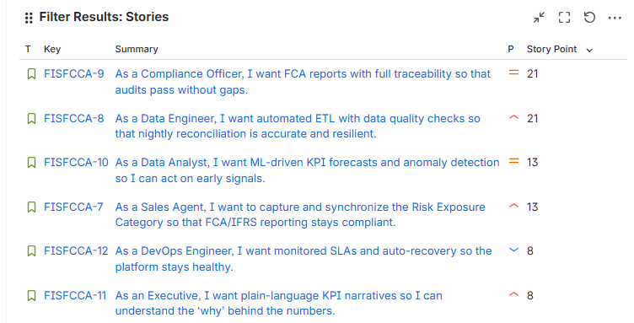

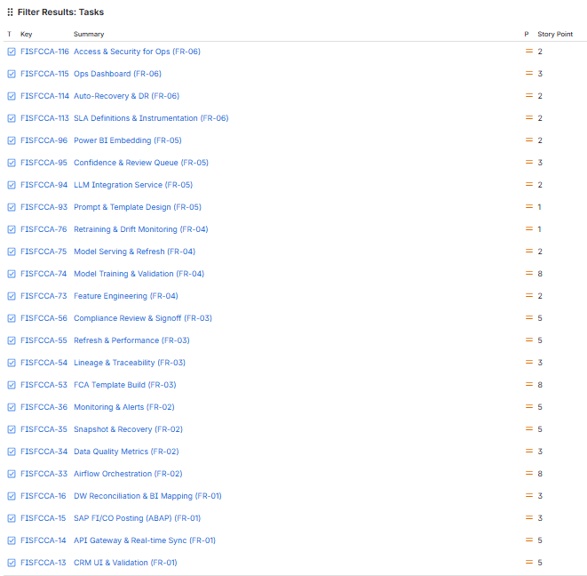

Backlog Management

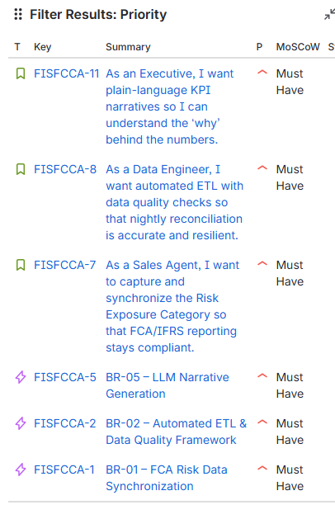

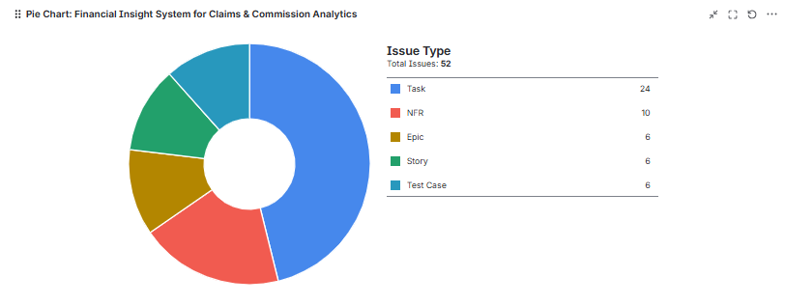

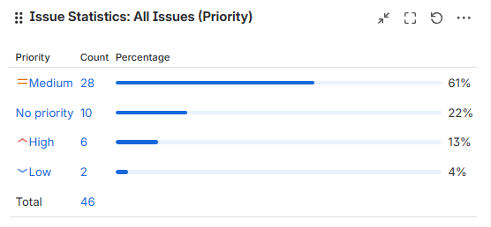

Confluence and Documentation
All the BRD, FRD, PM, QA, and Technical Development documents are stored on the Confluence page.

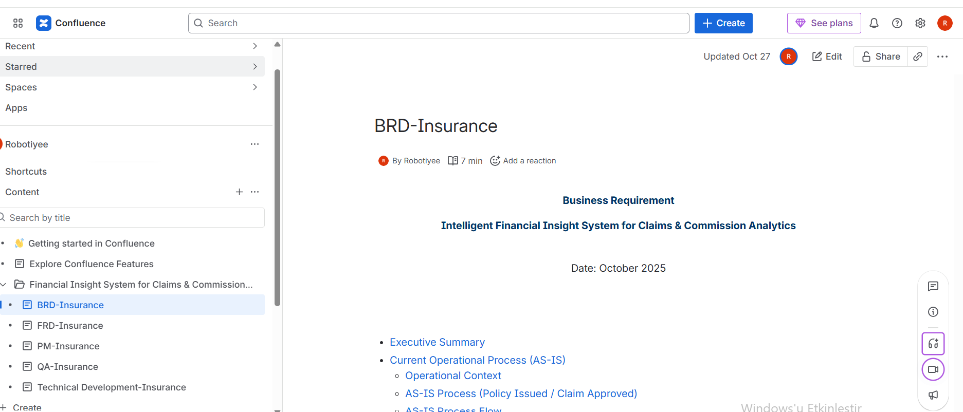

Requirement and Prioritization Frameworks

9.1 RACI
Helps resolve who has authority when stakeholder priorities conflict.
It doesn’t decide what should be prioritized — it clarifies who should decide and who should be consulted.
Role | Meaning | Example
Responsible (R) | Person(s) doing the work | BA drafting requirement
Accountable (A) | Final decision maker / owner | Product Owner / Sponsor
Consulted (C) | Provides input before decision | Compliance Officer, Finance Lead
Informed (I) | Kept updated on progress | Operations Team
Use in Conflicts:
When two departments (e.g., Compliance vs. Marketing) disagree on a feature’s priority, your RACI matrix ensures that only the Accountable stakeholder (A) has final say — while the others are consulted. This prevents scope creep and political tension.

9.2 MoSCoW — Prioritizing Requirements
Once RACI clarifies who decides, you apply MoSCoW to evaluate what matters most.
It helps stakeholders see trade-offs transparently.
Category | Description | Example
Must have | Non-negotiable (compliance, legal) | FCA data field requirement
Should have | Important but not mandatory | Reporting enhancement
Could have | Nice to include if time allows | Custom report filter
Won’t have this time | Deferred | Experimental analytics view
Use in Conflicts:
You can mediate discussions by showing that both parties’ needs are valid but fit different MoSCoW tiers.
E.g., “Compliance’s FCA rule is a Must have, while Marketing’s personalization idea is a Could have — to be revisited after MVP.”

9.3 SWOT — Strategic Alignment
SWOT helps justify your MoSCoW priorities and communicate why certain decisions serve the business better.
Factor | Example Insight
Strength | Regulatory compliance improves reputation
Weakness | Complex approval processes slow delivery
Opportunity | Automating compliance reporting improves efficiency
Threat | Non-compliance may lead to penalties
Use in Conflicts:
When stakeholders disagree, you can show objectively that addressing Threats and Weaknesses (via Must-haves) provides greater long-term value than focusing on Opportunities (Could-haves).

9.4 Root-Cause Analysis:
It is used to identify the underlying cause of a defect, issue, or conflict — not just the visible symptom.
It ensures corrective actions are focused on preventing recurrence, not merely fixing immediate problems.
Technique | Description | Example
5 Whys | Repeatedly ask “Why?” to drill down to the root cause. | The report failed → Why? Data missing → Why? API not called → Why? ETL job failed → Why? Server config error.
Fishbone (Ishikawa) Diagram | Visual tool that categorizes causes under areas such as People, Process, Technology, or Policy. | Helps analyze why a requirement was misunderstood or delayed.
Pareto Analysis (80/20 Rule) | Focus on the small number of causes that generate most issues. | Identify top 20% of requirements causing 80% of defects.
Failure Mode and Effects Analysis (FMEA) | Quantitatively assess the impact and likelihood of failures. | Prioritize corrective actions for high-risk processes.

9.5 SMART
The SMART framework ensures that requirements or objectives are well-defined and practical:
- Specific: Clearly describes what needs to be achieved.
- Measurable: Includes quantifiable success indicators.
- Achievable: Realistic given resources and constraints.
- Relevant: Aligned with project and business goals.
- Time-bound: Has a defined deadline or timeframe.
SMART goals improve focus, accountability, and project tracking.

9.6 INVEST
The INVEST model provides a quality checklist for User Stories in Agile methodologies.
- Independent: Each story should stand alone to enable flexible prioritization.
- Negotiable: The story is not a contract—it invites discussion and collaboration.
- Valuable: It must deliver clear business value to the user or customer.
- Estimable: The effort to complete it should be measurable and predictable.
- Small: The scope should fit within one iteration or sprint.
- Testable: The story should have clear acceptance criteria for validation.

9.7 Requirements Traceability Matrix (RTM)
It used to track each requirement throughout the project lifecycle, ensuring that every business need is addressed through design, development, testing, and deployment.
It establishes a clear link between:
- Business Requirements (BRD) → Functional Requirements (FRD) → Test Cases → Deliverables.
- To ensure no requirement is missed or out of scope.
- To provide visibility and control over requirement changes.
- To support compliance and auditability (especially critical for FCA/IFRS environments).
- To validate that each deliverable aligns with Business Objectives (BOs) and KPIs.

Requirement ID | Requirement Description | Source / Stakeholder | Functional Design Reference | Test Case ID | Status | Comments / Risk
BR-01 | Capture “Risk Exposure Category” in CRM | Compliance | FRD-1.1 | TC-001 | In Progress | Required for FCA reporting
BR-02 | Synchronize Risk Category to SAP FI/CO | Finance | FRD-1.2 | TC-002 | Pending | Dependent on API integration

9.8 Structured Conflict-Resolution Approach

Step | Description / Key Activity | Tools & Techniques | Deliverables / Artefacts | Expected Outcome
1. Conflict Identification & Root-Cause Analysis | Identify and analyze the underlying reasons for stakeholder disagreements (e.g., scope, compliance, or resource priorities). | • Root-Cause Analysis (5 Whys) • Stakeholder Interviews / Workshops | Conflict Log Issue Register | Clear understanding of conflicts, drivers, and affected objectives.
2. Communication & Transparency | Establish open, fact-based communication channels; ensure that each stakeholder understands the project goals, KPIs, and constraints. | • Stakeholder Meetings • Active Listening • Transparent Reporting | Communication Plan Meeting Minutes | Trust built among stakeholders through transparency and openness.
3. Expectation Alignment | Facilitate workshops to align all parties on shared Business Objectives (BOs) and KPIs; focus on desired outcomes rather than individual preferences. | • Alignment Workshops • KPI Mapping • BO Review Sessions | Updated Stakeholder Alignment Matrix | Shared understanding of project outcomes and measurable success indicators.
4. Prioritization & Analytical Resolution | Apply structured prioritization to balance business value, regulatory needs, and operational feasibility. | • MoSCoW Prioritization (Must, Should, Could, Won’t) • SWOT Analysis (to justify MoSCoW results) | Prioritized Requirements List SWOT Justification Report | Balanced and defensible prioritization of conflicting requirements.
5. Decision Governance & Accountability | Define who has authority to approve or reject each decision; clarify involvement roles. | • RACI Matrix (Responsible, Accountable, Consulted, Informed) | RACI Decision Matrix Decision Log | Transparent accountability and efficient decision-making.
6. Documentation & Traceability | Record all decisions, rationales, and stakeholder approvals for auditability and project governance. | • Requirements Traceability Matrix (RTM) • Decision Log | Updated BRD / RTM Change History | Ensures traceability and compliance with internal QA and audit processes.
7. Continuous Engagement & Monitoring | Maintain ongoing communication, provide updates, and re-evaluate priorities as business or compliance conditions evolve. | • Regular Check-ins • Retrospectives • Feedback Loops | Engagement Tracker Status Reports | Sustained stakeholder collaboration and prevention of future conflicts.

Agile Meetings (Ceremonies)

This table represents the agile ceremonies, summary and importance.

Ceremony / Activity | Category | Main Purpose | Key Steps | Actors Involved | Timing | Techniques / Tools | Frequency / Duration | Why It Matters / Key BA Value | BA Priority Level
Product Backlog Refinement (Grooming) | Preparation | Prepare and prioritize backlog items for upcoming sprints. | Review, clarify, and split backlog items into user stories; estimate (story points); define acceptance criteria. | Product Owner, Scrum Master, Development Team, BA | 3–4 days before Sprint Planning | MoSCoW, INVEST, Acceptance Criteria, RTM | Weekly or bi-weekly | Ensures clarity, prioritization, and readiness for Sprint Planning; BA defines acceptance criteria and verifies INVEST. | (Critical)
Sprint Planning | Execution | Define Sprint Goal and plan work for next Sprint. | Set Sprint Goal; select backlog items; estimate effort; assign ownership; identify risks; finalize Sprint Backlog. | Product Owner, Scrum Master, Development Team, BA | Start of each Sprint | SMART, MoSCoW, Risk Analysis, RACI | Every Sprint (2–4 weeks) | Aligns business goals, defines scope, validates feasibility; BA ensures stories meet DoR and map to KPIs. | (Critical)
Daily Stand-Up (Daily Scrum) | Monitoring | Synchronize progress and identify blockers. | Share updates on completed / upcoming tasks; raise impediments. | Development Team, Scrum Master, BA | Every working day | Task Board, Jira / Azure DevOps | Daily (15 minutes) | Provides visibility on blockers; BA monitors requirement dependencies or unclear stories. | (Low–Medium)
Sprint Review (Demo) | Validation | Demonstrate completed increment and collect feedback. | Present increment; gather stakeholder feedback; update backlog. | Product Owner, Scrum Team, Key Stakeholders, BA | End of each Sprint | KPI Review, Progress Report, Feedback Loop | End of Sprint | Validates business outcomes, captures stakeholder feedback; BA ensures deliverables meet requirements and KPIs. | (High)
Sprint Retrospective | Improvement | Reflect on process and identify improvement areas. | Discuss what went well / not well; define improvement actions; assign owners. | Scrum Master, Product Owner, Development Team, BA | After Sprint Review | SWOT, Root-Cause Analysis, Parametric Estimation, MoSCoW, SMART | End of Sprint (max 3 hrs for 1-month sprint) | Enables continuous improvement; BA contributes analytical insights, RCA, and measurable enhancements. | (Medium)
Release Planning / PI Planning | Coordination | Align teams on release goals, dependencies, and roadmap. | Define release goals; plan capacity; identify cross-team dependencies. | Product Owner, Release Train Engineer, BAs, Teams | Between major releases | Value Stream Mapping, Dependency Matrix, RACI | Every few sprints | Provides roadmap visibility; BA ensures alignment with business objectives and dependencies. | (High for scaled agile)
Stakeholder Alignment Workshop | Governance / Strategy | Resolve conflicts and realign scope and priorities. | Identify conflicts; apply SWOT, MoSCoW, and RACI; document decisions. | BA (facilitator), Product Owner, Stakeholders | As needed | SWOT, RACI, MoSCoW, RTM, SMART, RCA | Ad-hoc | Ensures stakeholder consensus, transparency, and documented traceability. | (High Strategic Value)

